**Ejercicio 3.1**

In Example 3.2, each union and intersection operation can be performed in time proportional to the sum of the number of records in the two input tables. Based on this, construct the weighted task-dependency graphs corresponding to Figures 3.2 and 3.3, where the weight of each node is equivalent to the amount of work required by the corresponding task. What is the average degree of concurrency of each graph?

* Dependency task graphs

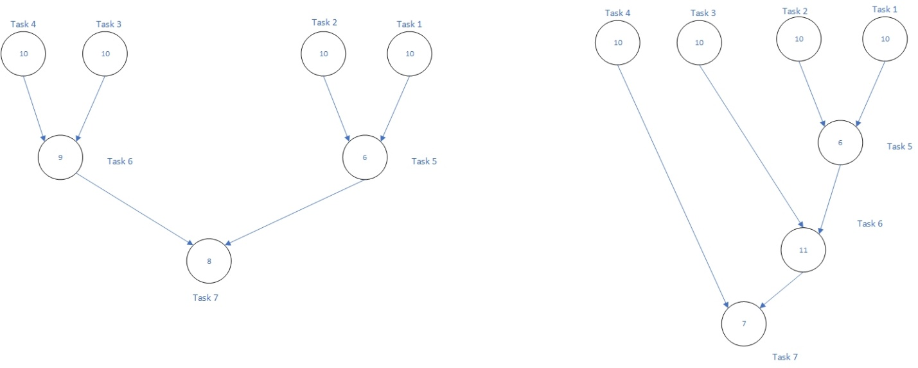

* Average degree of concurrency: este cálculo proviene de la división entre la cantidad total de trabajo de las tareas entre la suma del trabajo encontrado en la ruta crítica.
  + Para el 3.2: $\frac{63}{27}=2.33$
  + Para el 3.3: $\frac{64}{34}=1.88$

**Ejercicio 3.2** (se asume que el trabajo para cada tarea es de 1)

* **3.2.1 Máximo grado de concurrencia**

1. 8.
2. 8.
3. 8.
4. 2.

* **3.2.2 Longitud de la ruta crítica**

1. 4.
2. 4.
3. 7.
4. 8.

* **3.2.3 Máximo speedup**

1. 15/4
2. 15/4
3. 14/7
4. 15/8

* **3.2.4 Número mínimo de procesos necesarios para obtener el speedup máximo.**

1. 8.
2. 8.
3. 3.
4. 2.

* **3.2.5 Máximo speedup cuando se limita el número de procesos a 2, 4 y 8.**

1. 2 procesos: (a) 15/8, (b) 15/8, (c) 7/4, (d) 15/8
2. 4 procesos: (a) 15/5, (b) 15/5, (c) 14/7, (d) 15/8
3. 8 procesos: (a) 15/4, (b) 15/4, (c) 14/7, (d) 15/8

**Ejercicio 3.3**

What are the average degrees of concurrency and critical-path lengths of task dependency graphs corresponding to the decompositions for matrix multiplication shown in Figures 3.10 and 3.11?

* Para la figura 3.10, encontramos que las 4 tareas son independientes. Esto nos genera una ruta crítica de 1 y un promedio del grado de concurrencia igual a 4.
* Para la figura 3.11, encontramos 8 tareas en las cuales si existe dependencia. Las tareas pares dependerán de su antecesor. Esto nos arroja una ruta crítica de 2 tareas y un promedio del grado de concurrencia de 4.

**Ejercicio 3.4**

Let d be the maximum degree of concurrency in a task-dependency graph with t tasks and a critical-path length l. Prove that $\frac{t}{l}≤ d≤ t – l + 1$.

Sabemos que el número de caminos independientes desde el principio hasta el final del grafo vendrá dado por $\frac{t}{l}$, ya que l es la ruta crítica y no habrá camino más grande que ese. Dicho esto, entonces $d≥$ $\frac{t}{l}$. Continuando con el lado derecho de la desigualdad, $t – l + 1$ se cumple debido a que, si el grado máximo de concurrencia es mayor, entonces la ruta crítica dejaría de ser $l$ ya que le faltarían $l-1$ nodos para formarse.

**Ejercicio 3.5**

Consider LU factorization of a dense matrix shown in Algorithm 3.3. Figure 3.27 shows the decomposition of LU factorization into 14 tasks based on a two-dimensional partitioning of the matrix A into nine blocks Ai,j, 1 i, j 3. The blocks of A are modified into corresponding blocks of L and U as a result of factorization. The diagonal blocks of L are lower triangular submatrices with unit diagonals and the diagonal blocks of U are upper triangular submatrices. Task 1 factors the submatrix A1,1 using Algorithm 3.3. Tasks 2 and 3 implement the block versions of the loop on Lines 4–6 of Algorithm 3.3. Tasks 4 and 5 are the upper-triangular counterparts of tasks 2 and 3. The element version of LU factorization in Algorithm 3.3 does not show these steps because the diagonal entries of L are 1; however, a block version must compute a block-row of U as a product of the inverse of the corresponding diagonal block of L with the block-row of A. Tasks 6–9 implement the block version of the loops on Lines 7–11 of Algorithm 3.3. Thus, Tasks 1–9 correspond to the block version of the first iteration of the outermost loop of Algorithm 3.3. The remainder of the tasks complete the factorization of A. Draw a task-dependency graph corresponding to the decomposition shown in Figure 3.27.

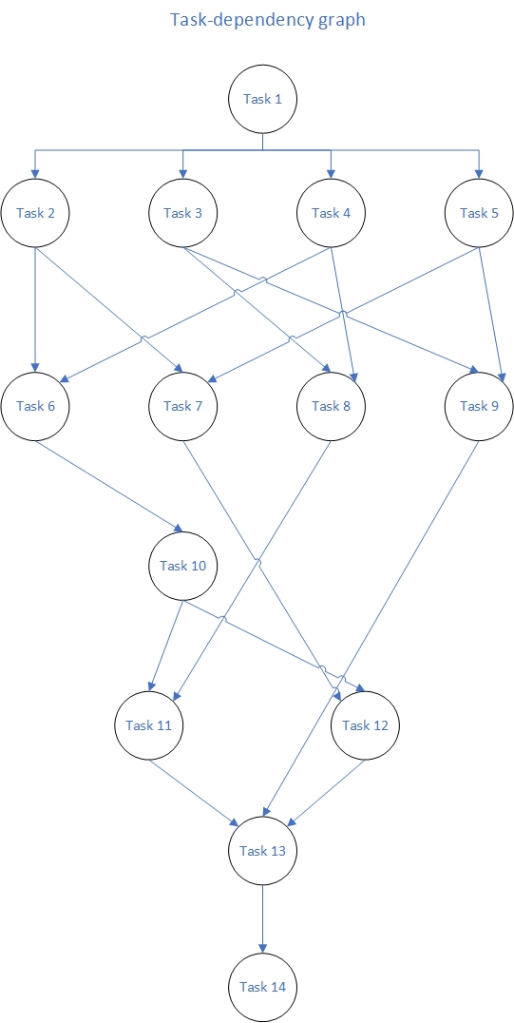

**Ejercicio 3.6**

Enumerate the critical paths in the decomposition of LU factorization shown in Figure 3.27.

$1→ 2→ 6→ 10→ 11→ 13→ 14$

$1→ 2→ 6→ 10→ 12→ 13→ 14$

$1→ 4→ 6→ 10→ 11→ 13→ 14$

$1→ 4→ 6→ 10→ 12→ 13→ 14$

**Ejercicio 3.7**

Show an efficient mapping of the task-dependency graph of the decomposition shown in Figure 3.27 onto three processes. Prove informally that your mapping is the best possible mapping for three processes.

|  |  |  |  |  |  |  |  |
| --- | --- | --- | --- | --- | --- | --- | --- |
|  | Nivel 0 | Nivel 1 | Nivel 2 | Nivel 3 | Nivel 4 | Nivel 5 | Nivel 6 |
| **P0** | **T1** | **T2** | **T5** | **T7** | **T12** | **T13** | **T14** |
| **P1** | **-** | **T4** | **T6** | **T10** | **T11** | **-** | **-** |
| **P2** | **-** | **T3** | **T8** | **T9** | **-** | **-** | **-** |

**Ejercicio 3.8**

Describe and draw an efficient mapping of the task-dependency graph of the decomposition shown in Figure 3.27 onto four processes and prove that your mapping is the best possible mapping for four processes.

|  |  |  |  |  |  |  |  |
| --- | --- | --- | --- | --- | --- | --- | --- |
|  | Nivel 0 | Nivel 1 | Nivel 2 | Nivel 3 | Nivel 4 | Nivel 5 | Nivel 6 |
| **P0** | **T1** | **T2** | **T6** | **T10** | **T11** | **T13** | **T14** |
| **P1** | **-** | **T5** | **T7** | **-** | **T12** | **-** | **-** |
| **P2** | **-** | **T4** | **T8** | **-** | **-** | **-** | **-** |
| **P3** | **-** | **T3** | **T9** | **-** | **-** | **-** | **-** |