**Spring Security OAuth2 + Google Integration**

The reference being taken from

<http://carminedimascio.com/2014/02/google-oauth2-and-jax-rs/>

Very IMP Docs:

<https://developers.google.com/accounts/docs/OAuth2ForDevices>

<https://developers.google.com/+/api/oauth#scopes>

<http://gotoanswer.com/?q=how+to+use+oAuth2+with+yii1+in+web+services>

<http://sohu.io/questions/3067127/missing-parameter-access-token-on-oauth2-request>

Github Link: <https://github.com/Sayi/oauth2-client4j>

<http://code.google.com/apis/console>

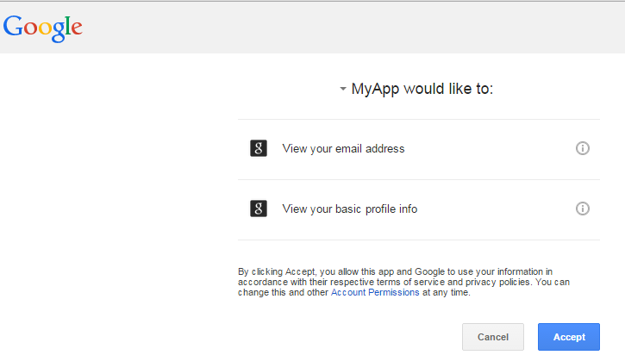’

<https://accounts.google.com/o/oauth2/auth?scope=https%3A%2F%2Fwww.googleapis.com%2Fauth%2Fuserinfo.email+https%3A%2F%2Fwww.googleapis.com%2Fauth%2Fuserinfo.profile&response_type=code&redirect_uri=http%3A%2F%2Flocalhost%3A8080%2Fapache-oltu%2Fgoogle%2Fredirect&client_id=755676439314-jcumfghnkmcm72hf40beikvoatknstml.apps.googleusercontent.com>

{    
   **"web"**:{    
      **"auth_uri"**:"https://accounts.google.com/o/oauth2/auth",  
      **"client_secret"**:"9kT21H5EO3DHRUdlkzzt5eVo",  
      **"token_uri"**:"https://accounts.google.com/o/oauth2/token",  
      **"client_email"**:"755676439314-jcumfghnkmcm72hf40beikvoatknstml@developer.gserviceaccount.com",  
      **"redirect_uris"**:[    
         "http://localhost:8080/apache-oltu/google/redirect"  
      ],  
      **"client_x509_cert_url"**:"https://www.googleapis.com/robot/v1/metadata/x509/755676439314-jcumfghnkmcm72hf40beikvoatknstml@developer.gserviceaccount.com",  
      **"client_id"**:"755676439314-jcumfghnkmcm72hf40beikvoatknstml.apps.googleusercontent.com",  
      **"auth_provider_x509_cert_url"**:"https://www.googleapis.com/oauth2/v1/certs",  
      **"javascript_origins"**:[    
         "http://localhost:8080/"  
      ]  
   }  
}