**Protecting Systems with Circuit Breakers**

Sequence to start the services –

co-eureka-server

co-eureka-tollrate-service

co-eureka-tollrate-billboard

co-eureka-fastpass-service

co-eureka-fastpass-console

<http://localhost:8761/>

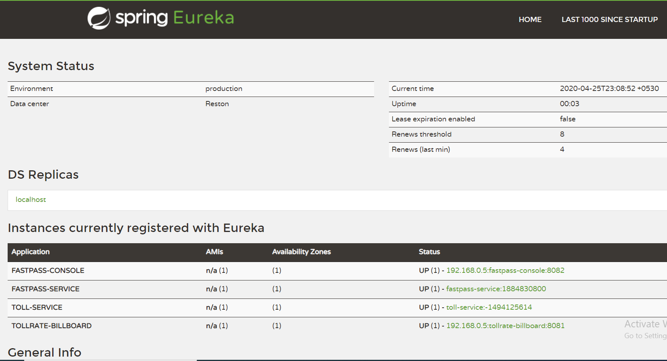  
<http://localhost:8082/customerdetails?fastpassid=101>

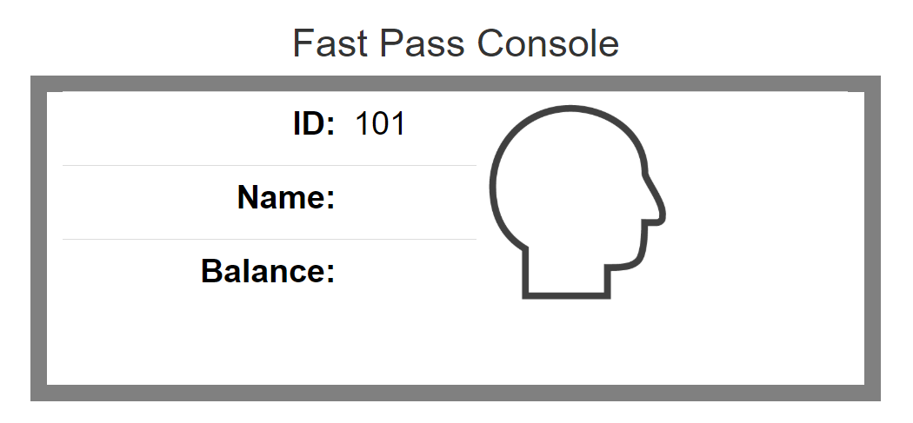

<http://localhost:8081/dashboard?stationId=3>

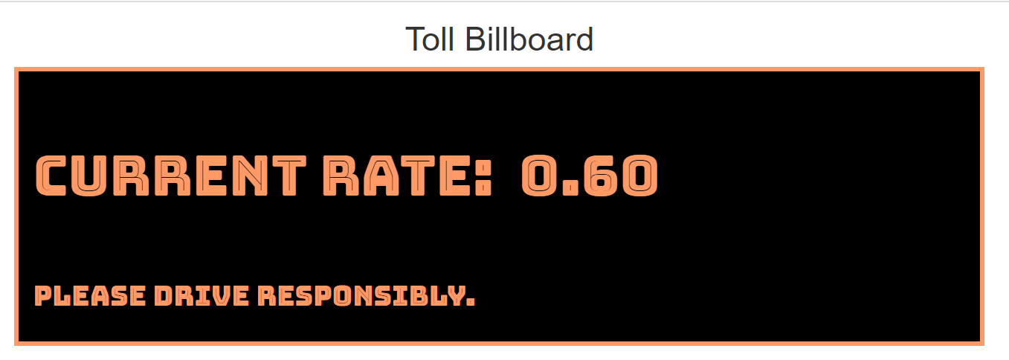

This gives constant hearbeats

Now simply call the **http://localhost:8081/hystrix.stream** and **http://localhost:8082/hystrix.stream**, make sure you're able to see the streams.

Now, down the **eureka-tollrate-service** and hit the <http://localhost:8081/dashboard?stationId=1> , fallback will be called.

Also, Now, down the **co-eureka-fastpass-service** and hit the <http://localhost:8082/customerdetails?fastpassid=101>, fallback will be called.

Make sure **hystrix-dashboard** is running and hit the [**http://localhost:8085/hystrix**](http://localhost:8085/hystrix)

Now pass the value <http://localhost:8081/hystrix.stream>

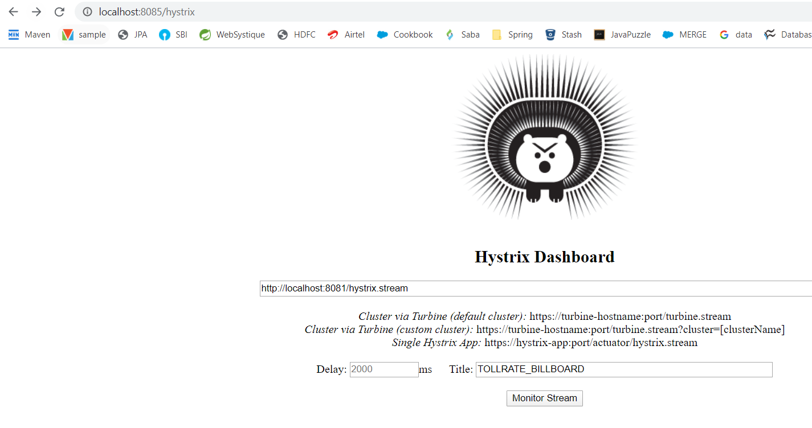

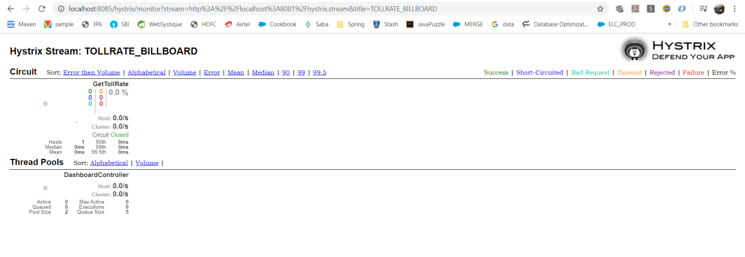

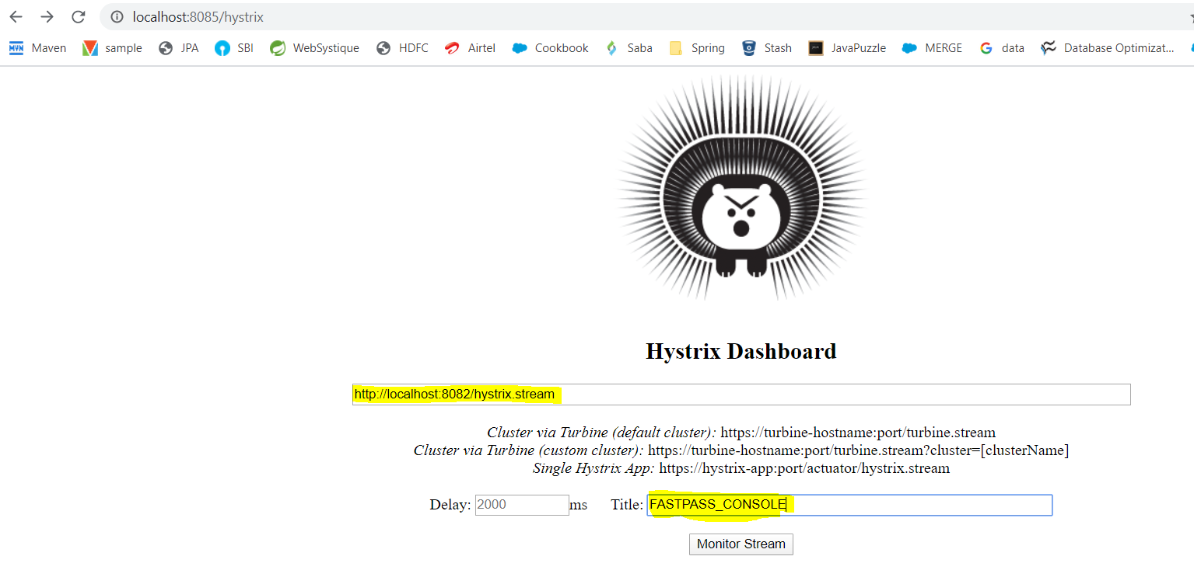

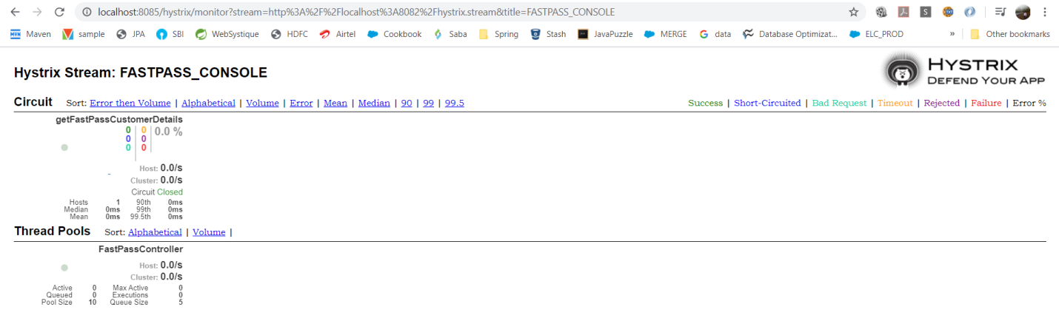

Now hit the <http://localhost:8081/dashboard?stationId=3> and <http://localhost:8082/customerdetails?fastpassid=101> multiple times

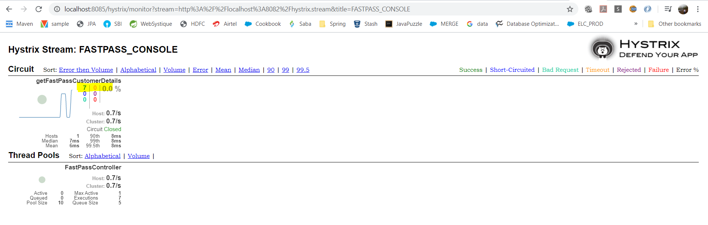

Now stop the **co-eureka-tollrate-service** and **co-eureka-fastpass-service.**  You should be able to see

Circuit is opened.

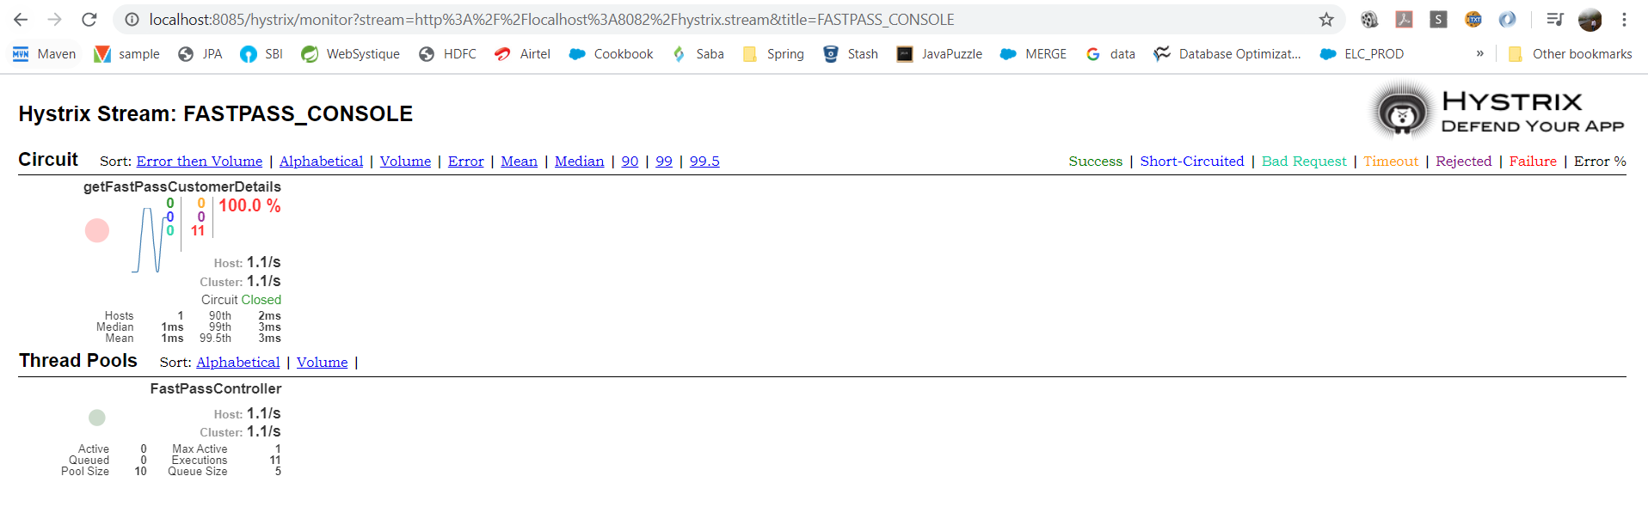

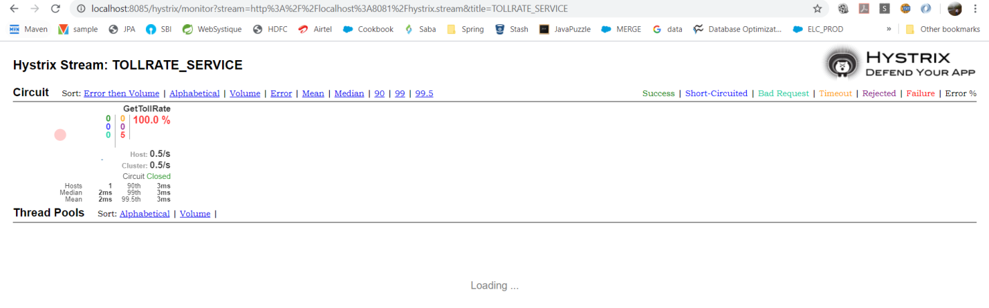

Now Perform the same with Turbine