**Connecting Microservices Through Messaging**

Demo-1 - [Creating Message Senders and Receivers](https://app.pluralsight.com/player?course=java-microservices-spring-cloud-coordinating-services&author=richard-seroter&name=3c4d1d96-609d-4980-8347-f1d5c259d79d&clip=4&mode=live)

Login to <http://localhost:15672/>

And then star the **co-eureka-fastpass-console**. Make sure you’ve initially started the **co-eureka-server**

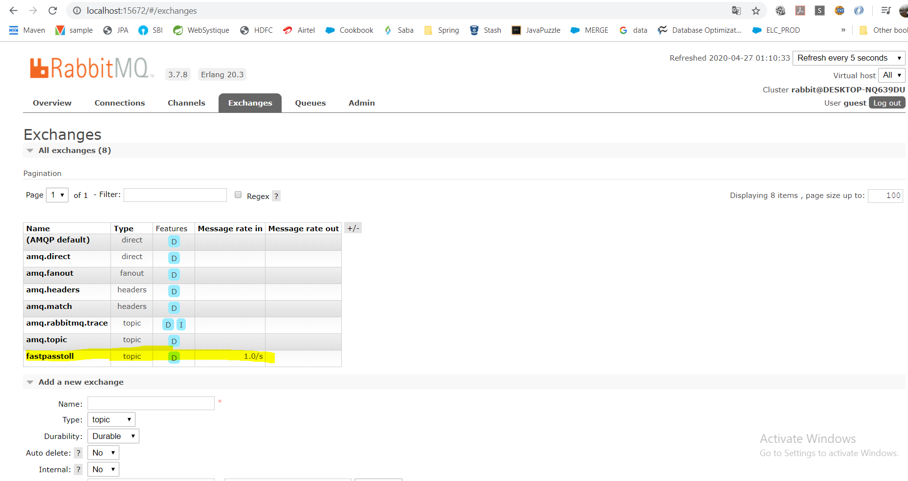

Now, start the **co-stream-tollintake**

