**Connecting Microservices Through Messaging**

Demo-4 - **Setting up and Using Partitions**

Start the 3 instances of **co-stream-tollintake,** do the **mvn package** in order to run 3 instances**.**

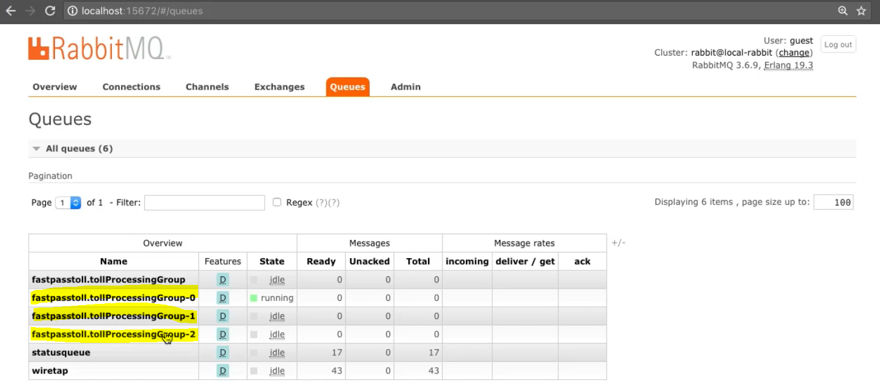

Now execute the POST few times –

