Spring Cloud Data Flow and Database Output

* Start the **spring-cloud-data-flow-server**. Make sure you’ve MySQL v8.0.11+ version installed om machine.
* This will create all the metadata tables into MySQL Test schema.

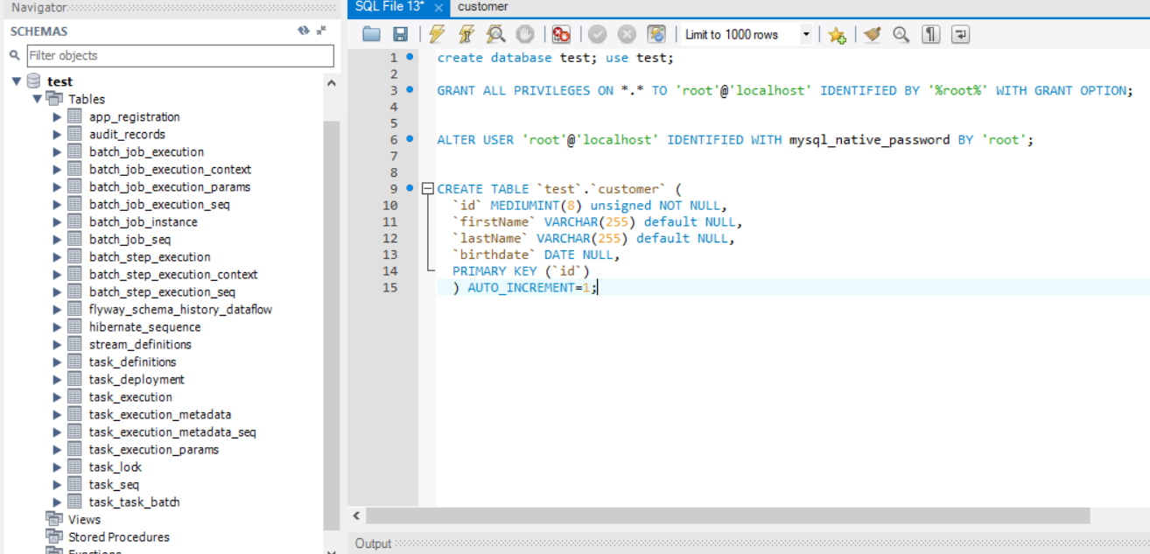

Launch : <http://localhost:9393/dashboard>

Click on “Add Application”

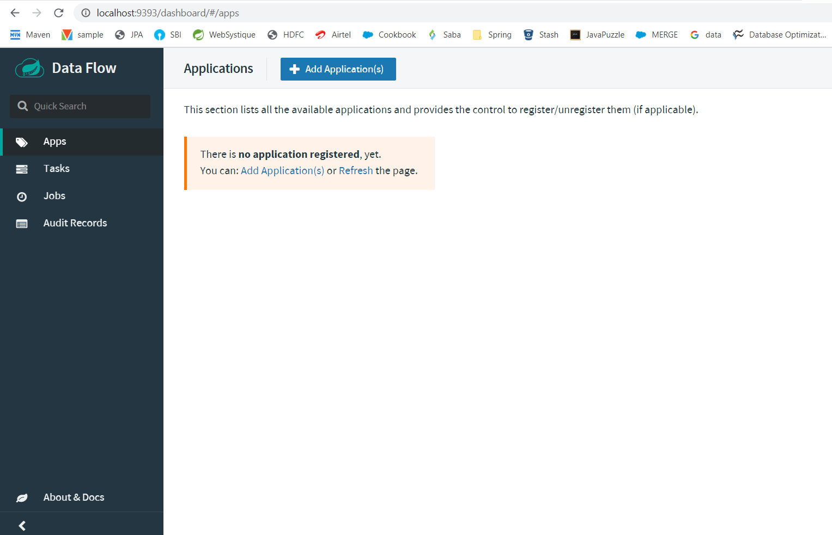

java -jar spring-cloud-dataflow-server-local-1.7.4.RELEASE.jar --spring.datasource.url=jdbc:mysql://localhost:3306/test --spring.datasource.username=root --spring.datasource.password=root --spring.datasource.driver-class-name=org.mariadb.jdbc.Driver &

Take the PATH where your jar file present.

<file://E:/spring-batch-latest/Minella/Spring-Batch-by-Michael-Minella/databaseOutput/target/databaseOutput-0.0.1-SNAPSHOT.jar>

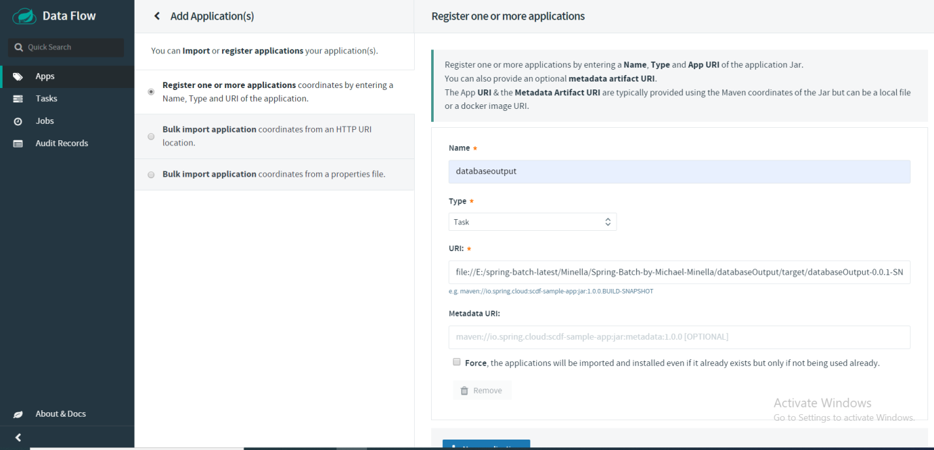

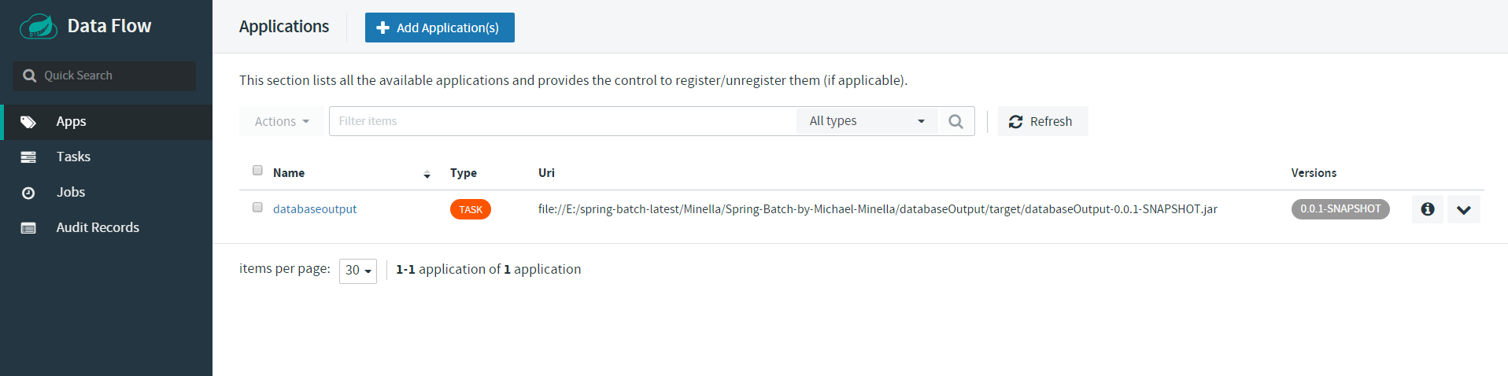

Click on Tasks and click on Create Tasks

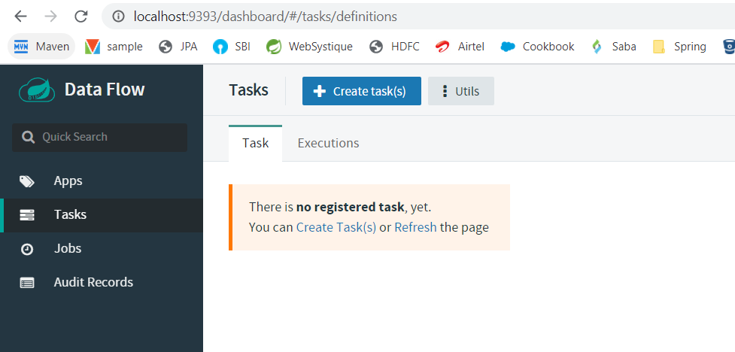

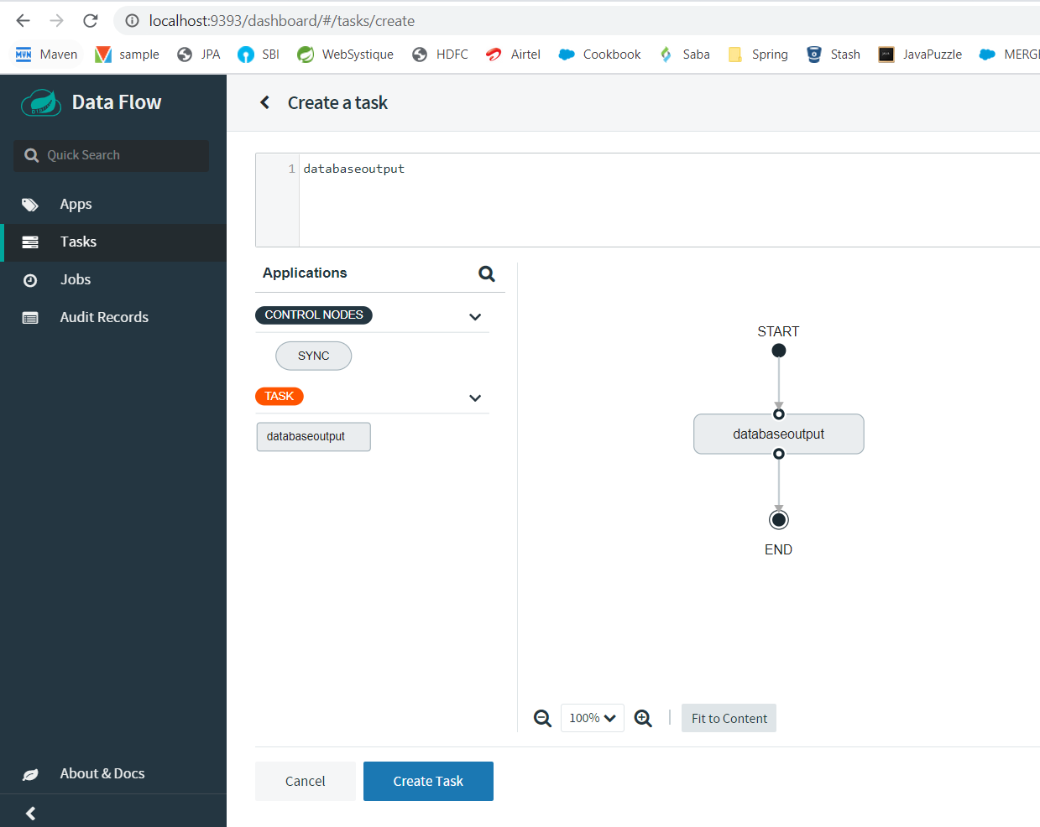

Click on create Task

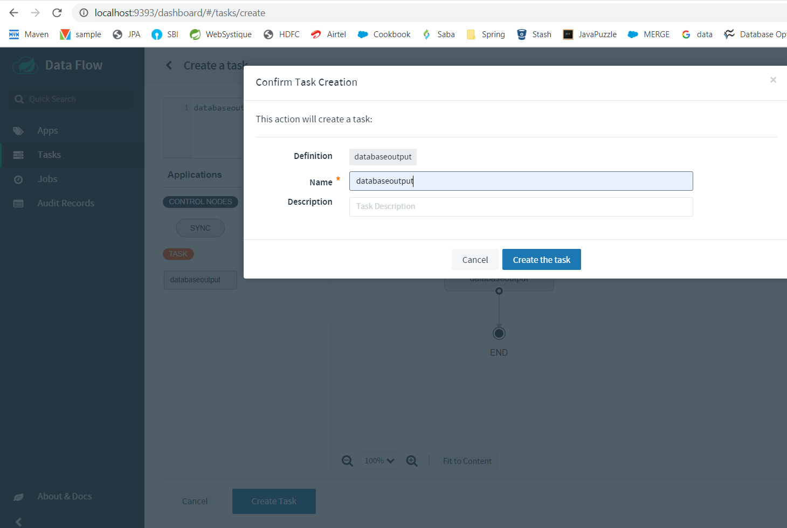

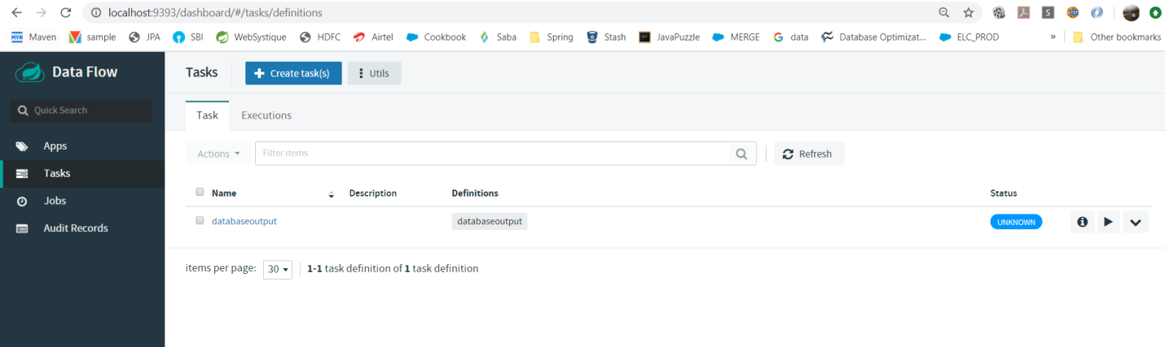

Then click on launch Task and Make sure you’ve created customer table in DB

CREATE TABLE `test`.`customer` (

`id` MEDIUMINT(8) unsigned NOT NULL,

`firstName` VARCHAR(255) default NULL,

`lastName` VARCHAR(255) default NULL,

`birthdate` DATE NULL,

PRIMARY KEY (`id`)

) AUTO_INCREMENT=1;

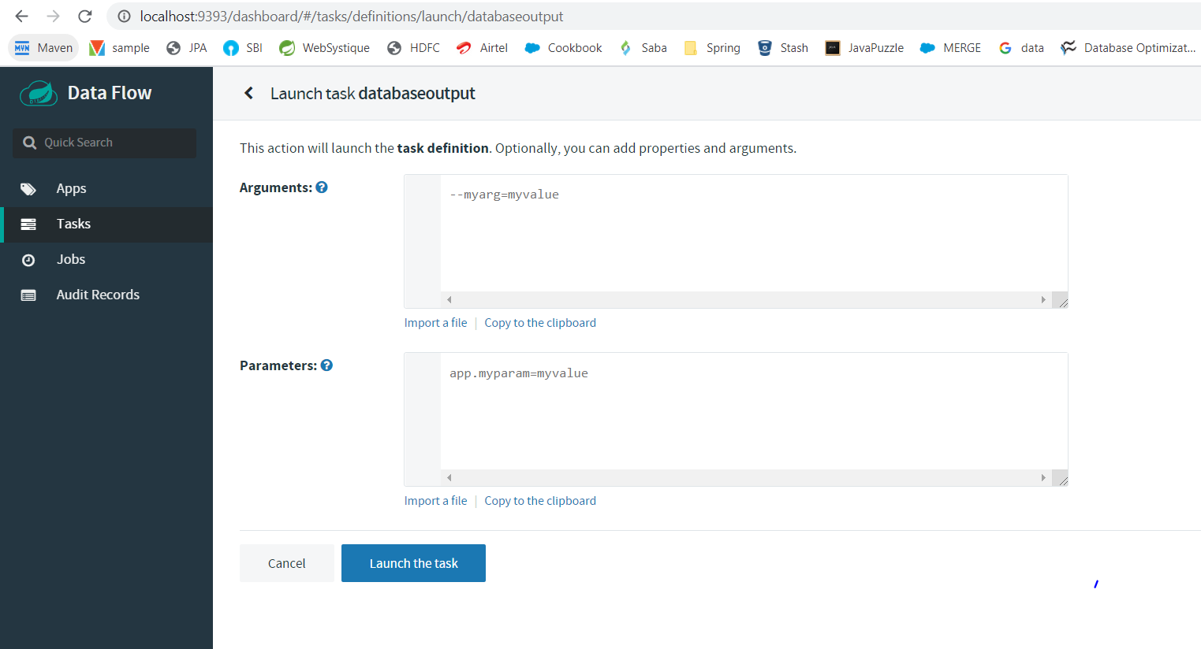

Simply click on launch Task.