Class: CMSC203 CRN 46519

 Program: Assignment #6

 Instructor: Professor Eivazi

 Summary of Description: this project is aimed at automating the order transactions for a beverage shop. There are three types of drinks and several requirements for costumer age, amount of alcohol drinks, day of the week, and several pricing conventions. The project consists of several classes and interfaces.

 Integrity Pledge: I pledge that I have completed the programming assignment independently.

 I have not copied the code from a student or any source

Leon Gabrielian.

UML Diagram

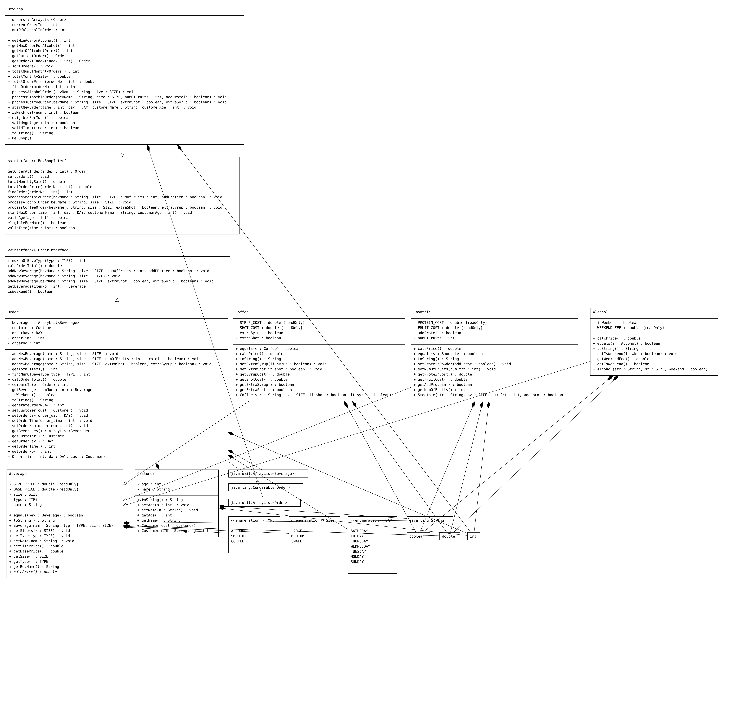

Screenshots

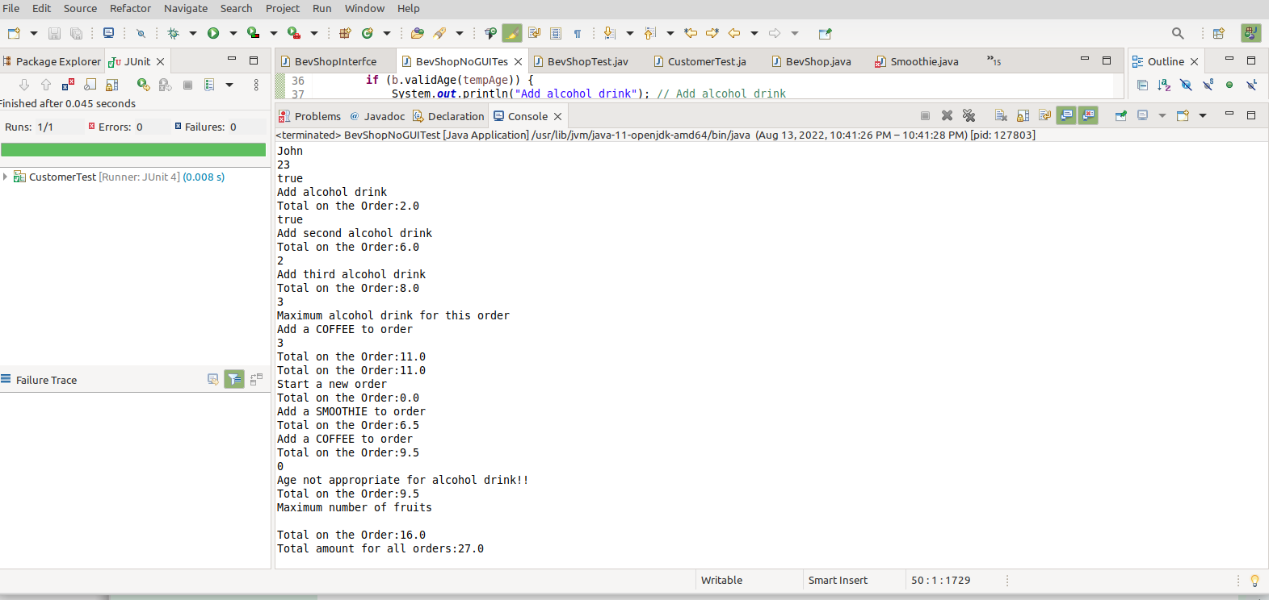1. NoGUI overall test, console output

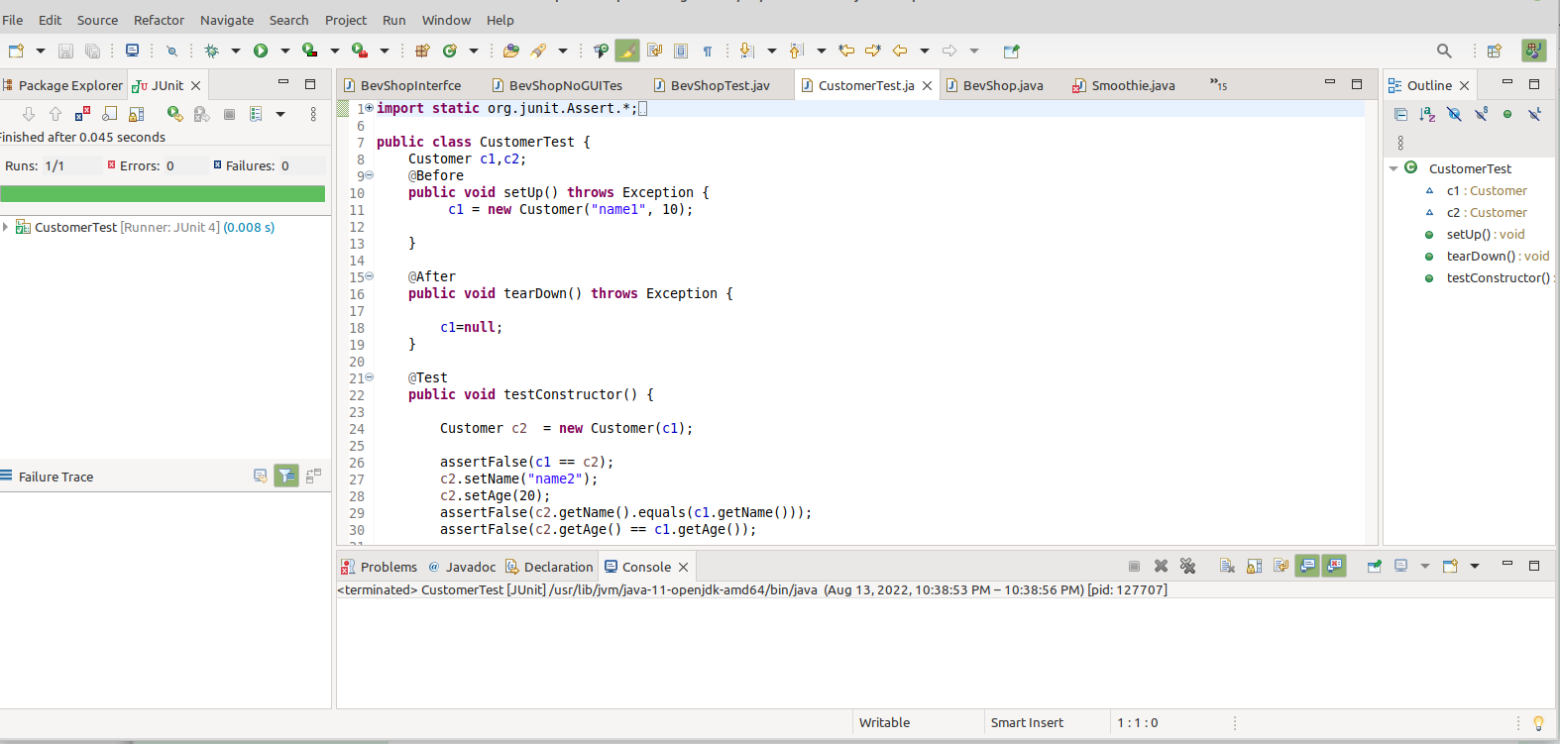2. Customer JUnit test

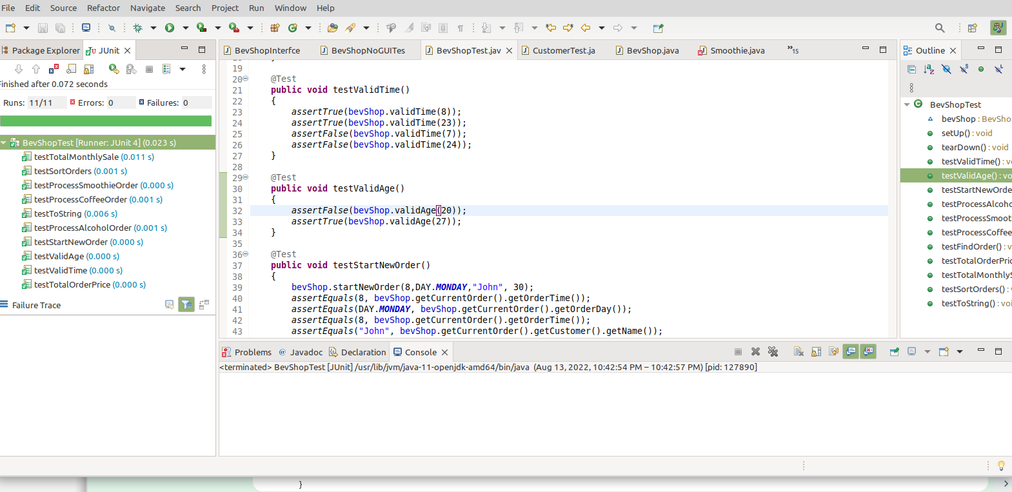3. BeverageShop JUnit test

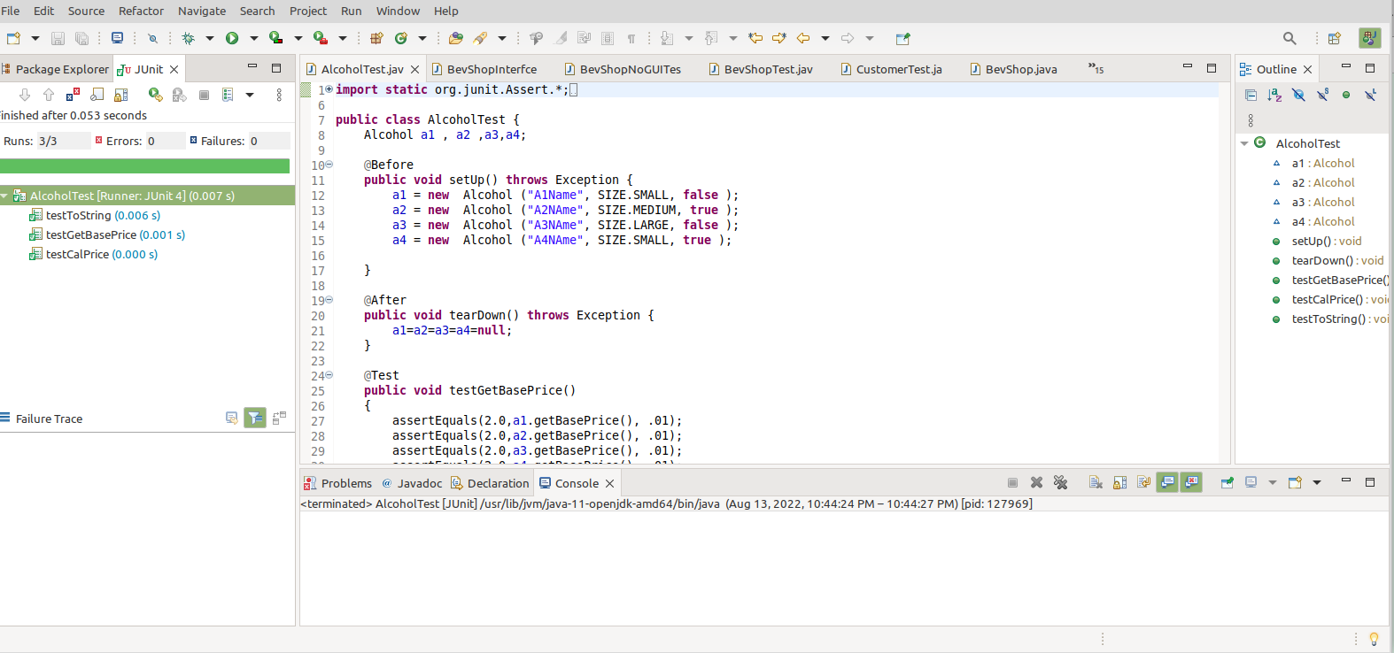4. Alcohol JUnit test

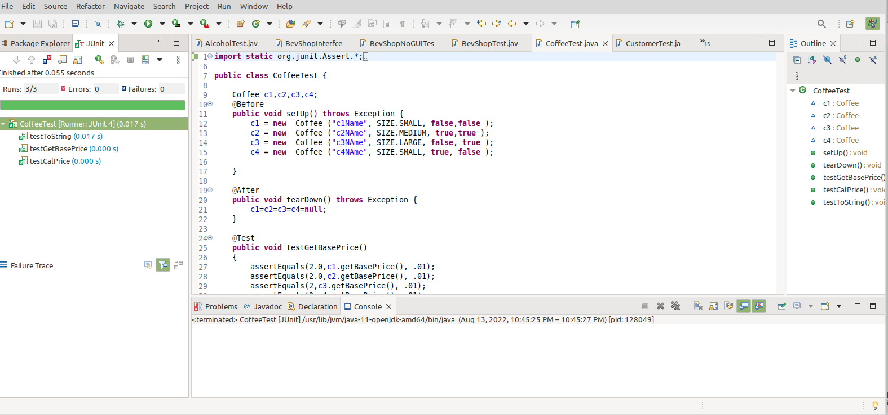5. Coffee JUnit test

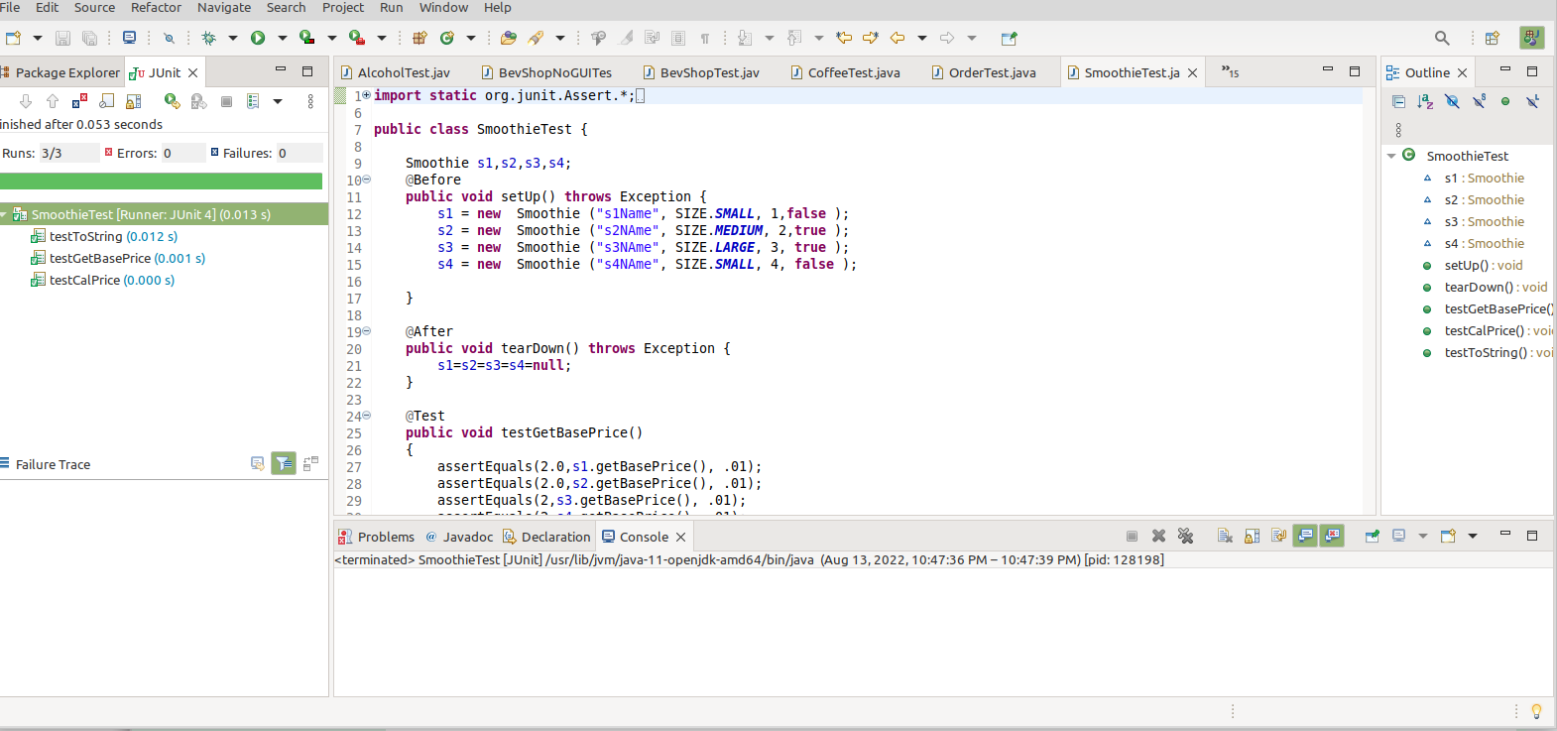6. Smoothie JUnit test

LESSONS LEARNED

Learned how to implement many OO concepts, including Aggregation, Inheritance, Polymorphism, etc.

Struggled with overall complexity of the task, and novelty of some concepts.

On a next project will try to work completely in IntelliJ IDE, which I found more comfortable and full-featured compared with Eclipse.

The project works successfully, all tests (JUnit and others) work fine. In general, the project feels too large and complex because we have to prepare to Final exam now.

