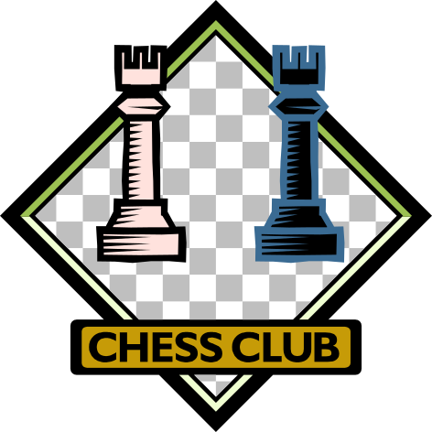

Central Middle School is starting a chess club after school on Tuesdays from 2:50-3:50. The chess club will meet once a week starting January 14th and will end on March 25th. The fee will be $75 which includes all class materials and coach fees. We are hoping to build a tournament team that will compete in local and regional competitions. Go Cobras!

Studies have shown that the same techniques used by chess players to hone their strategy skills could be applied in the classroom to help students with language arts, math and test-taking. There will be various skill levels in this program until the club is established and the coaches will evaluate each player. Beginners are encouraged to join.

Please fill out the form below by Friday, December 20th.

Space is limited. Contact Pamela Davis at ptribino@comcast.net with any questions. Please make checks payable to CMS PTO and return form and payment to your child’s homeroom teacher.

Student’s Name________________________________________________

Grade _______________________________________________________

Phone ________________________________________________________

Email ________________________________________________________

Parent’s Name_________________________________________________

Level of Play (please circle):

Beginner Beg/Intermediate Intermediate Advance

