**Lab 12-Postgresql**

Robiul Hasan

Tuesday Apr 29, 2025 (Introduction)

Class example:

Lab Exercise:12A

1. Table name: courses

1. Table name: Tuition

Thursday May 1, 2025 (CRUD)

Class example:

Insert a new row

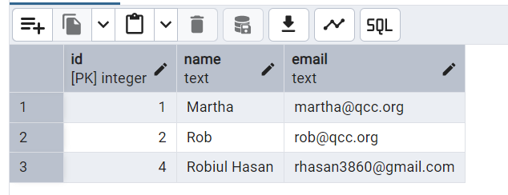

Then update the id to 3

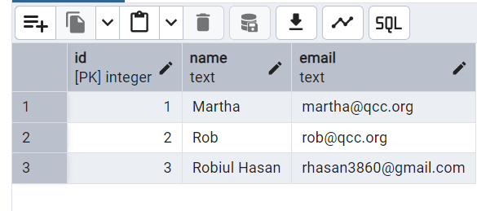

Lab Exercise:12B

1. Read Data

Select all books

Select books where the author is ‘George Orwell’

1. Update Data

1. Delete Data

1. View Final Table

Bonus Challenge:

Friday, May 2, 2025

Class example:

Lab Exercise:12C

1. Read all students and their majors

1. Read the titles of courses each student is enrolled in

1. Read all students with grades and courses

**All the queries for lab 12C:**

create table students(

id serial primary key,

name varchar(100),

major varchar(100)

);

insert into students(name, major) values

('Alice Brown', 'Computer Science'),

('Peter Pan', 'Mathematics'),

('Annie Chen', 'Physics'),

('Robiul Hasan', 'Mathematics');

select * from students;

create table courses(

id serial primary key,

title varchar(100),

department varchar(100)

);

insert into courses(title, department) values

('Database System', 'computer science'),

('Linear Algebra', 'mathematics'),

('Quantum Mechanics','physics'),

('Python programming', 'computer science'),

('Calculus III', 'mathematics');

create table enrollments(

id serial primary key,

grade char(2),

student_id integer references students(id) on delete cascade,

courses_id integer references courses(id) on delete cascade

);

insert into enrollments(grade, student_id, courses_id) values

('A', 4, 5),

('B', 3, 3),

('C', 2, 2),

('B+', 1, 4);

select * from courses;

select title from courses;

select students.name, courses.title, enrollments.grade

from enrollments

join students on enrollments.student_id=students.id

join courses on enrollments.courses_id=courses.id;