# Teacher

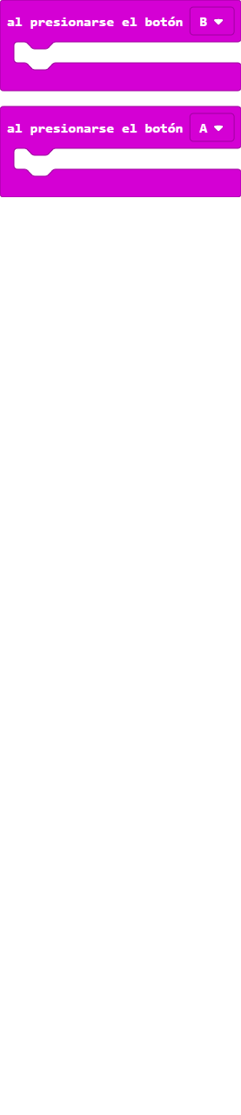

# 



# Bea

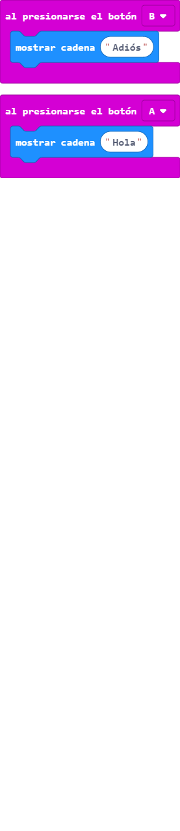

# Clara

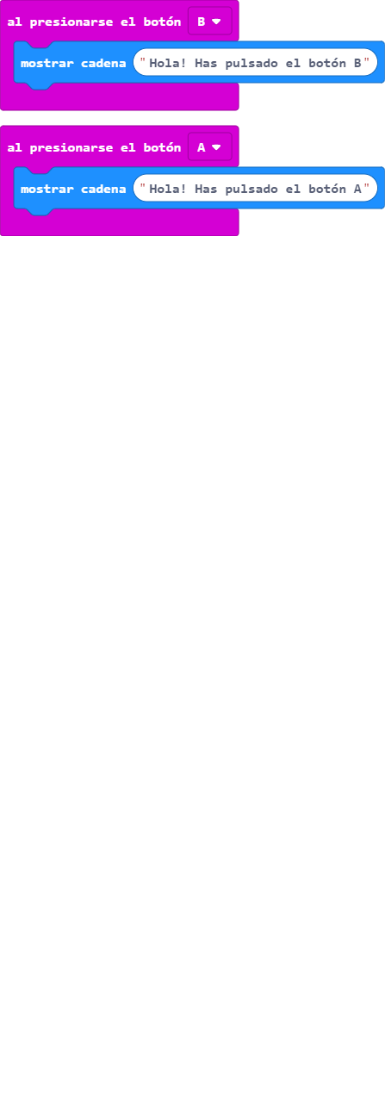

# esther

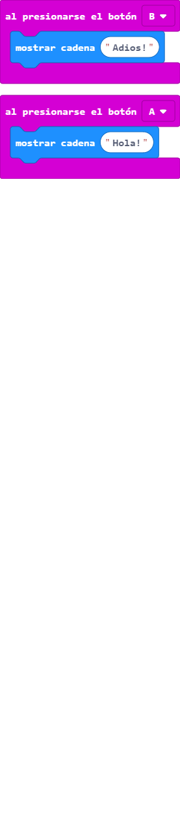

# Isabel

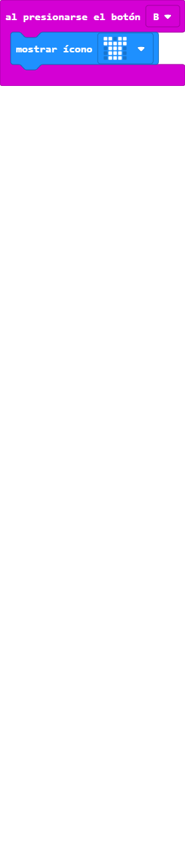

# Manuela

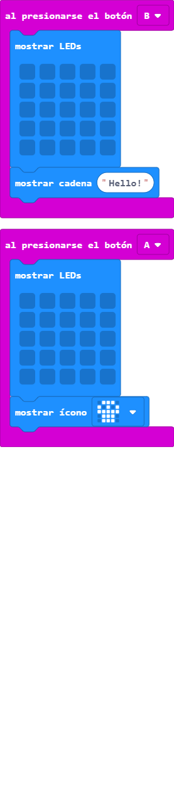

# Mari Carmen

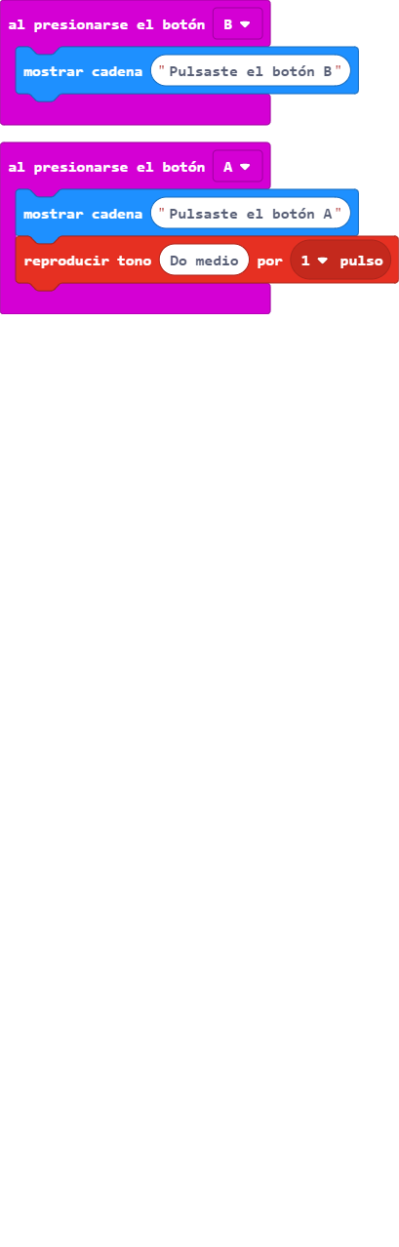

# PP

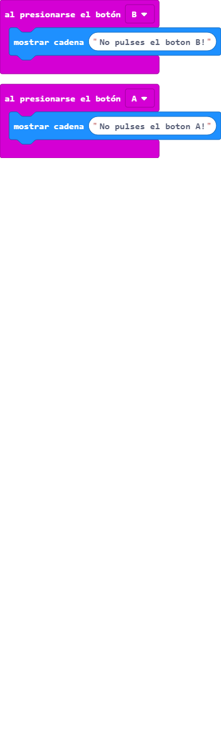

# Silvia

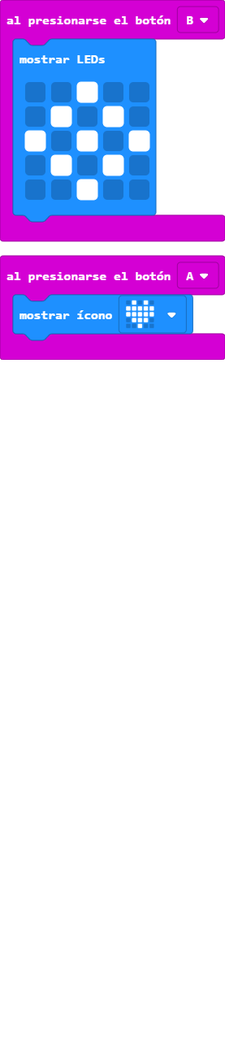

# Silvia (1)

