JSON Data/Media Type (Ex) using REST:
package com.app;

import javax.ws.rs.Consumes;
import javax.ws.rs.FormParam;
import javax.ws.rs.MatrixParam;
import javax.ws.rs.POST;
import javax.ws.rs.Path;
import javax.ws.rs.PathParam;
import javax.ws.rs.Produces;
import javax.ws.rs.QueryParam;
import javax.ws.rs.core.MediaType;

@Path("details")
public class Details {

@POST
@Path("{id}")
@Produces(MediaType.APPLICATION_JSON)
public Student getDetails(@QueryParam("name") String name,@PathParam("id")int id,@MatrixParam("sal")double mnop){
Student s1=new Student();
s1.setEmpId(id);
s1.setEmpName(name);
s1.setEmpSal(mnop);
return s1;
}

@POST
@Path("form")
public String getDetails1(@FormParam("numairc")String data){

return "Wlecome to WS :"+data;
}
@POST
@Path("read")
@Consumes(MediaType.APPLICATION_JSON)
public String read(Student s1){

return "Done"+s1.getEmpName();
}

}

Rest Spring Integration (default):

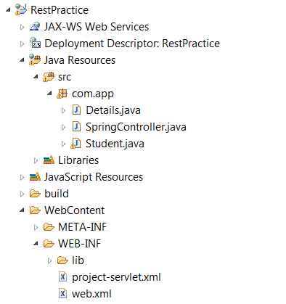
Web.xml
<web-app>
<servlet>
<servlet-name>project</servlet-name>
<servlet-class>org.springframework.web.servlet.DispatcherServlet</servlet-class>
<load-on-startup>1</load-on-startup>
</servlet>

<servlet-mapping>
<servlet-name>project</servlet-name>
<url-pattern>/app/*</url-pattern>
</servlet-mapping>
</web-app>
project-servlet.xml:
<?xml version="1.0" encoding="UTF-8"?>
<beans xmlns="http://www.springframework.org/schema/beans"
xmlns:xsi="http://www.w3.org/2001/XMLSchema-instance"
xmlns:context="http://www.springframework.org/schema/context"
xmlns:util="http://www.springframework.org/schema/util"
xsi:schemaLocation="http://www.springframework.org/schema/beans
http://www.springframework.org/schema/beans/spring-beans-3.0.xsd
http://www.springframework.org/schema/context
http://www.springframework.org/schema/context/spring-context-3.0.xsd
http://www.springframework.org/schema/util
http://www.springframework.org/schema/util/spring-util-3.0.xsd
">
<context:annotation-config/>
<context:component-scan base-package="com.app"/>
</beans>
Controller:
package com.app;

import org.codehaus.jackson.map.ObjectMapper;
import org.springframework.stereotype.Controller;
import org.springframework.web.bind.annotation.RequestBody;
import org.springframework.web.bind.annotation.RequestMapping;
import org.springframework.web.bind.annotation.RequestMethod;
import org.springframework.web.bind.annotation.ResponseBody;

@Controller
public class SpringController {

@RequestMapping(value="accessMethod",method=RequestMethod.POST)
public @ResponseBody String getDetails(@RequestBody String std) throws Exception{
Student std1=new ObjectMapper().readValue(std, Student.class);
return "Done"+std1.toString();
}
}
Model Bean:
package com.app;

import java.io.Serializable;

public class Student implements Serializable{

private int empId;
private String empName;
private double empSal;
public Student() {
super();
}
public int getEmpId() {
return empId;
}
public void setEmpId(int empId) {
this.empId = empId;
}
public String getEmpName() {
return empName;
}
public void setEmpName(String empName) {
this.empName = empName;
}
public double getEmpSal() {
return empSal;
}
public void setEmpSal(double empSal) {
this.empSal = empSal;
}
@Override
public String toString() {
return "Student [empId=" + empId + ", empName=" + empName + ", empSal="
+ empSal + "]";
}

}
Client Code:
package co.app;

import javax.ws.rs.core.MediaType;

import com.sun.jersey.api.client.Client;
import com.sun.jersey.api.client.ClientResponse;
import com.sun.jersey.api.client.WebResource;

public class Main {
public static void main(String[] args) {
String json="{\"empId\":101,\"empName\":\"AJ\",\"empSal\":10.0}";
Client client=Client.create();
WebResource resource=client.resource("http://localhost:2015/RestPractice/app");
resource=resource.path("accessMethod");
ClientResponse res=resource.type(MediaType.APPLICATION_JSON).post(ClientResponse.class,json);
System.out.println(res.getEntity(String.class));

}

}

