This project shows you how to use CANlib in Visual Studio code.

Download and Install Kvaser Driver for Windows:

go to Kvaser website at <https://www.kvaser.com/download/> and download latest version of Kvaser Driver for windows Figure 2.

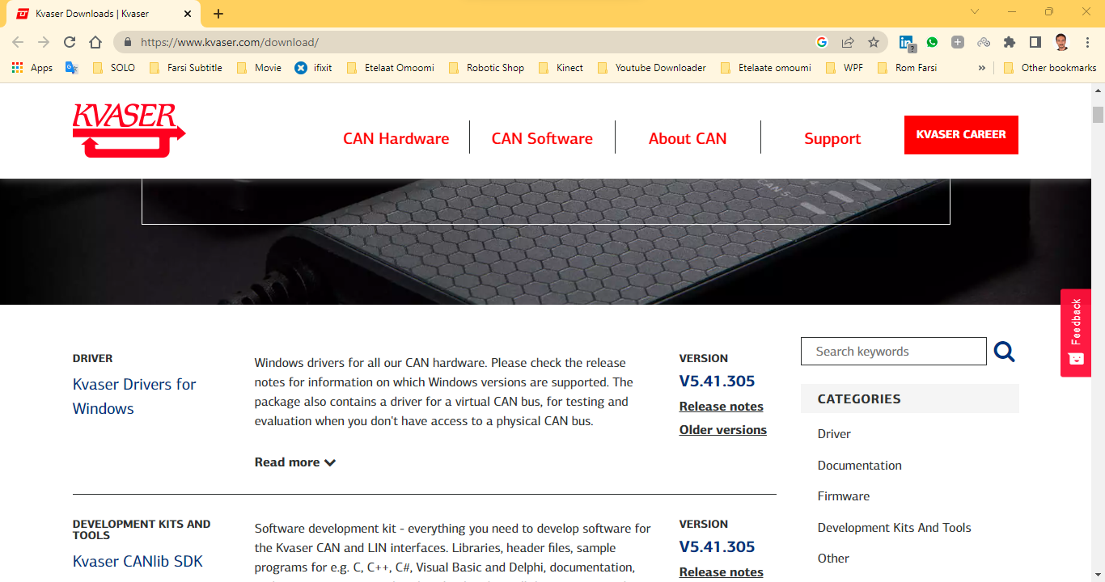

Project folder:

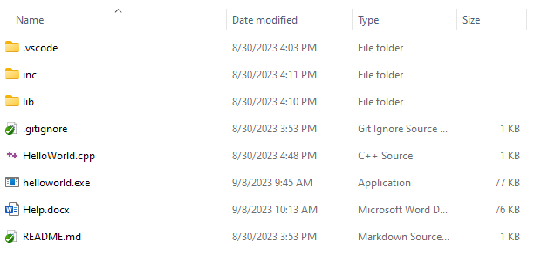

inc: include files needed by CANlib

lib: canlib32.lib

HelloWorld.cpp: a simple project for the show using the library

tasks.json:

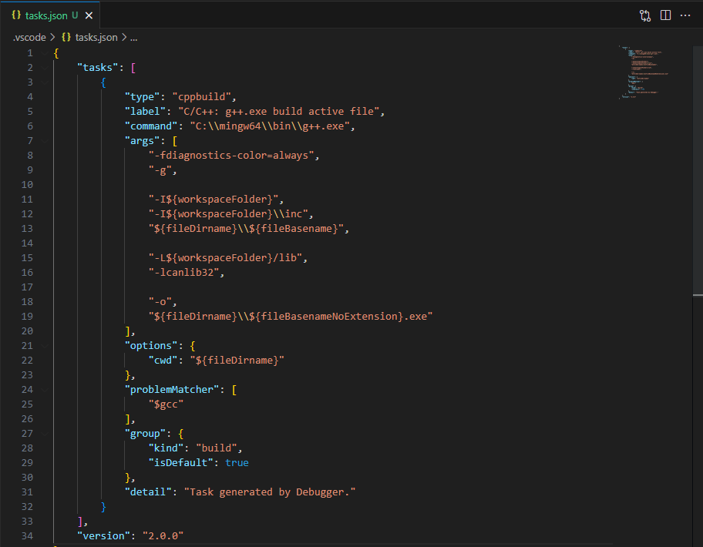

Configuration of the project exists in this file.

Line 6 determines the compiler path. I use MinGW. Change that to your compiler path



Lines 11 to 13 determine our include file paths



Line 15 determine our CANlib path in “lib” folder of project path and line 16 determine name of file.



Line 19 determine name and path of output file

