16 Apr 2020

Project #1 - Business Analytics Nanodegree

# Author:Javad Ebadi

I was interested in the Linkedin Top Skills for 2016 Tableau dashboard. The dashboard shows countries in rows and skill in columns. In each column a dashed line shows the average global ranking for that skill. Rank of each country in each skill is shown with a circle in corresponding cell. Color of the circle is either blue or green where blue means that a country’s rank on a skill is greater than global average and green means it is less than global average.

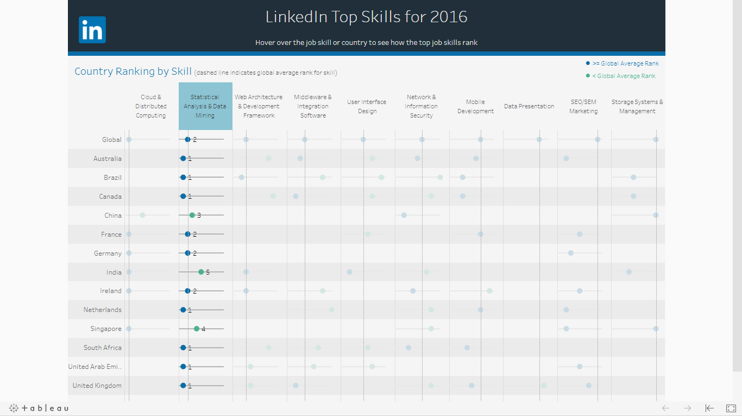

I wanted to compare countries rank in “Statistical Analysis and Data Mining” skill. I clicked on this column and the above picture appeared in tableau. Chine, India and Singapore were countries which had were ranked less than average global average in this skill. The United States was ranked 2 which was surprising for me, because I expected it to be rank 1.

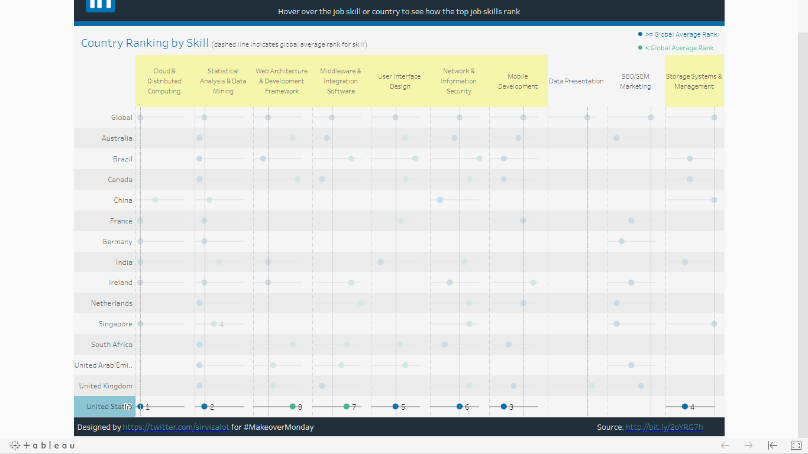

Since I was surprised with my first observation, I wanted to know in which skill the USA is ranked less than global average. I clicked on “Unites States” row and the above picture in tableau is created. It is interesting that in “Web Architecture & Development Framework” and “Middleware & Integration software” the USA was ranked less than global average. In addition, USA was ranked first just in one skill which was “Cloud & Distributed Computing”.

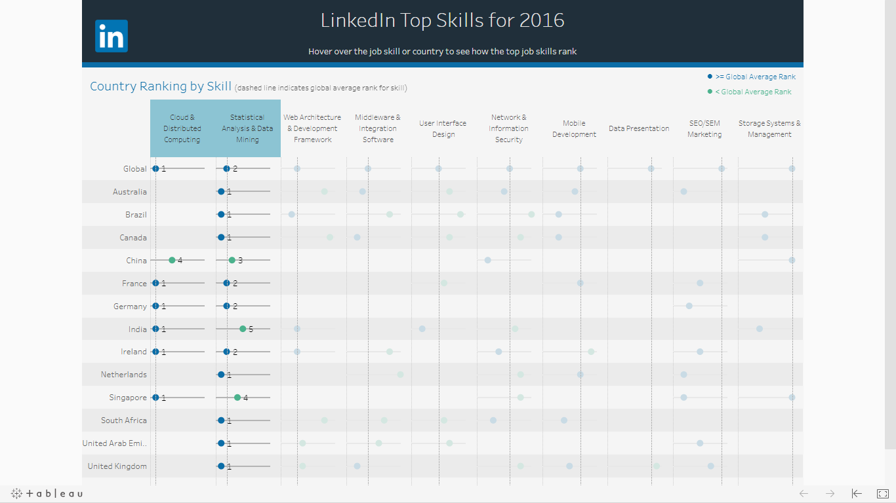

At least, since two skills “Cloud & Distributed Computing” and “Statistical Analysis & Data Mining” are both necessary for big data, I used ctrl and clicked on both columns for theses skills. As we See, Some countries such as South Africa are ranked high in “Statistical Analysis & Data Mining” skill but not ranked at all in “Cloud & Distributed Computing”. Thus since they are ranked high in just one of the skills, they won’t be able to use benefits of big data.