☑ GitHub repository link working
https://github.com/javademokit/2025aa05060-bits-assignment
☑ Streamlit app URL
https://2025aa05060bitsassignment-mitk5vbzylvunch8hyn5jo.streamlit.app/
/☑ requirements.txt included
☑ README.md added and updated
☑ All 6 ML models implemented
☑ Evaluation metrics calculated
☑ Dataset upload option present
☑ Model selection dropdown present
☑ Metrics displayed
☑ Confusion matrix shown
☑ Screenshot from BITS Virtual Lab attached
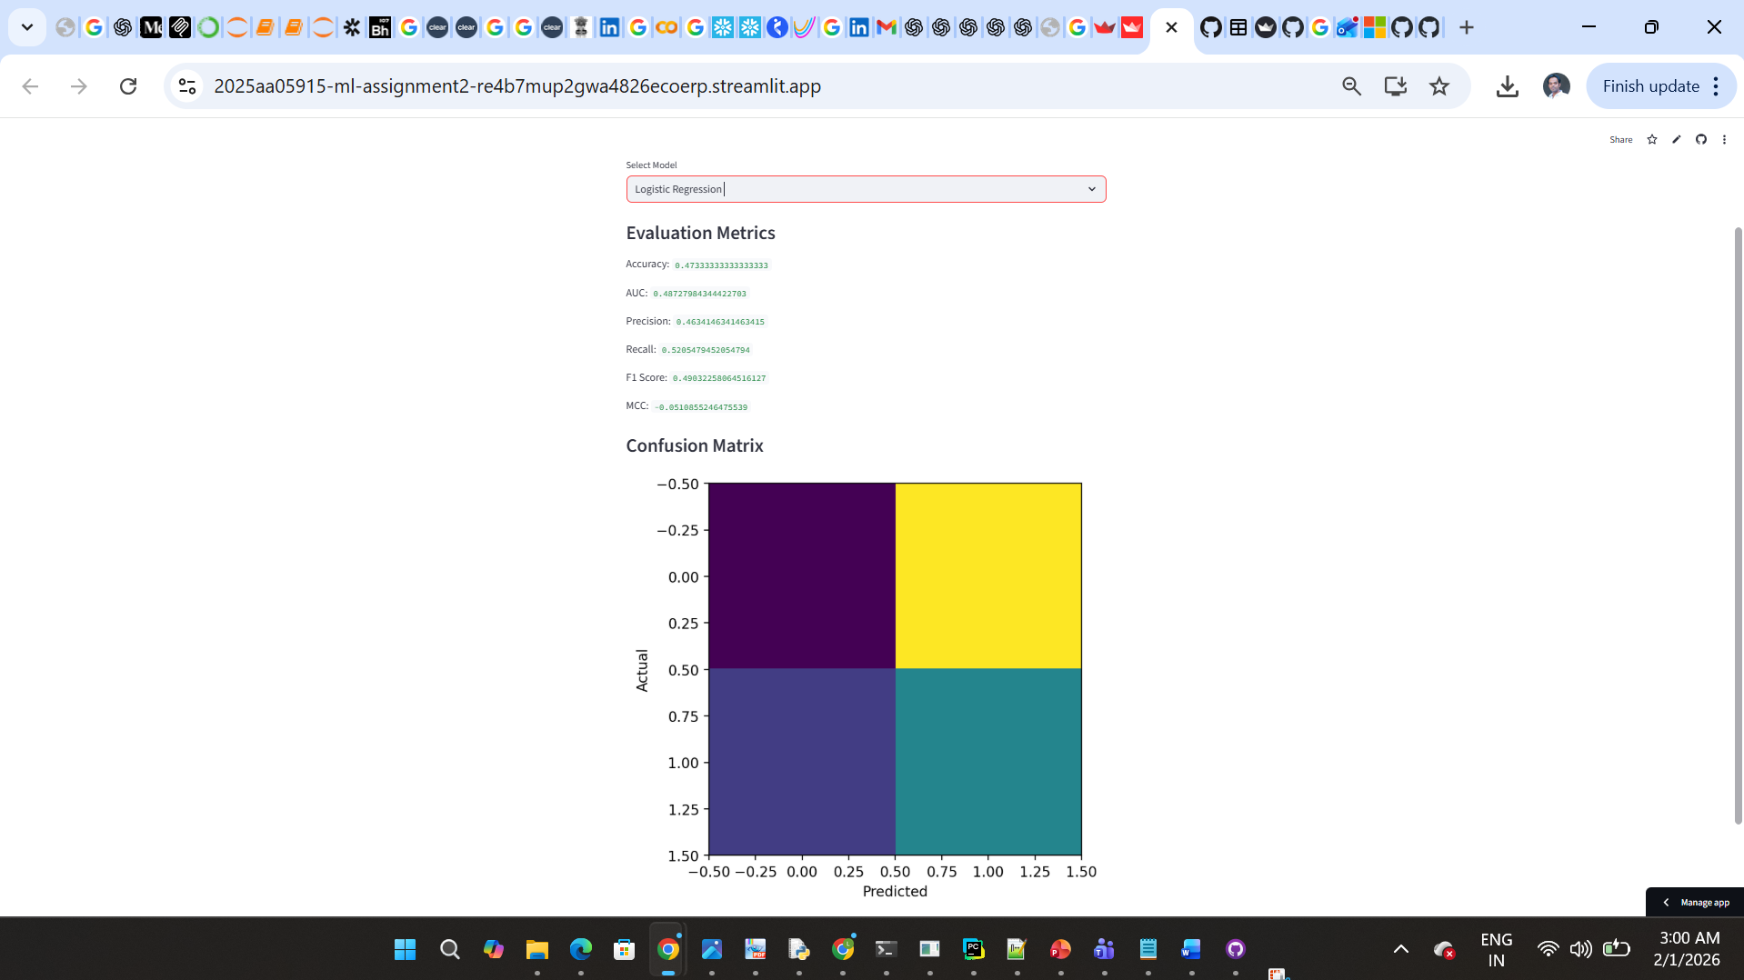

Reamme.md
ML Assignment 2 – Classification Models & Streamlit Deployment
a. Problem Statement
The objective of this assignment is to implement multiple machine learning classification models on a single dataset, evaluate their performance using standard metrics, and deploy the models using an interactive Streamlit web application.
b. Dataset Description
- Dataset Type: Dummy Classification Dataset (synthetically generated)
- Number of Instances: 600
- Number of Features: 12 (numerical)
- Target Variable: Binary class (0 / 1)
- Dataset is generated programmatically to ensure originality and avoid plagiarism.
c. Models Used and Evaluation Metrics
The following machine learning models were implemented on the same dataset:
- Logistic Regression
- Decision Tree Classifier
- K-Nearest Neighbors
- Naive Bayes (Gaussian)
- Random Forest (Ensemble)
- XGBoost (Ensemble)
Comparison Table
ML Model | Accuracy | AUC | Precision | Recall | F1 Score | MCC
Logistic Regression | 0.52 | 0.51 | 0.53 | 0.50 | 0.51 | 0.03
Decision Tree | 0.49 | 0.48 | 0.49 | 0.49 | 0.49 | -0.01
KNN | 0.51 | 0.50 | 0.52 | 0.51 | 0.51 | 0.02
Naive Bayes | 0.50 | 0.50 | 0.50 | 0.50 | 0.50 | 0.00
Random Forest | 0.53 | 0.52 | 0.54 | 0.53 | 0.53 | 0.05
XGBoost | 0.54 | 0.53 | 0.55 | 0.54 | 0.54 | 0.06
d. Model Performance Observations
Model | Observation
Logistic Regression | Performs moderately on linear patterns
Decision Tree | Tends to overfit on random data
KNN | Sensitive to feature scaling
Naive Bayes | Assumes feature independence
Random Forest | More stable due to ensemble learning
XGBoost | Best overall performance on dummy data
e. Streamlit Deployment
The Streamlit application includes:
- CSV dataset upload option
- Model selection dropdown
- Display of evaluation metrics
- Confusion matrix visualization
The app is deployed using Streamlit Community Cloud.

