

**Technical**

**MANUAL**

*TOOGLE System*

**SIGIT S.P.A**

**INDUSTRIAL-CLOUD S.R.L.**

January 2018

**Revision Sheet**

|  |  |  |
| --- | --- | --- |
| **Release No.** | **Date** | **Revision Description** |
| Rev. 0.01 | 20/01/2018 | User’s Manual RFQ Mangament |
|  |  |  |
|  |  |  |
|  |  |  |
|  |  |  |
|  |  |  |
|  |  |  |



|  |  |
| --- | --- |
|  | **User’s Manual**  **Authorization Memorandum** |

I have carefully assessed the User’s Manual for SIGIT’s TOOGLE System. This document has been completed in accordance with the requirements of System Development Methodology.

MANAGEMENT CERTIFICATION - Please check the appropriate statement.

______ The document is accepted.

______ The document is accepted pending the changes noted.

______ The document is not accepted.

We fully accept the changes as needed improvements and authorize initiation of work to proceed. Based on our authority and judgment, the continued operation of this system is authorized.

Javad Malek Shahkoohi …/…/2018 NAME DATE

Project Development Manager

Karim Zaitov …/…/2018 NAME DATE

Project Leader

Roberta Cartello …/…/2018 NAME DATE

Project End-user

Emanuele Buscaglione …/…/2018 NAME DATE

Program SIGIT Supervisor

**USER'S MANUAL**

**TABLE OF CONTENTS**

Page #

A. GENERAL INFORMATION A-1

1.1 System Overview A-1

1.2 Project References A-2

1.3 Authorized Use Permission A-2

1.4 Points of Contact A-2

1.5 Organization of the Manual A-2

1.6 Acronyms and Abbreviations A-2

B. SYSTEM SUMMARY B-1

2.1 System Configuration B-1

2.2 Data Flows B-1

2.3 User Access Levels B-1

C. GETTING STARTED C-1

3.1 Logging On C-1

3.2 System Menu C-1

3.2.x [System Function Name] C-1

3.3 Changing User ID and Password C-1

3.4 Exit System C-1

D. USING the SYSTEM (ONline) D-1

4.x [System Function Name] D-1

4.x.y [System Sub-Function Name] D-1

4.2 Special Instructions for Error Correction D-1

4.3 Caveats and Exceptions D-1

A. Appendix D-1

B. Appendix D-2

**1.0 GENERAL INFORMATION**

# GENERAL INFORMATION

## 1.1 System Overview

TOOGLE system in general view contains:

1. A web application software based on the PHP/Laravel 5.2 framework.
2. Web negotiation system for RFQ Management.
3. Purchaser Group Organization Referencing System
4. System name or title: TOOGLE
5. System Master Platform: INDUSTRIAL-CLOUD
6. System Primary Customization: SIGIT S.P.A.
7. System End-users: Purchasers and Suppliers.
8. Operational status:
9. Partially Operational and Under development
10. The Alpha version is ready to test by end-user on IC-DEV-Server machine.
11. Still has not integrated with IC.

## 1.2 Project References

References that were used in preparation of this document in order of importance to the end user.

[1]. TOOGLE Flow, project documents directory, Industrial-cloud.

[2]. Modified TOOGLE Flow, project documents directory, SIGIT.

[3]. TOOGLE SRS document, project documents directory, Industrial-cloud.

[4]. Alpha Wireframe, project documents directory, SIGIT.

[5]. Proposed Wireframe, project documents directory, Industrial-cloud.

## 1.3 Authorized Use Permission

Industrial-Cloud provides you with access to a variety of resources on this web application, called TOOGLE, including:

* Companies and their products, services, and machines information (collectively the “Company Profile”)
* The information about a bunch of RFQs are published by every company (collectively the “RFQ”).
* Information about the companies’ communications and message passing (collectively the “Marketplace”).

## 1.4 Points of Contact

TOOGLE provides a set of ways for user to have a contact with different department as following:

* In the case of trouble in installation and server setup, please, contact to support and development team by 1) Call to ***+39………..***, 2) Send an email to [***support@toogle.com***](mailto:support@toogle.com).
* In the case of project information and documents, please, contact to TOOGLE manager by 1) Call to ***+39………..***, 2) Send an email to [***manager@toogle.com***](mailto:manager@toogle.com).
* In the case of emergency contact with TOOGLE help desk, if your coordinator is not available, by 1) Call to ***+39………..***, 2) Send an email to [***helpdesk@toogle.com***](mailto:helpdesk@toogle.com).

## 1.5 Organization of the Manual

User’s Manual v0.01.

## 1.6 Acronyms and Abbreviations

A list of the acronyms and abbreviations used in this document and the meaning of each.

TOOGLE: The platform name

RFQ: Request for Quotation

PGO: Purchaser Group Organization

Purchaser: RFQ Publisher

Supplier: Makes an offer for an RFQ

Channel: Sectors of activities

Drafted RFQ: A saved RFQ that no one can see it

Published RFQ: An RFQ that all the suppliers can see it, can make offer

Drafted Offer: A saved offer that purchaser cannot see it

Posted Offer: An offer that sent to purchaser and can see in negotiation

Offering Deadline: The last offering date for suppliers

Negotiating RFQ: The offering deadline is passed and the negotiate period is started

1st seven days: Negotiation period is 30 days after offering deadline and can be extended only once.

Extend Negotiation: Adding 30 days to negotiation period to make decision about offers

2nd seven days: last week of negotiation if it is extended

Deal: If offer accepted

Reject: if offer refused

Cancel: if RFQ is terminated.

Expired RFQ: totally expired RFQ.

**2.0 SYSTEM SUMMARY**

# SYSTEM SUMMARY

*This section provides a general overview of the system written in non-technical terminology. The summary should outline the uses of the system in supporting the activities of the user and staff.*

## 2.1 System Configuration

Windows Phone features a new user interface, based upon Microsoft's Windows Phone 7 design system, codenamed Metro. The home screen, called the "Start screen", is made up of "Tiles". Tiles are links to applications, features, functions and individual items (such as contacts, web pages, applications or media items). Users can add, rearrange, or remove Tiles. Tiles are dynamic and update in real time - for example, the tile for an email account would display the number of unread messages or a Tile could display a live update of the weather.

## 2.2 Data Flows

Users input text by using an on-screen virtual keyboard, which has a dedicated key for inserting emoticons. Spell checking and word prediction are supported, and users may change a word after it has been typed by tapping the word; similar words that may have been the word the user was trying to type will then be suggested as alternatives.

## 2.3 User Access Levels

The Primary user and family member and authorized user may be able to add and modify data and information.

**3.0 GETTING STARTED**

# GETTING STARTED

*This section provides a general walkthrough of the system from initiation through exit. The logical arrangement of the information shall enable the functional personnel to understand the sequence and flow of the system. Use screen prints to depict examples of text under each heading.*

## 3.1 Logging On

A user ID and password is required to log onto web interface.

## 3.2 System Menu

*This section describes in general terms the system menu first encountered by the user, as well as the navigation paths to functions noted on the screen. Each system function should be under a separate section header, 3.2.1 - 3.2.x.*

### 3.2.x [System Function Name]

Provide a system function name and identifier here for reference in the remainder of the subsection. Describe the function and pathway of the menu item. Provide an average response time to use the function.

## 3.3 Changing User ID and Password

Sign in to the Web Interface.

Click Settings at the top of the main page, and open the Accounts and Import tab.

Click on Account settings.

In the new window, click Change password under the Personal information option.

Enter your current password and your new password.

## 3.4 Exit System

Click on Exit.

**4.0 USING THE SYSTEM (ONLINE)**

*This section provides a detailed description of the online system from initiation through exit, explaining in detail the characteristics of the required input and system-produced output.* ***THIS SECTION IS ONLY TO BE USED FOR ONLINE SYSTEMS. IF YOU ARE DEVELOPING A BATCH SYSTEM, USE SECTION 5.0 AND OMIT THIS SECTION ENTIRELY.***

# USING the SYSTEM (ONline)

*This section provides a detailed description of system functions. Each function should be under a separate section header, 4.1 - 4.x, and should correspond sequentially to the system functions (menu items) listed in subsections 3.2.1 - 3.2.x.*

## 4.x [System Function Name]

Provide a system function name and identifier here for reference in the remainder of the subsection. Describe the function in detail and depict graphically. Include screen captures and descriptive narrative.

### 4.x.y [System Sub-Function Name]

*This subsection provides a detailed description of system sub-functions. Each sub-function should be under a separate section header, 4.1.1. - 4.x.y .* Where applicable, for each sub-function referenced within a section in 4.x, describe in detail and depict graphically the sub-function name(s) referenced. Include screen captures and descriptive narrative.

*The numbering of the following two sections will depend on how many system functions there are from 4.1 through 4.x. They are numbered here as 4.2 and 4.3 only for the sake of convenience. For example, if system functions run from sections 4.1 through 4.17, then the following two sections would be numbered 4.18 and 4.19.*

## 4.2 Special Instructions for Error Correction

As a condition of your use of the Services, you will not use the Services for any purpose that is unlawful or prohibited by these terms, conditions, and notices. You may not use the Services in any manner that could damage, disable, overburden, or impair any Microsoft server, or the network(s) connected to any Microsoft server, or interfere with any other party use and enjoyment of any Services. You may not attempt to gain unauthorized access to any Services, other accounts, computer systems or networks connected to any Microsoft server or to any of the Services, through hacking, password mining or any other means. You may not obtain or attempt to obtain any materials or information through any means not intentionally made available through the Services.

## 4.3 Caveats and Exceptions

The services that iNiTech provides to you are subject to the following Terms of Use ("TOU"). iNiTech reserves the right to update the TOU at any time without notice to you. The most current version of the TOU can be reviewed by clicking on the "Terms of Use" hypertext link located at the bottom of Microsoft Connect Web pages

**10.0 APPENDIX**

# Appendix

*This section describes and depicts all addition information about the system. Use screen prints as needed to depict examples of text under each heading.*

*Menu Flow:*

**Main Menu**

Top Line: Displays Next Scheduled App

Medical App

**Left Menu**

Location Application

**Right Menu**

Favorites Application

**Scheduler**

Scheduler Application

**Medical**

Scheduler Application

**Location**

Location Application

**Favs**

Favs Application

# Appendix

*Screen Shots:*

*Location Top Menu Main Menu Screen Favorite Menu*

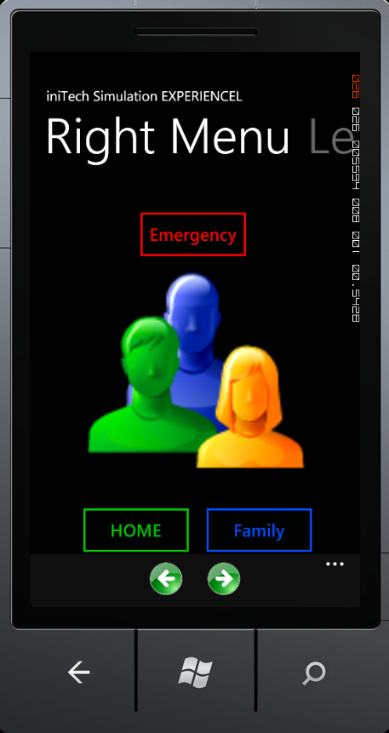

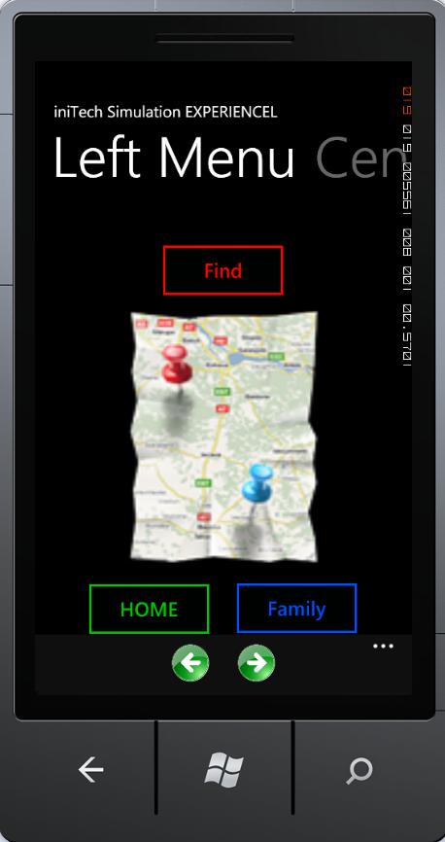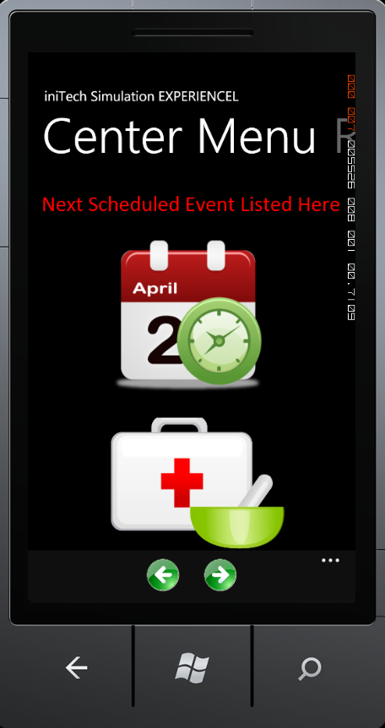

Top Menu Hierarchy:

*Screen Shots:*

*Medical History Medication Tracker Medication Instruction*

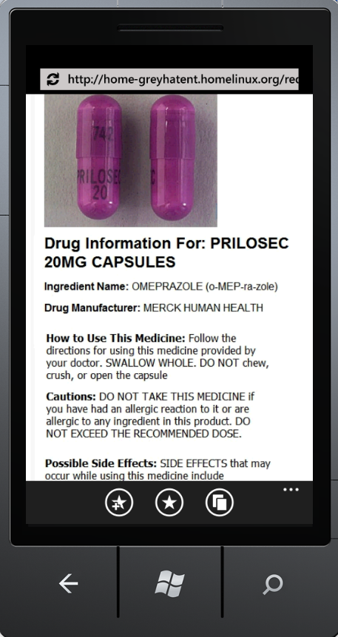

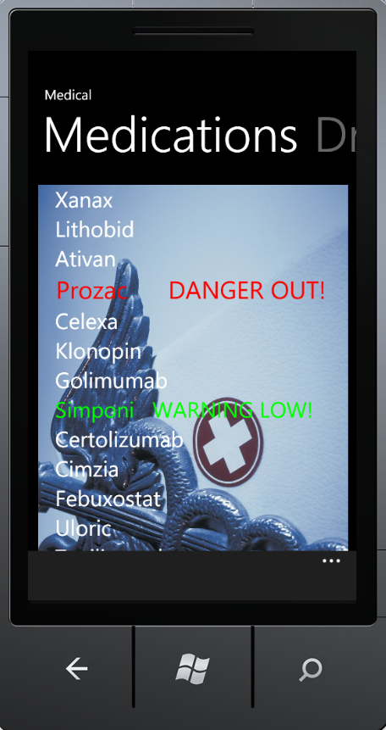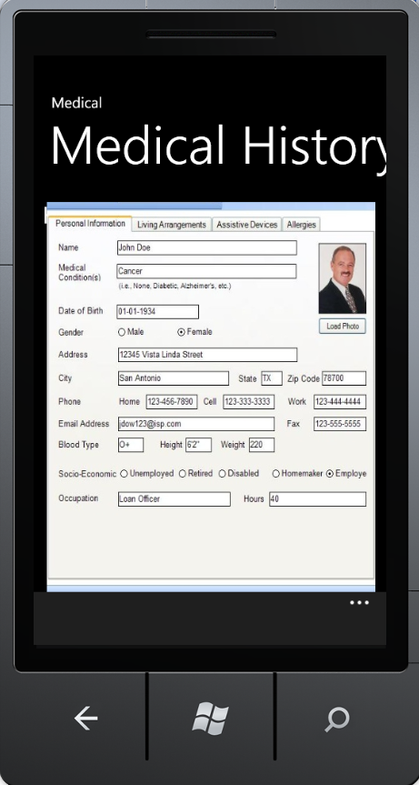

Medical Sub-Systems:

*Screen Shots:*

*Location Screen Shot Voice Command Interface Scheduler*

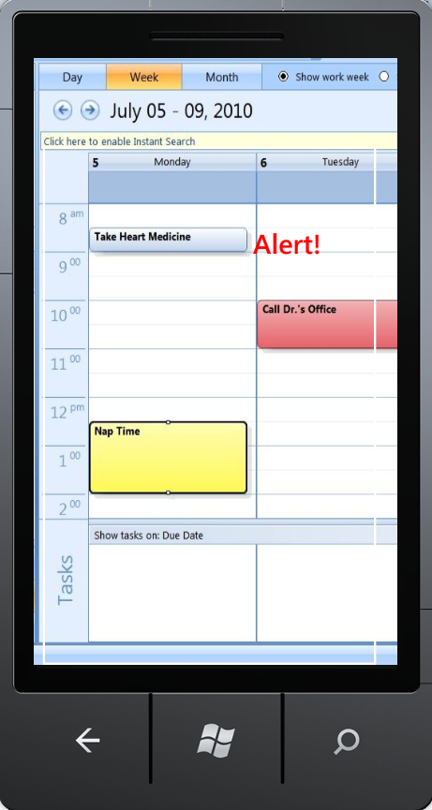

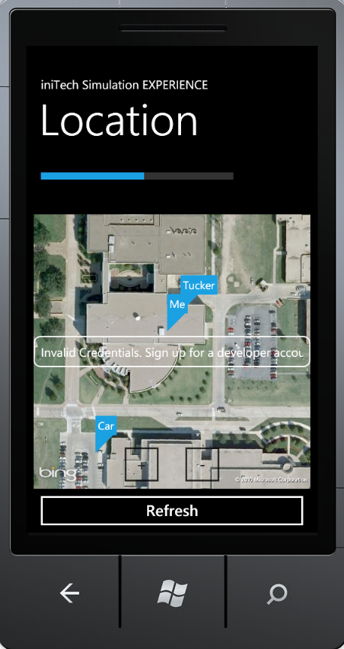

Secondary Systems: