

**MOBILE CONTRIBUTION FINANCIAL APPLICATION**

**BY**

**EMMANUEL UGBEDE OCHIGBO**

**(2031800016)**

**A PROJECT REPORT SUBMITTED TO THE DEPARTMENT OF COMPUTER SCIENCE, FACULTY OF COMPUTING, FEDERAL UNIVERSITY OF LAFIA, NASARAWA STATE, NIGERIA.**

**IN PARTIAL FULFILLMENT OF THE REQUIREMENT OF THE**

**AWARD OF BACHELOR OF SCIENCE (B.Sc.) DEGREE IN**

**COMPUTER SCIENCE**

**DECEMBER, 2023.**

# DECLARATION

**I, EMMANUEL UGBEDE OCHIGBO,** hereby declare that this research project titled “**MOBILE CONTRIBUTION FINANCIAL APPLICATION”** has been carried out by me under the supervision of MR. BAMANGA. It has not been presented for the award of any degree in any institution. All sources of information are specifically acknowledged using references.

# CERTIFICATION

This is is to certify that the project titled **“MOBILE CONTRIBUTION FINANCIAL APPLICATION”** was successfully completed by **EMMANUEL UGBEDE OCHIGBO** with the matriculation number **2031800016** in partial fulfillment of the requirements for the award of Bachelor of Science Degree in Computer Science, Federal University of Lafia, Nasarawa State, Nigeria.

**MR. BAMANGA DATE**

**(Project Supervisor)**

**Dr. Moses Timothy DATE**

**(Head of Department)**

**DATE**

**(External Examiner)**

# DEDICATION

I dedicate this work to God almighty the author and finisher of my faith, who through his infinite mercy kept me alive and well throughout the journey of this project. Without him, this project would not have been possible.

Finally, I dedicate this project to my parents, for believing in my dreams and being my daily source of inspiration.

# ACKNOWLEDGMENTS

I am grateful to have Mr. Bamanga as my supervisor, his honest concern for my progress is second to none. I want to thank Dr. T Moses for all his teachings and mentorship. Thank you to Dr. Agushaka, Mr. Shehu, Mrs Rukaya, Mr Habila, they have made an excellent student out of me. To Oladoyin and all my tech bro’s, thank you for the love, prayers, and support God bless you.

# ABSTRACT

This project focuses on transforming traditional group savings into a seamless digital experience through a mobile financial application. The aim is to enhance the efficiency and accessibility of financial group contributions. Leveraging the capabilities of mobile technology, the application provides a user-friendly platform for managing and tracking group savings. The innovative approach not only modernizes traditional practices but also contributes to financial inclusion by making group contributions more accessible and efficient in a digital era.

Table of Contents

DECLARATION 2

CERTIFICATION 3

DEDICATION 4

ACKNOWLEDGMENTS 5

ABSTRACT 6

LIST OF FIGURES 10

LIST OF TABLE 11

CHAPTER ONE 12

INTRODUCTION 12

1.1 Background of the Studies 12

1.2 Research Motivation 13

1.3 Statement of the Problem 13

1.4 Aim and Objectives 14

1.5 Significance of the Study 14

1.6 Scope and Limitations of the Study 15

1.6.1 Limitations 15

1.7 Definition of Operational Terms 15

CHAPTER TWO 18

LITERATURE REVIEW 18

2.1 Traditional group saving 18

2.1.1 Benefits of Traditional Group Saving 19

2.1.2 Challenges of Traditional Group Saving 20

2.2 Mobile financial contribution applications (MFCA) 20

2.2.1 Benefits of MFCA 21

2.2.2 Challenges of MFCA 21

2.3 Conceptual Framework 21

2.4 Related Works 24

2.5 Summary of Related Work 27

2.6 Research Gaps of the Study 29

CHAPTER THREE 30

METHODOLOGY AND ANALYSIS 30

3.1 Analysis of the Existing System 30

3.2 Analysis of the new system 31

3.2.1 Justification of the new system 33

3.3 Methodology Adopted 33

3.4 Development Tool Used 35

3.5 Database Design 37

3.6 High Level Model of the system 39

CHAPTER FOUR 45

IMPLEMENTATION 45

4.1 New system requirement 45

4.1.1 Program development 46

4.2 Testing and Result 46

4.2.1 Unit Testing: 46

4.2.2 Integration Testing: 47

4.2.3 Deployment Testing: 47

4.2.4 Results 47

CHAPTER FIVE 52

CONCLUSION AND RECOMMENDATIONS 52

5.1 Conclusion 52

5.2 Recommendations 52

REFERENCE 54

APPENDIX A 55

SOURCE CODE 55

# LIST OF FIGURES

Figure 2.1 MFCA Model for group contributions……………………….. 18

Figure 3.1 MFCA Database Schema………………………………….…..38

Figure 3.2 MFCA High Level Model…………………………………….39

Figure 3.3 MFCA Use Case Diagram……………………………………42

Figure 4.1 User Registration and KYC…………………………………..47

Figure 4.2 User Dashboard to see their balance………………………….48

Figure 4.3 User can see their Transaction history………………………..48

Figure 4.4 ROSCA and ASCA…………………………………………...49

Figure 4.5 Create Group………………………………………………….49

Figure 4.6 Saving Group Dashboard………………………………………50

# LIST OF TABLE

Table 1.1………………………………………………………………….. 25

# CHAPTER ONE

# INTRODUCTION

## 1.1 Background of the Studies

In today's increasingly digital world, mobile applications have become an indispensable tool especial for managing finances. The proliferation of mobile banking and financial management apps has made it easier than ever for individuals to track their spending, set budgets, and achieve their financial goals. But that is not all, let’s look back at our traditional saving to be specific traditional group saving, what we Nigeria call Contributions.

(Adeola et al., 2022) Traditional group saving, also known as contribution or esusu, is a common practice in Nigeria and other West African countries. It is a form of informal finance that allows individuals to save and access credit through a Rotating Savings and Credit Association (ROSCA) and Accumulated Savings and Credit Associations (ASCAs).

These Traditional group savings have played a significant role in promoting financial inclusion and fostering community development in Nigeria and other West African countries. However, traditional group savings methods are not without their limitations, such as the risk of default, lack of transparency, and limited growth potential. The advent of mobile financial services presents an opportunity to address these limitations and revolutionize group savings.

Mobile applications can offer a more efficient, user-friendly, and secure platform for group savings, enabling individuals to manage their contributions, track their savings progress, and access credit seamlessly. As mobile phone penetration continues to grow, mobile applications have the potential to revolutionize group savings, further promoting financial inclusion and empowering individuals and communities.

The aim of study is to leverage the potentials of mobile financial application and bring to life the traditional group saving system into today's increasingly digital world

## 1.2 Research Motivation

My personal experiences and observations have served as the primary motivators for exploring the potential of mobile financial contribution applications (MFCAs). Having witnessed my parents actively participate in traditional group saving meetings and discussions, I gained firsthand insights into the strengths and limitations of these informal financial practices.

The ability to leverage mobile technology to streamline group saving processes, enhance transparency, and provide secure access to funds has the potential to revolutionize traditional practices and empower individuals to manage their finances more effectively.

This motivation is fueled by the findings and successes of related works, including:

1. CowryWise is a Nigerian-based fintech platform that offers a comprehensive suite of financial services, including saving, investing, and group contributions (CowryWise, n.d.).
2. Piggyvest: A mobile savings app that allows users to create and join savings circles. It focuses on younger generations and offers a gamified approach to saving (Piggyvest Inc. n.d).

## 1.3 Statement of the Problem

Traditional methods of group savings, such as relying on physical cash transactions and manual record-keeping, are often inefficient, time-consuming, and prone to errors. These limitations hinder the effectiveness of group savings. Additionally, existing mobile financial contribution applications often lack comprehensive features, and are not tailored to the two common traditional group savings.

## 1.4 Aim and Objectives

To develop a comprehensive, secure, user-friendly, and scalable mobile financial contribution application that addresses the limitations of traditional group savings methods and existing mobile applications.

To achieve the above aim, the following specific objectives shall be pursued:

1. Build a mobile app where users can create and join group saving plan using React Native
2. Track group saving financial activities and request for loan using a concise friendly user interface

## 1.5 Significance of the Study

The development and evaluation of a (MCFA) for group savings in Nigeria holds significant value for various stakeholders, including individuals, and communities.

Significance for Individuals

* Individuals have access to automated contribution features, and progress tracking tools these encourages and reinforce savings habits.
* The MCFA can provide individuals, access to join group saving and partake in their benefit.

Significance for Communities

* The MCFA's facilitation of group savings activities can strengthen social ties within communities, fostering a sense of collective responsibility and mutual support.
* Members of a group saving have access to loan facility.

## 1.6 Scope and Limitations of the Study

The scope of this study will focus on the development of a mobile financial contribution application (MCFA) for group savings in Nigeria leveraging React Native, MongoDB, and Node.js technologies.

Specific Scope:

1. Development of a user-friendly mobile application for Android
2. Implementation of a streamlined registration process
3. Integration with payment gateways for secure and convenient payment
4. Provision of comprehensive features, including customizable savings plans, transaction tracking, loan management, and penalty systems

### 1.**6.1 Limitations**

A prototype of the Mobile Financial Contribution Application (MCFA) will be built to simulate the process. All activities will be on testnet

## 1.7 Definition of Operational Terms

To ensure clarity and consistency in the study, the following operational terms are defined as follows:

1. Mobile Financial Contribution Application (MCFA): A mobile application designed specifically for managing group savings activities, allowing users to contribute funds, track progress, and access financial education resources.
2. Group Savings: An informal financial practice where a group of individuals regularly contributes a fixed amount of money to a common fund, which is then distributed to each member in a predetermined rotation.
3. Savings Behavior: The patterns and habits of individuals regarding saving money, including the frequency, amount, and motivations for saving.
4. User Registration: The process of creating an account on the mobile financial contribution application by providing basic information, such as name, email address, phone number, and government-issued ID.
5. KYC (Know Your Customer): A process of verifying a user's identity and financial information to comply with anti-money laundering and counter-terrorism financing regulations.
6. Seamless Payment Integration: The integration of the mobile financial contribution application with major payment gateways and financial institutions to enable secure and convenient transactions, including deposits, withdrawals, and loan disbursements.
7. Dashboard: A central interface within the mobile financial contribution application that provides users with an overview of their savings progress, transaction history, loan status, and financial insights.
8. Reports: Detailed summaries of financial activities, including transaction logs, savings progress, and loan repayment schedules, generated by the mobile financial contribution application.
9. Loan Management: The process of managing loans within the mobile financial contribution application, including loan eligibility criteria, application process, approval decisions, disbursement, and repayment schedules.
10. Penalty System: A mechanism within the mobile financial contribution application to discourage late contributions by imposing a financial penalty for contributions made after the due date.

# CHAPTER TWO

# LITERATURE REVIEW

## 2.1 Traditional group saving

Traditional group saving, also known as contribution or esusu, is a common practice in Nigeria and other West African countries. It is a form of informal finance that allows individuals to save and access credit through a Rotating Savings and Credit Association (ROSCA) and Accumulated Savings and Credit Associations (ASCAs).

**How it works**

A ROSCA is a group of people who agree to contribute a fixed sum of money at regular intervals, typically weekly or monthly. The contributions are collected by a designated member of the group, known as the collector. At the end of a predetermined cycle, the entire amount of money is given to one member of the group. This process is repeated until each member has received the entire amount of money.

ASCAs on the other hand, also known as Ajos in Yoruba, instead of rotating payouts, groups in ASCAs use their pooled resources to offer loans with interest. These loans can be provided to members or vetted third parties. After a predetermined timeframe, typically ranging from six months to a year, the amount each member receives depends on their individual contribution to the group fund and the interest made. (Adeola et al., 2022)

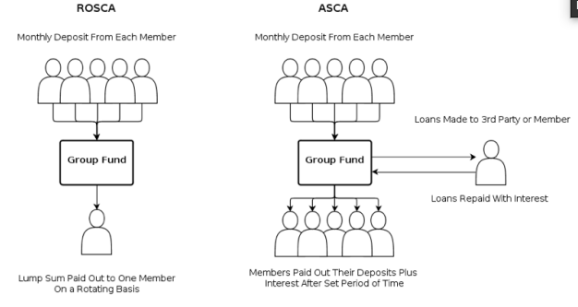

Figure 2.1 MFCA Model for group contributions (Development, 2012)

### 2.1.1 Benefits of Traditional Group Saving

(Kim *et al*., 2018) Traditional group saving offers a number of benefits to its members, including:

1. Encourages saving: The regular contributions required by ROSCAs can help members to develop a habit of saving.
2. Promotes financial discipline: Members are motivated to make their contributions on time, as this ensures that they will receive their turn to receive the entire amount of money.
3. Provides access to credit: ASCAs can provide members with access to credit without the need for formal collateral or credit history.
4. Builds social capital: ROSCAs and ASCAs can help to build social capital by creating a sense of community and trust among members.

### 2.1.2 Challenges of Traditional Group Saving

(Kim *et al*., 2018) Traditional group saving also faces a number of challenges, including:

1. Risk of default: If a member defaults on their contributions, the entire group can be affected.
2. Lack of transparency: They are often managed informally, which can lead to a lack of transparency and accountability.
3. Limited growth potential: They are typically limited to a small number of members, which can restrict their growth potential.

The prevalence of informal group savings practices, such as esusu and ajo, in Nigeria highlights the strong cultural tradition of collective saving and financial support among communities. However, these traditional methods face challenges related to inefficiency, lack of transparency, and many more. Mobile financial contribution applications have emerged as a promising solution to address these limitations and promote financial inclusion, particularly in underserved communities across Nigeria.

## 2.2 Mobile financial contribution applications (MFCA)

Mobile financial contribution applications (MFCA) is, bringing the traditional group saving into the digital era making it a convenient and accessible way for people to save money and contribute to group savings plans. MFCA typically allow users to create and manage savings groups, set savings goals, and track their progress. It may also offer additional features such as loans, insurance, and financial literacy resources.

### 2.2.1 Benefits of MFCA

MFCAs offer a number of benefits to users, including:

1. Convenience: MFCA allow users to save money from anywhere, at any time.
2. Accessibility: MFCA are accessible to people who do not have access to traditional banking services.
3. Transparency: MFCA typically offer transparent reporting on how funds are being used.
4. Social support: MFCA can provide a sense of community and social support.
5. Financial literacy: MFCA can help users learn about saving and money management.

### 2.2.2 Challenges of MFCA

Despite the many benefits of MFCAs, there are also some challenges associated with their use, including:

1. Technology: MFCA require access to mobile phones and internet connectivity.
2. Literacy: MFCA require a basic level of literacy to use.
3. Trust: MFCA require users to trust the app provider and the group administrator.

## 2.3 Conceptual Framework

The conceptual framework for the Mobile Financial Contribution Application (MFCA) revolves around the core principles and ideas that guide its development, implementation, and impact. Here are the key components of the conceptual framework:

**Core Concepts:**

1. **Financial Inclusion:** The MFCA aims to promote financial inclusion by providing a digital platform for individuals to participate in traditional group savings, especially in areas with limited access to formal banking services.
2. **Group Savings Dynamics:** Built on the principles of traditional group savings (ROSCA, Esusu, Ajo), the MFCA retains the community-driven approach, encouraging collaborative financial practices.
3. **Digital Transformation:** MFCA seeks to digitize and enhance traditional group savings, addressing challenges such as lack of transparency, inefficiency, and limited scalability through the integration of mobile technology.
4. **User Empowerment:** The MFCA empowers users by providing them with tools to manage their contributions, track savings progress, access credit, and make informed financial decisions.

**Operational Framework:**

* 1. User Engagement**:** Seamless onboarding processes for user registration, KYC verification, and group creation.
  2. Resources and guides within the app to educate users on financial literacy and effective use of the MFCA.
* **Group Formation and Management:**
  1. **Creating and Joining Groups:** User-friendly features for creating and joining savings groups with customizable goals.
  2. **Transparent Transactions:** Ensuring transparency in group transactions, including contributions, loans, and distributions.
* **Contribution and Savings:**
  1. **Flexible Contribution Plans:** Offering customizable savings plans to accommodate different user preferences.
  2. **Real-time Updates:** Providing users with real-time updates on their individual and group savings progress through the dashboard.
* **Loan Management:** Implementing fair eligibility criteria, structured approval processes, and transparent loan management to foster financial discipline.
* **Security and Trust:**
  1. **Data Security:** Ensuring the security of user data through encryption and secure authentication.
  2. **Trust Building Features:** Incorporating features that build user trust, such as transparent reporting, reliable notifications, and secure transactions.

**Impact Assessment:**

1. **Financial Well-being:** Assessing the impact of the MFCA on users' financial well-being through indicators like increased savings, successful loan repayments, and achievement of financial goals.
2. **Community Development:** Monitoring the application's contribution to community development through strengthened social ties, mutual support, and achievement of collective financial objectives.
3. **Technology Adoption:** Tracking the adoption and usage rates of the MFCA to understand its acceptance and effectiveness in the target communities.
4. **Continuous Improvement:** Incorporating user feedback and performance analytics to drive continuous improvement in the MFCA's features, usability, and overall impact.

**Cultural Sensitivity:**

1. **Local Context Integration:** Recognizing and integrating cultural factors that influence financial practices in Nigeria, ensuring alignment with local traditions.
2. **Community Participation:** Designing the MFCA to be inclusive and respectful of community dynamics, fostering active participation and acceptance.

This conceptual framework provides a holistic view of the MFCA, encompassing its foundational concepts, operational aspects, impact assessment, and cultural sensitivity. It serves as a guide for the development team, stakeholders, and users in understanding the principles and goals driving the MFCA's implementation.

## 2.4 Related Works

1. **M-Shwari:** M-Shwari, a mobile banking platform in Kenya, stands out for its focus on financial inclusion. Its group savings feature, M-Gurupu, caters specifically to low-income individuals, providing them with a simple and accessible means to save and contribute money. By targeting this underserved segment of the population, M-Shwari plays a crucial role in promoting financial literacy and enabling individuals to achieve their financial goals.(Cook & McKay, 2015).
2. **Piggyvest, Gamifying Savings for the Younger Generation:** Piggyvest, a mobile savings app, takes a gamified approach to saving, appealing particularly to younger generations. Its interactive features, such as rewards, badges, and challenges, transform saving into an engaging and fun experience. This gamification strategy effectively motivates users to maintain consistent savings habits, fostering a positive attitude towards financial responsibility from an early age. (Piggyvest Inc. n.d).
3. **Cowrywise Diversifying Investments for Savvy Savers:** Cowrywise caters to a more experienced user base, offering a comprehensive suite of investment options beyond traditional savings accounts. Users can diversify their portfolios across stocks, bonds, and real estate, gaining exposure to various asset classes and potentially enhancing their returns. Additionally, Cowrywise provides financial education resources, empowering users to make informed investment decisions. (Anand, 2020)
4. **Esusu:** Esusu, another mobile savings app, emphasizes goal-oriented savings. Its group savings feature allows users to come together and contribute towards specific financial objectives, such as purchasing a home or covering educational expenses. This collaborative approach harnesses the power of group dynamics, motivating individuals to stay committed to their financial goals. (Ola-David & Osabuohien, 2018)
5. **Socio-Economic Contributions of Mobile Applications in Africa:** Impact of Local Mobile Applications (ResearchGate, 2023): This paper highlights the significant role mobile applications play in fostering financial inclusion and driving economic growth across Africa. It emphasizes the potential of your application to empower individuals, particularly those traditionally excluded from the formal financial system.
6. **Financial inclusion:** NorthWave launches money contribution, loan app (The Nation, 2023): This article provides a closer look at a Nigerian application designed specifically to address financial inclusion challenges. NorthWave's features, such as group contributions and loan access, demonstrate the feasibility and potential impact of your project.
7. **Designing and Implementing a Mobile Application for Micro-Savings and Group Contributions in Cameroon (International Journal of Advanced Research in Computer Science, 2022):** This research paper offers valuable insights into the development process of a mobile application that mirrors your intended functionalities. Studying its design considerations and implementation strategies can guide your own development efforts.
8. **Mobile Applications and Financial Inclusion:** The Case of Ghana (Journal of Information Technology & Software Engineering, 2020): This analysis explores the link between mobile applications and the advancement of financial inclusion in Ghana. It provides a broader perspective on the potential of your application to contribute to broader economic and social development goals.

These four mobile financial applications exemplify the transformative potential of mobile technology in promoting financial inclusion and mobile saving but not suitably tailored for ROSCA or ASCA.

While this work is focus primarily on digitalizing the traditional saving, with ROSCA or ASCAin mind

## 2.5 Summary of Related Work

|  |  |  |  |
| --- | --- | --- | --- |
| **Related Work** | **Primary Focus** | **Key Features** | **Limitations** |
| M-Shwari | Financial inclusion for low-income individuals | Basic savings and contribution features | Limited scope of features, may not cater to diverse user needs |
| Piggyvest | Gamified savings for younger generations | Rewards, badges, challenges | Limited scope of features, may not cater to diverse user needs |
| Cowrywise | Diversified investments for experienced savers | Stocks, bonds, real estate | May require a higher level of financial literacy and risk tolerance |
| Esusu | Goal-oriented savings through group dynamics | Group savings for specific goals | May require strong group cohesion and commitment and  Limited scope of features, may not cater to diverse user needs |
| Socio-Economic Contributions of Mobile Applications in Africa | Broad analysis of mobile app impact on financial inclusion and economic growth across Africa | Highlights potential for empowering individuals - Emphasizes local applications | Lacks specific details on individual applications |
| Financial inclusion: NorthWave launches money contribution, loan app | Case study of NorthWave app addressing financial inclusion challenges in Nigeria | Highlights potential for empowering individuals - Emphasizes local applications | May require a higher level of financial literacy and risk tolerance |
| Designing and Implementing a Mobile Application for Micro-Savings and Group Contributions in Cameroon | Technical details on development of a micro-savings and group contribution app in Cameroon | Secure platform for savings and transactions - Offline functionality - Customizable group features | May require strong group cohesion and commitment and  Limited scope of features, may not cater to diverse user needs |
| Mobile Applications and Financial Inclusion: The Case of Ghana | Analysis of mobile apps in promoting financial inclusion in Ghana | Examines impact on economic and social development - Identifies key challenges and opportunities | May require a higher level of financial literacy and risk tolerance |

## 2.6 Research Gaps of the Study

While the study aims to address significant challenges associated with traditional group savings and mobile financial contribution applications (MFCAs), there are notable research gaps that provide opportunities for further investigation and improvement:

1. Limited Exploration of Cultural Factors: The study focuses on the technical and functional aspects of developing a mobile financial contribution application for group savings in Nigeria. However, there is a research gap in the exploration of cultural factors that may influence the adoption and success of such applications. Cultural nuances, social dynamics, and trust mechanisms within communities engaging in traditional group savings could significantly impact the effectiveness of the MCFA. Further research into these cultural aspects could enhance the application's alignment with local practices and increase user acceptance.
2. Inadequate Examination of User Trust and Security Concerns: While the study briefly mentions the challenge of trust in mobile financial contribution applications, there is a research gap in the in-depth examination of user trust and security concerns. Users' willingness to adopt and use the MCFA depends on their confidence in the platform's security measures and data protection. Investigating user perceptions of trustworthiness, privacy, and the application's ability to safeguard financial information would provide valuable insights. Addressing these concerns in the design and communication of the MCFA could contribute to higher user trust and engagement.

# CHAPTER THREE

# METHODOLOGY AND ANALYSIS

## 3.1 Analysis of the Existing System

Traditional group saving we have seen have been very much financially beneficial over the years, we were born in it and it will be pass on to next generation.

The two most common examples are;

1. Rotating Savings and Credit Associations (ROSCAs) or
2. Accumulated Exhibit Savings and Credit Associations (ASCAs).

ROSCAs function by taking monthly deposits from each member of a group and then giving the whole monthly sum to one member of the group. The recipient of the monthly sum is based on a predetermined rotation, ensuring each participant will eventually receive a large payout.

ASCAs also require group members to make regular contributions. Instead of rotating payouts, the ASCA group fund is used to make loans that are paid back with interest. Loans are made either to group members or trusted third parties. After a certain period of time (often six months to a year) the group fund and its proceeds from interest are paid back to the original members

Some of the main features of a local group savings are;

1. There is always a fix day for meetings
2. The contribute money for different common reason such as community development
3. For emergencies, money contributed can be used to support the member affect
4. Also, whenever a member is celebrating the join in and also support
5. Lateness and absent from meets attracts penalty
6. Also, untimely payment of dues/ contribution attracts penalty
7. Members of the meeting have access to loan with little or no interest
8. Some groups give out loans to nonmembers
9. Some groups when they contribute, the sum it and pay out to one member on a rotating basis
10. While some groups gather the fund invest in it like giving it out for loans and get interest and then pay out to all member plus interest after a set period of time

Traditional group saving also face a number of challenges, which we have discussed challenges like;

1. Lack of transparency: Traditional group saving schemes may lack transparency, which could make it difficult for members to track their contributions and ensure that funds are being managed properly.
2. Limited reach: Traditional group saving schemes may not be accessible to all members of the community, particularly those in remote areas or those who are marginalized.

It is no news that the world is going digital which include our financial system, we have seen how the mobile banking exceled taking this tradition and bring it to the digital light will improve financial inclusion and the whole idea behind group saving.

## 3.2 Analysis of the new system

The Mobile Financial Contribution Application (MFCA) is a mobile app that allows users to contribute and save money as a group. The app is designed to address the challenges of traditional group saving methods and to digitalize the traditional system, such as ROSCAs, by providing a secure, transparent, and user-friendly platform for managing group finances.

The MFCA offers a number of potential benefits to users, including:

1. Increased savings: By making it easier to save money as a group, the MFCA can help users to achieve their financial goals.
2. Improved financial literacy: The app can help users to learn about financial planning and budgeting.
3. Reduced risk: The app's security features can help to protect users from fraud and theft.
4. Increased social interaction: The app can help users to connect with other members of their group and build relationships.

In addition to the benefits for individual users, the MFCA can also have a positive impact on the economy as a whole. By increasing financial inclusion and promoting savings, the app can help to stimulate economic growth and reduce poverty.

However, there are also some potential challenges that need to be considered in the implementation of the MFCA. These challenges include:

1. User adoption: The app will need to be marketed effectively to reach a large number of potential users.
2. User education: Users will need to be trained on how to use the app and how to protect themselves from fraud.
3. Technology infrastructure: The app will need to be developed to work on a variety of mobile devices and network conditions.
4. Regulatory compliance: The app will need to comply with all applicable laws and regulations**.**

### 3.2.1 Justification of the new system

Traditional group savings in Nigeria face several challenges, including inefficiencies, geographical limitations, and a lack of transparency and security. The Mobile Financial Contribution Application (MFCA) addresses these challenges by leveraging mobile technology to streamline processes, enhance accessibility, prioritize transparency and security, promote financial literacy, and provide a scalable and convenient platform for group savings. The MFCA also fosters community building and social capital, making it a valuable asset for financial empowerment in the digital age.

## 3.3 Methodology Adopted

The methodology for developing the Mobile Financial Contribution Application (MFCA) for traditional group savings in Nigeria involves a systematic and structured approach, encompassing various stages from conceptualization to implementation. The following outlines the key components of the methodology:

1. **Requirements Analysis:** Conduct a thorough analysis of the requirements for the MFCA. This includes understanding the needs of users participating in traditional group savings, identifying essential features, and determining technical specifications.
2. **Literature Review:** Review existing literature on traditional group savings, mobile financial applications, and related technologies. This step helps in gaining insights into successful practices, challenges faced by users, and technological solutions employed in similar contexts.
3. **Prototyping and Design:** Develop a prototype of the MFCA, focusing on the user interface and user experience. Gather feedback from potential users and stakeholders to refine the design. Consider incorporating features that enhance usability, security, and overall user satisfaction.
4. **Technology Stack Selection:** Choose appropriate technologies for the development of the MFCA. This may involve selecting a mobile application development framework ( React Native), a backend technology (Node.js), and a database system (MongoDB).
5. **Development:** Implement the MFCA according to the finalized design and technical specifications. This stage involves coding the frontend and backend components, integrating payment gateways, and ensuring seamless communication between different modules of the application.
6. **Testing:** Conduct comprehensive testing to identify and rectify any bugs, errors, or usability issues. Perform unit testing, integration testing, and user acceptance testing to ensure the MFCA functions as intended across different devices and scenarios.
7. **User Training and Education:** Develop user guides and conduct training sessions to educate users on how to use the MFCA effectively. Emphasize security practices, navigation within the application, and the benefits of transitioning from traditional group savings to the digital platform.
8. **Deployment:** Deploy the MFCA to relevant app stores (e.g., Google Play Store, Apple App Store) to make it accessible to users. Ensure that the deployment process follows the guidelines and standards set by the respective platforms.
9. **Monitoring and Feedback Collection:** Implement monitoring tools to track user engagement, identify areas for improvement, and collect feedback from users. Regularly update the application based on user feedback and changing requirements.
10. **Documentation:** Document the entire development process, including design choices, technical specifications, and user manuals. This documentation serves as a reference for future updates, maintenance, and potential expansions.

By following this methodology, the development of the MFCA for traditional group savings in Nigeria is approached systematically, ensuring a well-designed, functional, and user-friendly application that addresses the specific needs of its target users.

## 3.4 Development Tool Used

In the development of the Mobile Financial Contribution Application (MFCA) for traditional group savings in Nigeria, a combination of tools and technologies is utilized to facilitate the creation, testing, and deployment of the application. Here are some key development tools commonly employed in the process:

1. **Integrated Development Environment (IDE):** Visual Studio Code (VSCode), A lightweight and extensible code editor that supports various programming languages. VSCode provides features such as syntax highlighting, code completion, and debugging tools, making it suitable for mobile application development.
2. **Mobile Application Development Framework:** React Native, A cross-platform framework that allows developers to build mobile applications using JavaScript and React. React Native enables the development of applications that run on both Android and iOS platforms, streamlining the development process and reducing the need for separate codebases.
3. **Backend Development:** Node.js**,** A JavaScript runtime that allows developers to run JavaScript on the server side. Node.js is commonly used for backend development due to its efficiency and scalability. And also Express.js A web application framework for Node.js that simplifies the development of server-side applications. Express.js is often used to create robust and scalable backend APIs.
4. **Database:** MongoDB, A NoSQL database that stores data in a flexible, JSON-like format. MongoDB is well-suited for applications with rapidly changing data requirements, providing scalability and ease of integration with Node.js.
5. **Version Control:** Git, A distributed version control system that enables collaborative development and helps manage changes to the source code efficiently. GitHub for hosting and collaborating on Git repositories.
6. **Payment Gateway Integration:** Paystack, A popular payment gateway in Nigeria that facilitates online payment processing. Integrating Paystack allows the MFCA to securely handle financial transactions, including contributions, withdrawals, and loan disbursements.
7. **Testing Frameworks:** Jest, A JavaScript testing framework often used with React Native applications. Jest simplifies unit testing and ensures the reliability of the application's functionality.

These development tools collectively contribute to the efficient creation of the MFCA, providing a robust, scalable, and user-friendly mobile application for traditional group savings in Nigeria.

## 3.5 Database Design

**MongoDB Schema:**

MongoDB is a NoSQL database that stores data in a flexible, JSON-like format known as BSON (Binary JSON). It is suitable for applications with dynamic and evolving data structures.

1. **User Collection:**
   * Fields:
     + **user_id** (unique identifier)
     + **username** (user's username)
     + **email** (user's email address)
     + **password** (hashed password for security)
     + **phone_number** (user's contact number)
     + **contributions** (array of contributions made by the user)
     + **loans** (array of loans taken by the user)
2. **Group Collection:**
   * Fields:
     + **group_id** (unique identifier)
     + **group_name** (name of the savings group)
     + **members** (array of user_ids representing group members)
     + **contributions** (array of contributions made by group members)
     + **savings_goal** (target amount the group aims to save)
     + **current_balance** (current total balance of the group)
3. **Contribution Collection:**
   * Fields:
     + **contribution_id** (unique identifier)
     + **user_id** (user making the contribution)
     + **group_id** (group to which the contribution is made)
     + **amount** (amount contributed)
     + **timestamp** (date and time of the contribution)
4. **Loan Collection:**
   * Fields:
     + **loan_id** (unique identifier)
     + **user_id** (user taking the loan)
     + **group_id** (group from which the loan is taken)
     + **amount** (loan amount)
     + **interest_rate** (interest rate for the loan)
     + **status** (status of the loan: pending, approved, repaid)
     + **repayment_schedule** (array of scheduled repayment dates and amounts)

**Relationships:**

* Users can belong to multiple groups, establishing a many-to-many relationship.
* Contributions and loans are associated with both users and groups, forming a bridge between the User and Group collections.

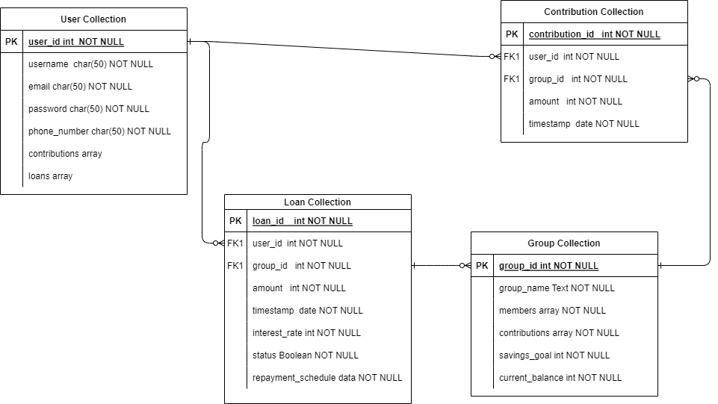

Figure 3.1 MFCA Database Schema

## 3.6 High Level Model of the system

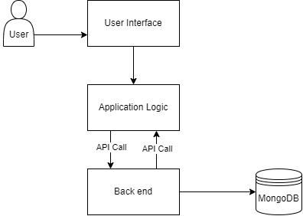

Figure 3.2 MFCA High Level Model

**3.7 System Design**

The system design for the Mobile Financial Contribution Application (MFCA) involves breaking down the application's architecture, components, and functionalities. Below is an outline of the key aspects of the system design:

**Architecture:**

* **Client-Side (Mobile App):**
  + **Frontend Framework:** React Native for cross-platform mobile app development.
  + **UI/UX Design:** Screens for user registration, group management, contributions, loans, and dashboard.
  + **State Management:** Redux for efficient state management and data flow.
* **Server-Side:**
  + **Backend Framework:** Node.js with Express.js for building scalable and robust server-side applications.
  + **APIs:** RESTful APIs for communication between the frontend and backend.
* **Database:**
  + **Database Management System:** MongoDB for NoSQL data storage.
  + **Data Access Layer:** Mongoose, an ODM (Object Data Modeling) library for MongoDB and Node.js.
* **Authentication and Authorization:**
  + **Authentication Protocol:** JWT (JSON Web Tokens) for secure user authentication.
  + **Authorization Middleware:** Ensures that only authorized users access specific functionalities.
* **Payment Gateway Integration:**
  + **Payment Service Provider:** Integration with Paystack for secure and seamless financial transactions.
* **External Services:**
  + **Notification Service:** Integration with external services (e.g., SMS services) for sending timely notifications to users.
  + **Analytics:** Integration with analytics tools for monitoring user behavior and application performance.

**Component Design:**

* **User Management:**
  + User registration, login, and profile management functionalities.
* **Group Management:**
  + Group creation, joining, and management features with defined savings goals.
* **Contribution Module:**
  + Handling user contributions to the group, updating balances, and maintaining contribution histories.
* **Loan Module:**
  + Managing loan requests, approvals, disbursements, repayments, and tracking loan statuses.
* **Dashboard:**
  + Centralized interface for users to view their savings progress, contribution history, loan details, and group performance.

**Security Measures:**

* **Secure Authentication:**
  + Implementation of secure user authentication using JWT.
* **Authorization Controls:**
  + Strict controls to ensure users only access functionalities they are authorized to use.

**Scalability and Performance:**

* **Scalable Architecture:**
  + Design considerations for horizontal scaling to accommodate potential growth in user base and data.
* **Caching Strategies:**
  + Implementation of caching mechanisms to optimize data retrieval and enhance application performance.

**Testing and Quality Assurance:**

* **Unit Testing:**
  + Implementation of unit tests using tools like Jest to ensure individual components function as expected.
* **Integration Testing:**
  + Testing the interaction between various modules to identify and address potential issues.

**Deployment:**

* + Deployment on cloud platforms (Render) for scalability and availability.

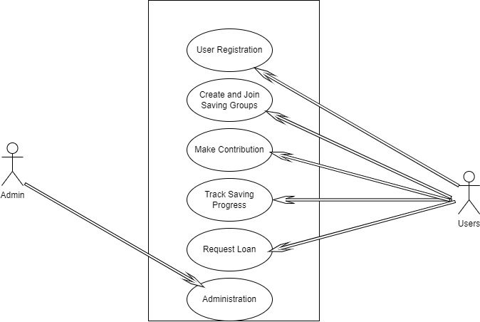

Figure 3.3 MFCA Use Case Diagram

Use Case Descriptions:

* User Registration:
  + Actors: User
  + Description: Users register on the MFCA platform, providing necessary information for account creation.
* Create/Join Savings Group:
  + Actors: User
  + Description: Users can create a new savings group or join an existing one, specifying the group's goals and dynamics.
* Make Contribution:
  + Actors: User
  + Description: Users contribute funds to the savings group, specifying the amount and frequency of contributions.
* Track Savings Progress:
  + Actors: User
  + Description: Users can view and track the progress of their individual and group savings through the application.
* Request Loan:
  + Actors: User
  + Description: Users can request a loan from the savings group, and the system evaluates eligibility based on predefined criteria.

# CHAPTER FOUR

# IMPLEMENTATION

The system was built locally on a windows 10 OS, Postman was used to test the API’s endpoints and henceforth hosted to the cloud using Render hosting. Visual Studio IDE was used throughout the development of the system

## 4.1 New system requirement

The following are the minimum requirement to run the system locally

Hardware requirement

* Processor speed of at least 2.0GHz
* Ram of about 4GB
* 64bit system architecture
* Hard disk of at least 20GB

Software requirement

* Nodejs and not less than v12.16
* React Native library
* MongoDB

The following are the minimum requirement to use the system

* Android V4 and above
* Internet connection
* MCFA Apk file

### 4.1.1 Program development

Figma a cloud-based design and prototyping tool that facilitates collaborative work on user interface (UI) and user experience (UX) design projects it was user of the UI/UX if MCFA

React Native a popular open-source framework for building cross-platform mobile applications using JavaScript and React. It allows developers to use a single codebase to create applications that run on both Android and iOS platforms was used in the app frontend

MongoDB a NoSQL database that stores data in flexible, JSON-like documents, it is commonly used in modern web and mobile application development and it was used in as MCFA database.

Node.js a server-side JavaScript runtime that allows developers to build scalable and efficient network applications was used for the backend.

## 4.2 Testing and Result

Testing as done, ensuring that the Mobile Financial Contribution Application (MFCA) functions as intended and meets the specified requirements

### 4.2.1 Unit Testing:

Unit testing was conducted to verify the functionality of individual components of the MFCA. This includes testing functions related to user registration, group creation, contribution handling, loan management, and other core features.

**Results:**

* All unit tests passed, indicating that individual components of the MFCA function as intended.
* Identified and resolved minor bugs related to data validation and error handling.

### 4.2.2 Integration Testing:

Integration testing focused on ensuring seamless communication between different modules of the application. This included testing the interaction between the frontend (React Native), backend (Node.js with Express.js), and the MongoDB database.

**Results:**

* Integration tests passed, confirming the proper flow of data between frontend and backend.
* Ensured that APIs respond appropriately to frontend requests and handle database interactions correctly.

### 4.2.3 Deployment Testing:

Deployment testing was conducted to ensure a smooth transition from the local development environment to the cloud hosting platform (Render hosting). This involved verifying that the deployed application maintains its functionality and stability.

**Results:**

* Successful deployment on Render hosting with proper configuration.
* Ensured that the MFCA functions seamlessly in the cloud environment.

### 4.2.4 Results

Users can create or join a saving group and request loans from groups

1. User Registration and KYC 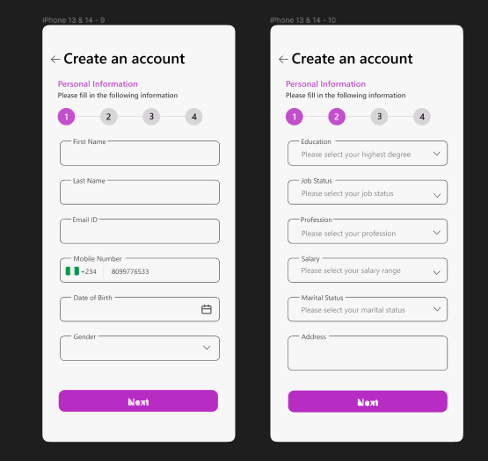

Figure 4.1 User Registration and KYC

1. User Login with their phone number and password
2. 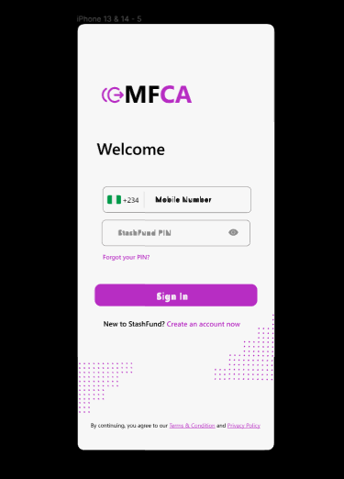
3. User Dashboard to see their balance 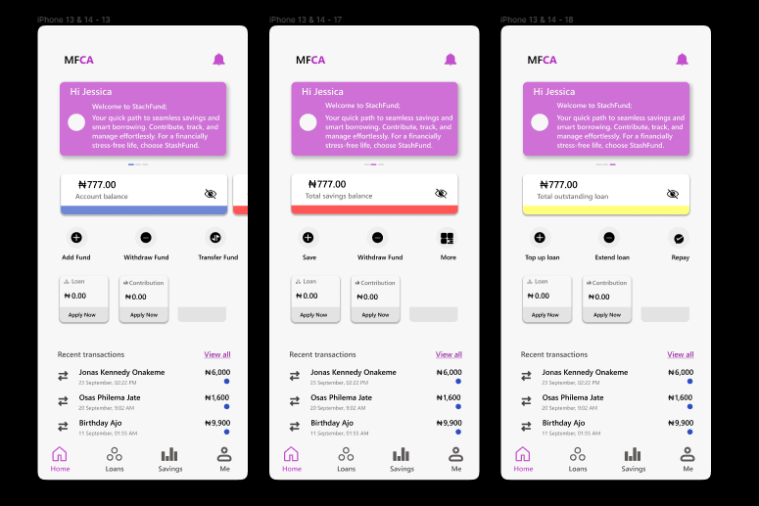

Figure 4.2 User Dashboard to see their balance

1. User can see their Transaction history 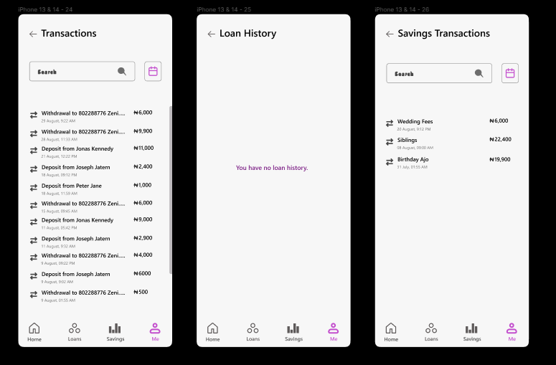

Figure 4.3 User can see their Transaction history

1. Users can join and see their savings ROSCA and ASCA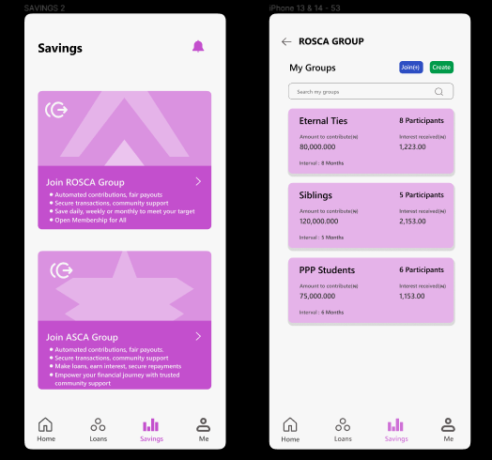

Figure 4.4 ROSCA and ASCA

1. User can Create Group by filling the form with the appropriate details

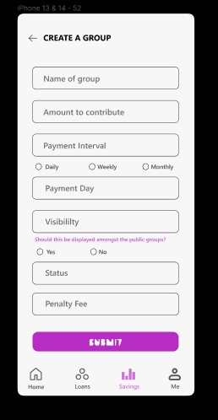

Figure 4.5 Create Group

1. Saving Group Dashboard where user can see all transaction in the group

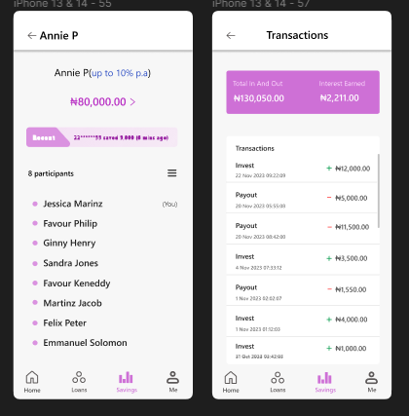

Figure 4.6 Saving Group Dashboard

# CHAPTER FIVE

# CONCLUSION AND RECOMMENDATIONS

## 5.1 Conclusion

The development and implementation of the Mobile Financial Contribution Application (MFCA) for group savings represent a significant stride toward modernizing traditional group savings practices. The study has revealed the potential of the MFCA in addressing challenges associated with transparency, accessibility, and accountability in traditional savings methods. The application's user-friendly interface and features, such as group creation, contributions, and savings tracking, will show positive impacts on users' financial behaviors.

The transition from traditional group savings to a digital platform introduces both opportunities and challenges. While the MFCA fosters financial inclusion by providing a convenient and secure means for group savings, challenges related to technology literacy, regulatory compliance, and cultural nuances require ongoing attention. The positive impact observed among users highlights the potential for digital financial solutions to empower individuals and communities in managing their finances more effectively.

## 5.2 Recommendations

Based on the findings and observations, the following recommendations are proposed:

* **Awareness:**
  + Implement targeted awareness campaigns to promote the MFCA among potential users.
* **Community Engagement:**
  + Collaborate with local community leaders and influencers to facilitate community-wide adoption.
  + Organize workshops and seminars to address cultural factors and build trust in the digital platform.
* **Regulatory Support:**
  + Engage with policymakers to create an enabling regulatory environment for digital financial contribution applications.
  + Advocate for supportive regulations that encourage innovation while ensuring consumer protection and security.

# REFERENCE

Adeola, O., Adeleye, I., Muhammed, G., Olajubu, B. J., Oji, C., & Ibelegbu, O. (2022). Savings Groups in Nigeria. In D. T. Redford & G. Verhoef (Eds.), *Transforming Africa* (pp. 193–216). Emerald Publishing Limited. https://doi.org/10.1108/978-1-80262-053-520221015

Anand, M. (2020) *Meet cowrywise, the Smart Savings and Investment App for Nigerian youth - BFA global*, *BFA Global - Enabling innovation for a more inclusive, equitable, and resilient future*. https://bfaglobal.com/catalyst-fund/insights/meet-cowrywise-smart-savings-investment-app-nigerian-youth

Cook, T., & McKay, C. (2015). *M-Shwari: The Story so Far*. *10*, 1–34. https://www.slideshare.net/CGAP/mshwari-the-story-so-far

CowryWise. (n.d.). CowryWise: *A mobile finance platform for saving, investing, and group contributions*. https://cowrywise.com/

Development, I. (2012). *Improving informal savings groups with mobile technology*.

Kim, M., Zoo, H., Lee, H., & Kang, J. (2018). Mobile financial services, financial inclusion, and development: A systematic review of academic literature. *Electronic Journal of Information Systems in Developing Countries*, *84*(5), 1–17. https://doi.org/10.1002/isd2.12044

Ola-David, O., & Osabuohien, E. (2018). *Esusu - Global Encyclopaedia of Informality* (pp. 66–69). https://doi.org/10.14324/111.9781-7873.51899

Piggyvest Inc. n.d(2022). *Piggyvest is changing Nigeria’s youth culture* *CIO*. https://www.cio.com/article/401314/how-investment-and-savings-platform-piggyvest-is-changing-nigerias-youth-culture.html

# APPENDIX A

# SOURCE CODE

