



**二 〇 一 九 届 毕 业 设 计**

**外文文献及译文**

**学 院：信息工程学院**

**专 业：计算机科学与技术（卓越工程师）**

**姓 名：刘发源**

**学 号：201524020411**

**指导教师：安毅生**

**二〇一九年三月**

Modeling Traffic Congestion Using Simulation Software

Author：Seongho Kim，Wonho Suh

**Abstract:**

Traffic simulations are being increasingly utilized as transportation systems have become more complex and congested. However, most simulation models have limitations in overcapacity demand conditions. When traffic in a congested area "fills" the available roadway space additional traffic demand may never be allowed to enter the network. The intent of this paper is to explore one possible means to address the issue of unserved vehicles in overcapacity conditions using the VISSIM trip chain. The VISSIM trip chain feature is used for this analysis as it has the advantage of not eliminating a vehicle when congestion hinders its entrance onto a network, instead holding the vehicle until an acceptable gap exists on the entry link. A sample network is built to investigate the difference between standard traffic flow inputs and the trip chain method in overcapacity conditions. Also, simulations with different minimum space headway parameters in the priority rules are analyzed, allowing for an initial investigation into the sensitivity of the model to this parameter. Based on the analysis conducted it is concluded that, with appropriate calibrations, the trip chain feature in VISSIM is a potentially useful method to provide realistic modeling of various overcapacity conditions.

**Introduction**

Traffic analysts are increasingly utilizing traffic simulation as a problem solving tool for transportation system analysis. The goal of the traffic analyst is to better describe and illustrate real world traffic and to develop efficient traffic operation plans [1]–[2][3]. However, most traffic simulation models have limitations in modeling overcapacity demand conditions. For example, when traffic in a congested area “fills” the available roadway space most simulation models do not allow additional vehicles to enter the system, even though unserved demand exists at that time. Unfortunately, demand not allowed into a system during one time period is typically not retained to be released into the system when capacity becomes available. The simulation essentially ignores the unserved demand, in some cases simply creating error messages stating all vehicles are not generated as the implemented discharge rate is smaller than the input flow. When this occurs, the total number of vehicles simulated does not match the vehicle demand input by the analyst and realistic operational statistics are not obtained.

The intent of this paper is to explore one possible means to address the issue of “lost” entering vehicles during congested conditions. The simulation tool used for this effort is VISSIM and the particular feature utilized is the ability to create trip chains, which allow the user to specify departure times and origin/destination points for individual vehicles. The advantage of using trip chains is that when congestion on the entry link hinders the generation of an additional vehicle, the vehicle is not lost, it is instead held until an acceptable gap exists on the entry link. Therefore, as long as the simulation model is run for a sufficient time period (this time may be significantly longer that the originally assumed analysis period) the total number of vehicles that enter at a particular entry point will equal that input by the traffic analyst.

To demonstrate the use of trip chains in the analysis of overcapacity scenarios a sample network was constructed in VISSIM. In the presented example we consider the analysis of a driveway intended to serve a new development on a busy roadway. This paper will explore the results obtained for this driveway under overcapacity conditions, both with and without trip chains. Also, simulations with different VISSIM priority rule parameters in overcapacity conditions are analyzed, allowing for an initial investigation of the potential sensitivity of modeling results to different priority rules.

SECTION II.

**Model Development**

VISSIM is a discrete, stochastic and time step based microscopic simulation model developed to model urban traffic and public transit operations. The model is a useful tool for the evaluation of various alternatives based on transportation engineering and planning measures of effectiveness [4]–[5][6][7]. VISSIM models individual vehicles using a psycho-physical driver behavior model developed by Wiedemann [8]. The underlying concept of the model is the assumption that a driver can be in one of four driving modes: free driving, approaching, following and braking. The model was originally developed at the University of Karlsruhe, Germany during the early 1970s.

Fig. 1 and Fig. 2 illustrate the VISSIM network utilized for this study. The network consists of a one-way 3-lane road (Main Street) with 4 signalized intersections (intersections of Main St. with First St., Second St., Third St., and Fourth St.) The scenarios under consideration assume that a new development is proposed on Main Street at an approximately mid-block location between intersections with Third St. and Fourth St. The driveway from the proposed development is assumed to be stop controlled. Each of the four signalized intersections operates a two-phase, 90 second cycle. For this sample network each roadway link is taken to be 880 ft long with a 100 ft driveway on the proposed development, the vehicle fleet is assumed to be 100% autos, and the desired speed is 30 mph. Main Street is a one-way 3-lane road and each side street is a one-way 2 lane road.

In order to adequately model the impact of overcapacity conditions it is necessary to model the periods before, during, and after the overcapacity demands are experienced. This allows for a modeling of the impact of increasing congestion, the congested period, and the return to non-congestion. For this study this was achieved by modeling an overcapacity traffic demand followed by an under capacity demand on Main Street and the four cross streets. In the first 60 minutes, representing the peak hour period, twice as many vehicles are generated over the network compared to the second 60 minutes simulation time period, resulting in each simulation run being 2 hours. From the proposed development on Main Street between intersection 3 and 4, a demand of 100 vehicles is generated from simulation time interval 30 minutes to 60 minutes (i.e. a traffic flow rate of 200 veh/hr is experienced for 30 minutes).

[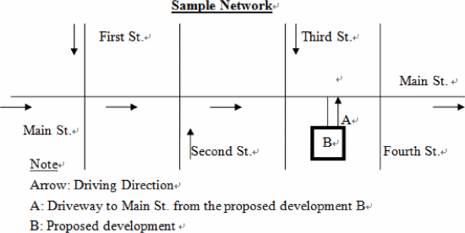](https://ieeexplore.ieee.org/mediastore_new/IEEE/content/media/6845033/6847317/6847430/6847430-fig-1-source-large.gif)

**Fig. 1.**

Illustration of sample network

[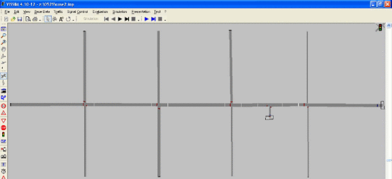](https://ieeexplore.ieee.org/mediastore_new/IEEE/content/media/6845033/6847317/6847430/6847430-fig-2-source-large.gif)

**Fig. 2.**

Illustration of sample network coded in vissim

**Table I.** Traffic scenarios

[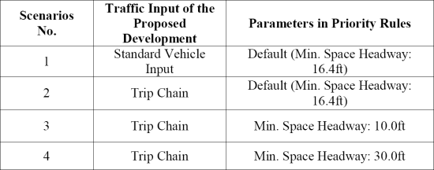](https://ieeexplore.ieee.org/mediastore_new/IEEE/content/media/6845033/6847317/6847430/6847430-table-1-source-large.gif)

SECTION III.

**Simulation Resutls**

For the scenarios utilizing trip chains to assign vehicles to the network, the time the vehicle is first assigned to enter the network is listed in the FKT file. If the driveway the vehicle is intended to depart on is congested, the vehicle is held until it finds a space to enter. For example, people who want to leave the parking lot of the proposed development (i.e. enter the simulated network) have to wait in the parking lot until there is space available in the driveway. In this paper, the time difference between the assigned departure time of trip chain and actual time the vehicle is able to enter the network is defined as departure delay time. The departure delay time accounts approximately 90% of total travel time from the proposed development to Main Street (Fig. 3) in the three scenarios utilizing trip chains. As there is no accounting for assigned departure time in scenario one, the departure delay time information is not taken into account in the scenario one simulation analysis.

Simulations with shorter and longer minimum space headways for the priority rules are tested in scenario three and four. Scenario three represents drivers who utilize smaller gaps to enter Main Street and in scenario four drivers who require larger gaps. The impact of reducing the minimum space headway in scenario three is to increase the number of available acceptable gaps in the Main Street traffic stream. Thus, more vehicles are able to enter Main Street and thereby more vehicles are able to enter the driveway from the proposed development during the peak period.

[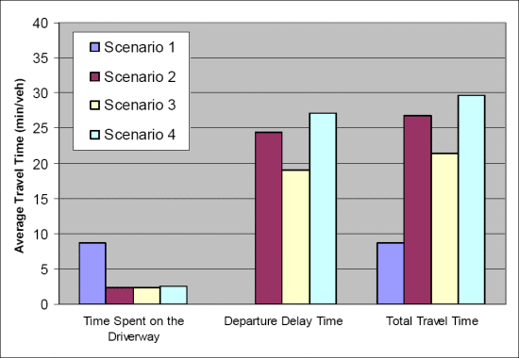](https://ieeexplore.ieee.org/mediastore_new/IEEE/content/media/6845033/6847317/6847430/6847430-fig-3-source-large.gif)

**Fig. 3.**

Average trave illustration of sample network

SECTION IV.

**Conclusion**

Modeling overcapacity conditions is a challenge for traffic analysts. The intent of this paper is to explore one possible means to address traffic conditions where demand exceeds capacity and to avoid the issue of “lost” demand. The VISSIM trip chain feature is used for this analysis as it has the advantage of not eliminating a vehicle when congestion hinders its entrance onto a network, instead holding the vehicle until an acceptable gap exists on the entry link. Therefore, the total number of vehicles simulated equals the vehicle demands input by the analyst, allowing for an accurate analysis of overcapacity demand scenarios. Also, using the trip chain feature it is possible to determine departure delay time, which is defined as the time difference between the “desired” assigned departure time and actual time the vehicle is able to enter the network. The paper also provides a limited demonstration of the sensitivity of the simulation model to differing minimum space headway parameters in the priority rules. This result implies that a small change in parameters of the priority in VISSIM can result in significant differences in simulation results under overcapacity conditions. Careful calibration of these factors should be conducted as part of any modeling effort. As a consequence of this analysis it is concluded that, with appropriate calibrations, the trip chain feature in VISSIM is a potentially useful method to provide realistic modeling of various overcapacity conditions.

使用仿真软件建模交通拥堵

作者： Seongho Kim , Wonho Suh

摘 要

由于交通系统变得更加复杂和拥挤，交通模拟正在被越来越多地利用。但是，大多数模拟模型在产能过剩需求条件方面存在局限性。当拥挤区域中的交通“填满”可用的道路空间时，可能永远不允许额外的交通需求进入网络。本文的目的是探索一种可能的方法，使用VISSIM旅行链来解决产能过剩条件下未得到服务的车辆问题。 VISSIM行程链功能用于此分析，因为它具有在拥塞阻碍其进入网络时不消除车辆的优点，而是保持车辆直到入口链路上存在可接受的间隙。建立一个样本网络，以研究标准交通流量输入与产能过剩条件下的旅行链方法之间的差异。此外，分析了优先级规则中具有不同最小空间车头时距参数的仿真，允许初始调查模型对该参数的灵敏度。根据所进行的分析，可以得出结论，通过适当的校准，VISSIM中的跳闸链特征是一种潜在有用的方法，可以提供各种过剩能力条件的真实模型。

介 绍

交通分析师越来越多地将交通模拟作为交通系统分析的问题解决工具。流量分析师的目标是更好地描述和说明现实世界的流量，并制定有效的交通运营计划[1] - [2] [3]。但是，大多数交通仿真模型在建设能力过剩需求条件方面存在局限性。例如，当拥挤区域中的交通“填充”可用的道路空间时，大多数模拟模型不允许额外的车辆进入系统，即使此时存在未服务的需求。遗憾的是，当容量变得可用时，通常不保留在一个时间段内不允许进入系统的需求以释放到系统中。模拟基本上忽略了未观察到的需求，在某些情况下简单地创建错误消息，表明由于实施的排放率小于输入流量而未生成所有车辆。当发生这种情况时，模拟的车辆总数与分析师输入的车辆需求不匹配，并且不能获得实际的运行统计数据。

本文的目的是探讨一种可能的方法来解决在拥挤的条件下“丢失”进入车辆的问题。 用于此项工作的模拟工具是VISSIM，所使用的特定功能是创建行程链的能力，允许用户指定单个车辆的出发时间和起点/终点。 使用行程链的优点在于，当进入链路上的拥塞阻碍了附加车辆的产生时，车辆不会丢失，而是保持直到入口链路上存在可接受的间隙。 因此，只要模拟模型运行足够的时间段（此时间可能明显长于最初假设的分析时段），在特定入口点进入的车辆总数将等于交通分析员输入的车辆总数。

为了证明在分析产能过剩情景中使用旅行链，在VISSIM中构建了一个样本网络。 在所提供的示例中，我们考虑对车道的分析旨在为繁忙的道路上的新开发提供服务。 本文将探讨在具有和不具有脱链条件的产能过剩条件下获得的该车道的结果。 此外，分析了在产能过剩条件下使用不同VISSIM优先级规则参数的模拟，允许初步调查建模结果对不同优先级规则的潜在敏感性。

模 型 开 发

VISSIM是一种基于离散，随机和时间步长的微观模拟模型，用于模拟城市交通和公共交通运营。 该模型是基于运输工程和有效性规划措施评估各种替代方案的有用工具[4] - [5] [6] [7]。 VISSIM使用由Wiedemann开发的心理物理驾驶员行为模型对个别车辆进行建模[8]。 该模型的基本概念是假设驾驶员可以处于四种驾驶模式中的一种：自由驾驶，接近，跟随和制动。 该模型最初是在20世纪70年代早期在德国卡尔斯鲁厄大学开发的。

图1和图2示出了用于该研究的VISSIM网络。 该网络包括一条单向3车道公路（主要街道），有4个信号交叉口（主街与第一街，第二街，第三街和第四街的交叉口）。正在考虑的情景假设 在主街道上，在与第三街和第四街交叉口之间的大约中间位置提出了一项新的开发项目。假定建议开发项目的车道是停止控制的。 四个信号交叉口中的每一个都操作两相90秒循环。 对于这个样本网络，每个道路连接的长度为880英尺，在拟议的开发项目上有一个100英尺的车道，车辆假设为100％汽车，所需的速度为30英里/小时。 主街是一条单行3车道公路，每条小街都是一条双向车道。

为了充分模拟产能过剩条件的影响，有必要对产能过剩需求经历之前，期间和之后的时期进行建模。 这允许模拟增加拥塞，拥塞时段和返回到非拥塞的影响。 在这项研究中，这是通过对产能过剩的交通需求进行建模，然后是主街和四条交叉街道的容量需求不足来实现的。 在代表高峰时段的前60分钟中，与第二个60分钟模拟时间段相比，在网络上生成两倍的车辆，导致每个模拟运行2小时。 从在交叉口3和4之间的主要街道上提出的开发，从模拟时间间隔30分钟到60分钟产生100辆车的需求（即，经历30车辆的交通流量200车/小时）。

[](https://ieeexplore.ieee.org/mediastore_new/IEEE/content/media/6845033/6847317/6847430/6847430-fig-1-source-large.gif)

图1**.**  样品网络的例证

[](https://ieeexplore.ieee.org/mediastore_new/IEEE/content/media/6845033/6847317/6847430/6847430-fig-2-source-large.gif)

图 2**.** 在vissim编码的样品网络的例证

表1**.** 交通场景[](https://ieeexplore.ieee.org/mediastore_new/IEEE/content/media/6845033/6847317/6847430/6847430-table-1-source-large.gif)

仿 真 结 果

对于利用行程链将车辆分配给网络的场景，首先将车辆首次分配进入网络的时间列在FKT文件中。如果车辆打算离开的车道是拥挤的，则车辆被保持直到它找到进入的空间。例如，想要离开拟议开发的停车场（即进入模拟网络）的人必须在停车场等待，直到车道中有可用空间。在本文中，行程链的指定出发时间与车辆能够进入网络的实际时间之间的时间差被定义为出发延迟时间。在使用旅行链的三种情景中，出发延迟时间约占从拟议开发到主街（图3）的总旅行时间的90％。由于在方案一中没有考虑分配的出发时间，因此在方案一仿真分析中不考虑离开延迟时间信息。

在方案三和方案四中测试了用于优先级规则的更短和更长的最小空间间距的模拟。 情景三表示利用较小差距进入主街的驾驶员以及需要较大差距的情景四驾驶员。 在方案三中减少最小空间进度的影响是增加主街交通流中可用的可接受间隙的数量。 因此，更多的车辆能够进入主街道，从而更多的车辆能够在高峰期从建议的开发进入车道。

[](https://ieeexplore.ieee.org/mediastore_new/IEEE/content/media/6845033/6847317/6847430/6847430-fig-3-source-large.gif)

**图 3.** 样本网络的平均交通流量例证

过度容量条件建模对流量分析师来说是一个挑战。本文的目的是探索一种可能的方法来解决需求超过容量的交通状况，并避免“失去”需求的问题。 VISSIM行程链功能用于此分析，因为它具有在拥塞阻碍其进入网络时不消除车辆的优点，而是保持车辆直到入口链路上存在可接受的间隙。因此，模拟的车辆总数等于分析师输入的车辆需求，从而可以准确分析产能过剩的需求情景。此外，使用行程链特征，可以确定出发延迟时间，其被定义为“期望的”指定出发时间与车辆能够进入网络的实际时间之间的时间差。本文还提供了有限的演示，模拟模型对优先级规则中不同的最小空间车头时距参数的敏感性。该结果意味着VISSIM中优先级参数的微小变化可导致产能过剩条件下的模拟结果的显着差异。应谨慎校准这些因素，作为任何建模工作的一部分。作为该分析的结果，可以得出结论，通过适当的校准，VISSIM中的跳闸链特征是提供各种过载能力条件的实际建模的潜在有用方法。