**Using grey model to predict remote homology proteins**

Wei-Zhong Lin1, Wei-Hua Cao1, Xuan Xiao1,2,*, Kuo-Chen Chou2,3

**1** Computer Department, Jing-De-Zhen Ceramic Institute, Jing-De-Zhen 333046 China; **2** Gordon Life Science Institute, Boston, MA 02478, USA; **3** Center for Informational Biology, University of Electronic Science and Technology of China, Chengdu, 610054, China

Authors’ e-mail address:

Xuan Xiao: [xxiao@gordonlifescience.org](mailto:xxiao@gordonlifescience.org)

Wei-Zhong Lin: [linweizhong@jci.edu.cn](mailto:linweizhong@jci.edu.cn)

Kuo-Chen Chou: [kcchou@gordonlifescience.org](mailto:kcchou@gordonlifescience.org)

*Corresponding author: Xuan Xiao, email: Lin [Wei-Zhong](mailto:Wei-Zhong): [linweizhong@jci.edu.cn](mailto:linweizhong@jci.edu.cn)

**Running Title: Remote Homology Protein detection**

**ABSTRACT**

Protein remote homology detection is a challenging problem for drug development. Although there are a couple of methods to deal with this problem, the benchmark datasets based on which the existing models were trained and tested contained many high homologous samples due to the fact that the cutoff threshold was set at 95%. In this study, we reconstructed the benchmark dataset by setting the threshold at 40%, meaning none of the proteins included has more than 40% pairwise sequence identity with any other. Using the new benchmark dataset, we proposed a new method called PHom-GRA to detect the remote homologous proteins by integrating various ranking approaches via grey relational analysis. Rigorous cross-validations have indicated that the new predictor is superior to its counterparts in both enhancing successes rates and reducing computational cost. For users’ convenience, the software source code were provided at <https://github.com/javafalcon/paperSrc/tree/master/RemoteHomo>. Besides, for most experimental scientists, a web-server for PHom-GRA are available at <http://www.jci-bioinfo.cn/PHom-GRA>.

**1. INTRODUCTION**

Detecting remote homology relationship among proteins plays one of the fundamental and central roles in computational proteomics. It is particularly useful for drug development (see, e.g., [1,2]). With the development of sequencing techniques, the protein sequence data rapidly raise. To find those proteins structure and function is more and more urgent. Although X-ray crystallography is a powerful tool in determining protein 3D structures, it is time-consuming and expensive. Particularly, not all proteins can be successfully crystallized, particularly for membrane proteins. The NMR technique is indeed a very powerful tool in determining the 3D structures for membrane proteins as indicated by a series of recent publications (see, e.g., [3-7]), it is time-consuming and costly. To acquire the structural information in a timely manner, one has to resort to various structural bioinformatics tools based on the sequence similarity principle (see, e.g., [8]). Unfortunately, such principle cannot cover the cases of remote homology proteins. In view of this, considerable efforts [9-14] have been made to detect remote homology proteins.

Although these methods each had their own merits and did play stimulating role in this area, further work is needed. Firstly, the benchmark datasets used in their studies had high similarity. For instance, the benchmark dataset in [10,12] contains 7329 proteins from 1070 different super families, with pairwise sequence identity cutoff set at 95%. In other words, it would allow those proteins with higher than 80% similarity in the data set. Secondly, the ranking algorithm used in those studies would spend a lot of time to training the learning model. For example, if the training dataset has N proteins, the LambdaMART need to deal with N2 proteins pair samples.

The present study was initiated to address the two problems with the aim to develop a more powerful method in this regard.

**2. MATERIALS AND METHOD**

**2.1 Benchmark Dataset**

According to Chou’s 5-step rules [15] that have been widely and increasingly used by many investigators (see, e.g., [16-32]), the first prerequisite in establishing a new predictor is to construct or select an effective benchmark dataset.

In this study, the benchmark dataset was taken from Liu et al. [12]. It included 7329 proteins from 1070 different super families and 1824 families derived from SCOP database. To reduce the redundancy and homology bias, the program CD-HIT [33] was adopted to cut down those proteins that had ≥40% pairwise sequence identity to any other in the dataset. Furthermore we removed those families that just had one protein sequence. Finally, we obtained 3128 proteins from 540 super-families and 777 families.

**2.2 Sample Formulation**

Given a protein with *L* amino acid residues, it is usually expressed by

|  |  |
| --- | --- |
|  | (1) |

where is the *i*-th residue in the protein. Since all the existing machine-learning algorithms can only handle vector but not sequence samples [34], one has to convert Eq.1 into a vector model. But a biological sequence expressed as a vector in the discrete framework may lose all the sequence-order or pattern information.

To avoid completely losing this kind of information for proteins, the pseudo amino acid composition (PseAAC) [35,36] was proposed. Ever since the concept of Chou’s PseAAC was proposed, it has been widely used in nearly all the areas of computational proteomics (see, e.g., [37] [38-44] as well as a long list of references cited in [45,46]). According to the general PseAAC [15], the protein of Eq.1 can be formulated as

|  |  |
| --- | --- |
|  | (2) |

where **T** is the transposing operator, the subscript is an integer, and its value and the components will depend on how to extract the desired features and properties from the protein sequence. In this study, their definitions are described below.

2.2.1 Grey-PSSM

This model was first proposed by Lin [47,48]. It extracted the sequential evolution information by the Position Specific Scoring Matrix (PSSM). For the concrete procedures, refer to the original papers [47,48].

2.2.2 PSSM-GLCM

Xiao et al. [49,50] described a protein as the cellular automation image and constructed its grey level co-occurrence matrix (GLCM) to express the protein via the angular second moment, contrast, inverse different moment, and entropy. The PSSM was a matrix:

(3)

where . We converted the PSSM to a grey graph as follow:

(4)

where (5)

Then, we can generate the GLCM of (4) to express the protein. The detailed process has been clearly described in the aforementioned papers and hence there is no need to repeat here again.

**2.3 Operation Engine or Algorithm**

After the Grey-PSSM treatment and the PSSM-GLCM treatment, we have finally got a 60-D and 4-D PseKNC vector for Eq.2, respectively. Its subscript parameter was respectively defined as and .

In this study, the grey relational analysis [51,52] was utilized to rank the relationship of proteins. The detailed algorithm was provided in [53]. Given a query protein, ~~the system will search it against the benchmark dataset and return the top ranked proteins.~~ we mixed the following 4 results: PSI-Blast and HMMER searching against the benchmark, grey incidence degree on grey-PSSM feature and PSSM-GLCM feature. Then return the top ranked protein. The predictor thus formed is called “PHom-GRA”. Illustrated in **Figure 1** is a flowchart to show how the proposed predictor is working.

**3. RESULT AND DISCUSSION**

The jackknife test is deemed the least arbitrary and most objective among three cross-validation methods: independent dataset test, K-fold cross-validation test and jackknife test [54]. Because the LambdaMART ranking algorithm used in preview studies [10,12] consumed more training time and computer memory, as a compromise the 5-fold cross-validation test was adopted there. Now, we employed GRA to compute the relationship score between the query protein and benchmark dataset proteins, significantly reducing the computing time and memory. Therefore it would be feasible to use the most rigorous jackknife test to examine the prediction quality. The outcome thus obtained are given in **Table 1**, where we can see that PHom-GRA, which combined the alignment score of PSI-BLAST, the alignment score of HMM, the grey incidence degree of Grey-PSSM feature, and the grey incidence degree of PSSM-GLCM, achieved the best performance in both the score of ROC1 and the score of ROC50.

**4. CONCLUSION**

Protein remote homology detection is vital for studying protein structures and functions. It is anticipated that the proposed method may become a useful high throughput toll for both basic research and drug design. For users’ convenience, the software source code were provided at <https://github.com/javafalcon/paperSrc/tree/master/RemoteHomo>. Besides, for most experimental scientists, a web-server for PHom-GRA are available at <http://www.jci-bioinfo.cn/PHom-GRA>.

**ACKNOWLEDGEMENTS**

This work was support by the grants from the National Natural Science Foundation of China (No.61462047, 31560316). Natural Science Foundation of Jiangxi Province, China (No. 20171ACB20023), the Department of Education of JiangXi Province (GJJ160866), The funders had no role in study design, data collection and analysis, decision to publish, or preparation of the manuscript.

**FIGURE LEGENDS**

**Figure 1**. A flowchart to illustrate how the proposed predictor is working.

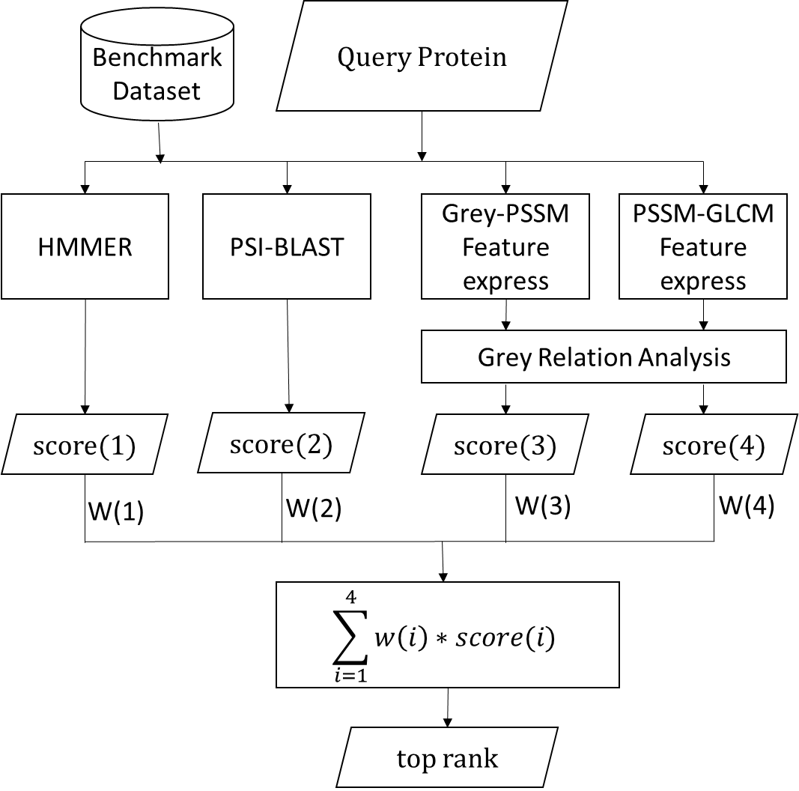

**Figure 1**

**Table 1**. A comparison of the jackknife test results for protein remote homology detection on the benchmark dataset

|  |  |  |
| --- | --- | --- |
| Methods | ROC1 | ROC50 |
| HMMER | 0.6981 | 0.7052 |
| PSI-BLAST | 0.7113 | 0.7647 |
| Phom-GRA(PSI-BLAST+PCA-GLCM) | 0.7138 | 0.7652 |
| Phom-GRA(PSI-BLAST+Grey-PSSM) | 0.7110 | 0.7737 |
| Phom-GRA(HMMER+Grey-PSSM+PCA-GLCM) | 0.7345 | 0.7895 |
| Phom-GRA(PSI-BLAST+Grey-PSSM+PCA-GLCM) | 0.7371 | 0.7968 |
| Phom-GRA(PS-BLAST+Grey-PSSM+PCA-GLCM+HMMER) | 0.7502 | 0.8057 |

**REFERENCES**

[1] Watenpaugh, K.D.; Heinrikson, R.L. A Model of the complex between cyclin-dependent kinase 5 (Cdk5) and the activation domain of neuronal Cdk5 activator. *Biochemical & Biophysical Research Communications (BBRC)*, **1999**, *259*, 420-428.

[2] Zhou, G.P.; Huang, R.B.; Troy, F.A., 2nd. 3D structural conformation and functional domains of polysialyltransferase ST8Sia IV required for polysialylation of neural cell adhesion molecules. *Protein Pept Lett*, **2015**, *22*, 137-148.

[3] Schnell, J.R.; Chou, J.J. Structure and mechanism of the M2 proton channel of influenza A virus. *Nature*, **2008**, *451*, 591-595.

[4] Berardi, M.J.; Shih, W.M.; Harrison, S.C.; Chou, J.J. Mitochondrial uncoupling protein 2 structure determined by NMR molecular fragment searching. *Nature*, **2011**, *476*, 109-113.

[5] OuYang, B.; Xie, S.; Berardi, M.J.; Zhao, X.M.; Dev, J.; Yu, W.; Sun, B.; Chou, J.J. Unusual architecture of the p7 channel from hepatitis C virus. *Nature*, **2013**, *498*, 521-525.

[6] Dev, J.; Park, D.; Fu, Q.; Chen, J.; Ha, H.J.; Ghantous, F.; Herrmann, T.; Chang, W.; Liu, Z.; Frey, G.; Seaman, M.S.; Chen, B.; Chou, J.J. Structural Basis for Membrane Anchoring of HIV-1 Envelope Spike. *Science*, **2016**, *353*, 172-175.

[7] Oxenoid, K.; Dong, Y.S.; Cao, C.; Cui, T.; Sancak, Y.; Markhard, A.L.; Grabarek, Z.; Kong, L.; Liu, Z.; Ouyang, B.; Cong, Y.; Mootha, V.K.; Chou, J.J. Architecture of the Mitochondrial Calcium Uniporter. *Nature*, **2016**, *533*, 269-273.

[8] Chou, K.C. Structural bioinformatics and its impact to biomedical science. *Current Medicinal Chemistry*, **2004**, *11*, 2105-2134.

[9] Chen, J.; Guo, M.; Wang, X.; Liu, B. A comprehensive review and comparison of different computational methods for protein remote homology detection. *Brief Bioinform*, **2016**.

[10] Chen, J.; Long, R.; Wang, X.-l.; Liu, B. dRHP-PseRA: detecting remote homology proteins using profile-based pseudo protein sequence and rank aggregation. *Scientific Reports*, **2016**, *6*, 32333.

[11] Liu, B.; Chen, J.; Wang, S. Protein Remote Homology Detection by Combining Pseudo Dimer Composition with an Ensemble Learning Method. *Current Proteomics*, **2016**, *13*, 86-91.

[12] Liu, B.; Chen, J.; Wang, X. Application of learning to rank to protein remote homology detection. *Bioinformatics*, **2015**, *31*, 3492-3498.

[13] Liu, B.; Chen, J.; Wang, X. Protein remote homology detection by combining Chou’s distance-pair pseudo amino acid composition and principal component analysis. *Molecular Genetics and Genomics*, **2015**, *290*, 1919-1931.

[14] Liu, B.; Zhang, D.; Xu, R.; Xu, J.; Wang, X.; Chen, Q. Combining evolutionary information extracted from frequency profiles with sequence-based kernels for protein remote homology detection. *Bioinformatics*, **2014**, *30*, 472-479.

[15] Chou, K.C. Some remarks on protein attribute prediction and pseudo amino acid composition (50th Anniversary Year Review). *Journal of Theoretical Biology*, **2011**, *273*, 236-247.

[16] Chen, W.; Feng, P.; Ding, H.; Lin, H. Using deformation energy to analyze nucleosome positioning in genomes. *Genomics*, **2016**, *107*, 69-75.

[17] Cheng, X.; Xiao, X. pLoc-mGneg: Predict subcellular localization of Gram-negative bacterial proteins by deep gene ontology learning via general PseAAC. *Genomics*, **2017**, *doi:10.1016/j.ygeno.2017.10.002*.

[18] Chen, W.; Feng, P.; Yang, H.; Ding, H.; Lin, H. iRNA-AI: identifying the adenosine to inosine editing sites in RNA sequences. *Oncotarget*, **2017**, *8*, 4208-4217.

[19] Cheng, X.; Xiao, X. pLoc-mHum: predict subcellular localization of multi-location human proteins via general PseAAC to winnow out the crucial GO information. *Bioinformatics*, **2017**, *doi:10.1093/bioinformatics/btx711*.

[20] Jia, J.; Liu, Z.; Xiao, X.; Liu, B. Identification of protein-protein binding sites by incorporating the physicochemical properties and stationary wavelet transforms into pseudo amino acid composition (iPPBS-PseAAC). *J Biomol Struct Dyn (JBSD)*, **2016**, *34* 1946-1961.

[21] Cheng, X.; Zhao, S.G.; Lin, W.Z.; Xiao, X. pLoc-mAnimal: predict subcellular localization of animal proteins with both single and multiple sites. *Bioinformatics*, **2017**, *33*, 3524-3531.

[22] Jia, J.; Liu, Z.; Xiao, X.; Liu, B. pSuc-Lys: Predict lysine succinylation sites in proteins with PseAAC and ensemble random forest approach. *Journal of Theoretical Biology*, **2016**, *394*, 223-230.

[23] Cheng, X.; Zhao, S.G.; Xiao, X. iATC-mISF: a multi-label classifier for predicting the classes of anatomical therapeutic chemicals. *Bioinformatics (Corrigendum, ibid., 2017, Vol.33, 2610)*, **2017**, *33*, 341-346.

[24] Jia, J.; Zhang, L.; Liu, Z.; Xiao, X. pSumo-CD: Predicting sumoylation sites in proteins with covariance discriminant algorithm by incorporating sequence-coupled effects into general PseAAC. *Bioinformatics*, **2016**, *32*, 3133-3141.

[25] Feng, P.; Ding, H.; Yang, H.; Chen, W. iRNA-PseColl: Identifying the occurrence sites of different RNA modifications by incorporating collective effects of nucleotides into PseKNC. *Molecular Therapy - Nucleic Acids*, **2017**, *7*, 155-163.

[26] Liu, B.; Wang, S.; Long, R. iRSpot-EL: identify recombination spots with an ensemble learning approach. *Bioinformatics*, **2017**, *33*, 35-41.

[27] Liu, B.; Yang, F. 2L-piRNA: A two-layer ensemble classifier for identifying piwi-interacting RNAs and their function. *Molecular Therapy - Nucleic Acids*, **2017**, *7*, 267-277.

[28] Cheng, X.; Xiao, X. pLoc-mEuk: Predict subcellular localization of multi-label eukaryotic proteins by extracting the key GO information into general PseAAC. *Genomics*, **2018**, *110*, 50-58.

[29] Ehsan, A.; Mahmood, K.; Khan, Y.D.; Khan, S.A. A Novel Modeling in Mathematical Biology for Classification of Signal Peptides. *Scientific Reports*, **2018**, *8*, 1039.

[30] Feng, P.; Yang, H.; Ding, H.; Lin, H.; Wei Chen. iDNA6mA-PseKNC: Identifying DNA N6-methyladenosine sites by incorporating nucleotide physicochemical properties into PseKNC. *Genomics*, **2018**, *doi:10.1016/j.ygeno.2018.01.005*.

[31] Liu, B.; Yang, F.; Huang, D.S. iPromoter-2L: a two-layer predictor for identifying promoters and their types by multi-window-based PseKNC. *Bioinformatics*, **2018**, *34*, 33-40.

[32] Song, J.; Li, F.; Takemoto, K.; Haffari, G. Webb, G.I. PREvaIL, an integrative approach for inferring catalytic residues using sequence, structural and network features in a machine learning framework. *Journal of Theoretical Biology*, **2018**, *doi:10.1016/j.jtbi.2018.01.023*.

[33] Huang, Y.; Niu, B.; Gao, Y.; Fu, L.; Li, W. CD-HIT Suite: a web server for clustering and comparing biological sequences. *Bioinformatics*, **2010**, *26*, 680-682.

[34] Chou, K.C. Impacts of bioinformatics to medicinal chemistry. *Medicinal Chemistry*, **2015**, *11*, 218-234.

[35] Chou, K.C. Prediction of protein cellular attributes using pseudo amino acid composition. *PROTEINS: Structure, Function, and Genetics (Erratum: ibid., 2001, Vol.44, 60)*, **2001**, *43*, 246-255.

[36] Chou, K.C. Using amphiphilic pseudo amino acid composition to predict enzyme subfamily classes. *Bioinformatics*, **2005**, *21*, 10-19.

[37] Dehzangi, A.; Heffernan, R.; Sharma, A.; Lyons, J.; Paliwal, K.; Sattar, A. Gram-positive and Gram-negative protein subcellular localization by incorporating evolutionary-based descriptors into Chou's general PseAAC. *Journal of Theoretical Biology*, **2015**, *364*, 284-294.

[38] Behbahani, M.; Mohabatkar, H.; Nosrati, M. Analysis and comparison of lignin peroxidases between fungi and bacteria using three different modes of Chou's general pseudo amino acid composition. *Journal of Theoretical Biology*, **2016**, *411*, 1-5.

[39] Yu, B.; Li, S.; Qiu, W.Y.; Chen, C.; Chen, R.X.; Wang, L.; Wang, M.H.; Zhang, Y. Accurate prediction of subcellular location of apoptosis proteins combining Chou's PseAAC and PsePSSM based on wavelet denoising. *Oncotarget*, **2017**, *8*, 107640-107665.

[40] Meher, P.K.; Sahu, T.K.; Saini, V.; Rao, A.R. Predicting antimicrobial peptides with improved accuracy by incorporating the compositional, physico-chemical and structural features into Chou's general PseAAC. *Sci Rep*, **2017**, *7*, 42362.

[41] Rahimi, M.; Bakhtiarizadeh, M.R.; Mohammadi-Sangcheshmeh, A. OOgenesis_Pred: A sequence-based method for predicting oogenesis proteins by six different modes of Chou's pseudo amino acid composition. *Journal of Theoretical Biology*, **2017**, *414*, 128-136.

[42] Tahir, M.; Hayat, M.; Kabir, M. Sequence based predictor for discrimination of enhancer and their types by applying general form of Chou's trinucleotide composition. *Comput Methods Programs Biomed*, **2017**, *146*, 69-75.

[43] Tripathi, P.; Pandey, P.N. A novel alignment-free method to classify protein folding types by combining spectral graph clustering with Chou's pseudo amino acid composition. *Journal of Theoretical Biology*, **2017**, *424*, 49-54.

[44] Zhang, S.; Duan, X. Prediction of protein subcellular localization with oversampling approach and Chou's general PseAAC. *Journal of Theoretical Biology*, **2018**, *437*, 239-250.

[45] Chou, K.C. Pseudo amino acid composition and its applications in bioinformatics, proteomics and system biology. *Current Proteomics*, **2009**, *6*, 262-274.

[46] Chou, K.C. An unprecedented revolution in medicinal chemistry driven by the progress of biological science. *Current Topics in Medicinal Chemistry*, **2017**, *17*, 2337-2358.

[47] Lin, W.Z.; Fang, J.A.; Xiao, X.; Chou, K.C. iLoc-Animal: a multi-label learning classifier for predicting subcellular localization of animal proteins. *Mol Biosyst*, **2013**, *9*, 634-644.

[48] Lin, W.Z.; Fang, J.A.; Xiao, X.; Chou, K.C. Predicting secretory proteins of malaria parasite by incorporating sequence evolution information into pseudo amino acid composition via grey system model. *PLoS One*, **2012**, *7*, e49040.

[49] Xiao, X.; Wang, P.; Chou, K.C. GPCR-CA: A cellular automaton image approach for predicting G-protein-coupled receptor functional classes. *J Comput Chem*, **2009**, *30*, 1414-1423.

[50] Xiao, X.; Wang, P.; Chou, K.C. Cellular automata and its applications in protein bioinformatics. *Curr Protein Pept Sci*, **2011**, *12*, 508-519.

[51] Deng, J.L. Introduction to Grey System Theory. *The Journal of Grey System*, **1989**, 1-24.

[52] Liu, S.; Fang, Z.; Lin, Y. A new definition for the degree of grey incidence. *Scientific Inquiry*, **2006**, *7*, 111-124.

[53] Lin, W.Z.; Xiao, X.; Chou, K.C. GPCR-GIA: a web-server for identifying G-protein coupled receptors and their families with grey incidence analysis. *Protein Eng Des Sel*, **2009**, *22*, 699-705.

[54] Chou, K.C.; Zhang, C.T. Review: Prediction of protein structural classes. *Critical Reviews in Biochemistry and Molecular Biology*, **1995**, *30*, 275-349.