Supplementary data S2

PreDNA: Accurate prediction of DNA-binding sites in proteins by integrating sequence and geometric structure information
Tao Li¹ and Qian-Zhong Li¹*, Shuai Liu², Guo-Liang Fan¹, Yong-Chun Zuo^{1, 3} and Yong Peng¹
¹Laboratory of Theoretical Biophysics, School of Physical Science and Technology, Inner Mongolia University, Hohhot 010021, China
²College of Computer Science, Inner Mongolia University, Huhhot, 010021, China.
³The National Research Center for Animal Transgenic Biotechnology, Inner Mongolia University, Hohhot, 010021, China.

Part 1: The SVM input features and the encoding scheme
Part 2: The 3-fold cross-validation method for obtaining the slope (A) and offset (B) in the sigmoid function
Part 3: The observed method for obtaining the constant coefficients A^{d}, B^{d}, A^{α}, B^{α}, A^{θ} and B^{θ} in Eqn 3, 4 & 5
Part 4: The process for fixing the probability value (p)
Part 5: The process for fixing the threshold of ξ₀
Part 1: The SVM input features and the encoding scheme

Evolutionary information
Evolutionary information in the form of position-specific scoring matrix (PSSM) profile has been widely used for the identification of functional sites in proteins. In this work, the PSSM profile for each protein sequence is directly generated by running PSI-BLAST to search against the NCBI non-redundant (nr) database for three iterations with 0.001 as the E-value threshold. Then, the PSSM elements are normalized to fall with the range 0~1 by the standard logical function,
where V_{i,j} is the log-odd score of the PSSM profile at position i (the PSSM profile at each position in protein sequence contains 20 items corresponding to 20 amino acids) for amino acid j, L is the length of protein sequence, MIN_V_{i} and MAX_V_{i} is the minimum and maximum log-odd score of the PSSM profile at position i, respectively.
Therefore, 20 information parameters for each position in protein sequence can be obtained.
Solvent accessible surface area
The solvent accessible surface area (SASA) had been widely used in the research of protein structure and function. The SASA of each residue in protein sequence is calculated by using the dictionary of protein secondary structure program (DSSP). In this article, the normalized solvent accessible surface area (NSASA) is introduced to describe the solvent accessibility. The NSASA for a residue at the position k can be obtained by following method,
where S_{a(k)} is the solvent accessible surface area directly obtained by the DSSP program, L is the length of protein sequence and MAX_ S_{a(k)} is the maximum possible solvent accessible surface area of residue type a(k) in Gly- a(k)-Gly tripetide.
Protein backbone structures
Several works pointed out that the protein backbone structure (PBS) is related to the function of protein. The backbone structure of the polypeptide chain can be precisely described by a series of torsion angle pairs (φ, ψ), one pair for each residue. Due to the spatial obstacles (NH…NH clash, CO…CO clash, NH …CO clash, side chain-backbone clash, etc.) and other physical limitations, the φ/ψ torsion angle pairs of protein structures are actually clustered into some discrete regions. Therefore, the PBS can be accurately described by the clustered discrete regions of φ/ψ torsion angle pairs, namely Shape Strings. The eight-state Shape Strings (S, R, U, V, K, A, T, G) were defined in Figure 1. In order to reduce dimension, the eight-state structure features were transformed into the three-state structure features according to the encoded scheme: S, R, U and V to S, K and A to H, T and G to T in our previous work. Therefore, for an arbitrary protein, a protein sequence with 20 amino acids can be changed into a three-state shape string sequence.
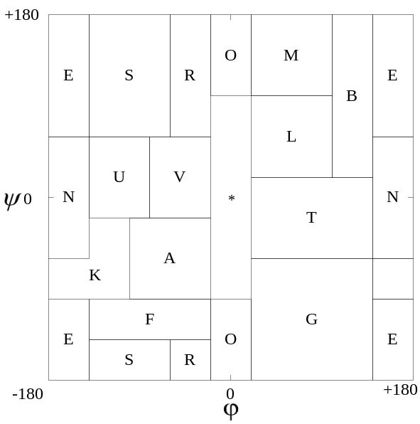
Fig.1. The definition of protein backbone structure features (S, R, U, V, K, A, T, G). E denotes extended chain, N denotes NH…NH clash, O denotes CO…CO clash, * represents NH …CO clash and B represents side chain-backbone clash, etc.

Encoding scheme for the SVM input vectors
Based on the features above, the feature vector for each site is represented by K×P numerical values, where K is the length of sliding window and P is the number of numerical values used to describe each residue in the sliding window. The feature vector of the SVM parameters is shown in Figure 2. In our model, each residue in the sliding window is described by 24 numerical values (P=24). The first 20 items are the normalized PSSM score (NPSSM) for each residue. The following three items are the protein backbone structure (PBS) of each residue: the structure feature H is represented by (1, 0, 0); the structure feature S is represented by (0, 1, 0); the structure feature T is represented by (0, 0, 1). The last item is the normalized solvent accessible surface area (NSASA) for each residue.
Due to the distance between different site and central site in the sliding window is not same, each residue in the sliding window has different effect on central site, and then a weight factor is introduced. The numerical values of each residue are multiplied by the weight factor,
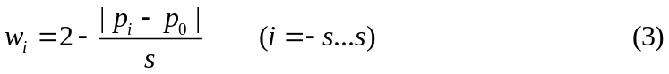
where p_{i} is the position of residue i in the sequence, p₀ is the position of the centered residue and s = (K-1)/2.

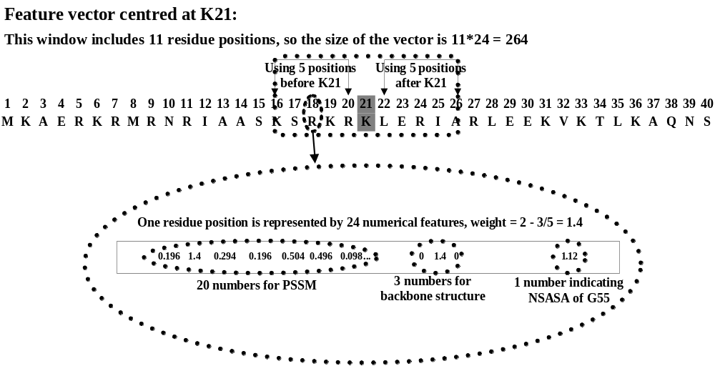
Fig.2. The feature values of SVM input vectors.

Part 2: The 3-fold cross-validation method for obtaining the slope (A) and offset (B) in the sigmoid function

The parameters slope (A) and offset (B) in the sigmoid function (equation 1 in our paper) are fit using maximum likelihood estimation for a training set (f_{i}, y_{i}).First, we define a new training set (f_{i}, t_{i}), where t_{i} are target probabilities,
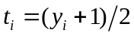 (4)
The parameters slope (A) and offset (B) in the sigmoid function (equation 1 in MS) are obtained by minimizing the negative log likelihood the training data, which is a xross-entropy error function:
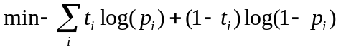 (5)
where 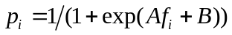 (6)
The minimization in (5) is a two-parameter minimization. Hence, it can be performed using any number of optimization algorithms (a model minimization algorithm).
Two issues arise in the optimization of (5): the choice of the sigmoid training set (f_{i}, y_{i}) and the method to avoid over-fitting this set.
For robustness, we used cross-validation method for deriving an unbiased training set. Cross-validation method is an even better method for estimating the parameters slope (A) and offset (B). In this paper, we use the three-fold-cross-validation. In the three-fold-cross-validation, a training dataset is randomly divided into three non-overlapping sets, two of which are used for training and the f_{i} is assessed on the remaining sets. This process is repeated three times. The union of all three sets of f_{i} can form the training set of the sigmoid.

Part 3: The observed method for obtaining the constant coefficients A^{d}, B^{d}, A^{α}, B^{α}, A^{θ} and B^{θ} in Eqn 3, 4 & 5

The six parameters A^{d}, B^{d}, A^{α}, B^{α}, A^{θ} and B^{θ} are chosen so that two amino acid-nucleotide pairs will be considered similar if the values of d, α and θ are in a specified range expected from uncertainties in the X-ray structure. To this end, we compared crystal structures in which the same complex occurred more than once in the asymmetric unit. There were 27 such complexes, resulting in ~12,000 analogous amino acid-nucleotide comparisons. Differences between d, α and θ for analogous amino acid-nucleotide pairs in such complexes provide a measure of the geometric variation that is due solely to experimental uncertainty and not to meaningful biological differences. Distributions of d, α and θ were determined, and the values at which 90% and 95% of the “analogous amino acid-nucleotide pairs” were within a specified cut-off were obtained. These cut-off values were 1.6 Å and 2.6 Å for d, 0.3 Å and 0.5 Å for α, and 14 degree and 25 degree for θ, respectively. Values for B^{d}, B^{α} and B^{θ} were fixed by requiring that the functions s^{d}{(i,c)(m,n)}, s^{α}{(i,c)(m,n)} and s^{θ}{(i,c)(m,n)} be equal to 0.5 when 95% of the analogous amino acid-nucleotide pairs had values less than B^{d}, B^{α} and B^{θ}, respectively, i.e. B^{d} =2.6 Å , B^{α}=0.5 Å and B^{θ}=25degree (see Figure 3). A^{d}, A^{α} and A^{θ} determine the steepness of the logistic curves and were set to ensure that s^{d}{(i,c)(m,n)}, s^{α}{(i,c)(m,n)} and s^{θ}{(i,c)(m,n)} would be essentially 1 by for values of d, α and θ that were less than their 90% cut-off values.
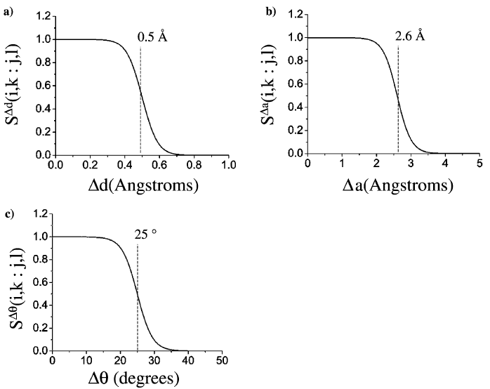
Fig. 3. Transforming d, α and θ. (a) d is used to determine s^{d}{(i,c)(m,n)}, and, a score from 0 to 1, using a logistic function. At the "cut-off" value of 0.5 Å (95% value), s^{d}{(i,c)(m,n)}, is 0.5. (b) and (c). Similarly, α and θ are used to determine s^{α}{(i,c)(m,n)} and s^{θ}{(i,c)(m,n)}, with their respective cut-off values shown at 2.6 Å and 25degeree.

Part 4: The process for fixing the probability value (p)

In order to find the probability values (p) for the most effective prediction performance, we calculated the Expectation value based on different probability values (form 0 to 1with step 0.5). The Sn, Sp, MCC, Acc and Str values for different probability values are shown in Table 1 of Supplementary data S2. The results show that the optimal probability value is assigned to be p=0.45 for our calculation.
Table 1. The test results for the PDNA-62 dataset with respect to different window sizes
p | Sn (%) | Sp (%) | Acc (%) | MCC | Str (%)
0.00 | 78.34 | 84.95 | 84.13 | 0.4962 | 81.64
0.05 | 80.39 | 85.46 | 84.84 | 0.5179 | 82.93
0.10 | 82.45 | 85.58 | 85.19 | 0.5337 | 84.01
0.15 | 83.01 | 85.73 | 85.39 | 0.5397 | 84.37
0.20 | 83.47 | 85.54 | 85.29 | 0.5401 | 84.51
0.25 | 84.31 | 85.45 | 85.31 | 0.5444 | 84.88
0.30 | 84.59 | 85.45 | 85.34 | 0.5463 | 85.02
0.35 | 85.06 | 85.40 | 85.36 | 0.5487 | 85.23
0.40 | 85.15 | 85.42 | 85.39 | 0.5497 | 85.28
0.45 | 85.06 | 85.50 | 85.45 | 0.5503 | 85.28
0.50 | 84.97 | 85.58 | 85.51 | 0.5509 | 85.27
0.55 | 84.87 | 85.73 | 85.62 | 0.5524 | 85.26
0.60 | 84.50 | 85.93 | 85.75 | 0.5529 | 85.21
0.65 | 83.75 | 86.16 | 85.86 | 0.5515 | 84.96
0.70 | 83.29 | 86.44 | 86.05 | 0.5526 | 84.86
0.75 | 82.07 | 86.89 | 86.29 | 0.5515 | 84.48
0.80 | 81.42 | 87.55 | 86.79 | 0.5578 | 84.48
0.85 | 78.43 | 88.58 | 87.32 | 0.5547 | 83.50
0.90 | 74.79 | 90.16 | 88.26 | 0.5582 | 82.47
0.95 | 60.22 | 94.06 | 89.88 | 0.5378 | 77.14
1.00 | 28.57 | 98.25 | 89.62 | 0.4024 | 63.41

Part 5: The process for fixing the threshold of ξ₀

The com(x) elements are normalized to fall with the range 0~1 by the sigmoid function defined by equation (1). The final decision value is made using the normalized com(x) value. Given a protein sequence X with l residues, we obtain an l-dimensional feature vector [com(1), com(2), ..., com(l)]. Then, we use a threshold ξ₀ to integrate the vector into a non-linear discriminant function. The threshold ξ₀ gives the decision for sample X. As com(x) >ξ₀, the sample X is classified into the positive group, or into the negative group as com(x) ≤ξ₀.
In order to find the threshold value for the accurate prediction of DNA-binding sites in proteins, the threshold values are optimized. In this work, the performance with respect to the Sn, Sp, MCC, Acc, Str and FPR values are obtained by using different threshold value from 0.40 to 0.60 with step 0.01. The tested results are shown in Table 2 of Supplementary data S2. It can be seen that the optimization threshold value is 0.52
Table 2. The test results for the PDNA-62 dataset with respect to different threshold values
ξ₀ | Sn (%) | Sp (%) | Acc (%) | MCC | Str (%)
0.40 | 88.33 | 82.31 | 83.06 | 0.5276 | 85.32
0.41 | 87.86 | 82.47 | 83.14 | 0.5265 | 85.17
0.42 | 87.77 | 82.59 | 83.23 | 0.5275 | 85.18
0.43 | 87.58 | 82.79 | 83.38 | 0.5288 | 85.18
0.44 | 87.30 | 82.92 | 83.46 | 0.5287 | 85.11
0.45 | 87.02 | 83.17 | 83.65 | 0.5302 | 85.09
0.46 | 87.02 | 83.37 | 83.82 | 0.5329 | 85.19
0.47 | 86.83 | 83.54 | 83.95 | 0.5340 | 85.19
0.48 | 86.55 | 83.92 | 84.25 | 0.5374 | 85.24
0.49 | 85.71 | 84.34 | 84.51 | 0.5377 | 85.03
0.50 | 85.43 | 84.78 | 84.86 | 0.5421 | 85.11
0.51 | 85.25 | 85.16 | 85.17 | 0.5464 | 85.20
0.52 | 85.06 | 85.50 | 85.45 | 0.5503 | 85.28
0.53 | 84.78 | 85.78 | 85.66 | 0.5526 | 85.28
0.54 | 84.31 | 86.12 | 85.90 | 0.5547 | 85.22
0.55 | 83.47 | 86.40 | 86.04 | 0.5533 | 84.94
0.56 | 83.19 | 86.65 | 86.22 | 0.5553 | 84.92
0.57 | 82.54 | 86.90 | 86.36 | 0.5549 | 84.72
0.58 | 81.89 | 87.26 | 86.59 | 0.5562 | 84.57
0.56 | 81.61 | 87.52 | 86.79 | 0.5586 | 84.56
0.60 | 81.23 | 87.80 | 86.99 | 0.5607 | 84.52

SUPPLEMENTAL REFERENCES

Ahmad, S., Gromiha, M.M. and Sarai, A. (2003) Real value prediction of solvent accessibility from amino acid sequence, Proteins, 50, 629-635.
Ahmad, S. and Sarai, A. (2005) PSSM-based prediction of DNA binding sites in proteins, BMC Bioinformatics, 6, 33.
Altschul, S.F., et al. (1997) Gapped BLAST and PSI-BLAST: a new generation of protein database search programs, Nucleic Acids Res. , 25, 3389-3402.
Chou, K.C. and Shen, H.B. (2007) MemType-2L: a web server for predicting membrane proteins and their types by incorporating evolution information through Pse-PSSM, Biochem. Biophys. Res. Commun. , 360, 339-345.
Connolly, M.L. (1983) Solvent-accessible surfaces of proteins and nucleic acids, Science, 221, 709-713.
Du, P. and Li, Y. (2008) Prediction of C-to-U RNA editing sites in plant mitochondria using both biochemical and evolutionary information, J. Theor. Biol. , 253, 579-586.
Hayat, M. and Khan, A. (2012) MemHyb: predicting membrane protein types by hybridizing SAAC and PSSM, J. Theor. Biol. , 292, 93-102.
Huang, Y.F., et al. (2009) DNA-binding residues and binding mode prediction with binding-mechanism concerned models, BMC Genomics, 10 Suppl 3, S23.
Hwang, S., Gou, Z. and Kuznetsov, I.B. (2007) DP-Bind: a web server for sequence-based prediction of DNA-binding residues in DNA-binding proteins, Bioinformatics, 23, 634-636.
Ison, R.E., Hovmoller, S. and Kretsinger, R.H. (2005) Proteins and their shape strings. An exemplary computer representation of protein structure, IEEE Eng. Med. Biol. Mag. , 24, 41-49.
Kabsch, W. and Sander, C. (1983) Dictionary of protein secondary structure: pattern recognition of hydrogen-bonded and geometrical features, Biopolymers, 22, 2577-2637.
Kretsinger, R.H., Ison, R.E. and Hovmoller, S. (2004) Prediction of protein structure, Methods Enzymol. , 383, 1-27.
Kuznetsov, I.B., et al. (2006) Using evolutionary and structural information to predict DNA-binding sites on DNA-binding proteins, Proteins, 64, 19-27.
Li, T. and Li, Q.Z. (2012) Annotating the protein-RNA interaction sites in proteins using evolutionary information and protein backbone structure, J. Theor. Biol. , 312C, 55-64.
Ofran, Y., Mysore, V. and Rost, B. (2007) Prediction of DNA-binding residues from sequence, Bioinformatics, 23, i347-353.
Pu, X., et al. (2007) Prediction of membrane protein types from sequences and position-specific scoring matrices, J. Theor. Biol. , 247, 259-265.
Shen, H.B. and Chou, K.C. (2009) Predicting protein fold pattern with functional domain and sequential evolution information, J. Theor. Biol. , 256, 441-446.
Shu, N., Zhou, T. and Hovmoller, S. (2008) Prediction of zinc-binding sites in proteins from sequence, Bioinformatics, 24, 775-782.
Spriggs, R.V., et al. (2009) Protein function annotation from sequence: prediction of residues interacting with RNA, Bioinformatics, 25, 1492-1497.
Wu, J., et al. (2009) Prediction of DNA-binding residues in proteins from amino acid sequences using a random forest model with a hybrid feature, Bioinformatics, 25, 30-35.
Zhou, T., Shu, N. and Hovmoller, S. (2010) A novel method for accurate one-dimensional protein structure prediction based on fragment matching, Bioinformatics, 26, 470-477.

*TP*Corresponding author. Tel: +86-471-4993158 E-mail address: qianzli@sina.com (Q.-Z. Li).

