**PerfectLawyer**

Perfect Lawyer is a lawyer directory where users can search for lawyers by the following categories:

Accident & Personal Injury

Bankruptcy and debt

Commercial Law

Criminal Law

Divorce and separation

Employment Law

Family Law

Immigration Law

Legal Translation & Transcription

Property Law

Real estate

After the category selection lawyer firms are listed based on the user’s location. Users can see the ratings of the lawyers / lawyer firms. Users can filter the results by location.

**Lawyer Profile**

**Users can:**

* see photos of the firm
* see a basic description / introduction of the lawyer firm
* read & write reviews (only registered users can write reviews)
* see the location of the firm (google maps) & see the distance from the current location
* Contact the firm (call now button & contact form)
* See social media buttons and company’s website

If lawyer firms want to register they have to choose from one of our packages.

**STEP 1 PACKAGES**

* Basic package £xx price/6 months
* Featured package £XX price / 6 months

Featured listings can be seen on the front page.

**STEP 2 – CREATE A LAWYER PROFILE**

**Lawyer Firms can:**

* Register their company on the website, create a lawyer profile.
* Add pictures of their firm
* Add description / basic information of their firm
* Add their firm’s location, social media pages etc…

**STEP 3 – PAYMENT**

* Payment should be processed by Stripe.
* Lawyer firms can use Voucher codes to get discounts.
* The payments are subscription based – Automatically renews after X months, Lawyer firms can cancel payment anytime on their profile.

**WEBSITE – FRONT PAGE / FEATURES**

**Categories**

Users can choose from the categories listed above.

**Search by location**

Users can search by their location

**Featured Listings**

Users can see the Featured listings on the front page.

**Blog**

Users can see latest blog posts by admin

**WEBSITE MENU**

**HOME**

**SEARCH**

**LAWYERS**

**ADD LISTING**

**ABOUT**

**CONTACT**

**Admin Page**

**Admin can:**

* **Add/edit blog posts**
* **Add/edit lawyer categories**
* **Create new packages / subscriptions**
* **Add/Edit lawyer profiles**
* **See the latest payments / subscriptions**

**EXTRA FEATURES FOR THE APPS:**

**LOCATION BASED SEARCH**

**CONTACT FORM**

**GOOGLE MAPS on LAWYER PROFILES**

**CURRENT DISTANCE**

**SOCIAL MEDIA ICONS for LAWYER PROFILES**

**MILESTONES**

1. **PAYMENT PROCESSING & BLOG**
2. **DESIGN**
3. **EVERYTHING ELSE**

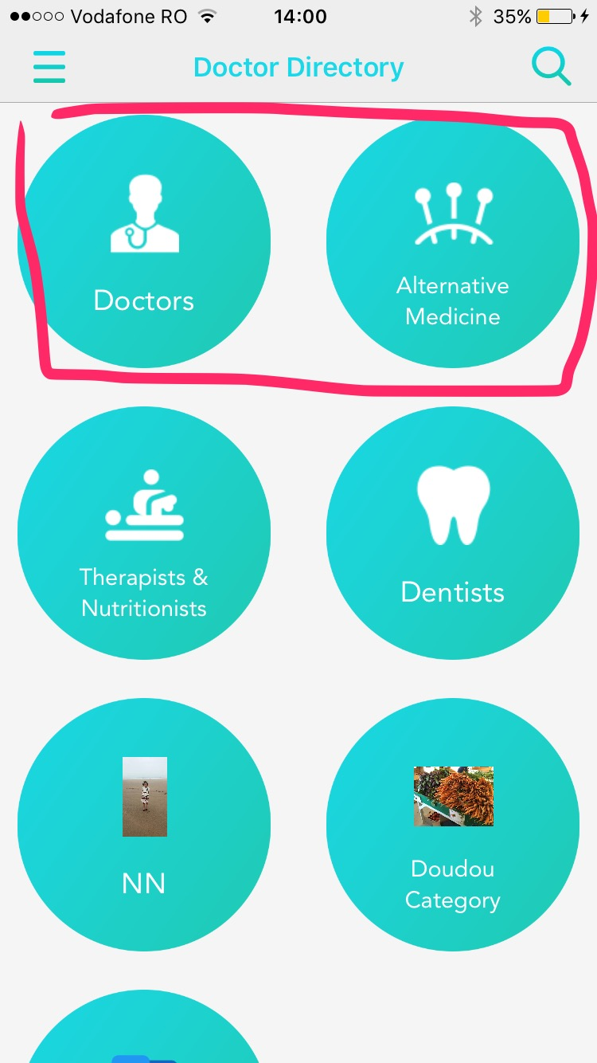

**PAYMENT PROCESSING & BLOG**

**Integrate the payment processing & add lawyer profiles**

**Adding the blog feature to the website**

**DESIGN**

**I am quite happy with the current layout. I would only like to change the colours and the icons.**

**ON THE APPS, instead of the round shaped categories I would like to use rectangular shape.**