

Latvijas Universitātes Vadības un uzņēmējdarbības mācību centrs

(LU VUMC)

**IEVADS PROGRAMMATŪRAS TESTĒŠANĀ**

2021

ESF projekts Nr. 8.4.1.0/16/l/001  
‘’Nodarbināto personu profesionālās kompetences pilnveide”

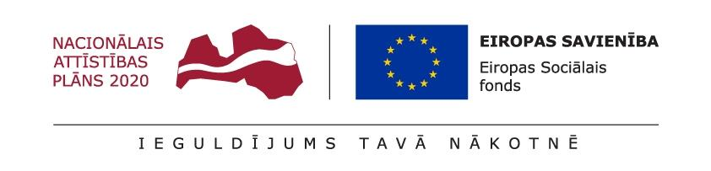

## **Lekcija 10**

**Mājasdarbs**

Obligātais mājasdarbs

Pabeigt uzdevumus.

Otrā uzdevuma atbildes noformēt atbilstoši standartam

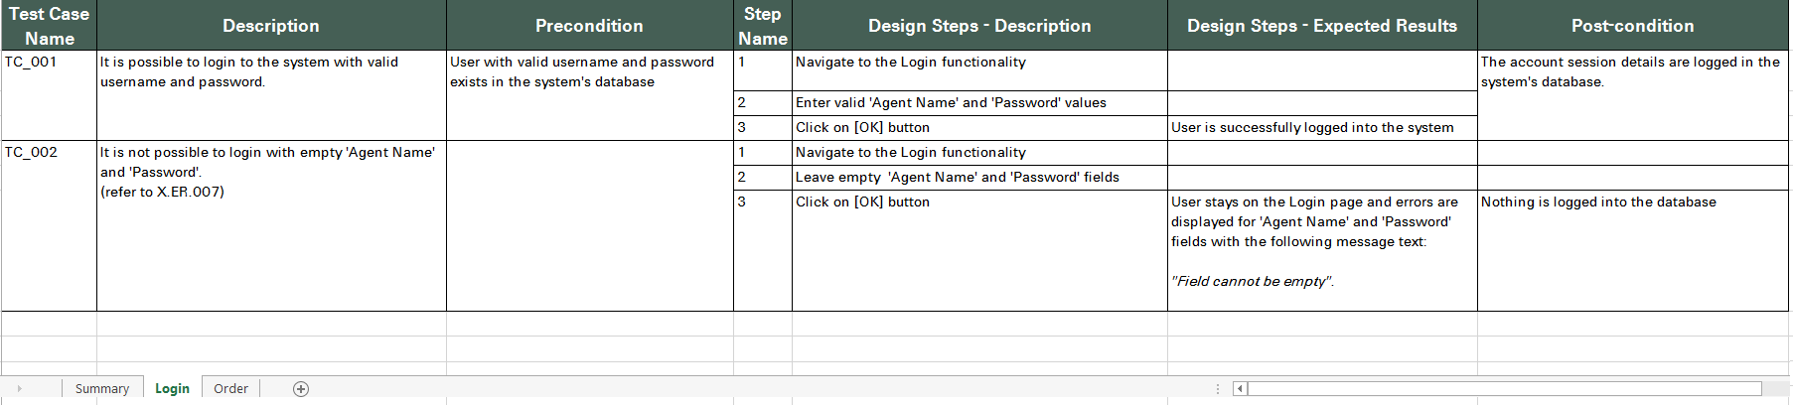

Izvēles mājasdarbs

Atbildēt uz intervijas jautājumiem.

Pielikums Intervijas_jautājumi .docx

Nav nepieciešams atbildēt izvērsti.

Jautājumi:

1. What is White Box testing?

2. What is Black Box testing?

3. Explain the difference between Authorization and Authentication.

4. Define HTTP.

5. Define HTTPS.

6. What is the difference between functional and non functional tests

7. What is accessibility

8. What is integration testing

9. What is unit testing

10. What is regression testing

11. What is acceptance testing

12. What is the difference between positive and negative scenarios

13. Is it possible to do exhaustive testing

14. Are defects clustered?

15. What is SDLC

16. What is SCRUM

17. What is AGILE

18. What is STLC

19. What is equivalence partitioning

20. What boundary values would you test

21. What is specification

22. What are acceptance criteria

23. What is a test plan

24. What is a test scenario

25. What is a test management tool

26. What tests would you automate?

27. What tests would you not automate?

28. What is a mind map

29. What is a bug

30. What is severity

31. What is priority

32. What is the difference between severity and priority

33. What is Jira

34. What are logs

35. What are common objectives of testing

36. What is exploratory testing

37. What is Ad-hoc testing

38. What is waterfall

39. What is SQL

40. When do you need SQL