# Restaurant Reviews Restful API

Application Configuration

1. Created custom configuration class AppConfig.java

To configure hibernate Session Factory Bean, JPA Entity Manager Bean and to define and set Data Source.

1. Modified the application.properties file

To define properties for data source and hibernate.

Data Source

1. Data Source

Could not connect to the H2 console so, I decided to go with a Postgres data source.

1. Starting Postgres

pg_ctl -D C:\Progra~1\PostgreSQL\9.4\data start

1. View of Database

Created powerreviewsdb database and created three tables in the public schema. When the application starts up the table schemas will be created.

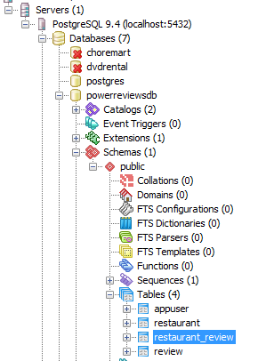

Define the Entity Persistence Classes

1. Entity Classes

From the base code that was pulled from GitLab I move the two entity classes (RestaurantEntity and UserEntity) into the model package. Plus I create a new object for the reviews (ReviewEntity) which would have a child relationship with the other two entities which can be considered as parent entities. RestaurantEntity and UserEntity would both contain a collection of reviews as an attribute and have a one-to-many relationship to the ReviewEntity.

1. JSON file to Load some test reviews

Created the reviews.json file to load review data into the review table

1. Modified the Application.java

Added the following code to load review data into the review table when application starts up.

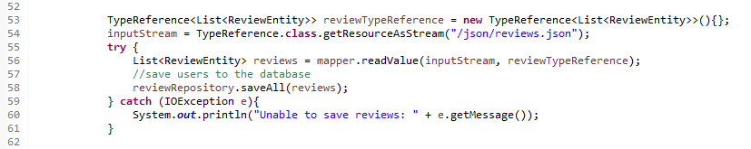

1. Custom Serializer

I was running into the Jackson JSON infinite recursion problem because in **bidirectional relationships Jackson** will throw a JsonMappingException exception when I try to serialize an instance of “ReviewEntity“ therefore, had to create a custom serializer class based on following resource: [Custom Serializer](https://www.baeldung.com/jackson-bidirectional-relationships-and-infinite-recursion)

Created class:



After implementing this class problem resolved

Start Application In Eclipse

Set the Run Configuration for the project as shown below:

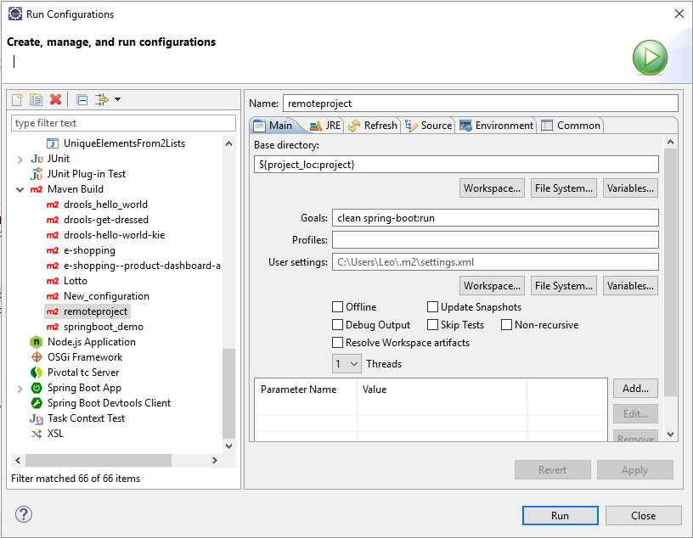

Testing Endpoints

* Return reviews for a single restaurant, sorted by date from newest to oldest.

Test using Postman

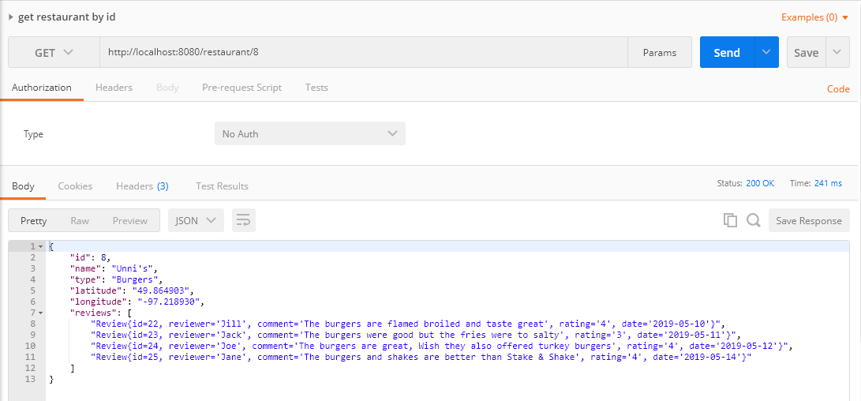

* Return restaurants that serve a particular type of food (e.g, Burgers), sorted from highest to lowest average rating.

Test

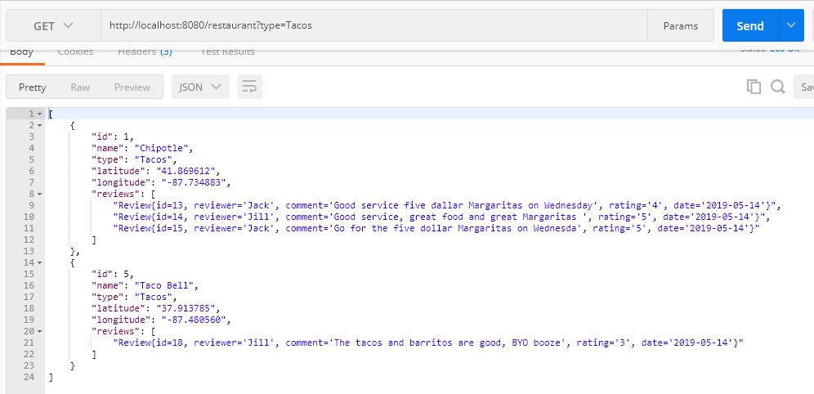

* Add a review to a restaurant

Because the Review entity is a child of the both the Restaurant and User entities, I created a controller class with an end point to insert a review into the review table.

Example endpoint to add a user review: http://localhost:8080/user/10/reviews

The request body would look like the following:

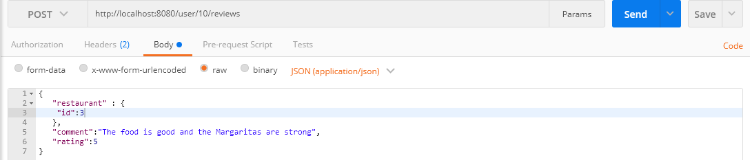

Response:

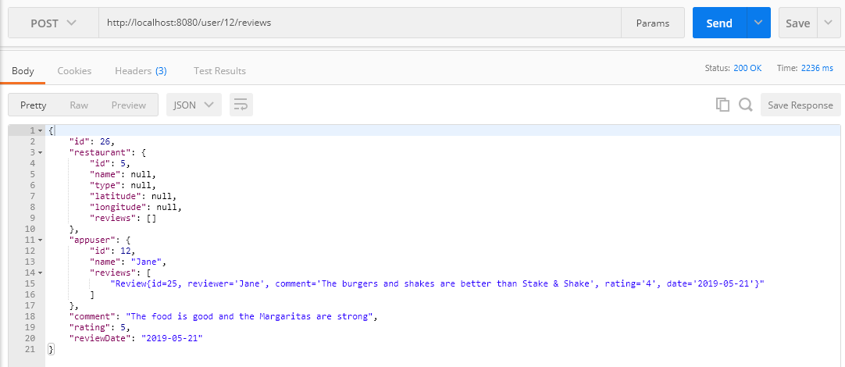

When I check the review table the new review can be seen. See below:

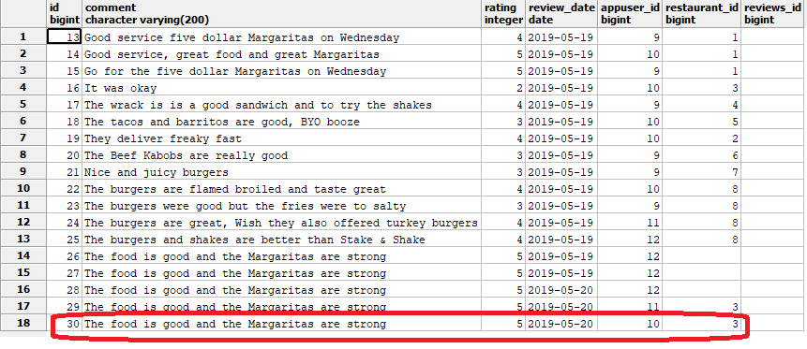

Added Error Handling

The following files were included for error handling:

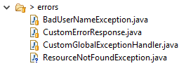

* Ratings should be between 1-5.

Request:

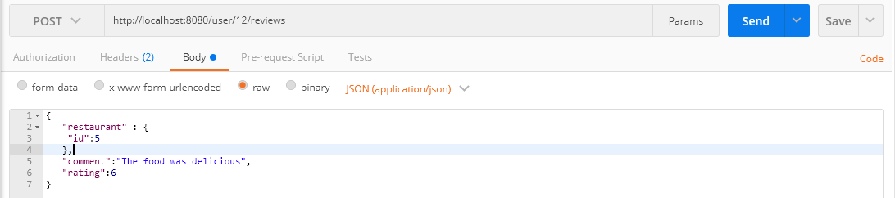

Response:

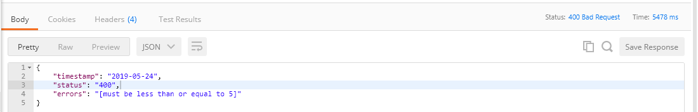

* We should not accept reviews from users with the names Darth Vader and/or AC Slater.

Test for above requirement by adding a new user:

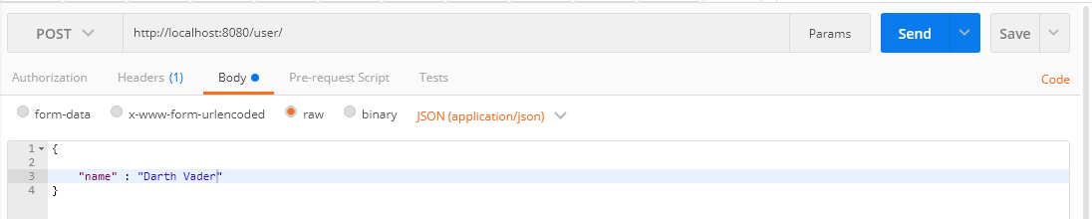

Response:

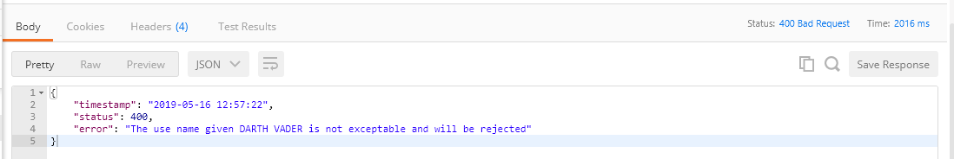

Validation Use Cases

Review comments should not exceed 200 characters:

Request:

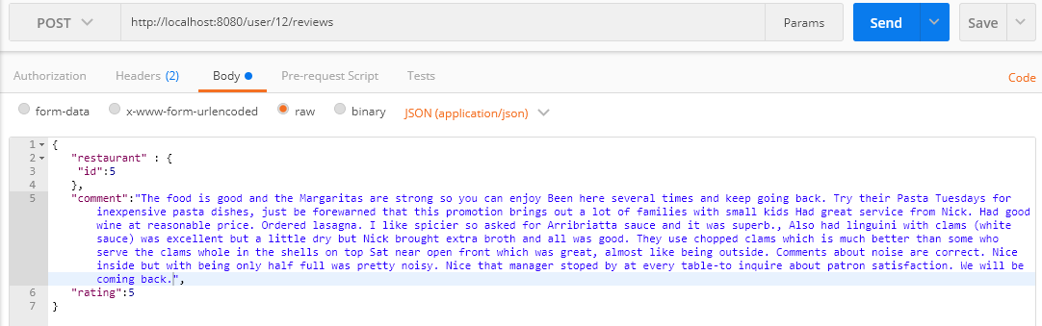

Response:

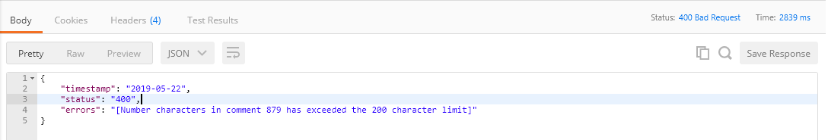

Review comments cannot contain any of the following words:

* lit, hella, chill, bro

Request:

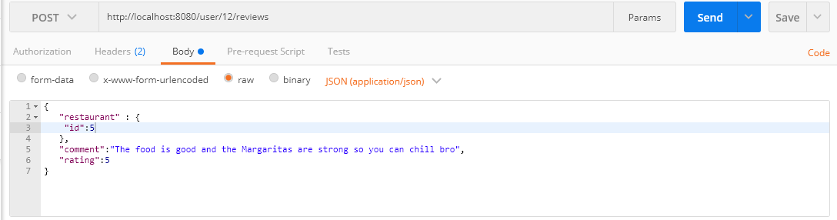

Response:

