Nokia Challenge

- Understanding the Real Goal of the Challenge
The challenge wants to evaluate whether we can build:
- A production-style backend service
- A monitoring/event-processing system
- Clean architecture
- Intelligent event logic
- Maintainable codebase
- Good developer tooling
- AI-assisted workflow using Cursor
- What You Need to Build

WatchAgent: Weather Monitor & AI Assistant
The system must:
- Poll live weather data
- Store readings
- Detect meaningful events
- Save events
- Expose everything through APIs
- Run in Docker
- Include CI/CD
- Include Cursor AI setup
- High-Level System Architecture

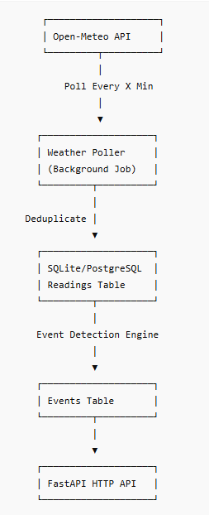
- Project Structure

watchagent/
│
├── app/
│ ├── api/
│ │ ├── routes/
│ │ │ ├── health.py
│ │ │ ├── readings.py
│ │ │ └── events.py
│ │
│ ├── core/
│ │ ├── config.py
│ │ ├── logging.py
│ │ └── scheduler.py
│ │
│ ├── db/
│ │ ├── database.py
│ │ ├── models.py
│ │ └── session.py
│ │
│ ├── services/
│ │ ├── weather_service.py
│ │ ├── polling_service.py
│ │ ├── event_engine.py
│ │ └── deduplication.py
│ │
│ ├── schemas/
│ │ ├── reading.py
│ │ └── event.py
│ │
│ ├── utils/
│ │ └── weather_codes.py
│ │
│ └── main.py
│
├── tests/
│ ├── test_api.py
│ ├── test_events.py
│ └── test_deduplication.py
│
├── .cursor/
│ ├── rules/
│ ├── agents/
│ └── skills/
│
├── docker-compose.yml
├── Dockerfile
├── requirements.txt
├── .env.example
├── README.md
└── .github/workflows/ci.yml

- Implement the Weather Polling System

This step transforms our project from a static API into a live weather-monitoring system. It introduces the logic that fetches real weather data, stores it, and detects events.
  - Purpose of the Polling System
The WatchAgent system must:
- Automatically fetch weather data every few minutes
- Store each reading in the database
- Detect meaningful weather changes
- Generate events when something important happens
- Avoid storing duplicate readings
This requires a background process that runs continuously inside Docker. That process is our poller.
  - Components You Will Build
The polling system consists of four main modules:
- weather_service.py — Fetch Weather Data
This module will:
  - Call the Open-Meteo API
  - Request temperature, humidity, wind speed, and weather code
  - Parse the JSON response
  - Return a clean Python dictionary
It will support multiple cities, each with its own latitude/longitude.
- polling_service.py — Main Polling Loop
This module will:
  - Run every X seconds (from .env)
  - Loop through all cities
  - Call weather_service
  - Save readings to the database
  - Trigger event detection
  - Log activity for debugging
This file is executed by the poller container in Docker.
- deduplication.py — Prevent Duplicate Readings
This module ensures:
  - You don’t store the same reading twice
  - You only store new data
  - You avoid unnecessary database writes
It compares:
  - The latest reading in the DB
  - The new reading from Open-Meteo
If they match → skip & If they differ → store
- event_engine.py — Detect Weather Events
This module will:
- Compare the new reading with the previous one
- Detect meaningful changes (e.g., temperature drop, wind spike)
- Generate an event record
- Save it to the database
Examples of events:
- “Temperature dropped by more than 5°C”
- “Wind speed increased sharply”
- “Weather code changed (e.g., clear → rain)”
  - How These Modules Work Together
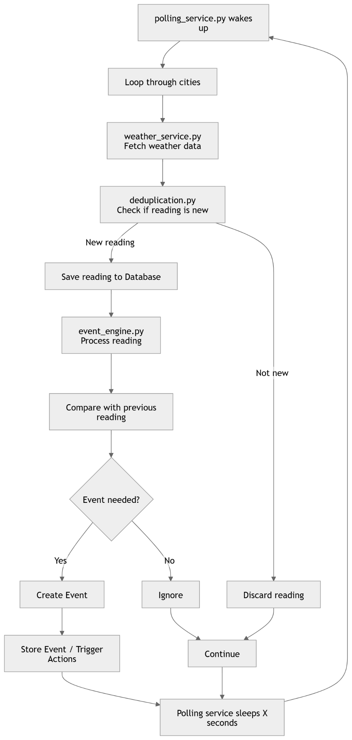
  - Build the Complete Weather Polling System

This step includes every backend component needed to fetch real weather data, store it, detect events, and run continuously.

Database Layer (3 scripts)
These define your tables and database connection.
- models.py
- session.py
- database.py

Pydantic Schemas (2 scripts)
These define the API input/output shapes.
- reading.py
- event.py

CRUD Operations (2 scripts)
These handle database writes.
- crud_readings.py
- crud_events.py

Weather Polling Logic (4 scripts)
These implement the actual weather monitoring system.
- weather_service.py
- deduplication.py
- event_engine.py
- polling_service.py
  - Mapping API → Your Database Columns
DB Column | API Field | Meaning
city | (your own value) | Ottawa, Toronto, Vancouver
temperature | temperature_2m | Actual air temperature at 2 meters
apparent_temperature | apparent_temperature | “Feels like” temperature
precipitation | precipitation | Rain/snow amount in mm
wind_speed | wind_speed_10m | Wind speed at 10 meters (km/h)
weather_code | weather_code | Encoded weather condition
timestamp | (your DB timestamp) | When your poller inserted the row
  - Ottawa example explained:
- temperature = 15°C Actual measured temperature.
- apparent_temperature = 12.6°C Feels colder due to wind.
- precipitation = 0 mm No rain or snow.
- wind_speed = 14.8 km/h From wind_speed_10m.
- weather_code = 1 Weather code 1 = Mainly clear.
- timestamp When your poller saved the reading.
Code | Meaning | Code | Meaning
0 | Clear sky | 51–57 | Drizzle
1 | Mainly clear | 61–67 | Rain
2 | Partly cloudy | 71–77 | Snow
3 | Overcast | 80–82 | Rain showers
45/48 | Fog | 95–99 | Thunderstorms

