Tumor Segmentation in Multimodal Brain MRI Using Deep Learning Approach
Muhammad Javaid Iqbal^{1,2}, Dr. Usama Ijaz Bajwa¹, Dr. Ghulam Gillanie¹
¹COMSATS University Islamabad, Lahore, Pakistan
²The Superior University, Lahore, Pakistan
javaid.ciit@gmail.com, usamabajwa@cuilahore.edu.pk , gilanie@cuilahore.edu.pk
Abstract Brain tumor is that in which some tissues become old or damaged, but they do not die at the time. They must die so that new tissues are allowed to be born. This is very challenging and time-consuming task for the experts to find manually such masses in the brain by analyzing the MRI images. In this study our main objective is to detect the tumorous part of the brain with the help of computer science knowledge especially by using image processing techniques and deep learning prediction algorithms. In our research we make an automatic system which is capable to find the tumor in the MRI images of brain. This fully automatic model can be implemented in the clinics where human experts consume most of the time to identify the tumorous part of the brain. The proposed model is capable to help in a way in which we can proceed rapidly by treating the main disease. In this study we worked on a standard MICCAI BRATS 2018 dataset which contains the MRI images with different modalities. The limitations of this study are we used four sequences in MRI images like T1, T1Gd, T2, and FLAIR. It is classifying the tumor types which are labeled by the state-of-the-art research paper published in IEEE [1] as enhancing tumor (label 4), Peritumoral edema (label 2), Necrotic and non-enhancing tumor core (label 1), and the Remaining Region is label 0 such that edema (whole tumor), necrosis, and active. The proposed model used deep learning model named U-Net for the tumor segmentation on the BRATS 2018 dataset which is CNN flavor. The proposed model evaluated and got dice coefficient (DCS) value for HGG volumes test set-1, test set-2 and test set-3 are 0.9795, 0.9855, and 0.9793 respectively. DSC value for LGG volumes test set is 0.9950 which show the proposed model has achieve optimum results to segment out the tumor in MRI by using the deep learning techniques.
Index Terms Brain Tumor Segmentation, MICCAI BRATS, FALIR, MRI Modalities, U-Net, CNN

I. Introduction
Cancer is a combination of different diseases. According to the “National Institute of Cancer” [2] normal cells in the human body grow becomes old and die, after that new cell take their place when the body needs them. But when the cancer occurs in the body this process disturbs and when the cells should die, they remain alive, divide, and spread into the other tissues of the body. This process of division and spreading keeps continue and they make tumor. Tumors are two types in general one of them is malignant tumor and the second is benign tumor. Malignant tumor divides and can spread to different positions in the body to make new tumor cells [3].
This spreading of tumor cells happens through blood or lymph system. On the other hand, benign tumor does not divide and spread, however it could be removed from the body easily. This study is very important and challenging too because many people are suffering with this disease and dying because of late diagnosis of the disease. Most of the time experts takes or wastes to identify if a patient has tumor or not and if it has then where to locate it. This is all because of manual system of the human experts. Now a day’s computer science is working in every field of study and performing very well tasks. Especially in biomedical imaging field computer science working so much. An MRI image of a doubtful patient is taken to visualize his/her brain for tumor existence.
MRI (magnetic resonance imaging) is an imaging technology. This technology mostly used in neurology and neurosurgery. Through this imaging technology the brain, spinal cord and anatomy of vascular tissues can be viewed easily. The main advantage of this technology is it provides 3D view of the concerned area or location. For example, to view the brain it can be viewed by axial, sagittal and coronal. Axial means top of the brain, sagittal means left or right of the brain and coronal means from the back of the brain. MRI has 4 different modalities T1, T1C, T2 and FLAIR [1]. Each of them has a specific purpose but the most common use of T1, T1C, T2 FLAIR are used to understand the structuring of the brain so that edema or necrosis could be detected. But routinely FLAIR imaging sequence is used as a standard MRI sequence to detect the tumor tissues in the brain. The main challenge is to detect the tumorous region in the brain after analyzing the MRI image of the brain. For this there are three different ways: one of them is manual, other is semi-automatic and the third and the last one is fully automatic. In the manual method the experts of neurology and neurosurgery manually view and analyze the brain MRI and highlight the tumorous area if found. In the second method of tumorous detection, in this method the human expert and the computing software are involved. The human expert gives the input to the system and the software process the information and returns the results to the human expert and then the expert analyzes the results. This method is not too good because for every expert it can change the output results.
The fully automatic method [1] means no involvement of human expert. The system itself works. There are some image processing and machine learning algorithm works in the system which segments the image and then classify the normal cells and the tumorous cells of the brain. The main challenge of this method is to handle different size, shape, and irregular boundaries of the brain images. For this method, the research is going on so that the fully automatic method challenges could be removed.
The proposed model is an automatic brain tumor segmentation and used deep learning model U-Net for the tumor segmentation in the state-of-the-art dataset BRATS 2018 [1].

II. Literature Review
Muhammad et al. [4] proposed an automatic technique for brain tumor segmentation using MRI. They used super pixel-based method for image segmentation and the features were extracted manually like statistical, texture, fractal, and curvature features. At the end applied Randomized classifier to classify between normal and abnormal superpixels. The proposed model was evaluated using the BRATS 2017 dataset with FLAIR sequence. The main objective of the proposed system was to identify the tumorous images. They got the DSC value 0.88.
Rehman et al. [5] discussed a classification method which takes FLAIR images as input and classify the results into tumor and non-tumor image. In this method they used super-pixel segmentation method to partition the image into small patches. From the segmented images features (statistical, texture and fractal) were extracted. At the end they applied 3 different classifiers SVM, AdaBoost and Random Forest and RF to classify the superpixels. After comparison between three they found RF which gives better performance and have precision value of 5%. BRATS 2012 dataset was used to evaluate the results of classifier.
Khan MA, Lali IU, Rehman A, et al. [6] introduced a new model for the extraction of brain tumor. In their method they used MRI images with FLAIR sequence. After image acquisition the tumor is enhanced in the images. After that tumor is segmented and marker-based watershed segmentation method was used to extract shape, texture, and point features. At the step of feature selection, they used chi-square approach to select 70% of high priority features. To classification, they pass these features to SVM (Support Vector Machine) machine learning classifier which classifies the images to tumorous and non-tumorous. The proposed method was trained and tested upon three different datasets (Harvard, BRATS-2013 and privately) collected data. Accuracy of these datasets is 98.17%, 98.88% and 98.50% respectively.

Rajan, P.G.et al. [7] in this study the proposed method finds normal and abnormal images and with this this technique finds the volume of the tumor. The proposed method takes MRI images as an input and preprocesses them to enhance the image. Then with clustering algorithm clusters of images are generated using k-means and Fuzzy C-Means. Then the features are extracted from the clustered images and these features are passed to SVM classifier which categorizes the images normal or abnormal. In that case the image is abnormal the image is segmented through active contour by level set (ACLS). Then the intensity adjustment is done and tumor area and volume are computed from the abnormal images. The tested dataset consists of 40 slices collected privately.
In [8] the focus was to find tumor region and finding whether it is benign or malignant. The whole process follows these steps: preprocessing of the images to remove noise, segmentation to find area of interest, features extraction and the classification using Neural Network. The results of the proposed model are 93.33% accuracy, 96.6% specificity, 93.33% sensitivity and precision with 94.44% they claim that their model performs better than the AdaBoost that classifies the images to three types (Normal image, benign image, and malignant image) with accuracy 89.90%. 60 MRI images privately collected to train and test the proposed model.
In [9] the work was done on brain segmentation, detecting tumorous area and evaluation of efficacy of Statistical features over Gabor features. They claim that this comparison was done first time. The algorithm uses mutual information of two hemispheres of the brain. When an image slice having tumor is found then it is segmented so that the tumor area can be delineate. The proposed algorithm takes fewer computing powers than the others. They trained and tested the model over BRATS-2013 standard dataset.
By studying various techniques, we conclude to implement the deep learning techniques of the semantic segmentation on the state-of-the-art dataset MICCAI BRATS 2018. Deep learning models like CNN, RNN and U-Net already suggested for the segmentation and they required large amount of the dataset. MICCAI BRATS challenges like BRAST 2012 to BRATS 2020 a large amount of the MRI dataset available open source. The proposed model is an automatic and based on the U-Net model for the segmentation.
Already working on the Machine Learning techniques which takes time for this process as it required feature engineering separately and then apply classification on the dataset. But deep learning technique work together for feature engineering and classification. The proposed system focuses on the deep learning in which the CNN advanced model used U-Net for the semantic segmentation. The details are given below for the proposed model.

III. Materials
There is various open-source dataset for the brain tumor segmentation challenge in which the most common using now a days are MICCAI BRATS. We have collected Multimodal MRI dataset for the brain tumor segmentation from BRATS 2018 challenge [10]. This dataset has some specifications as it has only Axial view and there are four sequences as discussed below in details. And there are some most important points about the BRATS 2018 dataset discussed here.
As all the given volumes in the BRATS 2018 were available in the form of neuro images named NifTI (.nii.gz) which has different modalities like T1, T2, T1Gd, and FLAIR. Various available techniques using only the FLAIR sequence for experimental analysis because it has more visible spatial. The BRATS dataset already defined their three labels in their research paper [1] published in IEEE. In which the labels are like enhancing tumor labeled 4, Edema labeled 2, Necrotic tumor and the tumor which is non-enhancing core labeled 1 and label 0 for the other remaining regions.
After performing pre-processing, we have distributed the dataset such that converted into the same structural format. As all the data was skull stripped, we convert into the (1 mm^3) resolution which was same for all the datasets. All the BRATS 2018 dataset contains in two main folders named HGG (High Grade Glioma) which has total 210 volumes(patients) data. And the other is LGG (Low Grade Glioma) which has only 75 volumes or patient’s data. Each volume has MRI scan of the specific patient, the folders or volumes has four modalities as mentioned above. There is also a ground truth for each volume inside and in volume one NifTI file consists of four modalities and one ground truth for each modality. There are various solutions to read and convert the NifTI (. nii.gz) files into the array named 3D NumPy. As the reason all the volumes has NifTI files, and it is difficult to compute as it in the format.
IV. The Proposed Methodology
The proposed model has some most important points which we discussed in the study and implement during the development and research work. The main purpose was brain tumor segmentation from the MRI using deep learning techniques and find the accurate tumor from the MRI. There are following steps which are performed during the research and development.
A. Data Pre-Processing
There are some steps performed for the data pre-processing:
Step-01
The dataset which we obtained from the BRATS 2018 was already skull stripped, we collect all the MRI scan for each patient and then combined them. The purpose was to make them NumPy array and the size for the array mentioned in the form of (N, S, N1, N1, X), where these annotations are:
N = Number of HGG/LGG dataset or volumes
N1 = Total 2D slices from the MRI 3D each volume
X = Number of modalities or sequences
So, all the pre-processing was held by using the Google Collaboratory which is providing free GPU and TPU services to compute the large amount of data. Due to RAM availability and fast computation used and handled very accurately.
Step-02
First of all, we handled the HGG and LGG volumes one by one, the purpose was to get the 3-D volume which has given in example as (N,155,240,240,4). As, HGG has total 210 patient’s or volumes dataset, and LGG has 75 patient’s or volumes. There was need to distribute HGG volumes into three equal parts like N= 70 and which total makes 210 for the three HGG sets and makes three sets named data11.npy for the first set contains N=70, second was data12.npy which has N=70 and the last was data13.npy also has N=70. LGG has only N=75 which is only one set and named data2.npy. As all the volumes has ground truths so it was gt11, gt12 and gt13 for the HGG volumes and gt2 for the LGG volumes specifies.
Step-03
In this step we pre-processed al the given data separately. By observing the slices all the slices are not showing the tumor area, so we decide to remove the unnecessary slices from the volumes. We used only slices form 30 to the 120 for all the data files. The final shaped was extracted as (N1,240,240,4) also same shape was extracted for the ground truths. As for the HGG volume the value for N1 was 90X70 = 5600 and for the LGG volumes the N1 was 90X75 = 6750.
Step-04
The final and experimental dimension was with the optimum value (N1,192,192,4) and we used this shape for all the data files.
Step-05
In the last pre-processing step, we divide the data into three forms first was training with 60%, second was validation with 20% and last was testing with 20% ratio.
B. Proposed Model
We proposed the deep learning model named U-Net for the semantic segmentation problem. Brain tumor segmentation is crucial problem and various techniques applied to solve the problem. The details are shown in the given picture below.
In the proposed model all the steps are discussed which are performed during the execution as from start of the input layer, convolution layer, pooling, and final to the segmented results. The detailed picture showing how the U-net model worked for the semantic segmentation in the brain tumor segmentation process. Basically, we are inspired to study the semantic segmentation [11] and applied for the brain tumor segmentation problem as it is basically using U-Net for this problem. U-Net model has various convolution operation on each layer, and it improves the segmentation of the tumor in MRI. The U-Net model [12] is convolutional network architecture which is used for fast and precise image segmentation specifically in medical imaging. It has multi-channel feature map and number of channels are normally shown top of the architecture. The x-y size is showing the lower left edge of the box and some boxes showing the feature maps. And the arrows denote the different operations. Most of the already existing techniques using FCNN [13] and various using RNN [14] models for the tumor segmentation in MRI using the different types of the datasets.
There are multiple applications for the U-net as it is using for pattern recognition, image segmentation and computer vision. In this proposed model update the existing U-Net and add more layers to get the best outcome by using BRATS 2018 MRI for the brain tumor segmentation.

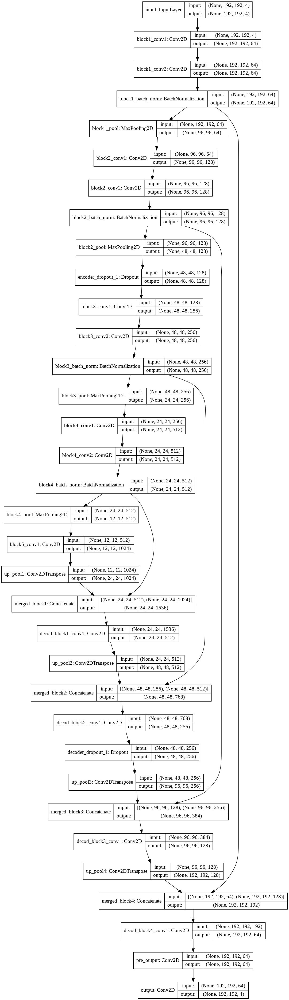

FIGURE 1. Proposed Model using U-Net

V. Results and Discussion
The obtained results from the proposed model are good to see the resulted images which are shown in the figure 2 and figure 3. Proposed model is evaluated both for HGG and LGG volumes. The pictorial results view for the HGG volumes and LGG volumes are shown in figure 2 and figure 3 respectively.
A. Results for HGG Volumes
HGG volumes test results shown in figures 2 and 3 are for few samples to show the model’s accuracy and physical view of the results in figures. In which figure 2 shown as (a) actual slice for the test set-01, (b) segmented image for the test set-01, (c) ground truth for the test set-01 slice. Whereases (d)HGG test set-02 actual slice, (e) segmented image from test set-02, and (f) ground truth for the test set-02 slice.
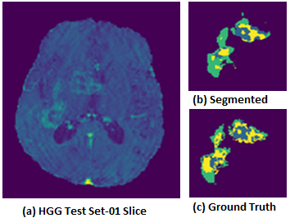
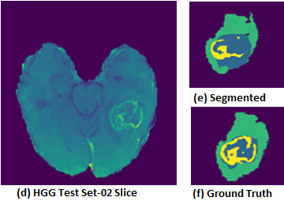

FIGURE 2. HGG Volumes where (a) HGG test set-01 Slice, (b) segmented image test set-01, (c)ground truth image test set-01, (d) HGG test set-02 Slice, (e) segmented image test set-02, (f)ground truth image test set-02

Figure 3 shows about the HGG volume test set-03 pictorial results in which (a) HGG test set-03 actual slice, (b) segmneted image, and (c) ground truth for the given slice.
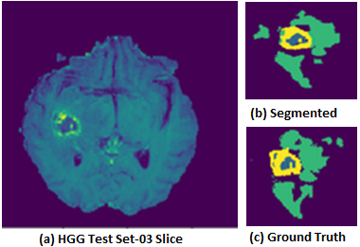

FIGURE 3. HGG Volume where (a) HGG test set-03 Slice, (b) segmented image test set-03, (c)ground truth image test set-03

B. Results for LGG Volumes

Results obtained to evaluate the LGG volumes test set are shown in figure 4. Which shows (a) LGG test set actual slice, (b)segmented image obtained from slice, (c)ground truth whereases shows other sample slice results in (d) test set actual slice, (e)segmented image, and (f) ground truth for the second slice.
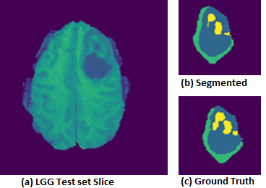
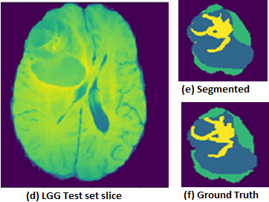
FIGURE 4. LGG Volumes where (a) LGG test set-01 Slice, (b) segmented image test set, (c)ground truth image test set, whereas other slice (d) LGG test set Slice, (e) segmented image test set, (f)ground truth image test set

C. Evaluated Results
Dice Coefficient (DSC) & Dice Coefficient Loss Function are most commonly using to check the model’s accuracy. DSC mostly using for the medical imaging analysis and to evaluate the models for the medical imaging. The DSC formula is shown in the given below equation.
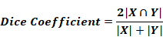

Here cardinalities for the two sets representing by |X| and |Y| in which east set showing the elements in them. By applying this equation, we can get the overlap values for the actual resulted image with the ground truth images. Which give us the values the images overlap to each other.
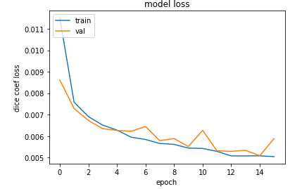
Model Loss Graph
The graph for the DSC loss is shown in the figure 5, in which the training and validation datasets model loss shown. As the number of epochs increasing the DSC for the training and validation dataset going down. On the start of the epochs the DSC values were maximum and as increasing the number epochs the dice values go down as shown in the figure 5. It means our proposed model is best and gives good results.

FIGURE 5. Model loss graph for training and validations data with
DSC & epoch
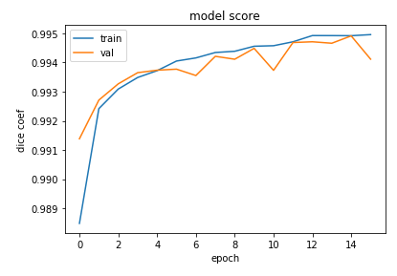
Model Score Graph
The model score graph shown in figure 6 which shows the DSC value against the training and validation datasets. By increasing the number of epochs, the DSC values are going best as shown in the figure 6. By seeing the graph is very clear about the model’s accuracy and we can say it is very near to the actual results. Increasing the number epochs, it is going to increase the DSC values.

FIGURE 6. Model score graph for the Training and Validations data
with DSC and epochs

The proposed model outperformed for the brain tumor segmentation in the state-of-the-art dataset BRATS 2018 and the DSC values for the test sets both for HGG and LGG volumes are shown in the table 1.
As we divide the dataset for training, validation, and testing. The testing sets are used here to check the model’s accuracy and it gets outperformed results as shown in the table 1.
Table 1. Proposed Model Test Sets with Dice Coefficient Values
Test Samples | Test Sets | DSC Values
1 | HGG Volumes Set-01 | 0.9795
2 | HGG Volumes Set-02 | 0.9855
3 | HGG Volumes Set-03 | 0.9793
4 | LGG Volumes Set | 0.9950

After performing various experiments, we got the best value for DSC for both HGG and LGG volumes. The HGG volumes and LGG volumes used for the testing got max DSC values 0.9855, 0.9950 respectively. These proofs of our proposed model.
State-of-the-art Results Comparison (working)
The proposed model compared with the various techniques. Other techniques used the same dataset wo evaluate as a whole model and the results as shown in the table 2. The results are better than the state-of-the-art.

No. | State-of-the-art | DSC Values
1 |  | 0.9795
2 |  | 0.9855
3 |  | 0.9793
4 |  | 0.9950

The problem statement points has resolved developing this problem and the challenge for getting the three labels tumor from the MRI has been performed with best DSC values for HGG and LGG volumes.
The proposed model can accurately determine the size and structure of the tumor in MRI. The DSC values and pictorial results shows that the proposed model outperforms for the BRATS dataset.

VI. Conclusion
Our proposed model outperformed in brain tumor segmentation. We used state-of-the-art dataset BRATS 2018. There are some pre-processing steps performed and pass the prepared dataset to the deep learning model for segmentation. DSC value is good after applying on the test dataset. The accurate tumor can be seen according to the problem statement as shown in figure 2 and figure 3. The test data results for the proposed model are shown in the table 1. All the three labels for the tumor can be seen in the figure 2 and figure 3 against the ground truths.
The proposed model fulfilled all the mentioned requirements in the problem statement and challenge to solve the tumor segmentation in the brain MRI. In the future work we can use various other datasets like BRATS or other real time datasets to improve the model scalability. It is concluded that the proposed model fulfills the requirements as it is performing automatic for the large amount of the datasets, it can segment out accurately size of the tumor as given in the ground truths. The DSC values shows the proposed model has best results with maximum value obtained by test sets.
REFERENCES
[1] | B. H. Menze et al., "The Multimodal Brain Tumor Image Segmentation Benchmark (BRATS)," IEEE Transactions on Medical Imaging, vol. 34, no. 10, pp. 1993-2024, Oct 2015.
[2] | "What is Cancer?," [Online]. Available: https://www.cancer.gov/about-cancer/understanding/what-is-cancer. [Accessed 13 4 2021].
[3] | M. Sabrina Felson, "Brain Cancer," WebMD LLC, 9 10 2019. [Online]. Available: https://www.webmd.com/cancer/brain-cancer/brain-cancer. [Accessed 13 4 2021].
[4] | S. Mohammadreza, "Automated brain tumour detection and segmentation using superpixel-based extremely randomized trees in FLAIR MRI," International journal of computer assisted radiology and surgery, vol. 12, pp. 183-203, 2017.
[5] | Z. U. Rehman and Naqvi, "Fully automated multi-parametric brain tumour segmentation using superpixel based classification," Expert systems with applications, vol. 118, pp. 598--613, 2019.
[6] | M. A. Khan, "Brain tumor detection and classification: A framework of marker-based watershed algorithm and multilevel priority features selection," Microscopy research and technique, vol. 82, pp. 909--922, 2019.
[7] | R. PG and S. C, "Brain tumor detection and segmentation by intensity adjustment," Journal of medical systems, vol. 43, pp. 1--13, 2019.
[8] | B. Himaja and Lingaraju, "Automatic segmentation and classification of brain tumor using machine learning techniques," International Journal of Applied Engineering Research, vol. 13, pp. 11686--11692, 2018.
[9] | N. Nooshin and K. Miroslav, "Brain tumors detection and segmentation in MR images: Gabor wavelet vs. statistical features," Computers \& Electrical Engineering, vol. 45, pp. 286--301, 2017.
[10] | SBIA, "Multimodal Brain Tumor Segmentation Challenge 2018," [Online]. Available: https://www.med.upenn.edu/sbia/brats2018/data.html. [Accessed 13 04 2021].
[11] | H. Te-Wei, Q. Te-Wei and et.al., "Brain Tumor Segmentation Using U-Net and Edge Contour Enhancement," in Proceedings of the 2019 3rd International Conference on Digital Signal Processing, 2019, pp. 75--79.
[12] | J. JORDAN, "An overview of semantic image segmentation," Machine Learning Blogs , 21 05 2018. [Online]. Available: https://www.jeremyjordan.me/semantic-segmentation/. [Accessed 12 04 2021].
[13] | Z. Xiaomei and et.al,, "A deep learning model integrating FCNNs and CRFs for brain tumor segmentation," Medical image analysis, vol. 43, pp. 98--111, 2018.
[14] | L. Zhihua and et.al., "Deep learning based brain tumor segmentation: A survey," arXiv preprint arXiv:2007.09479, 2020.

