Pounds to Kilograms

OBJECTIVE: Create a program that asks a user for their weight (in pounds) and converts it to kilograms.
      - Prompt the user for their weight. Store the value in a variable, pounds.
      - Convert the user's weight to kilograms by dividing it by 2.21. Store the result in a variable, kilograms.
      - Output the user's weight in kilograms by displaying the variable, kilograms.

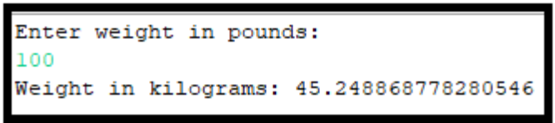

GRADING: (20 points total)

Points Objective

1 Empty shell – Program compiles and runs without any errors.

2 No variables are used. Everything is outputted as a string literal.
10 User is not prompted for their weight, instead, variable, pounds, is declared and initialized with a set starting weight. The conversion of pounds to kilograms is computed without the program and initialized in variable, kilograms. Variable, kilograms, is outputted to the screen.
15 User is not prompted for their weight, instead, variable, pounds, is declared and initialized with a set starting weight. The value in pounds is converted (by the program) to kilograms and the value is stored in variable, kilograms. Variable, kilograms, is outputted.
20 User is prompted for their weight. The value is stored in variable, pounds. The value in pounds is converted (by the program) to kilograms and the value is stored in variable, kilograms. Variable, kilograms, is outputted as shown above.

