Seconds Converter

OBJECTIVE: Write a program that asks the user to enter a number (integer) of seconds.

- There are 60 seconds in a minute. If the number of seconds entered by the user is greater than or equal to 60, the program should display the number of minutes equal to the number of specified seconds.

- There are 3,600 seconds in an hour. If the number of seconds entered by the user is greater than or equal to 3,600, the program should display the number of hours equal to the number of specified seconds.

- There are 86,000 seconds in a day. If the number of seconds entered by the user is greater than or equal to 86,400, the program should display the number of days equal to the number of specified seconds.

- If the number of seconds entered by the user is below 60, but still positive, that number should just be displayed to match the input.

- If the number of seconds entered by the user is negative, the program should provide a message.

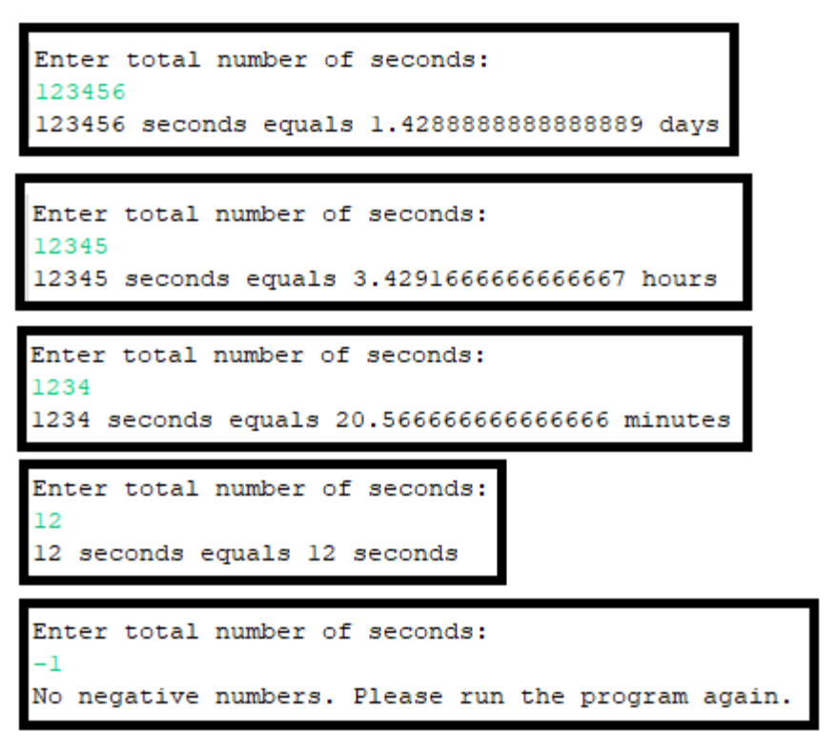

GRADING: (70 points total)
Points Objective
3 Empty shell – Program compiles and runs without any errors, but doesn't do anything.
30 User is prompted for total number of seconds. This value is converted to the equivalent number of days, minutes, hours, or seconds, all of which are calculated incorrectly. The values are outputted similar as shown above. Program may or may not account for negative input values.
40 User is prompted for total number of seconds. This value is converted to the equivalent number of days, minutes, hours, or seconds, three of which are calculated incorrectly. The values are outputted similar as shown above. Program may or may not account for negative input values.

50 User is prompted for total number of seconds. This value is converted to the equivalent number of days, minutes, hours, or seconds, two of which are calculated incorrectly. The values are outputted similar as shown above. Program may or may not account for negative input values.
60 User is prompted for total number of seconds. This value is converted to the equivalent number of days, minutes, hours, or seconds, one of which is calculated incorrectly. The values are outputted similar as shown above. Program may or may not account for negative input values.
70 User is prompted for total number of seconds. This value is converted to the equivalent number of days, minutes, hours, or seconds, all of which are calculated correctly. The values are outputted exactly as shown above. If a negative value is received, the program outputs a message as shown above.
80 User is prompted for total number of seconds. This value is converted to the equivalent number of days, minutes, hours, and seconds correctly. The value is outputted exactly as shown in the sample program. If a negative value is received, the program outputs a message and ends.

