Volume of a Cylinder

OBJECTIVE: Create a program that displays the volume of a cylindrical fuel tank. The formula for the volume of a cylinder is:
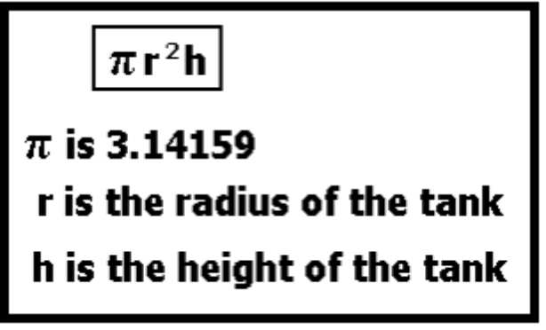
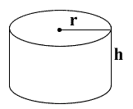
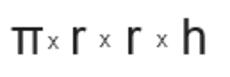
Prompt the user for the height of the tank and the radius of the tank. Output the volume as shown.
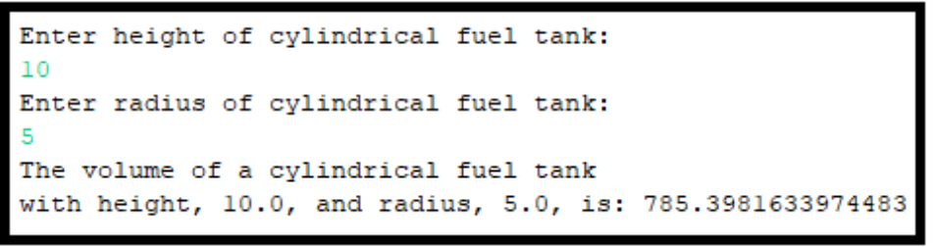
GRADING: (20 points total)
Points Objective

1 Empty shell – Program compiles and runs without any errors.
10 User is not prompted for the radius and height, instead, two variables representing the tank's radius and height are initialized with pre- determined values. The volume of the tank is calculated by the program, stored in a variable, and outputted to the screen as shown above.
15 User is prompted for the fuel tank's radius and height. The 2 values are stored into variables and used by the program to calculate the tank's volume. The pow( ) function is not used. The tank's volume is outputted to the screen as shown above.
20 User is prompted for the fuel tank's radius and height. The 2 values are stored into variables and used by the program to calculate the tank's volume. The pow( ) function is used. The tank's volume is outputted to the screen as shown above.
25 User is prompted for the fuel tank's radius and height. The 2 values are stored into variables and used by the program to calculate the tank's volume. The pow( ) function is used. The tank's volume and surface area is outputted to the screen as shown above.

