Character Values

OBJECTIVE: Write a program that stores 2 characters, lowercase “z” and uppercase “V”, in two
separate variables. Subtract the “v” from the “z” and store the result into a new
character variable (using casting). Display the result as shown below.

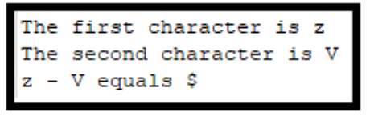
NOTE: The ASCII table can be viewed at: https://www.ascii-code.com/. However, Java does not use the “extended ASCII codes”, but uses Unicode instead.
GRADING: (15 points total)
Points Objective
1 Empty shell – Program compiles and runs without any errors.
8 Characters, z and V, are stored in two separate variables. The computer does the subtraction and stores the result into another variable.
The message,
The first character is z.
The second character is V
“z - V equals $” is displayed.

10 Characters, z and V, are stored in two separate variables. The computer does the subtraction and stores the result into another variable.
The message,
The first character is <variable 1>.
The second character is <variable 2>.
“z - V equals <result>” is displayed.
12 Characters, z and V, are stored in two separate variables. The computer does the subtraction and stores the result into another variable.
The message,
“<variable1> - <variable2> equals <result>” is displayed.
13 Characters, z and V, are stored in two separate variables. The computer does the subtraction and stores the result into another variable.
The message,
The first character is z.
The second character is V.
“<variable1> - <variable2> equals <result>” is displayed.
15 Characters, z and V, are stored in two separate variables. The computer does the subtraction and stores the result into another variable.
The message,
The first character is <variable 1>.
The second character is <variable 2>.
“<variable1> - <variable2> equals <result>” is displayed.

