Data Type Review

OBJECTIVE: Write a program that contains 5 variables (1 variable per data type). The program must have the following:
      - Declare 5 variables. Each variable must be one of the 5 data types previously discussed.
      - Store the following values in their correct variable.
          - VALUES: 53, W, Bob Brown, true, and 226.4
      - Output each variable as shown below:

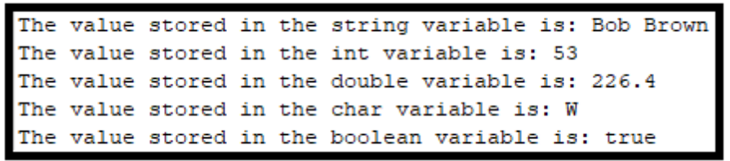
GRADING: (20 points total)
Points Objective
1 Empty shell – Program compiles and runs without any errors.

2 No variables created and used, however program still correctly displays
message shown above.

4 Creates 1 variable and stores correct value inside. Outputs variable as shown above.
8 Creates 2 variables (of different data types) and stores correct values inside each. Outputs both variables as shown above.
12 Creates 3 variables (of different data types) and stores correct values inside each. Outputs three variables correctly as shown above.
15 Creates 5 variables (of different data types) and stores correct values inside each. Variables are not actually outputted, but their values are.
16 Creates 4 variables (of different data types) and stores correct values inside each. Outputs four variables correctly as shown above.
20 Creates 5 variables (of different data types) and stores correct values inside each. Outputs all variables correctly as shown above.

