Introduction to Objects

OBJECTIVE: Create two class files in your package for program 11. The first called,
“Program11.java” and the second called “NumberPair.java”. Copy the contents from
the following link:
https://github.com/javainajiffy/javainajiffy.github.io/blob/main/programs/11/NumberPair.java
and paste them into the class file, NumberPair.java.

In the file, Program11.java, write the code that
            - Creates an instance of a NumberPair object by using “new” and passes in the numbers, 10 and 2, to the constructor.
            - Uses all the methods in the NumberPair object to output a result that matches the following:
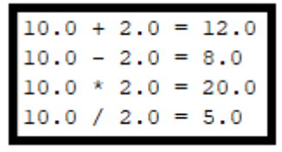

GRADING: (30 points total)
Points Objective
3 Empty shell – Program compiles and runs without any errors.

10 The output is similar to the above image, however, an instance of the NumberPair object was not created.

15 The output is similar to the above image, however, an instance of the NumberPair object was created, but not used.

25 The output is similar to the above image. An instance of the NumberPair object was used, but not all of the methods were used.
28 The output is similar to the above image. An instanced of the NumberPair object was used and all of the methods were used, however there was at least one formatting error.
30 The output matches exactly as the above image. An instanced of the NumberPair object was used and all of the methods were used. There were no formatting errors.

