Switch It Up

OBJECTIVE: Write a program that asks the user to enter a number within the range of 1 through 10.
Use a switch statement to display the Roman Numeral version of that number.

Input Validation: Do no accept a number less than 1 or greater than 10.

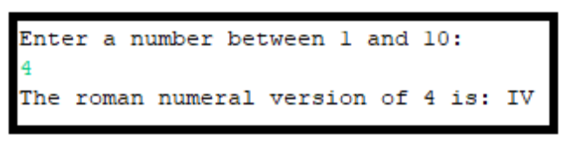

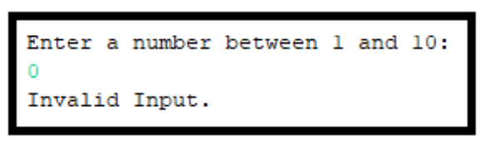

GRADING: (30 points total)
Points Objective
2 Empty shell – Program compiles and runs without any errors.
10 When user inputs a number, the program displays that number in roman numeral form. Program does not use a switch statement.

15 When user inputs a number, the program displays that number in roman numeral form, but also “waterfalls” meaning it displays other numbers in roman numeral form. Program uses a switch statement.

28 When user inputs a number, the program displays that number in roman numeral form, but has at least one mistake. Program uses a switch statement.

30 When user inputs a number, the program displays that number in roman numeral form correctly as shown in the examples. Program uses a switch statement.

