**JAVAIRIA REHMAN**

**19P-0020**

**BS(CS) 19-5A**

**“computer network lab ”**

**Lab 6 home work**

**STEP 1 SINERIO**

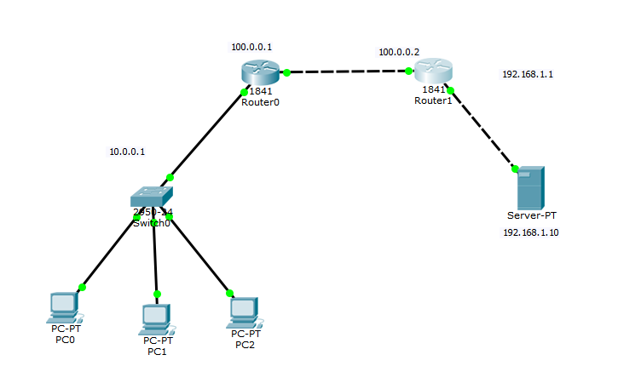

**STEP 2 assigning ip to server**

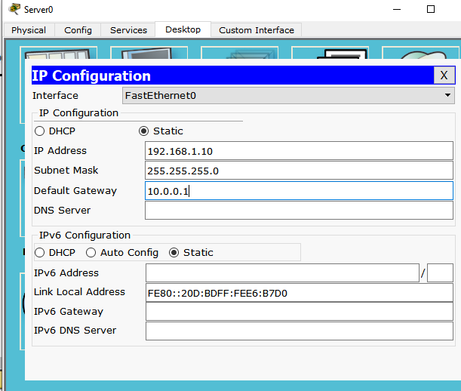

**assigning ip to pc**

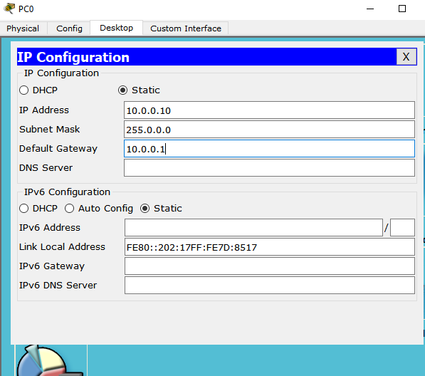

**Step 3 changing in router CLI(both routers):**

**Router1**

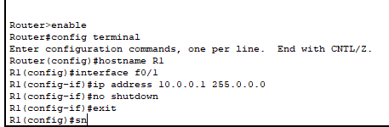

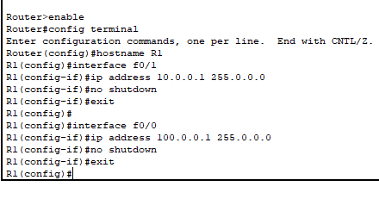

**Router 2**

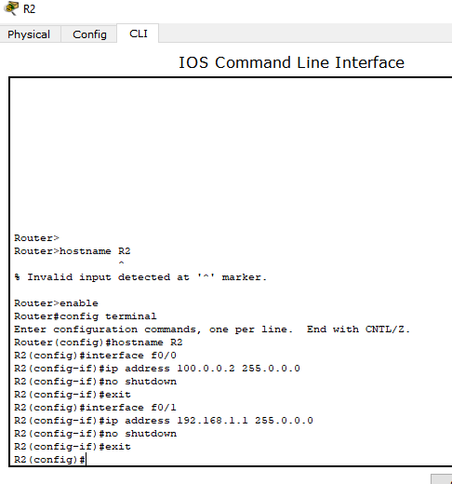

**Step 4 static configuration of NAT**

* **Define IP address mapping**



* **3. Define inside local interface**
* 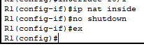
* **4. Define inside global interface**



**Router 2**

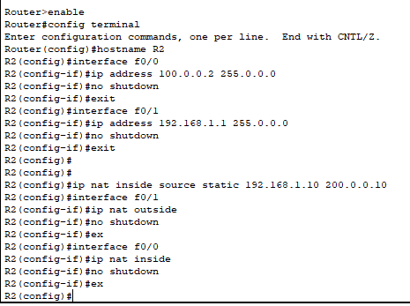

**Configure r1 and r2**





**Check from command promp of any pc using ping command**

