**JAVAIRIA REHMAN**

**19P-0020**

**BS(CS) 19-5A**

**“computer network lab ”**

**Lab 11**

**STEP 1**

Design topology

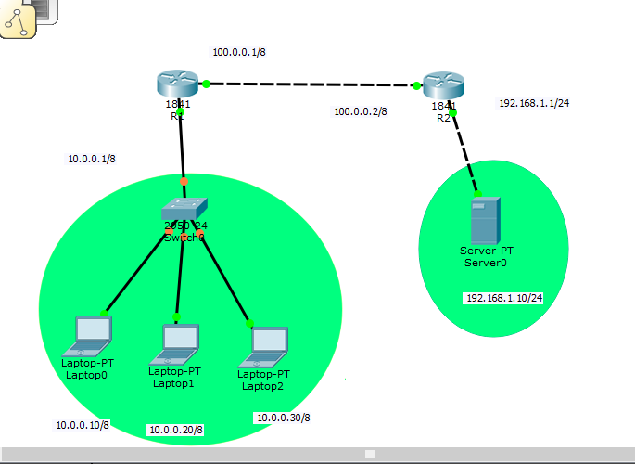

**STEP2**

Assign ip to pc and server

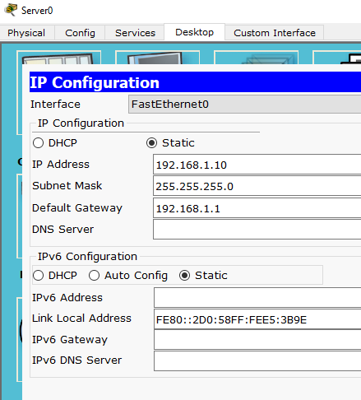

**STEP 3**

Go to router

Assign router names to router

Perform configuration

**r2**

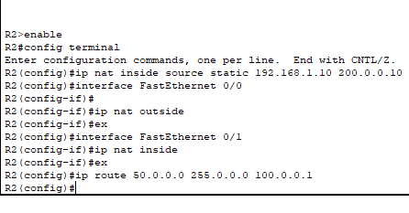

**r1**

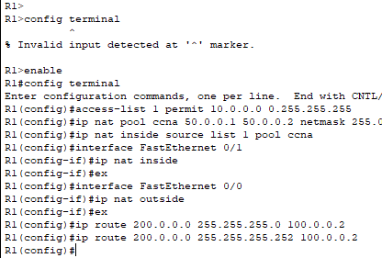

**output**

