**JAVAIRIA REHMAN**

**19P-0020**

**BS(CS) 19-5A**

**“computer networks ”**

**Lab home work**

**User exec mode**

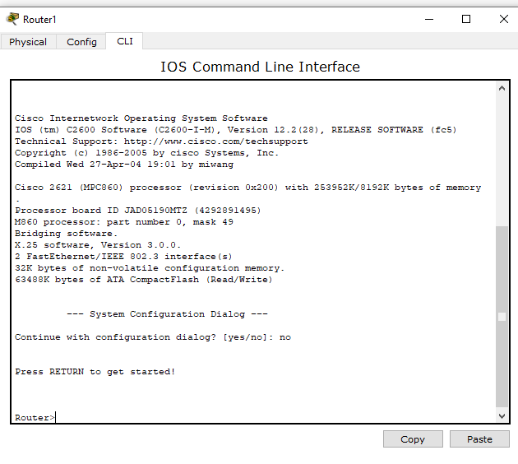

**Privileged EXEC Mode**

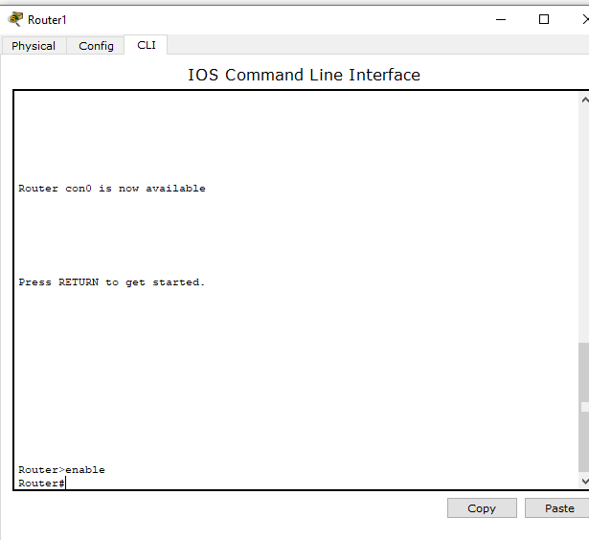

**Global Configuration Mode**

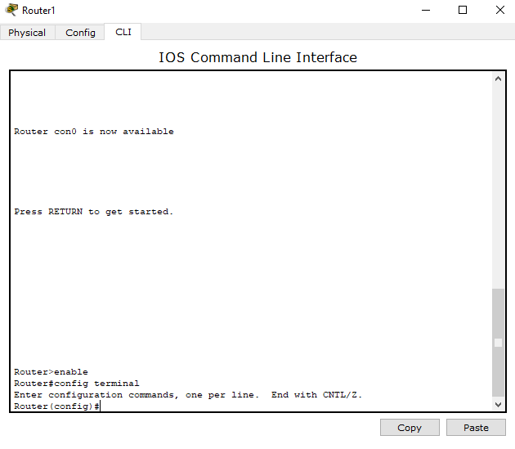

**Interface Configuration**



**modes**

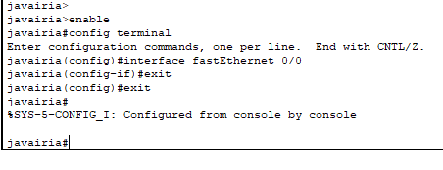

**Changing host name**

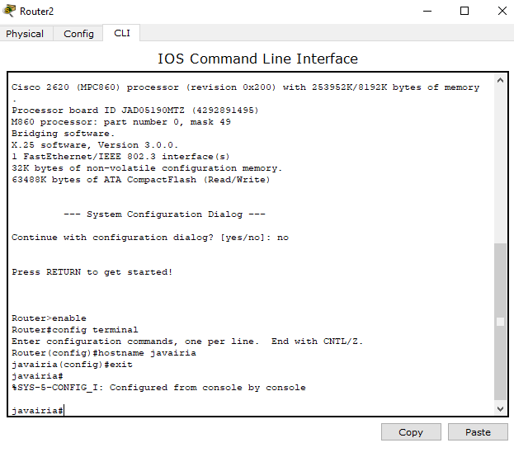

**Configuration of date and time**

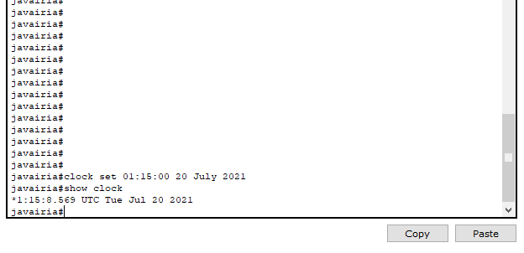

**Setting a banner**

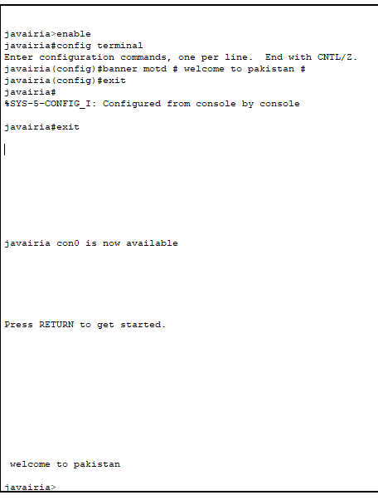

**Displaying running configuration**

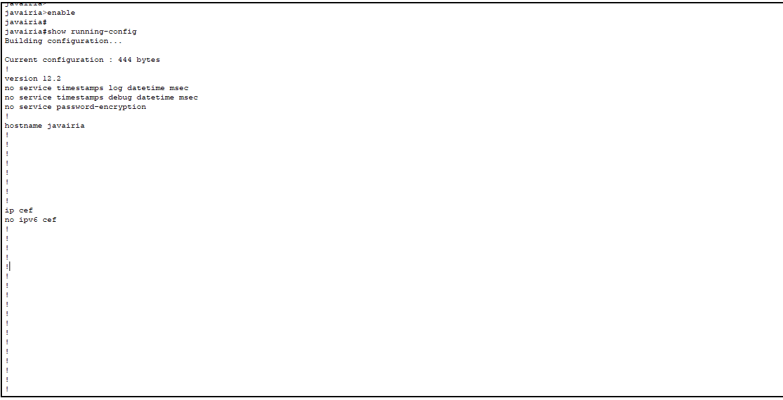

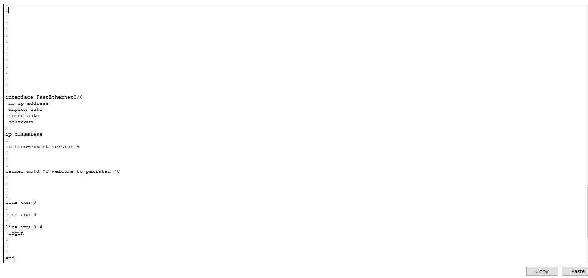

**LINE CONSOLE PASSWORD**

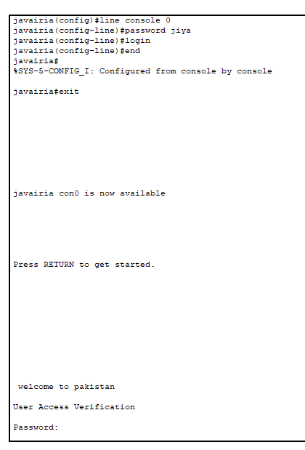

**LINE VTY / TELNET PASSWORD**

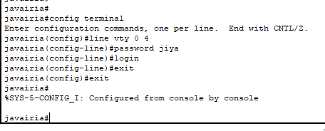

**AUXILIARY LINE PASSWORD**

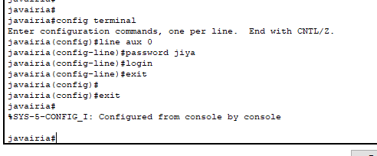

**PASSWORD FOR PRIVILEGED MODE**

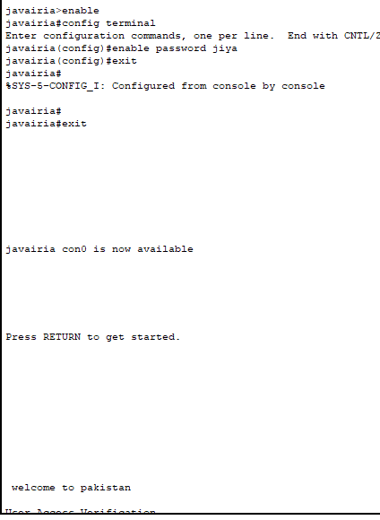

**REMOVING LINE CONSOLE PASSWORD**

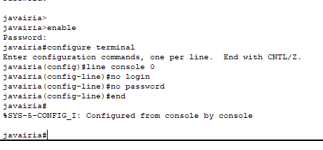

**REMOVING LINE VTY / TELNET PASSWORD**

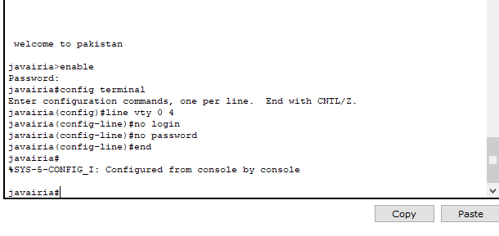

**REMOVING AUXILIARY LINE PASSWORD**

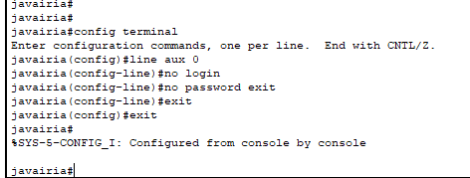

**REMOVING PASSWORD FOR PRIVILEGED EXEC MODE**

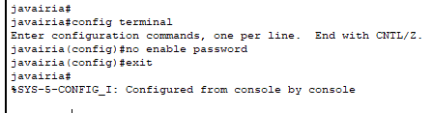

**REMOVING SECRET PASSWORD**

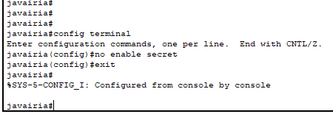

**How to enable a port or interface**

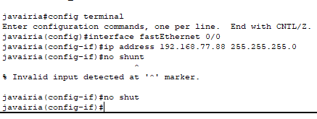

**How to check the IP address of all interfaces:**

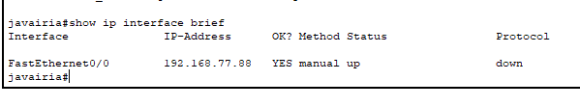

**Task sinerio**

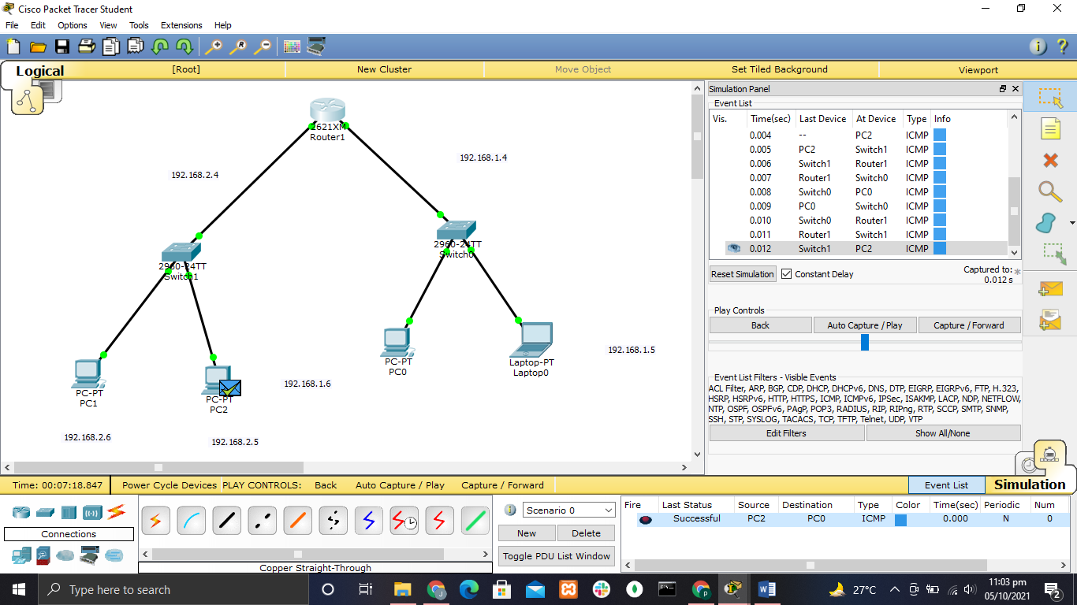

**Changing hostname to jiya**

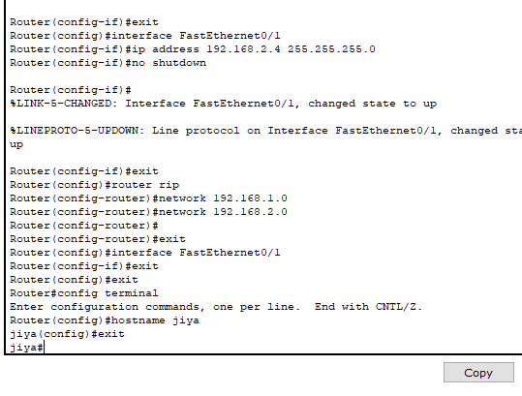

**Changing date and time**

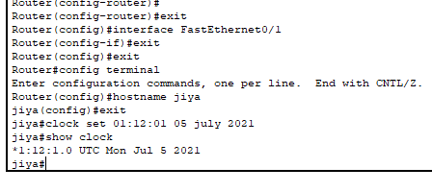

**Setting banner**

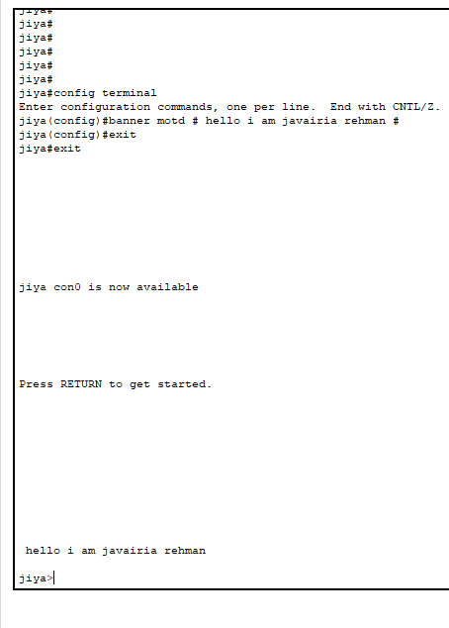

**Line console password:**

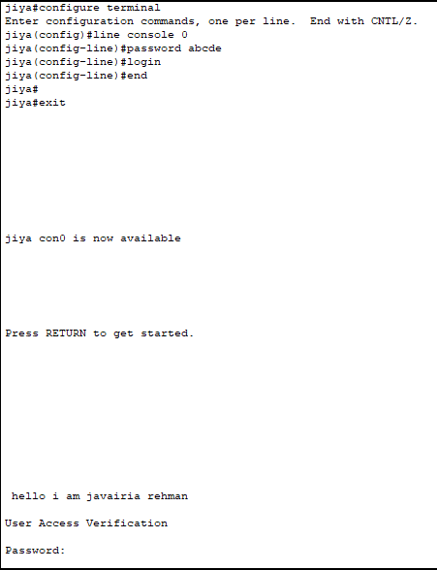

**Vty password**

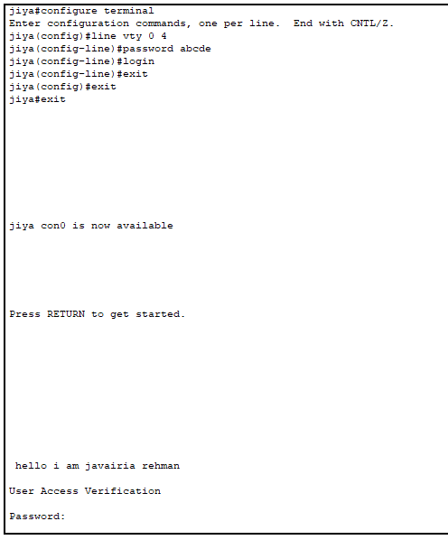

**Auxeliry password**

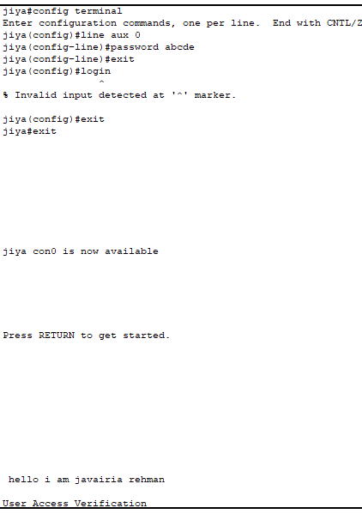

**Auxellary line password**

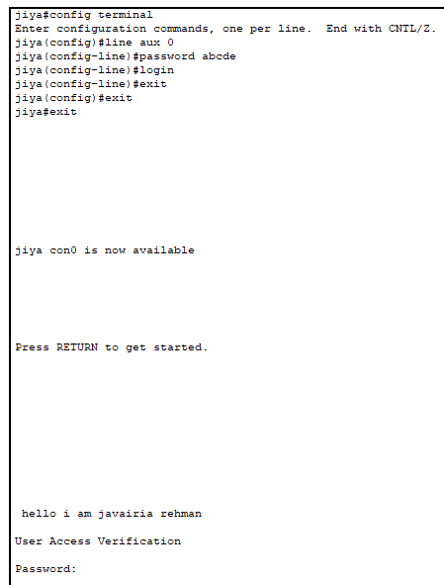

**Password for privillage mode**

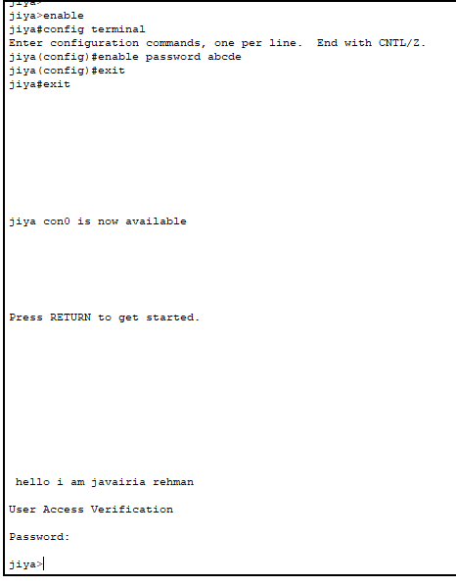

**Ip interference**

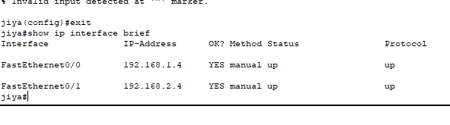

**What is telnet**

Telnet, developed in 1969, is a protocol that provides a command line interface for communication with a remote device or server, sometimes employed for remote management but also for initial device setup like network hardware

**Uses of router with different topology**

**Star topology**

Star topology has a central connection point,which is normally a devide such as a hub,switch,router.each host on a network has a cable segment that attaches the host directly to the central connection point.

**Ring topology**

A ring topology can be fairly easily developed from a peer to peer network by adding one transmission facility and an extre port on two routers

**Mash topology**

In a Mash topology there is one coordinator and a set of nodes associated to it.each node is a router and permits other nodes to associate

**Bus topology**

Bus topology is use for : small workgroup local area networks whose computers are connected using a thinnet cable…backboning by joining switches and routers to form campus wide networks

**Hybraid topology**

Hybraid network relies on a special hybraid routers ,hubs and switches to connect both wired and wireless computers and other network enabled devices

