**JAVAIRIA REHMAN**

**19P-0020**

**BS(CS) 19-5A**

**“computer network lab ”**

**Lab 4 hw**

**Scenario**

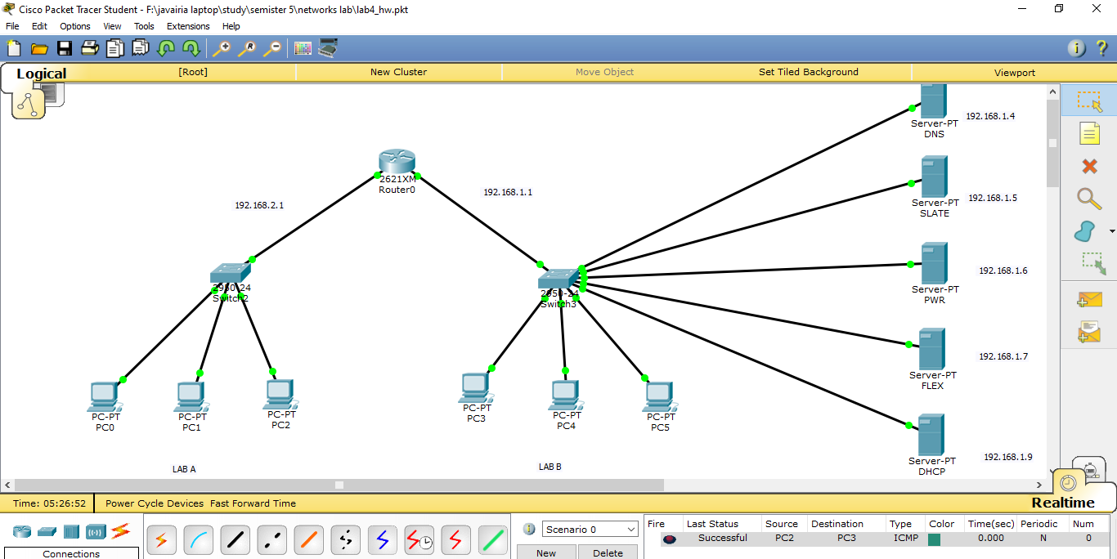

**Pwr page**

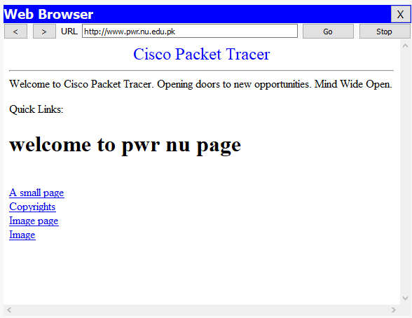

**Slate**

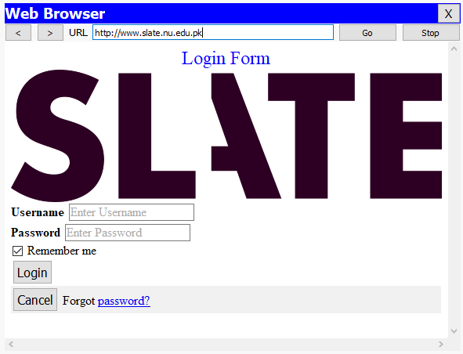

**Flex**

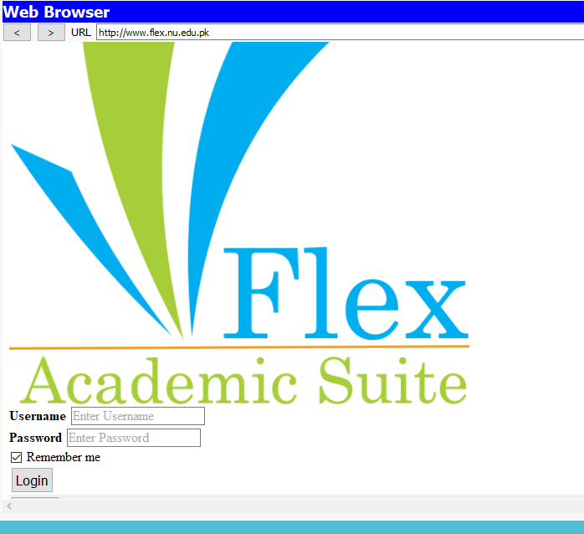

**Setting up router configuration in CLI**

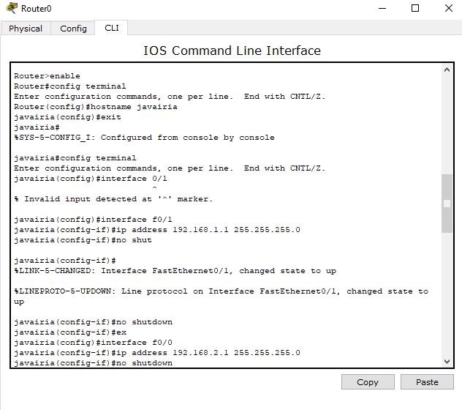

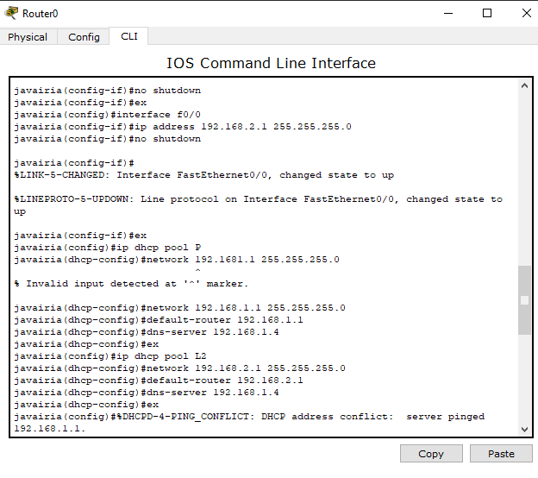

**Setup web server for each website**

**Slate**

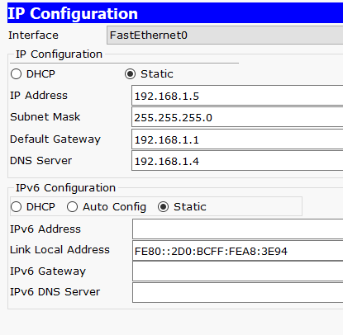

**Flex**

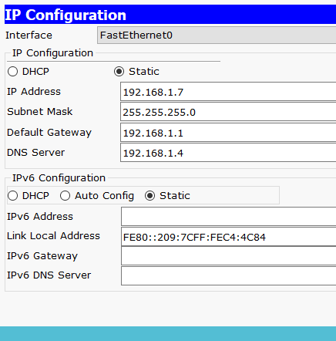

**Pwr**

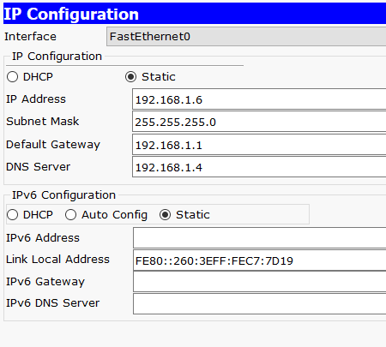

**Dns**

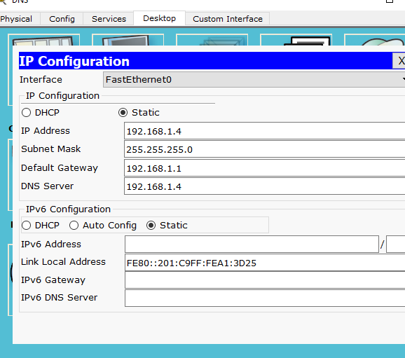

**Dns pools**

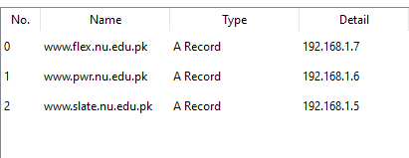

**Dhcp**

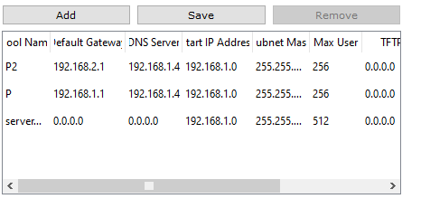

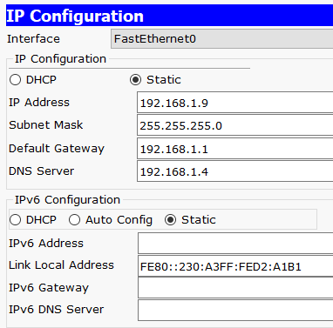

**Pc automatic values**

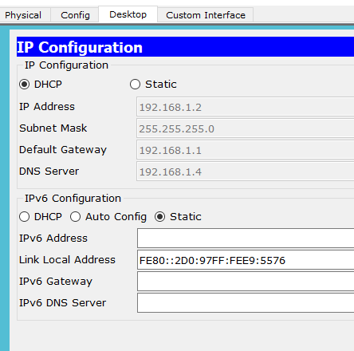

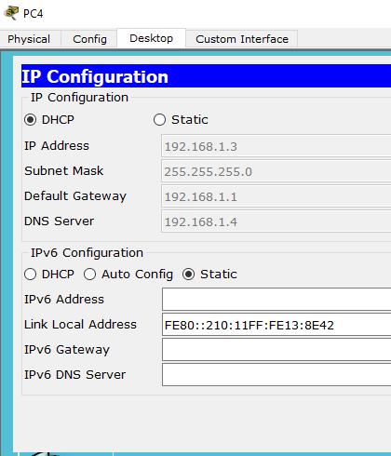

**observation**

Test it in Simulation mode and observe how PC, DNS and Webserver passing request.IP address when entered by a PC, it directly goes to the web server to fetch the website rather than going to the DNS server first. Since, there is no URL entered to be converted, the DNS server has no role to play in this process. b. URL of a website when entered by a PC, it goes to the DNS server first, which then looks for the Ip address of this URL and returns it to the PC which is then used to access the web server. Once we have gotten result from the DNS server, now when we try and access the same site again using the URL, it will directly go the web server without going to the DNS server first, since the connection with the DNS server has already been established and the Ip address of the website is stored in the cache.