**JAVAIRIA REHMAN**

**19P-0020**

**BS(CS) 19-5A**

**“computer network lab ”**

**Lab 12 subneting**

**Step 1 design topology**

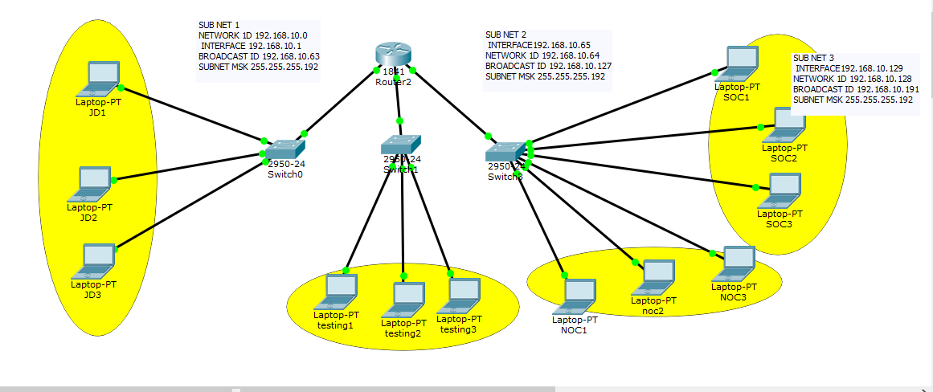

**Step 2**

**Do subnetting**

**On paper**

**Step 3 router configuration**

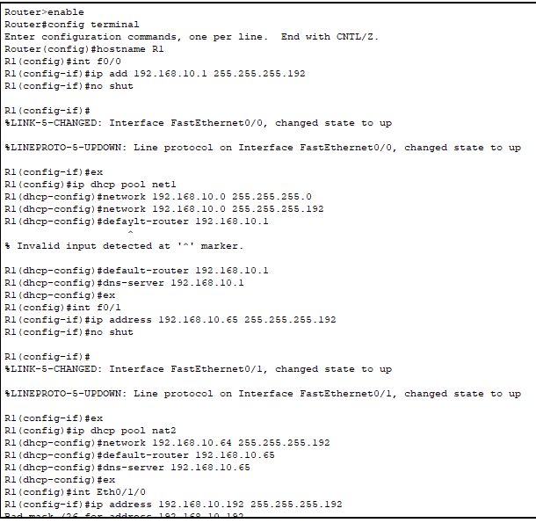

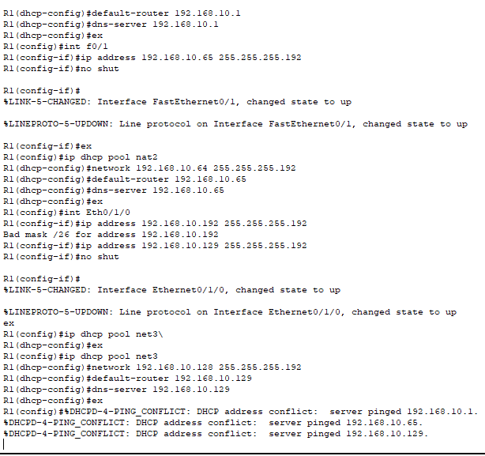

**Step 4 enable dhcp**

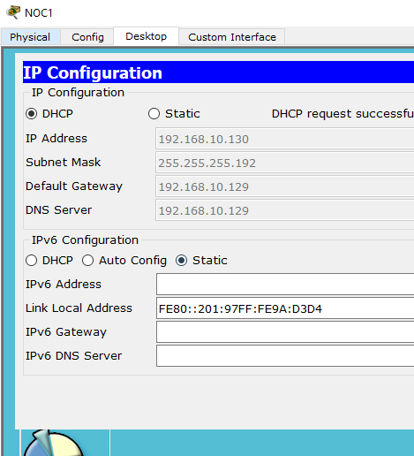

**Step 5 packet sending**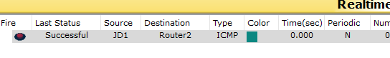

**Senerio 2**

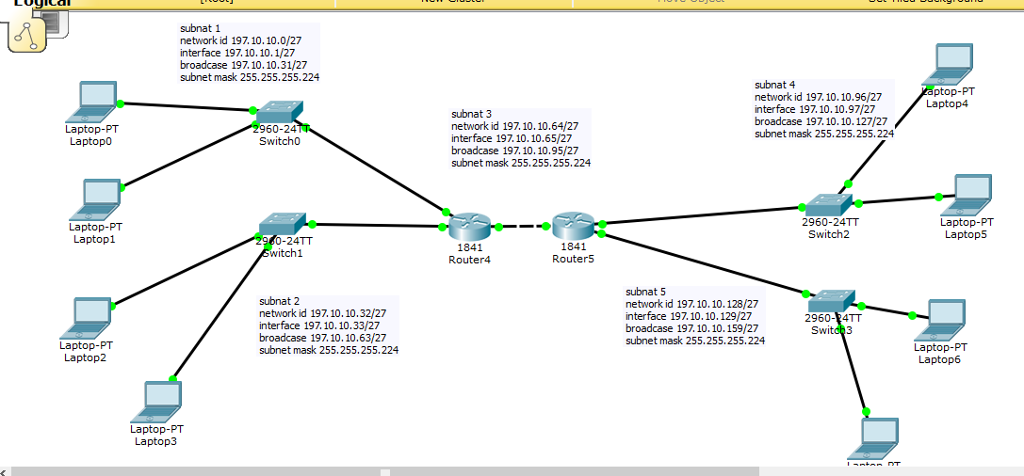

Router 1

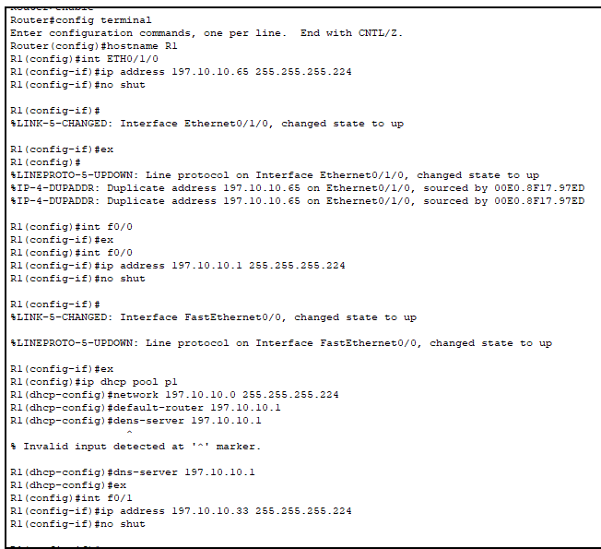

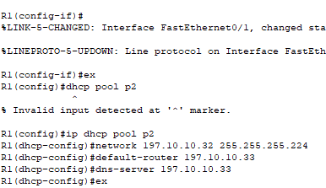

R2

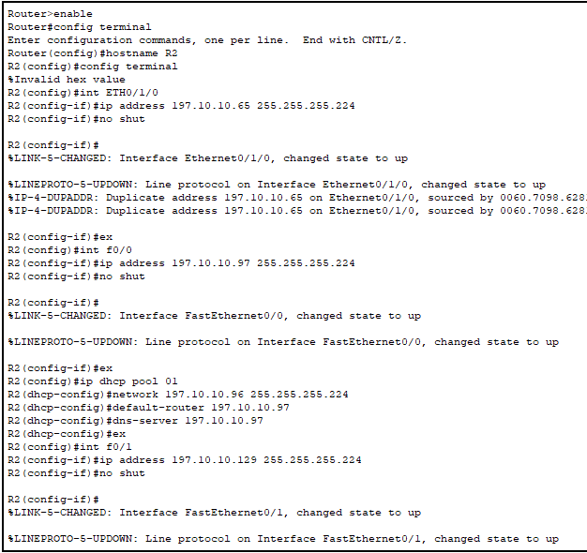

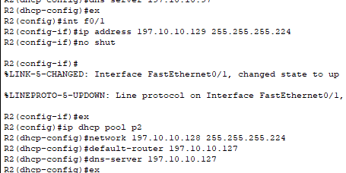

Route defining

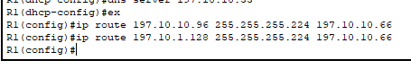



Packet sending

