**JAVAIRIA REHMAN**

**19P-0020**

**BS(CS) 19-5A**

**“computer networks ”**

**wireshark home work**

1. **Run nslookup to obtain the IP address of a Web server in Asia.What is the IP address of that server?**

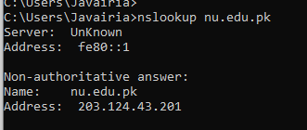

1. **Run nslookup to determine the authoritative DNS servers for a university in Europe.**

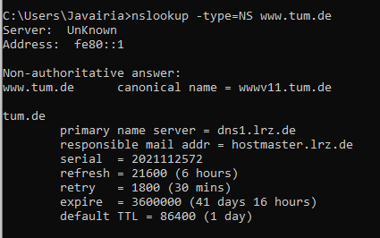

1. **Run nslookup so that one of the DNS servers obtained in Question2 is queried forthe mail servers for Yahoo! mail. What is its IP address?**

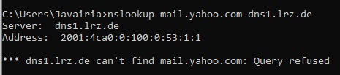

As query is refused.so ip address is 129.187.255.151

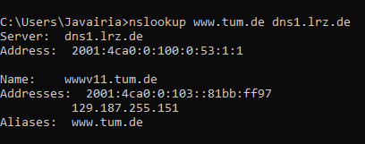

1. **Locate the DNS query and response messages. Are then sent over UDP or TCP?**

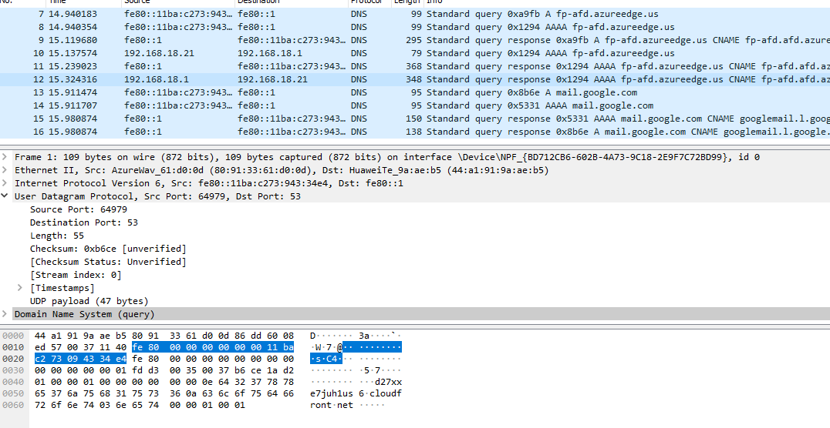

**UDP**

1. **What is the destination port for the DNS query message? What is the source port of DNS response message?**

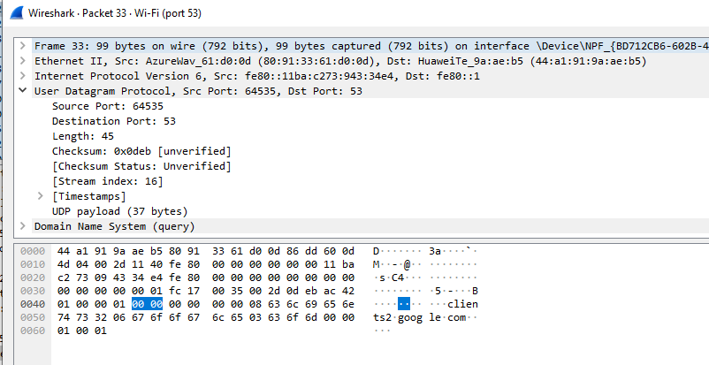

**Fig a**

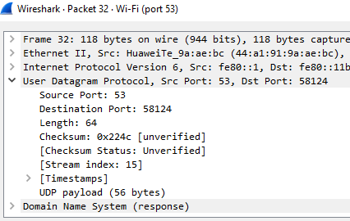

**Fig b**

Source of fig b and destination on fig a are same

**6. To what IP address is the DNS query message sent? Use ipconfig to determine the**

**IP address of your local DNS server. Are these two IP addresses the same?**

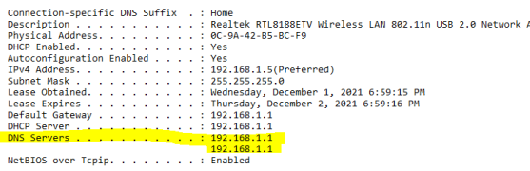

**yes**

**7. Examine the DNS query message. What “Type” of DNS query is it? Does the**

**query message contain any “answers”?** 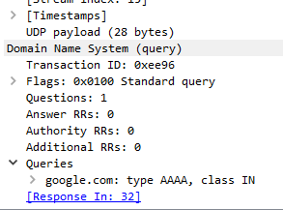

type AAAA with class IN

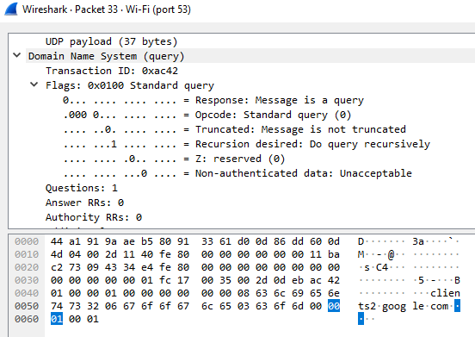

**8. Examine the DNS response message. How many “answers” are provided? What**

**do each of these answers contain?**

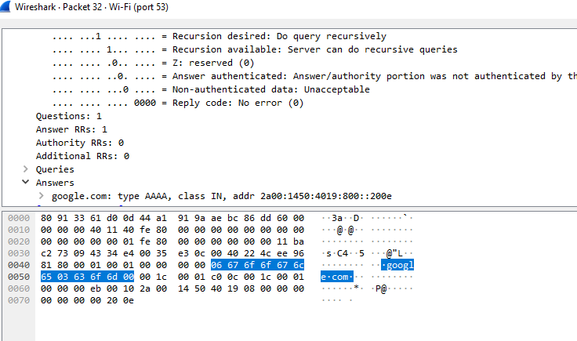

**9. Consider the subsequent TCP SYN packet sent by your host. Does the destination**

**IP address of the SYN packet correspond to any of the IP addresses provided in**

**the DNS response message?**

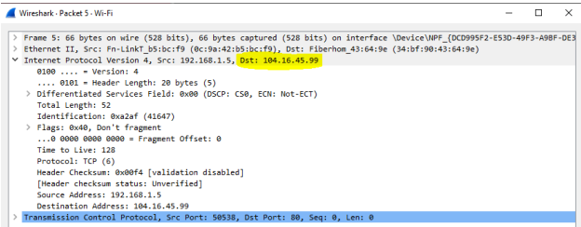

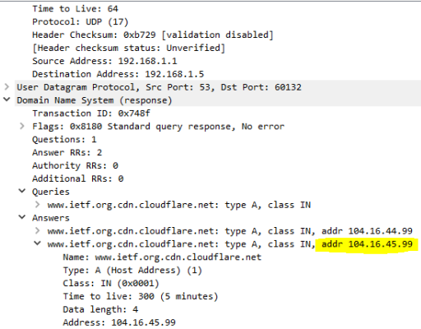

**yes**

**10. This web page contains images. Before retrieving each image, does your host**

**issue new DNS queries?**

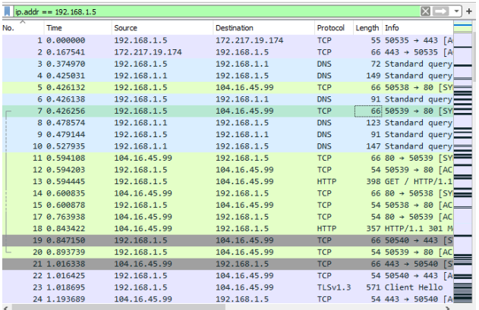

**no**

**11. What is the destination port for the DNS query message? What is the source port**

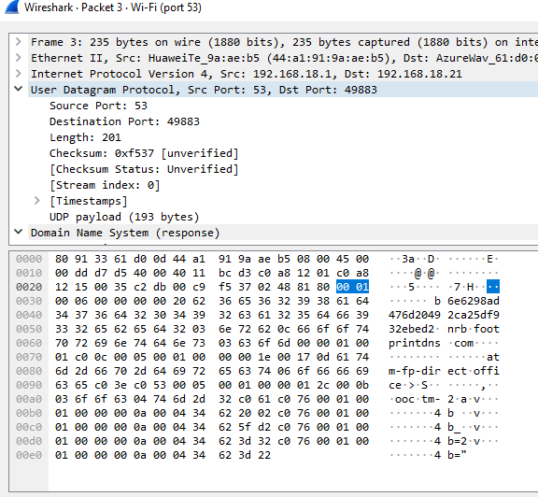

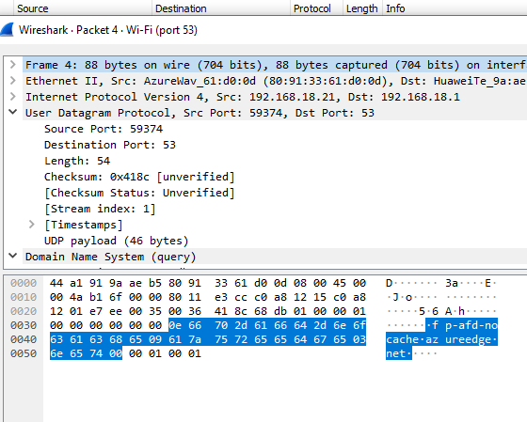

Souce of packet 3 is equal to destination of packet 4

**12. To what IP address is the DNS query message sent? Is this the IP address of your**

**default local DNS server?**

**Yes**

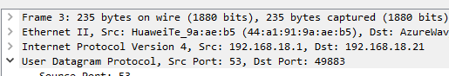

**13. Examine the DNS query message. What “Type” of DNS query is it? Does the**

**query message contain any “answers”?**

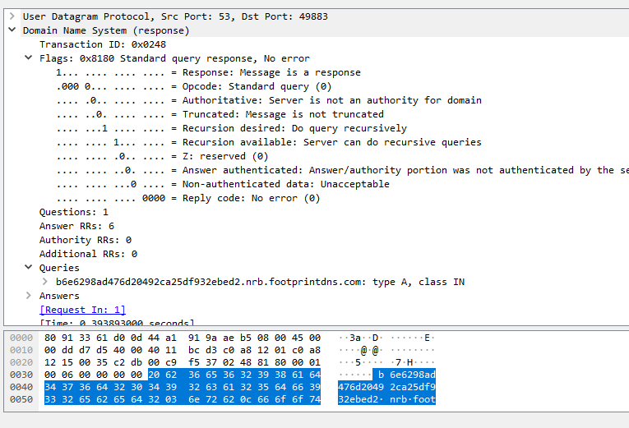

**14. Examine the DNS response message. How many “answers” are provided? What**

**do each of these answers contain?**

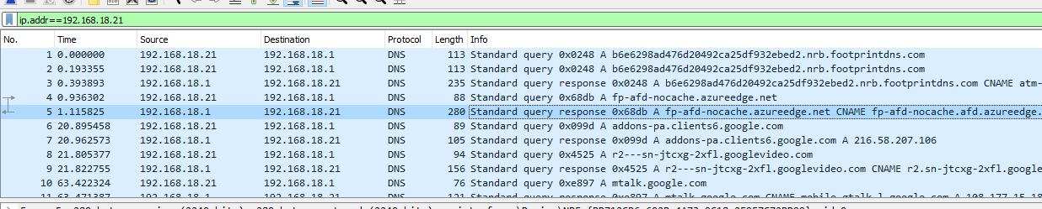

No of responses equal to no of answers here both are 5

**16. To what IP address is the DNS query message sent? Is this the IP address of your**

**default local DNS server?** 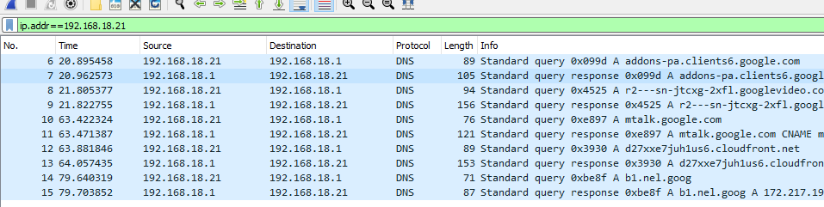

**17. Examine the DNS query message. What “Type” of DNS query is it? Does the**

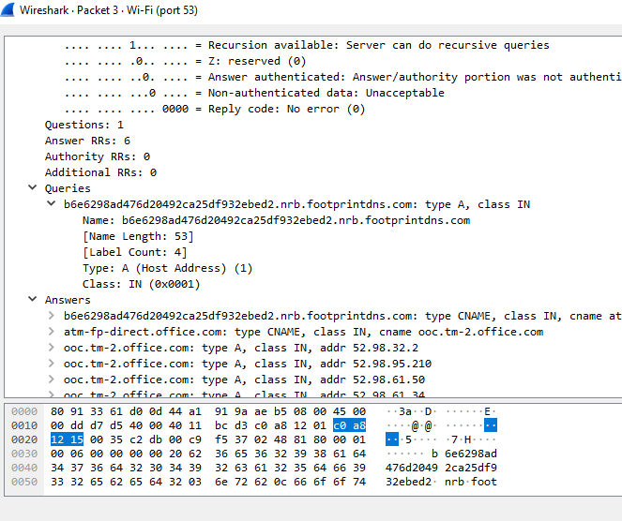

**18. Examine the DNS response message. What MIT nameservers does the response**

**message provide? Does this response message also provide the IP addresses of the**

**MIT namesers?**

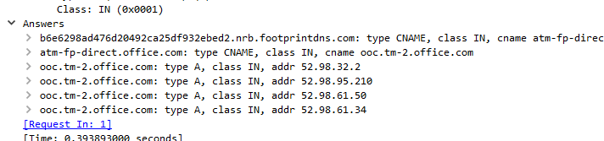

**20. To what IP address is the DNS query message sent? Is this the IP address of your**

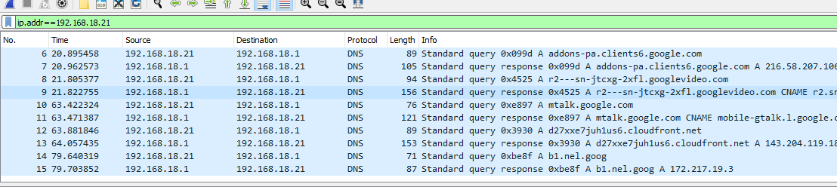

**default local DNS server? If not, what does the IP address correspond to?**

**21. Examine the DNS query message. What “Type” of DNS query is it? Does the**

**query message contain any “answers”?**

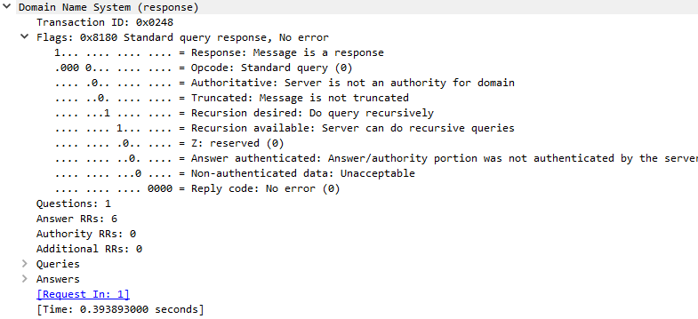

**22. Examine the DNS response message. How many “answers” are provided? What**

**does each of these answers contain?**

