**GROUP MEMBERS**

**JAVAIRIA REHMAN 19P-0020**

**MINA RIAZ 19P-0099**

**FARKHANDA SALEEM 19P-0004**

**SYED M.HUZAIFA SHAH 19P-0021**

**USAMA YOUSAF 20P-0646**

**OISHII Ordering System**

In today's age of last food and take-out, many restaurants have chosen to focus on quick preparation and speedy delivery of orders rather than offering a rich dining experience. Until very recently, all of these delivery orders were placed over the phone, but there are many disadvantages to this system. First, the customer must have a physical copy of the restaurant's menu to look at while placing the inorder and this menu must be up to date. While this expectation is not unreasonable, it is certainly inconvenient. Second, the orders are placed using strictly oral communication, which makes it far more difficult for the customer to receive immediate feedback on the order they have placed. This often leads to confusion and incorrect orders. The current system is also inconvenient for the restaurant itself, as they must either have a dedicated staff member to answer the phone and take orders, or some employees must perform double-duty, distracting them from their regular tasks.

What we propose is an online ordering system.The main advantage of my system is that it greatly simplifies the ordering process for both the customer and the restaurant. When the customer visits the ordering webpage, they are presented with an interactive and up-to-date menu, complete with all available options and dynamically adjusting prices based on the selected options. After making a selection, the item is then added to their order, which the customer can review the details of at any time before checking out. This provides instant visual confirmation of what was selected and ensures that items in the order are ,infact ,what was intended

The structure of the system can be divided into three main logical components. The first component must provide some form of menu management, allowing the restaurant to control what can be ordered by customers. The second component is the web ordering system and provides the functionality for customers to place their order and supply all necessary details. The third and final logical component is the order retrieval system. Used by the restaurant to keep track of all orders which have been placed, this component takes care of retrieving and displaying order information, as well as updating orders which have already been processed.

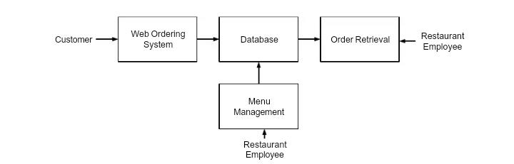

**FUNCTIONALITY**

Users of the web ordering system, namely restaurant customers, must be provided the

following functionality:

1. Create an account.
2. Manage their account.
3. Log in to the system.
4. Navigate the restaurant's menu.
5. Select an item from the menu.
6. Customize options tor a selected item.
7. Add an item to their current order.
8. Review their current order.
9. Remove an item/remove all items from their current order.
10. Provide delivery and payment details.
11. Place an order.
12. Receive confirmation in the form of an order number.

As the goal of the system is to make the process of placing an order as simple as possible

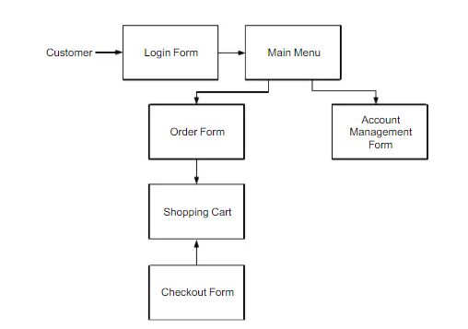

**REFERENCES**

https://www.academia.edu/33253493/An_Online_Food_Ordering_System_System_Documentation