 | NATIONAL UNIVERSITY  OF COMPUTER & EMERGING SCIENCES  PESHAWAR CAMPUS | 

Student Name: Javairia Rehman Roll No: 19P-0020 Sec:3A

Problem Set : Implement 01 Semester: FALL 2021
Date Set : Monday December 20, 2021 Due Date : Friday Dec.24, 2021
Course : CS301 Theory of Automata Instructor: Shakir

language {a^nb^2nc^3n | n>=1}

Descriptive Definition:
Any number of a’s greater then or equal to 1 follwed by b which is 2 times number of a’s and c which is 3 times number of a’

Words:
{abbccc, aabbbbcccccc, aaabbbbbbccccccccc, aaaabbbbbbbbcccccccccccc, aaaaabbbbbbbbbbccccccccccccccc, aaaaaabbbbbbbbbbbbccccccccccccccc, aaaaaaabbbbbbbbbbbbbbccccccccccccccccccccc, aaaaaaaabbbbbbbbbbbbbbbccccccccccccccccccccccc, aaaaaaaaabbbbbbbbbbbbbbbbbcccccccccccccccccccccccccc, aaaaaaaaaabbbbbbbbbbbbbbbbbbbbcccccccccccccccccccccccccccccc,...}

Turning machine
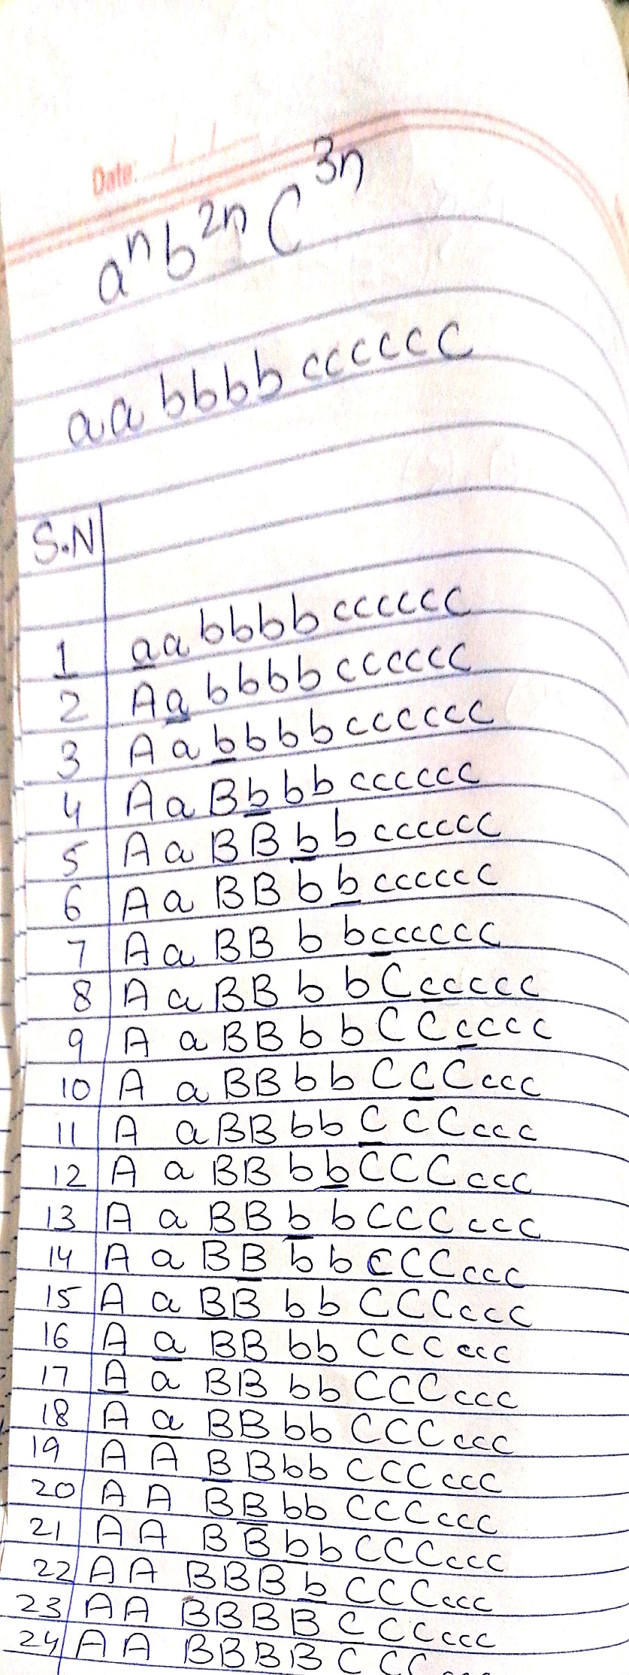
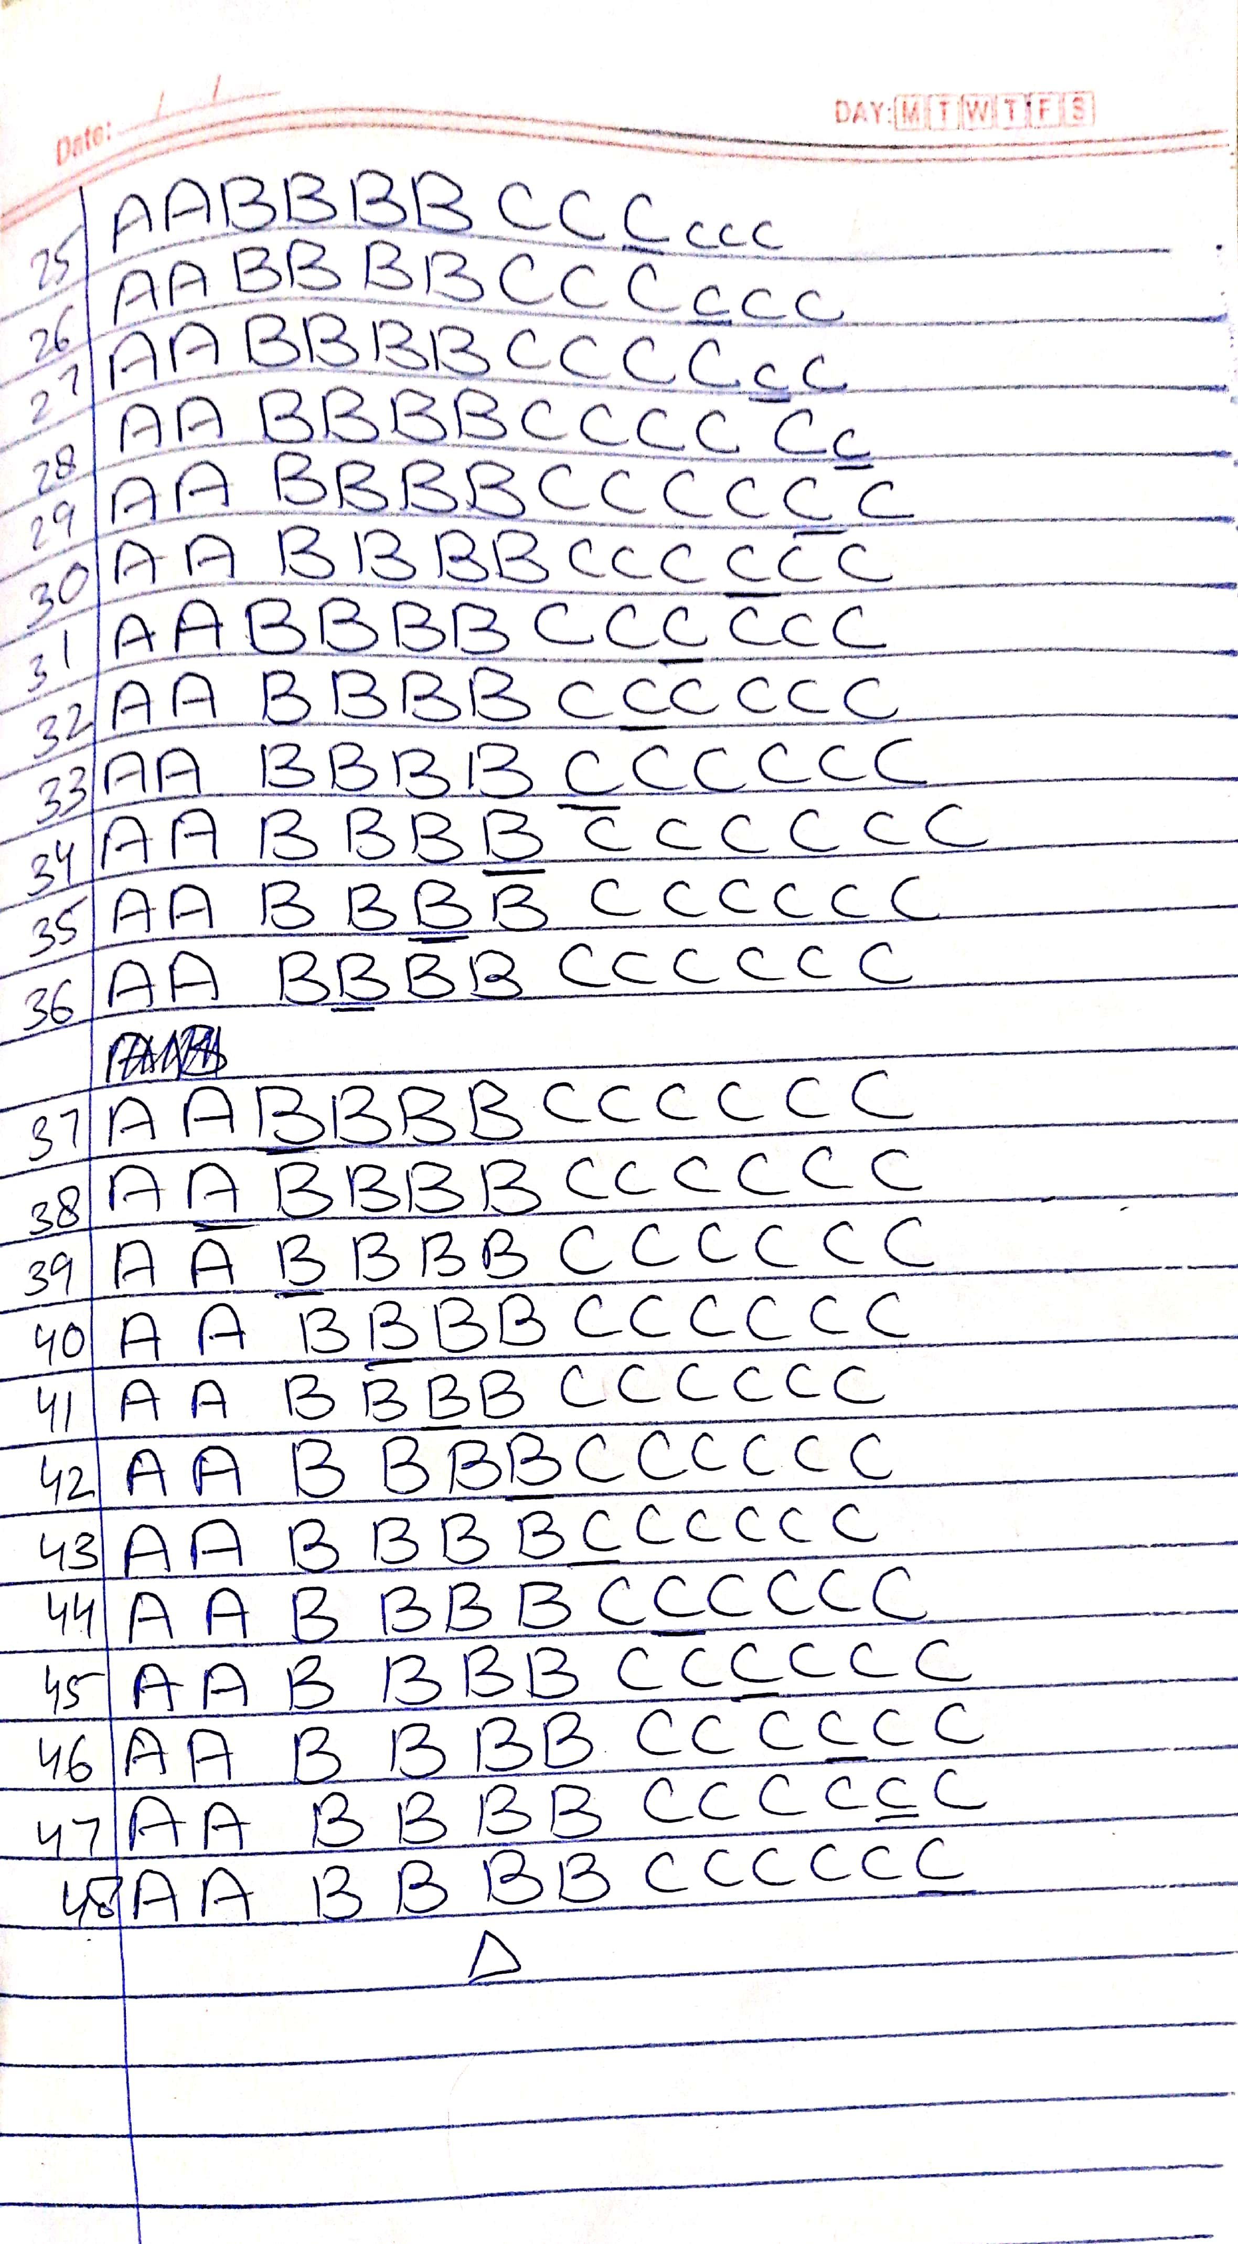
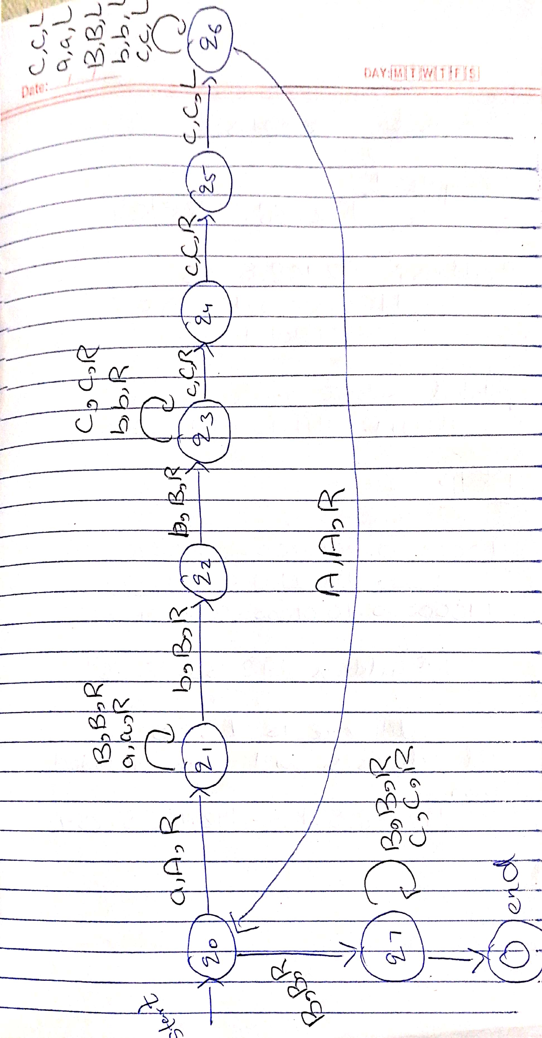
Code
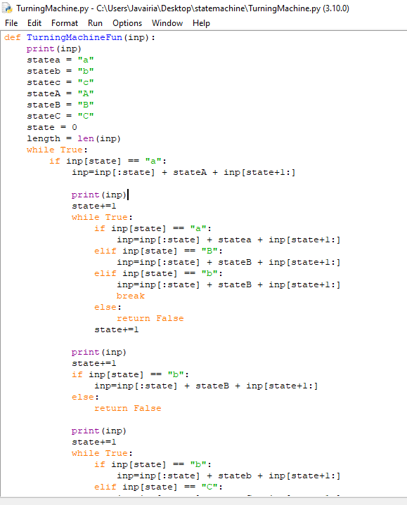
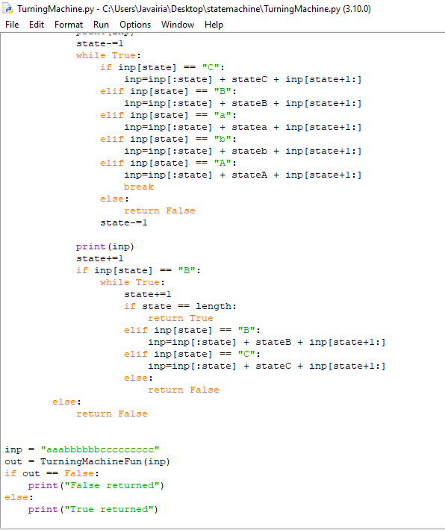

Output
