 | NATIONAL UNIVERSITY  OF COMPUTER & EMERGING SCIENCES  PESHAWAR CAMPUS | 

Student Name: Javairia Rehman Roll No: 19P-0020 Sec:5A

Problem Set : Implement 02 Semester: FALL 2021
Course : CS301 Theory of Automata Instructor: Shakir

WEB SCRAPPING PROJECT
WEATHER DATA EXTRACTION USING PYTHON

AIM:
To extract data from weather forcast website by using beautiful soap,and find all desire values you want from that extraction usinf find() function.
Code
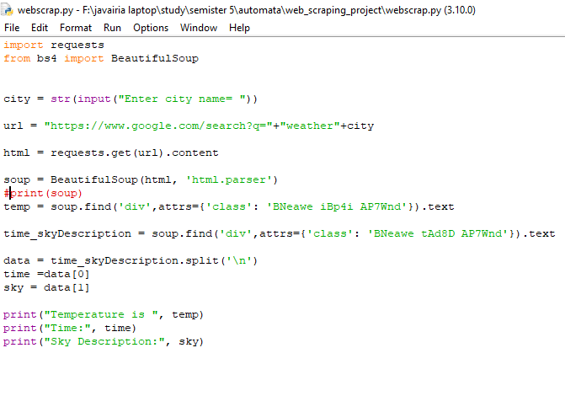
full Extracted data
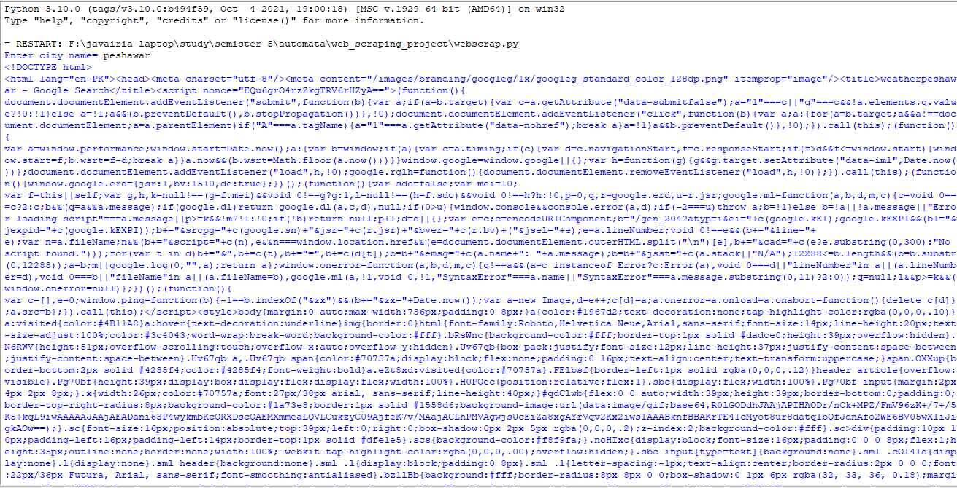
Extract wanted data by using find() function
