Technologies used:

1. Java 8

2. Struts 2

3. HTML 5

4 CSS3

5. Apache tomcat 8.0

6. Eclipse Neon(Version: Neon.3 Release (4.6.3))

7. Java Script

8. jQuery1.12.0

9. Datatable

Step 1:Import war file into Eclipse Neon and add tomcat 8.0 server

2. Run Code on Server

3. Login With user id "sam" and password "sam@123"

Screen:

1.

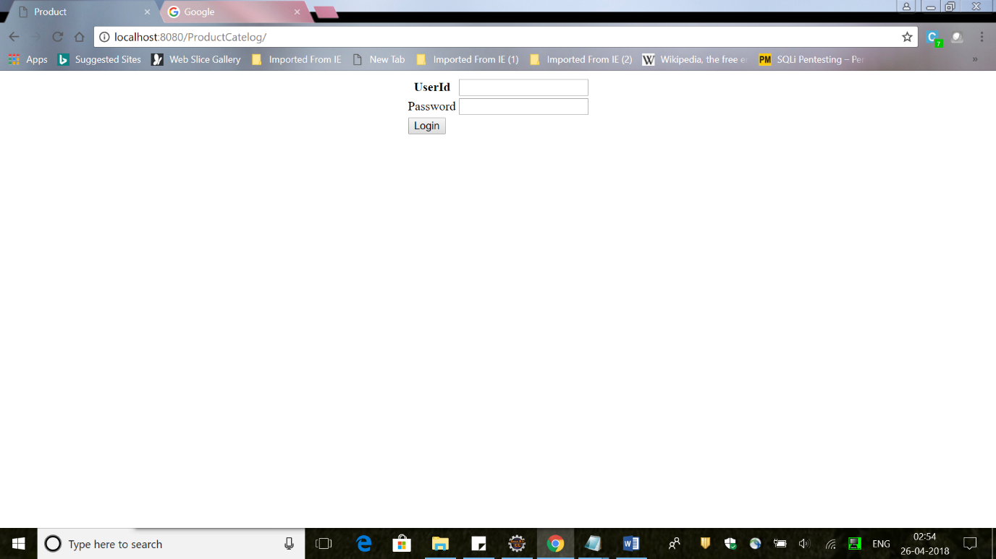

2.

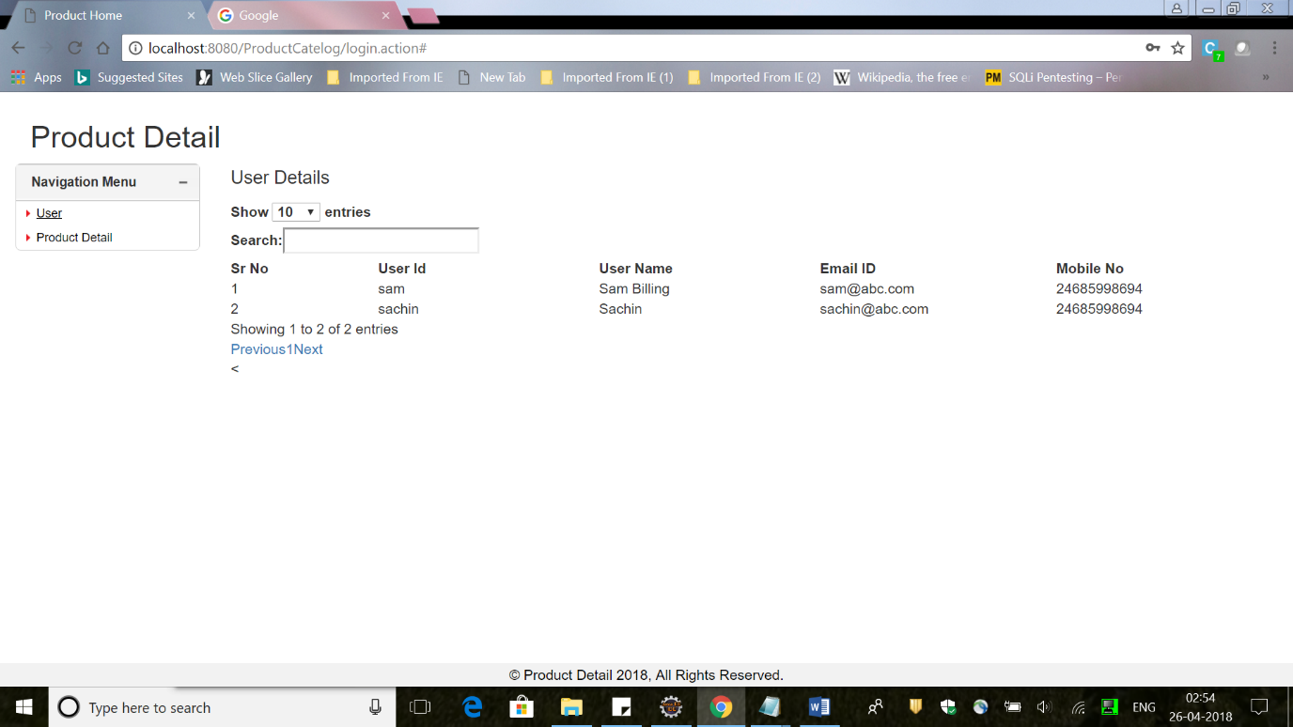

3.

