1. Write a shell script whose single command line argument is a file. If you run the program with an ordinary file, the program displays the owner’s name and last update time for the file. If the program is run with more than one argument, it generates meaningful error messages.

ANS:
#!/bin/bash

# Check the number of arguments
if [ "$#" -ne 1 ]; then
echo "Error: Please provide exactly one file as an argument."
exit 1
fi

filename=$1

# Check if the specified file exists
if [ ! -e "$filename" ]; then
echo "Error: File '$filename' does not exist."
exit 1
fi

# Display owner's name and last update time
owner=$(stat -c "%U" "$filename")
last_update_time=$(stat -c "%y" "$filename")

echo "File: $filename"
echo "Owner: $owner"
echo "Last Update Time: $last_update_time"
Save this script, for example, as file_info.sh, and make it executable:
chmod +x file_info.sh
You can then run it with a file name as an argument:
./file_info.sh yourfile.txt
2

Write a shell script that accepts two directory names bar1 and bar2, and delete those files in bar2 whose contents are identical to their namesakes in bar1.
Ans:
#!/bin/bash

# Check if the number of arguments is exactly 2
if [ "$#" -ne 2 ]; then
echo "Error: Please provide exactly two directory names (bar1 and bar2)."
exit 1
fi

# Check if the provided arguments are directories
if [ ! -d "$1" ] || [ ! -d "$2" ]; then
echo "Error: Both arguments must be directories."
exit 1
fi

# Loop through files in bar2 and delete those with identical content in bar1
for file2 in "$2"/*; do
file1="$1/$(basename "$file2")"

# Check if the file in bar2 has a corresponding file in bar1
if [ -e "$file1" ]; then
# Check if the contents of the two files are identical
if cmp -s "$file1" "$file2"; then
echo "Deleting file: $file2"
rm "$file2"
fi
fi
done

echo "Files with identical content in bar1 and bar2 have been deleted."
Save this script, for example, as delete_identical_files.sh, and make it executable using the following command:
chmod +x delete_identical_files.sh
You can then run it with the directory names as arguments:
./delete_identical_files.sh bar1 bar2
This script compares files in bar2 with their namesakes in bar1 and deletes those with identical content. Please be cautious when using scripts that delete files, and make sure you have appropriate backups or confirm the behavior in a safe environment.

3

Write a script that reads a "password" from a user (it will not show when typed, but will get displayed after the carriage return is entered).

Ans :
#!/bin/bash

# Prompt the user for a password
read -sp "Enter your password: " password
echo # Move to a new line after user presses Enter

# Display the entered password

echo "You entered: $password"
Save this script, for example, as read_password.sh, and make it executable using the following command:
chmod +x read_password.sh
You can then run it:
./read_password.sh

4

Write a shell script called whichdaemon.sh that checks if the httpd and init daemons are running on your system. If an httpd is running, the script should print a message like, "This machine is running a web server."

Ans:
#!/bin/bash

# Check if httpd daemon is running
if pgrep -x "httpd" > /dev/null; then
echo "This machine is running a web server."
else
echo "No web server (httpd) is running on this machine."
fi

# Check if init daemon is running
if pgrep -x "init" > /dev/null; then
echo "init daemon is running on this machine."
else
echo "No init daemon is running on this machine."
Fi
Save this script and make it executable:
chmod +x whichdaemon.sh
You can then run it
./whichdaemon.sh

5

Write a script that simulates the ls –l command but prints only three columns of your choice
#!/bin/bash

# Check if a directory is provided, otherwise use the current directory
directory="${1:-.}"

# Simulate ls -l with three columns (file/directory name, size, and permissions)
echo "File/Directory | Size | Permissions"
echo "----------------------------------"
for item in "$directory"/*; do
# Extract file/directory name, size, and permissions
name=$(basename "$item")
size=$(du -h "$item" | awk '{print $1}')
permissions=$(ls -l "$item" | awk '{print $1}')

# Print the three chosen columns
echo "$name | $size | $permissions"
done
Save this script, for example, as custom_ls.sh, and make it executable:
chmod +x custom_ls.sh
You can then run it without arguments to list the current directory:
./custom_ls.sh

6

Write a shell script that, given a filename as the argument, deletes all even lines (lines 2,4,6…n) in the file.

Ans :
#!/bin/bash

# Check if a filename is provided as an argument
if [ "$#" -ne 1 ]; then
echo "Error: Please provide a filename as an argument."
exit 1
fi

filename=$1

# Check if the file exists
if [ ! -e "$filename" ]; then
echo "Error: File '$filename' does not exist."
exit 1
fi

# Use sed to delete even lines
sed -i.bak -n 'p;n' "$filename"

echo "Even lines have been deleted from '$filename'. Backup created: '$filename.bak'"

Save this script, for example, as delete_even_lines.sh, and make it executable:
chmod +x delete_even_lines.sh
You can then run it with the filename as an argument:
./delete_even_lines.sh yourfile.txt

7

Write a shell script that, given a filename as the argument, combines odd and even lines together. In other words, lines 1 and 2 become line 1, lines 3 and 4 become line 2 and so on.
Ans :
#!/bin/bash

# Check if a filename is provided as an argument
if [ "$#" -ne 1 ]; then
echo "Error: Please provide a filename as an argument."
exit 1
fi

filename=$1

# Check if the file exists
if [ ! -e "$filename" ]; then
echo "Error: File '$filename' does not exist."
exit 1
fi

# Use awk to combine odd and even lines
awk 'BEGIN { getline; odd=$0 } { getline; print odd " " $0; }' "$filename" > "$filename.new"

echo "Odd and even lines have been combined and written to '$filename.new'."
Save this script, for example, as combine_lines.sh, and make it executable:
chmod +x combine_lines.sh
You can then run it with the filename as an argument
./combine_lines.sh yourfile.txt

8

Write a shell script named count, which takes a file name as its parameter and prints number of blank lines in it. Also display the lines containing ‘is’ as a whole word in it (or the only word).
Ans :
#!/bin/bash

# Check if a filename is provided as an argument
if [ "$#" -ne 1 ]; then
echo "Error: Please provide a filename as an argument."
exit 1
fi

filename=$1

# Check if the file exists
if [ ! -e "$filename" ]; then
echo "Error: File '$filename' does not exist."
exit 1
fi

# Count blank lines
blank_lines=$(grep -c '^$' "$filename")

# Display the number of blank lines
echo "Number of blank lines in '$filename': $blank_lines"

# Display lines containing 'is' as a whole word
echo "Lines containing 'is' as a whole word in '$filename':"
grep -w 'is' "$filename"
Save this script and make it executable:
chmod +x count
You can then run it with the filename as an argument:
./count yourfile.txt

9

Write a shell script that takes a variable number of directory names as arguments. If no arguments are entered the script should abort with an appropriate error message.
For each directory in the given list, the script should display the filename and the size of the directory (including hidden files) in the following format:
<Directory Name>: - bytes occupied
Ans :
#!/bin/bash

# Check if at least one directory name is provided
if [ "$#" -eq 0 ]; then
echo "Error: Please provide at least one directory name as an argument."
exit 1
fi

# Loop through each provided directory
for dir in "$@"; do
# Check if the directory exists
if [ ! -d "$dir" ]; then
echo "Error: Directory '$dir' does not exist."
else
# Calculate the size of the directory (including hidden files)
size=$(du -sh "$dir" | awk '{print $1}')

# Display the filename and size
echo "$dir: $size bytes occupied"
fi
done
Save this script, for example, as directory_size.sh, and make it executable
chmod +x directory_size.sh
You can then run it with one or more directory names as arguments:
./directory_size.sh /path/to/dir1 /path/to/dir2

10

Write a script that takes exactly one argument, a directory name. If the number of arguments is more or less than one, print a usage message. If the argument is not a directory, print another message. For the given directory, print the five biggest files and the five files that were most recently modified.

Ans:
#!/bin/bash

# Check the number of arguments
if [ "$#" -ne 1 ]; then
echo "Usage: $0 <directory>"
exit 1
fi

directory="$1"

# Check if the argument is a directory
if [ ! -d "$directory" ]; then
echo "Error: '$directory' is not a directory."
exit 1
fi

# Print the five biggest files
echo "Five biggest files in '$directory':"
find "$directory" -type f -exec du -h --block-size=1M {} + | sort -rh | head -n 5

# Print the five most recently modified files
echo "Five most recently modified files in '$directory':"
find "$directory" -type f -exec stat --format="%Y %n" {} + | sort -nr | head -n 5
Save this script, for example, as directory_info.sh, and make it executable
chmod +x directory_info.sh
You can then run it with a directory name as an argument:
./directory_info.sh /path/to/directory

11

Write a script that does the following: Display the name of the script being executed.
Display the first, third and tenth argument given to the script.
Display the total number of arguments passed to the script.
If there were more than three positional parameters, use shift to move all the values 3 places to the left.
Print all the values of the remaining arguments.
Print the number of arguments.

Test with zero, one, three and over ten arguments.

Ans :
#!/bin/bash

# (a) Display the name of the script being executed.
echo "Script name: $0"

# (b) Display the first, third, and tenth argument given to the script.
echo "First argument: $1"
echo "Third argument: $3"
echo "Tenth argument: ${10}"

# (c) Display the total number of arguments passed to the script.
echo "Total number of arguments: $#"

# (d) If there were more than three positional parameters, use shift to move all the values 3 places to the left.
if [ "$#" -gt 3 ]; then
echo "Shifting arguments three places to the left..."
shift 3
fi

# (e) Print all the values of the remaining arguments.
echo "Remaining arguments:"
for arg in "$@"; do
echo "$arg"
done

# (f) Print the number of arguments.
echo "Number of arguments after possible shift: $#"\
Save this script, for example, as argument_script.sh, and make it executable:
chmod +x argument_script.sh
You can then test it with different numbers of arguments:
# Test with zero arguments
./argument_script.sh

# Test with one argument
./argument_script.sh arg1

# Test with three arguments
./argument_script.sh arg1 arg2 arg3

# Test with over ten arguments
./argument_script.sh arg1 arg2 arg3 arg4 arg5 arg6 arg7 arg8 arg9 arg10 arg11 arg12

12

Write a shell script that locates all the hard links of the argument file from the home directory. The filename provided as argument must exist in the current directory.

Ans ;
#!/bin/bash

# Check if a filename is provided as an argument
if [ "$#" -ne 1 ]; then
echo "Usage: $0 <filename>"
exit 1
fi

filename=$1

# Check if the specified file exists in the current directory
if [ ! -e "$filename" ]; then
echo "Error: File '$filename' does not exist in the current directory."
exit 1
fi

# Find hard links of the file in the home directory
echo "Hard links of '$filename' in the home directory:"
find "$HOME" -samefile "./$filename" -type f
Save this script, for example, as find_hard_links.sh, and make it executable:
chmod +x find_hard_links.sh
You can then run it with the filename as an argument:
./find_hard_links.sh yourfile.txt

13

Write a shell script that takes an ordinary file as an argument and removes the file if its size is zero. Otherwise, the script displays file’s name, size, number of hard links, owner, and modify date. Your script must do appropriate error checking.

Ans :
#!/bin/bash

# Check if a filename is provided as an argument
if [ "$#" -ne 1 ]; then
echo "Usage: $0 <filename>"
exit 1
fi

filename=$1

# Check if the specified file exists
if [ ! -e "$filename" ]; then
echo "Error: File '$filename' does not exist."
exit 1
fi

# Check if the specified path is a regular file
if [ ! -f "$filename" ]; then
echo "Error: '$filename' is not a regular file."
exit 1
fi

# Check if the file size is zero
if [ -s "$filename" ]; then
# Display information about the file
echo "File Name: $filename"
echo "Size: $(du -h "$filename" | awk '{print $1}')"
echo "Number of Hard Links: $(stat -c "%h" "$filename")"
echo "Owner: $(stat -c "%U" "$filename")"
echo "Modify Date: $(stat -c "%y" "$filename")"
else
# Remove the file if its size is zero
echo "Removing '$filename' as its size is zero."
rm "$filename"
fi
Save this script, for example, as file_info_and_remove.sh, and make it executable:
chmod +x file_info_and_remove.sh
You can then run it with the filename as an argument:
./file_info_and_remove.sh yourfile.txt

14

Write a script that would recognize if a word entered from the keyboard started with an upper or lower case character or a digit. The script would then output the word, followed by "upper case", "lower case", "digit", or "not upper, lower, or digit".
Ans
#!/bin/bash

# Prompt the user to enter a word
read -p "Enter a word: " word

# Check the first character of the word
first_char=$(echo "$word" | cut -c1)

# Check if the first character is an upper case letter
if [[ $first_char =~ [A-Z] ]]; then
echo "$word: upper case"
# Check if the first character is a lower case letter
elif [[ $first_char =~ [a-z] ]]; then
echo "$word: lower case"
# Check if the first character is a digit
elif [[ $first_char =~ [0-9] ]]; then
echo "$word: digit"
else
echo "$word: not upper, lower, or digit"
fi
Save this script, for example, as check_word_case.sh, and make it executable:
chmod +x check_word_case.sh
You can then run it and enter a word when prompted:
./check_word_case.sh
15

You are making a batch of beer. The beer has to stand in a warm place for 7 days and after that it has to stand in a cooler place for 2 weeks. You have a tendency to loose track of such mundane things so you want to write a small script that sends you a letter after 7 days telling you to move the beer and another letter 2 weeks after that that tells you that the beer is finished.
Ans :

You are making a batch of beer. The beer has to stand in a warm place for 7 days and after that it has to stand in a cooler place for 2 weeks. You have a tendency to loose track of such mundane things so you want to write a small script that sends you a letter after 7 days telling you to move the beer and another letter 2 weeks after that that tells you that the beer is finished.

Make sure to replace "your@email.com" with your actual email address. Also, note that this script uses the ssmtp command to send emails, so you'll need to have a working mail setup on your system or replace it with another command that suits your mail configuration.
Save this script, for example, as beer_notification.sh, and make it executable:

chmod +x beer_notification.sh

16

Write a shell script to convert file names from UPPERCASE to lowercase file names or vice versa.
Ans :
#!/bin/bash

# Check if a directory name is provided as an argument
if [ "$#" -ne 1 ]; then
echo "Usage: $0 <directory>"
exit 1
fi

directory="$1"

# Check if the specified directory exists
if [ ! -d "$directory" ]; then
echo "Error: Directory '$directory' does not exist."
exit 1
fi

# Convert file names from uppercase to lowercase or vice versa
for file in "$directory"/*; do
# Extract the directory and the filename
dir=$(dirname "$file")
filename=$(basename "$file")

# Convert the filename to uppercase or lowercase
new_filename=$(echo "$filename" | tr '[:upper:]' '[:lower:]') # To convert to lowercase
# OR
# new_filename=$(echo "$filename" | tr '[:lower:]' '[:upper:]') # To convert to uppercase

# Rename the file if the new filename is different
if [ "$filename" != "$new_filename" ]; then
mv "$file" "$dir/$new_filename"
echo "Renamed: $filename -> $new_filename"
fi
done

echo "Conversion complete."
Save this script, for example, as convert_case.sh, and make it executable:
chmod +x convert_case.sh
You can then run it with a directory name as an argument:
./convert_case.sh /path/to/directory

17

Write script to determine whether given command line argument ($1) contains "*" symbol or not, if $1 does not contains "*" symbol add it to $1, otherwise show message "Symbol is not required".
Ans :
#!/bin/bash

# Check if a command line argument is provided
if [ "$#" -ne 1 ]; then
echo "Usage: $0 <argument>"
exit 1
fi

# Check if the argument contains the "*" symbol
if [[ "$1" == *"*"* ]]; then
echo "Symbol is not required."
else
argument_with_asterisk="$1*"
echo "Modified argument: $argument_with_asterisk"
fi
Save this script, for example, as check_asterisk.sh, and make it executable:
chmod +x check_asterisk.sh
You can then run it with a command line argument:
./check_asterisk.sh your_argument

18

Write a script to calculate factorial of a given number.
(b) Write a script that will print message “Hello World” in bold and blink effect, and in different colors like red, brown etc.
Ans :
(a) Factorial Calculation:

#!/bin/bash

# Check if a number is provided as an argument
if [ "$#" -ne 1 ]; then
echo "Usage: $0 <number>"
exit 1
fi

number=$1
factorial=1

# Calculate factorial
for ((i = 1; i <= number; i++)); do
factorial=$((factorial * i))
done

echo "Factorial of $number is: $factorial"
Save this script, for example, as calculate_factorial.sh, and make it executable:
chmod +x calculate_factorial.sh
You can then run it with a number as an argument:
./calculate_factorial.sh 5

(b) Hello World in Bold and Blink with Different Colors:
#!/bin/bash

# ANSI escape codes for formatting
bold=$(tput bold)
blink=$(tput blink)
reset=$(tput sgr0)

# Colors
red=$(tput setaf 1)
brown=$(tput setaf 3)

echo "${bold}${blink}${red}Hello World in Bold, Blink, and Red${reset}"
echo "${bold}${brown}Hello World in Bold and Brown${reset}"
Save this script, for example, as hello_world_format.sh, and make it executable:
chmod +x hello_world_format.sh
You can then run it:
./hello_world_format.sh

19

Write script to implement background process that will continually print current time (digital clock) in upper right corner of the screen, while user can do his/her normal job at $ prompt
Ans :
#!/bin/bash

# Function to clear the line and move the cursor to the upper right corner
clear_line() {
echo -e "\033[1A\033[K"
}

# Continuously print the current time in the upper right corner
while true; do
current_time=$(date +"%T")
echo -en "\033[1;30H${current_time}" # Move cursor to row 1, column 30
sleep 1
clear_line
done
Save this script, for example, as digital_clock.sh, and make it executable:
chmod +x digital_clock.sh
You can then run it in the background:
./digital_clock.sh &

20

Write shell scripts which works similar to the following Linux commands:
head tail
Try to incorporate as many options as possible that are available with these Linux commands.
Ans :

myhead - Similar to head command

#!/bin/bash

# Default number of lines to display
num_lines=10

# Process command-line options
while getopts ":n:" opt; do
case $opt in
n)
num_lines="$OPTARG"
;;
\?)
echo "Invalid option: -$OPTARG" >&2
exit 1
;;
esac
done

# Shift option arguments
shift $((OPTIND-1))

# Display specified number of lines or default 10 lines
if [ "$#" -eq 0 ]; then
cat | head -n "$num_lines"
else
for file in "$@"; do
echo "==> $file <=="
head -n "$num_lines" "$file"
done
fi

mytail - Similar to tail command

#!/bin/bash

# Default number of lines to display
num_lines=10

# Process command-line options
while getopts ":n:" opt; do
case $opt in
n)
num_lines="$OPTARG"
;;
\?)
echo "Invalid option: -$OPTARG" >&2
exit 1
;;
esac
done

# Shift option arguments
shift $((OPTIND-1))

# Display specified number of lines or default 10 lines
if [ "$#" -eq 0 ]; then
cat | tail -n "$num_lines"
else
for file in "$@"; do
echo "==> $file <=="
tail -n "$num_lines" "$file"
done
fi
These scripts support the -n option to specify the number of lines to display and accept file names as arguments. They also read from standard input if no file names are provided.
For example, you can use them like this:

# Display the first 5 lines of a file
./myhead -n 5 filename.txt

# Display the last 15 lines of a file
./mytail -n 15 filename.txt

# Display the last 20 lines of multiple files
./mytail -n 20 file1.txt file2.txt

# Display the first 3 lines from standard input
echo -e "Line 1\nLine 2\nLine 3" | ./myhead -n 3

B-206 WORK
21 .Write a script that asks the user to input a number and displays the squares of all
numbers from 1 upto that number as follows: 1 Square=________
2 Square=________ :
n Square=________
(n is the number entered by the user)
Ans. #!/bin/bash
# Ask the user to input a number
echo "Enter a number:"
read n
# Check if the input is a valid number
if [[ $n =~ ^[0-9]+$ ]]; then
# Display squares for numbers from 1 to n
for ((i = 1; i <= n; i++)); do
echo "$i Square = $((i * i))"
done
else
echo "Invalid input. Please enter a valid number."
fi
22. Write a shell script, which takes a argument either R, W or X and displays
the names of all the ordinary files for which the user has read, write and
execute permissions, respectively. If no arguments are entered, then the script
should display the message: Enter Either R, W or X: And accept the argument. If
an invalid argument is given, the script should sound the system bell, display
the following message, and exit. INVALID ARGUMENT! CANNOT EXECUTE
Ans. #!/bin/bash
# Check if an argument is provided
if [ "$#" -eq 0 ]; then
echo "Enter Either R, W or X:"
read -r permission
else
permission="$1"
fi
# Check the validity of the argument
if [[ ! "$permission" =~ ^[RWX]$ ]]; then
echo -e "\aINVALID ARGUMENT! CANNOT EXECUTE!"
exit 1
fi
# Find and display ordinary files based on the specified permission
case "$permission" in
R)
find . -type f -perm /u=r -exec echo "Read permission: {}" \;
;;
W)
find . -type f -perm /u=w -exec echo "Write permission: {}" \;
;;
X)
find . -type f -perm /u=x -exec echo "Execute permission: {}" \;
;;
esac
23. While executing a shell script either the LOGNAME or the UID is
supplied at the command prompt. Write a shell script to find out at
how many terminals has this user logged in.
Ans. #!/bin/bash
# Check if either LOGNAME or UID is supplied
if [ -n "$LOGNAME" ]; then
user="$LOGNAME"
elif [ -n "$UID" ]; then
user=$(id -un "$UID")
else
echo "Unable to determine the user. Exiting."
exit 1
fi
# Use the 'who' command to find the number of terminals the user is logged
into
terminals=$(who | grep -c "^$user ")
echo "User $user is logged in at $terminals terminals."
24. Write a shell script for renaming each file in the directory such
that it will have the current shell PID as an extension. The shell script
should ensure that the directories do not get renamed.
Ans. #!/bin/bash
# Loop through each item in the directory
for item in *; do
# Check if the item is a file (not a directory)
if [ -f "$item" ]; then
# Get the file extension (if any)
extension="${item##*.}"
# Check if the file has an extension
if [ -n "$extension" ]; then
# Rename the file by appending the current shell PID as an extension
mv "$item" "${item%.*}_$$.$extension"
else
# Rename the file by appending the current shell PID
mv "$item" "$item_$$"
fi
fi
done
echo "Files renamed with PID as extension."
25. . Write a shell script, which receives any year from the Keyboard, and
determine whether the year is a leap year or not. If no argument is supplied
the current year should be assumed.
Ans. #!/bin/bash
# Function to check if a year is a leap year
is_leap_year() {
year=$1
if [ $((year % 4)) -eq 0 ] && [ $((year % 100)) -ne 0 ] || [ $((year % 400)) -eq 0
]; then
echo "Leap year"
else
echo "Not a leap year"
fi
}
# Check if an argument is provided
if [ "$#" -eq 0 ]; then
# If no argument is provided, assume the current year
current_year=$(date +%Y)
is_leap_year "$current_year"
else
# If an argument is provided, use it as the year
is_leap_year "$1"
fi
26. Write a shell script, which will automatically get executed, on
logging in. This shell script should display the present working
directory and report whether your friend whose logname is aa10 has
currently logged in or not. If he has logged in then the shell script
should send a message to his terminal suggesting a dinner tonight. If
you do not have write permission to his terminal or if he hasn’t
logged in then such a message should be mailed to him with a
request to send confirmation about your dinner proposal
Ans. #!/bin/bash
# Get the present working directory
pwd
# Check if user 'aa10' is currently logged in
if who | grep -qw "aa10"; then
# Send a message to the terminal
echo "Hello aa10! How about dinner tonight? "
else
# If 'aa10' is not logged in, send an email
echo "Hello aa10! Can we plan for dinner tonight? Please
confirm. - Your Friend" | mail -s "Dinner Proposal"
aa10@example.com
fi
27. . Write a script asking the user to input some numbers. The script
should stop asking for numbers when the number 0 is entered. The
output should look like: i. user: logon_name ii. Lowest number
entered: iii. Highest number entered: iv. Difference between the two:
v. Product of the two:
Ans.#!/bin/bash
# Prompt the user for input
echo "Enter numbers (enter 0 to stop):"
# Initialize variables
lowest=99999999999999999999 # Set initial value to a large number
highest=-99999999999999999999 # Set initial value to a small
number
product=1
# Read input in a loop until 0 is entered
while true; do
read -p "Enter a number: " num
# Check if the entered number is 0
if [ "$num" -eq 0 ]; then
break
fi
# Update lowest and highest values
if [ "$num" -lt "$lowest" ]; then
lowest="$num"
fi
if [ "$num" -gt "$highest" ]; then
highest="$num"
fi
# Calculate product
product=$((product * num))
done
# Display the results
echo "i. User: $LOGNAME"
echo "ii. Lowest number entered: $lowest"
echo "iii. Highest number entered: $highest"
echo "iv. Difference between the two: $((highest - lowest))"
echo "v. Product of the two: $product"
28. A shell script receives even number of filenames. Suppose four
filenames are supplied then the first file should get copied into
second file, the third file should get copied into fourth file, and so on.
If odd number of filenames are supplied then no copying should take
place and an error message should be displayed.
Ans. #!/bin/bash
# Check if the number of arguments is even
if [ "$#" -lt 2 ] || [ $(( $# % 2 )) -ne 0 ]; then
echo "Error: Even number of filenames required."
exit 1
fi
# Loop through the pairs of filenames and copy the first into the
second
for ((i = 1; i <= $#; i += 2)); do
cp "${!i}" "${!((i + 1))}"
echo "Copied ${!i} to ${!((i + 1))}"
done
echo "Copying complete."
29. Write a shell script, which displays a list of all files in the current
directory to which you have read, write and execute permissions.
Ans.#!/bin/bash
echo "Files with read, write, and execute permissions for the current
user:"
# Use find to locate files with rwx permissions for the user
find . -maxdepth 1 -type f -perm -u=rwx -exec echo "{}" \;
30. Write a script that would first verify if file "myfile" exists. If it does
not, create it, then ask the user for confirmation to erase it...
Ans. #!/bin/bash
filename="myfile"
# Check if the file exists
if [ -e "$filename" ]; then
echo "File '$filename' already exists."
else
# Create the file if it does not exist
touch "$filename"
echo "File '$filename' created."
fi
# Ask the user for confirmation to erase the file
read -p "Do you want to erase the file? (y/n): " choice
if [ "$choice" == "y" ]; then
# Erase the file
rm "$filename"
echo "File '$filename' erased."
else
echo "File '$filename' not erased."
fi

30. Write a script that would first verify if file "myfile" exists. If it does not, create it, then ask
the user for confirmation to erase it…
Ans.
#!/bin/bash
file="myfile"
# Check if the file exists
if [ -e "$file" ]; then
echo "File '$file' already exists."
else
# If the file doesn't exist, create it
touch "$file"
echo "File '$file' created."
fi
# Ask for confirmation to erase the file
read -p "Do you want to erase '$file'? (y/n): " choice
if [ "$choice" = "y" ]; then
# Erase the file
rm "$file"
echo "File '$file' erased."
else
echo "File '$file' was not erased."
fi
Save the script to a file, for example, verify_and_erase.sh, and make it executable using the
following command:
chmod +x verify_and_erase.sh
Then, you can run the script using:
./verify_and_erase.sh
31. Write a shell script, which receives two filenames as arguments. It should check whether
the two file’s contents are the same or not. If they are the same then the second file should
be deleted.
Ans.
#!/bin/bash
# Check if two arguments are provided
if [ "$#" -ne 2 ]; then
echo "Usage: $0 <file1> <file2>"
exit 1
fi
file1="$1"
file2="$2"
# Check if both files exist
if [ ! -e "$file1" ] || [ ! -e "$file2" ]; then
echo "Error: Both files must exist."
exit 1
fi
# Compare the contents of the two files
if cmp -s "$file1" "$file2"; then
echo "Contents of '$file1' and '$file2' are the same. Deleting '$file2'."
rm "$file2"
else
echo "Contents of '$file1' and '$file2' are different."
fi
Save the script to a file, for example, compare_and_delete.sh, and make it executable using
the following command:
chmod +x compare_and_delete.sh
Then, you can run the script with two filenames as arguments, like this:
./compare_and_delete.sh file1.txt file2.txt
32. Write a shell script that adds an extension “.new” to all the files in a directory.
Ans.
#!/bin/bash
directory="." # Change this to the target directory if needed
# Check if the directory exists
if [ ! -d "$directory" ]; then
echo "Error: Directory '$directory' not found."
exit 1
fi
# Add ".new" extension to all files in the directory
for file in "$directory"/*; do
if [ -f "$file" ]; then
mv "$file" "$file.new"
echo "Added '.new' extension to '$file'"
fi
done
33. Write a shell script whose single command line argument is a file. If you run the
program with an ordinary file, the program displays the owner’s name and last
update time for the file. If the program is run with more than one argument, it
generates meaningful error messages.
Ans.
#!/bin/bash
# Check if exactly one argument is provided
if [ "$#" -ne 1 ]; then
echo "Error: Please provide exactly one file as an argument."
exit 1
fi
file="$1"
# Check if the file exists
if [ ! -e "$file" ]; then
echo "Error: File '$file' does not exist."
exit 1
fi
# Get and display the owner's name and last update time for the file
owner=$(stat -c "%U" "$file")
last_update=$(stat -c "%y" "$file")
echo "Owner: $owner"
echo "Last Update Time: $last_update"
Save the script to a file, for example, file_info.sh, and make it executable using the following
command:
chmod +x file_info.sh
Then, you can run the script with a single file as an argument:
./file_info.sh your_file.txt
34. Write a shell script to print a number in reverse order. It should support the following
requirements.
• The script should accept the input from the command line.
• If you don’t input any data, then display an error message to execute the script
correctly.
Ans.
#!/bin/bash
# Check if at least one argument is provided
if [ "$#" -eq 0 ]; then
echo "Error: Please provide a number as an argument."
exit 1
fi
number="$1"
# Check if the provided argument is a valid number
if ! [[ "$number" =~ ^[0-9]+$ ]]; then
echo "Error: '$number' is not a valid number."
exit 1
fi
# Reverse the number and print it
reversed_number=$(echo "$number" | rev)
echo "Reversed Number: $reversed_number"
Save the script to a file, for example, reverse_number.sh, and make it executable using the
following command:
chmod +x reverse_number.sh
Then, you can run the script with a number as an argument:
./reverse_number.sh 12345
Replace ‘12345’ with the number you want to reverse. If you don't provide any data, the
script will display an error message instructing you to execute the script correctly.
35. How will you delete a file which has special characters in its file name? Write a shell
script.
Ans.
#!/bin/bash
# Check if exactly one argument is provided
if [ "$#" -ne 1 ]; then
echo "Error: Please provide exactly one file as an argument."
exit 1
fi
file="$1"
# Check if the file exists
if [ ! -e "$file" ]; then
echo "Error: File '$file' does not exist."
exit 1
fi
# Delete the file using quotes to handle special characters
rm "$file"
# Check if the file was successfully deleted
if [ $? -eq 0 ]; then
echo "File '$file' deleted successfully."
else
echo "Error: Unable to delete file '$file'."
fi
Save the script to a file, for example, delete_file.sh, and make it executable using the
following command:
chmod +x delete_file.sh
Then, you can run the script with a single file as an argument:
./delete_file.sh "file with special characters.txt"
Replace "file with special characters.txt" with the actual filename you want to delete. The
script uses double quotes around the filename to handle special characters properly.
36. WAS How can we perform numeric comparisons in Linux?
Ans.
Using test command:
#!/bin/bash
# Example: Compare if a is greater than b
a=5
b=3
if [ "$a" -gt "$b" ]; then
echo "$a is greater than $b"
else
echo "$a is not greater than $b"
fi
In this example, -gt is used for the greater-than comparison.
Using double parentheses:
#!/bin/bash
# Example: Compare if a is less than or equal to b
a=5
b=10
if ((a < b)); then
echo "$a is less than $b"
else
echo "$a is not less than $b"
fi
In this example, < is used for the less-than comparison.
Using arithmetic expressions:
#!/bin/bash
# Example: Compare if a is equal to b
a=5
b=5
if [ "$a" -eq "$b" ]; then
echo "$a is equal to $b"
else
echo "$a is not equal to $b"
fi
In this example, -eq is used for the equal-to comparison.
37. WAS How will you find the sum of all numbers in a file in Linux?
Ans.
#!/bin/bash
# Example: Sum all numbers in a file
file="numbers.txt"
# Check if the file exists
if [ ! -e "$file" ]; then
echo "Error: File '$file' does not exist."
exit 1
fi
# Use awk to calculate the sum
sum=$(awk '{ total += $1 } END { print total }' "$file")
echo "Sum of numbers in '$file': $sum"
Replace "numbers.txt" with the actual filename you want to process. The awk
command reads each line from the file and adds the number to the total variable. The
END { print total } part ensures that the sum is printed after processing all lines.
38.Write a shell script to delete the lines containing a word if it appears between the 5th and
7th position?
Ans.
#!/bin/bash
# Check if a file is provided as an argument
if [ "$#" -ne 1 ]; then
echo "Usage: $0 <filename>"
exit 1
fi
filename="$1"
# Check if the file exists
if [ ! -e "$filename" ]; then
echo "Error: File '$filename' does not exist."
exit 1
fi
# Use sed to delete lines with <dd> between the 5th and 7th position
sed '/^.\{4\}<dd>/d' "$filename" > "$filename.new"
echo "Lines with '<dd>' between the 5th and 7th position deleted. Result saved to
'$filename.new'."
Save the script to a file, for example, ‘delete_lines.sh’, and make it executable using:
chmod +x delete_lines.sh
Then, you can run the script with a filename as an argument:
./delete_lines.sh your_file.txt
39. Write a shell script to find out the unique words in a file and also count the occurrence of
each of these words. We can say that the file under consideration contains many lines, and
each line has multiple words.
Ans.
#!/bin/bash
# Check if a file is provided as an argument
if [ "$#" -ne 1 ]; then
echo "Usage: $0 <filename>"
exit 1
fi
filename="$1"
# Check if the file exists
if [ ! -e "$filename" ]; then
echo "Error: File '$filename' does not exist."
exit 1
fi
# Use tr to replace spaces with newlines, sort the words, count unique occurrences
unique_words_count=$(tr -s ' ' '\n' < "$filename" | sort | uniq -c | awk '{print $2 "\t" $1}')
# Print the result
echo "Unique words and their occurrences in '$filename':"
echo -e "Word\tOccurrences\n$unique_words_count"
Save the script to a file, for example, ‘unique_words_count.sh’, and make it executable
using:
chmod +x unique_words_count.sh
Then, you can run the script with a filename as an argument:
./unique_words_count.sh your_file.txt
40. Write a shell script to get the total count of the word “Linux” in all the “.txt” files and also
across files present in subdirectories.
Ans.
#!/bin/bash
# Use find to locate all .txt files in the current directory and its subdirectories
files=$(find . -type f -name "*.txt")
# Initialize a counter for the total count
total_count=0
# Loop through each file
for file in $files; do
# Use grep to count the occurrences of the word "Linux" in each file
count=$(grep -o -i "Linux" "$file" | wc -l)
# Add the count to the total count
total_count=$((total_count + count))
# Print the count for each file
echo "Count of 'Linux' in $file: $count"
done
# Print the total count across all files
echo "Total count of 'Linux' across all .txt files: $total_count"

Q42 Write a shell script to print the count of files and subdirectories in the specified directory.

#!/bin/bash

# Check if a directory path is provided as an argument
if [ $# -eq 0 ]; then
echo "Usage: $0 <directory_path>"
exit 1
fi

directory_path=$1

# Check if the provided path is a directory
if [ ! -d "$directory_path" ]; then
echo "Error: '$directory_path' is not a directory."
exit 1
fi

# Count files and subdirectories
file_count=$(find "$directory_path" -maxdepth 1 -type f | wc -l)
dir_count=$(find "$directory_path" -maxdepth 1 -type d | wc -l)

# Print the results
echo "Number of files in '$directory_path': $file_count"
echo "Number of subdirectories in '$directory_path': $dir_count"

Q43 . Write a shell script to print the reverse of an input number.

#!/bin/bash

# Check if a number is provided as an argument
if [ $# -eq 0 ]; then
echo "Usage: $0 <number>"
exit 1
fi

number=$1

# Check if the provided input is a valid number
if ! [[ $number =~ ^[0-9]+$ ]]; then
echo "Error: '$number' is not a valid number."
exit 1
fi

# Reverse the number
reverse=0
while [ $number -gt 0 ]; do
digit=$((number % 10))
reverse=$((reverse * 10 + digit))
number=$((number / 10))
done

# Print the reversed number
echo "Reverse of the input number: $reverse"

Q44 . Write a shell script to reverse the list of strings and reverse each string further in the list.

#!/bin/bash

# Check if strings are provided as arguments
if [ $# -eq 0 ]; then
echo "Usage: $0 <string1> <string2> ..."
exit 1
fi

# Reverse the order of strings in the list
reversed_list=("$@")

# Reverse each individual string in the list
for ((i=0; i<${#reversed_list[@]}; i++)); do
original_string="${reversed_list[$i]}"
reversed_string=""

# Reverse each character in the string
for ((j=${#original_string}-1; j>=0; j--)); do
reversed_string="${reversed_string}${original_string:$j:1}"
done

reversed_list[$i]=$reversed_string
done

# Print the reversed list
echo "Original list: ${@}"
echo "Reversed list: ${reversed_list[@]}"
Q45 Write a shell script to display the last updated file or the newest file in a directory?

#!/bin/bash

# Check if a directory path is provided as an argument
if [ $# -eq 0 ]; then
echo "Usage: $0 <directory_path>"
exit 1
fi

directory_path=$1

# Check if the provided path is a directory
if [ ! -d "$directory_path" ]; then
echo "Error: '$directory_path' is not a directory."
exit 1
fi

# Find the newest file in the specified directory
newest_file=$(find "$directory_path" -type f -printf '%T@ %p\n' | sort -n | tail -1 | cut -d ' ' -f 2-)

# Check if any files were found
if [ -z "$newest_file" ]; then
echo "No files found in '$directory_path'."
exit 1
fi

# Print the newest file
echo "Newest file in '$directory_path': $newest_file"

Q47 While executing a shell script either the LOGNAME or the UID is supplied at the command prompt. Write a shell script to find out at how many terminals has this user logged in.

#!/bin/bash

# Check if either LOGNAME or UID is supplied
if [ $# -eq 0 ]; then
echo "Usage: $0 <LOGNAME or UID>"
exit 1
fi

# Get the user information based on either LOGNAME or UID
user_info=$(who | awk -v user=$1 '$1 == user || $3 == user {print $0}')

# Count the number of terminals the user is logged into
num_terminals=$(echo "$user_info" | wc -l)

# Display the result
echo "User '$1' is logged in at $num_terminals terminal(s):"
echo "$user_info"

Q48 Write a shell script for renaming each file in the directory such that it will have the
current shell PID as an extension. The shell script should ensure that the directories do not
get renamed.
#!/bin/bash

# Check if a directory path is provided as an argument
if [ $# -eq 0 ]; then
echo "Usage: $0 <directory_path>"
exit 1
fi

directory_path=$1

# Check if the provided path is a directory
if [ ! -d "$directory_path" ]; then
echo "Error: '$directory_path' is not a directory."
exit 1
fi

# Navigate to the specified directory
cd "$directory_path" || exit 1

# Loop through each file in the directory
for file in *; do
# Check if it is a regular file and not a directory
if [ -f "$file" ]; then
# Get the current shell PID
pid=$$

# Extract the file extension (if any)
extension="${file##*.}"

# Rename the file with PID as extension
mv "$file" "${file%.*}_$pid.$extension"
echo "Renamed: $file -> ${file%.*}_$pid.$extension"
fi
done

49. Write a shell script to find out the unique words in a file and also count the occurrence of each of these words. We can say that the file under consideration contains many lines, and each line has multiple words.

#!/bin/bash

# Check if a file path is provided as an argument
if [ $# -eq 0 ]; then
echo "Usage: $0 <file_path>"
exit 1
fi

file_path=$1

# Check if the provided path is a file
if [ ! -f "$file_path" ]; then
echo "Error: '$file_path' is not a file."
exit 1
fi

# Use tr to convert spaces and punctuation to newline
# Use tr to convert to lowercase, sort, and count unique occurrences
# Use awk to print the word and its count
cat "$file_path" | tr -s '[:space:]' '\n' | tr '[:upper:]' '[:lower:]' | tr -d '[:punct:]' | sort | uniq -c | awk '{print $2, $1}'

50. Write a shell script to get the total count of the word “Linux” in all the “.txt” files and
also across files present in subdirectories.
Ans:

#!/bin/bash

# Get the current working directory
cwd=$(pwd)

# Find all .txt files in the current directory and subdirectories
txt_files=$(find $cwd -type f -name "*.txt")

# Count the number of times the word "Linux" appears in each file
linux_count=$(for file in $txt_files; do grep -c "Linux" $file; done)

# Sum the number of times the word "Linux" appears in all files
total_linux_count=$(sum $linux_count)

# Print the total number of times the word "Linux" appears
echo "The total number of times the word \"Linux\" appears is $total_linux_count"

51. Write a shell script to validate password strength. Here are a few assumptions for the
password string.
Length – minimum of 8 characters.
Contain both alphabet and number.
Include both the small and capital case letters.
If the password doesn’t comply with any of the above conditions, then the script
should report it as a <Weak Password>.

Ans:
echo "enter the password"
read password
len="${#password}"

if test $len -ge 8 ; then

echo "$password" | grep -q [0-9]
if test $? -eq 0 ; then
echo "$password" | grep -q [A-Z]
if test $? -eq 0 ; then
echo "$password" | grep -q [a-z]
if test $? -eq 0 ; then
echo "Strong password"
else
echo "weak password include lower case char"
fi
else
echo "weak password include capital char"
fi
else
echo "please include the numbers in password it is weak pas>
fi
else
echo "password lenght should be greater than or equal 8 hence >
fi

52. Write a shell script to print the count of files and subdirectories in the specified
Directory.
Ans:
#!/bin/bash

# Check if the directory path is provided as an argument
if [ "$#" -ne 1 ]; then
echo "Usage: $0 <directory>"
exit 1
fi

directory="$1"

# Check if the specified path is a directory
if [ ! -d "$directory" ]; then
echo "Error: '$directory' is not a directory."
exit 1
fi

# Count regular files and subdirectories
file_count=$(ls -l "$directory" | grep "^-" | wc -l)
subdirectory_count=$(ls -l "$directory" | grep "^d" | wc -l)

echo "Number of regular files in '$directory': $file_count"
echo "Number of subdirectories in '$directory': $subdirectory_count"

53. Write script to determine whether given command line argument ($1) contains "*"
symbol or not, if $1 does not contains "*" symbol add it to $1, otherwise show message
"Symbol is not required".

Ans:
#!/bin/bash

# Check if the command-line argument is provided
if [ "$#" -eq 0 ]; then
echo "Usage: $0 <argument>"
exit 1
fi

# Check if the argument contains the "*" symbol
if grep -q "*" "$1" ; then
echo "Symbol is not required."
else
echo "*" >> "$1"
echo "Symbol '*' added to $1."
fi

54. Write a shell script that, given a filename as the argument, combines odd and even lines
together. In other words, lines 1 and 2 become line 1, lines 3 and 4 become line 2 and so
On.
Ans:
#!/bin/bash

if [ "$#" -ne 1 ]; then
echo "Usage: $0 <filename>"
exit 1
fi

filename="$1"

if [ ! -f "$filename" ]; then
echo "Error: File '$filename' not found."
exit 1
fi

sed -i 'N;s/\n/ /' "$filename"

55. Write a shell script named count, which takes a file name as its parameter and prints
number of blank lines in it. Also display the lines containing ‘is’ as a whole word in it (or
the only word).
Ans:

#!/bin/bash

# Check if the filename is provided as an argument
if [ "$#" -ne 1 ]; then
echo "Usage: $0 <filename>"
exit 1
fi

filename="$1"

# Check if the file exists
if [ ! -f "$filename" ]; then
echo "Error: File '$filename' does not exist."
exit 1
fi

# Count the number of blank lines
blank_lines=$(grep -c '^$' "$filename")
echo "Number of blank lines in '$filename': $blank_lines"

# Display lines containing 'is' as a whole word
echo "Lines containing 'is' as a whole word:"
grep -w 'is' "$filename"

56. Write a shell script that takes a variable number of directory names as arguments. If no
arguments are entered the script should abort with an appropriate error message.
For each directory in the given list, the script should display the filename and the
size of the directory (including hidden files) in the following format:
<Directory Name>: - bytes occupied

Ans:
#!/bin/bash

# Check if at least one directory name is provided as an argument
if [ "$#" -eq 0 ]; then
echo "Error: No directory names provided. Please provide at least one directory."
exit 1
fi

# Loop through each provided directory name
for dir in "$@"; do
# Check if the current argument is a directory
if [ ! -d "$dir" ]; then
echo "Error: '$dir' is not a directory."
continue
fi

# Get the directory size, including hidden files
dir_size=$(du -sh "$dir" | cut -f1)

# Display directory name and size
echo "$dir: $dir_size"
done

57. Write a shell script to validate password strength. Here are a few assumptions for the
password string.
Length – minimum of 8 characters.
Contain both alphabet and number.
Include both the small and capital case letters.
If the password doesn’t comply with any of the above conditions, then the script
should report it as a <Weak Password>.

Ans:
echo "enter the password"
read password
len="${#password}"

if test $len -ge 8 ; then

echo "$password" | grep -q [0-9]
if test $? -eq 0 ; then
echo "$password" | grep -q [A-Z]
if test $? -eq 0 ; then
echo "$password" | grep -q [a-z]
if test $? -eq 0 ; then
echo "Strong password"
else
echo "weak password include lower case char"
fi
else
echo "weak password include capital char"
fi
else
echo "please include the numbers in password it is weak pas>
fi
else
echo "password lenght should be greater than or equal 8 hence >
fi

58.. Write a shell script called whichdaemon.sh that checks if the httpd and init daemons
are running on your system. If an httpd is running, the script should print a message like,
"This machine is running a web server."
Ans:
#!/bin/bash

# Check if httpd daemon is running
httpd_status=$(ps -e | grep -c "httpd")
if [ $httpd_status -gt 0 ]; then
echo "This machine is running a web server (httpd daemon)."
else
echo "No web server (httpd daemon) is running on this machine."
fi

# Check if init daemon is running
init_status=$(ps -e | grep -c "init")
if [ $init_status -gt 0 ]; then
echo "The init daemon is running on this machine."
else
echo "No init daemon is running on this machine."
fi

exit 0

59. Write a shell script that takes an ordinary file as an argument and removes the file if its
size is zero. Otherwise, the script displays file’s name, size, number of hard links, owner,
and modify date. Your script must do appropriate error checking.
Ans:
if [ $# -ne 1 ]; then
echo "Invalid number of arguments. Please provide a filename."
exit 1
fi

filename=$1

if [ ! -f "$filename" ]; then
echo "Error: '$filename' is not an ordinary file."
exit 1
fi

if [ -s $filename ]; then
echo "File Name: $filename"
echo "File Size: `ls -l $filename | awk '{print $5}'`"
echo "Number of Hard Links: `ls -l $filename | awk '{print $2}'`"
echo "Owner : `ls -l $filename | awk '{print $3}'`"
echo "Modify Date : `ls -l $filename | awk '{print $6, $7, $8}'`"
fi

60. Write a script that would recognize if a word entered from the keyboard started with an
upper or lower case character or a digit. The script would then output the word, followed
by "upper case", "lower case", "digit", or "not upper, lower, or digit".
Ans:
read -p "Enter a word or number: " word

case $word in
[A-Z]*)
echo "$word is in upper case.";;
[a-z]*)
echo "$word is in lower case.";;
[0-9]*)
echo "$word is a digit.";;
*)
echo "$word is not upper case, lower case, or a digit.";;
esac

exit 0

PRACTICAL FILE

Lab Exercise - 1
Give the commands for the following:

- Display the name of your home directory on the screen.
- Create the following directory structure (Defense, army, navy and Airforce are directories, and under them are the files)

Defense
Army
Navy
Airforce
Major. Arm
Lieutenant. arm
Colonel. arm

Cadet.nav
Captain.nav
Wingcdr.air
Pilot. Air
Cader.air

3. Add the following content to these files:
Major. arm – All the second lieutenant works under the major. It is a high post in the army.
Colonel. arm – Colonel is responsible for all the majors under his regiment.
Lieutenant. arm – He is responsible to look after all the cadets.
Captain.nav – One ship is managed by one captain.
Cadet.nav – Cadets are the trimness in Navy.
Cader.air – Cader are the cadets of Air force
Pilot.air – Pilot manages the higher plain.
Wingcdr.air – Wing Cdr manages all pilots under his regiment

- Write the command to display the contents of these files.
- Standing in the home directory, go to the Airforce subdirectory in a single command.
- Create sub directories Operating and reporting under Airforce directory.
- Go to the directory reporting, and create sub directories, secretary and sergeant.
- Go to the directory defense and create sub directories wings, groups and squadron under operating sub directory using a single command.
- Standing in the defense directory, append the content to the file captain.nav in navy subdirectory.
- Copy the file major. arm to Wingcdr.air.
- Display the content of the file Wingcdr.air.\
- Concatenate the contents of the files Colonel. arm and Cader.air to a new file , Test, under Navy sub directory.
- Copy the file, Test, to a new file, Tmpfile, under Groups sub directory.
- Delete the file Test interactively.
Solutions Lab Exercise -1 :-

1.

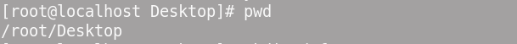

2.

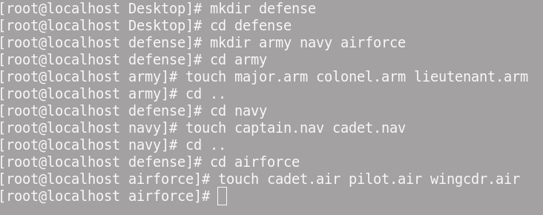

3.

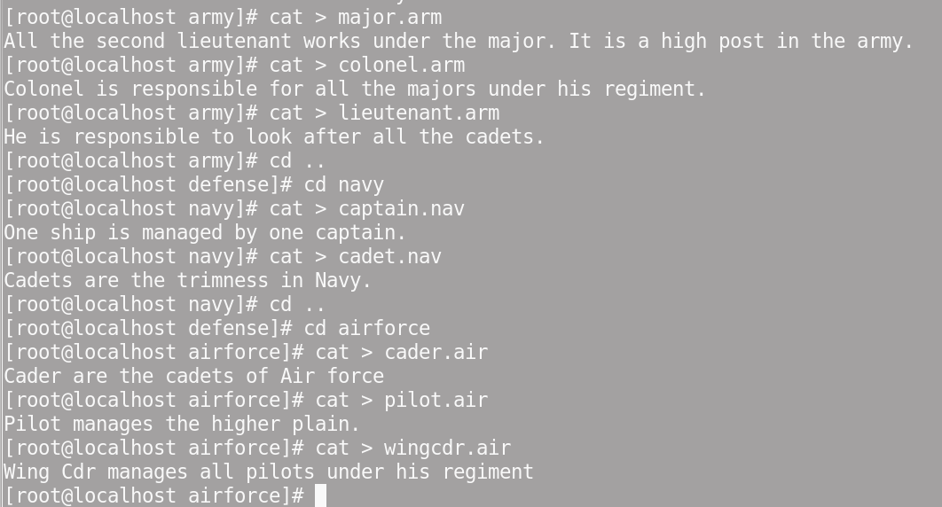

4.

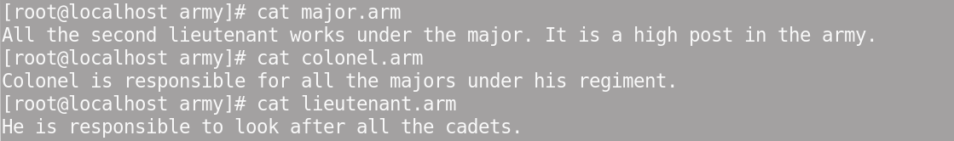



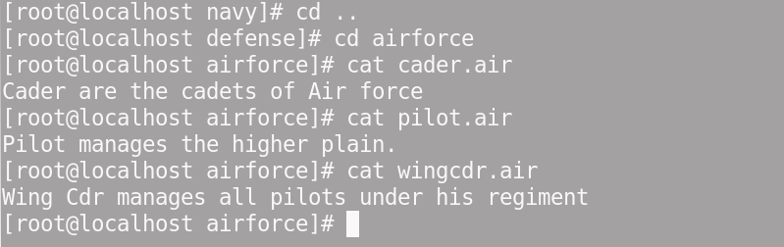

5.

6.



7.



8.

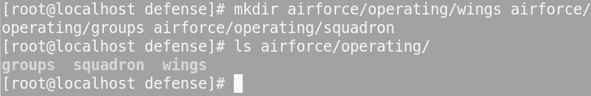

9.



10.

11.



12.

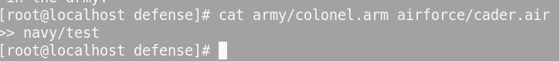

13.

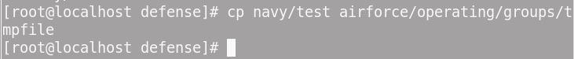

14.

Lab Exercise - 2

Refer to assignment 1 for directory structure.
Give the commands for the following:

- Move the file Tmpfile from sub directory Groups to sub directory, Sergeant.
- Rename the file Tmpfile as Subordinate. air
- Create a directory Navalchief in Navy subdirectory .
- Move this directory Navalchief from Navy subdirectory to Reporting subdirectory.
- Rename this directory Navalchief, as Airchief.
- Verify that directory has been renamed.
- Display the name of all users logged in currently and determine your terminal name.
- Now display only your terminal filename.
- Create five empty files Empty1, Empty2, Empty3, Empty4 and Empty5 under defense directory.
- Display the names of all ordinary files in your home directory.
- Standing in home directory give command
who >oldfile

Now append the contents of a file called oldfile to newfile. Display the contents of oldfile and newfile to see if you have given the correct commands.
- Suppose there are following files in present working directory:
art, part, part1, part2, part3, mozart, tart, quartz.

Which of the above files would qualify for the following searches:
- ls a?
- ls a*
- ls *.*
- ls [!abc]art
- ls [a!bc]art
- ls [b-dku-z]*

- Suppose the path dir1/dir2/dir3/dir4 exists in your directory. All these directories are empty. Write down the command to remove all of them at one shot?
- Create a hidden file hidden1 in defense directory.
- Verify that the hidden file is created.
- Standing in the defense directory list all the files starting with ‘e’
- Standing in the defense directory list all the files starting with any single character but end with ‘ing’
- Standing in the Navy subdirectory list all files starting with a, b, c and ending with any no of characters.
- Standing in the Navy subdirectory list all files NOT starting with a, b, and c
- Standing in the Army subdirectory list all three character files whose first character can be anything from a to z, second character any vowel and third character can be anything.
- Display the long listing of all files present in the directory Navy. Note the entries for Directories and files.
- Display the names of all files that start with a lower case alphabet followed by a digit and ending with ‘.c’ or ‘.o’ in army subdirectory.
- Move all the files whose names end with ‘.c’ or ‘.o’ to the directory Olddir in secretary sub directory.
- In one command, remove all the files in Olddir and the directory itself.
- Append the following content in the empty file, Empty1
A line is any group of characters not containing a newline
A word is a group of characters not containing a space, tab or newline.
A character is the smallest unit of information, and includes a space, tab and newline.
- Display the no of lines, words and characters present in the file, Empty1.
- Redirect the output of file Empty1 to a new file, infile, in the same directory.
- Compare the contents of these two files.
- Append the content to the file, infile.
wc offers three options to make a specific count.
- Now compare the content of these two files, Empty1 and infile.
- Display what is common in these two files. Observe the display.

Solutions of Lab Exercise 2:-

15.
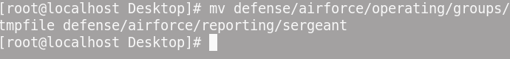

16.

17.

18.

19.
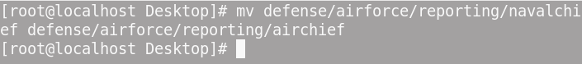

20.


21.


22.


23.
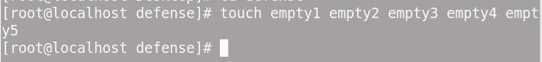

24.


25.


26.
a) ls a
Ans: No such files present

b) ls a*
Ans: art

c) ls*.*
Ans: andaconda-ks.cfg install.log install.log.syslog

d) ls [!abc]art
Ans: part, tart


e) ls [a!bc]art
Ans: event not found.

- ls [b-dku-z]*
Ans: No such file or directory
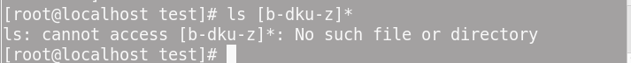
27.
28.
29.
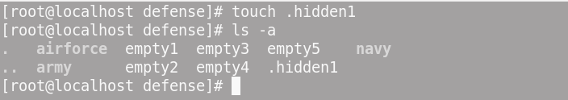
30.

31.

32.

33.
34.

35.
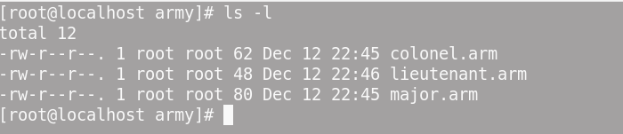
36.

37.
38.


39.
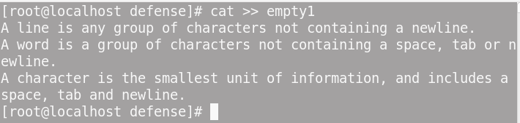
40.

41.
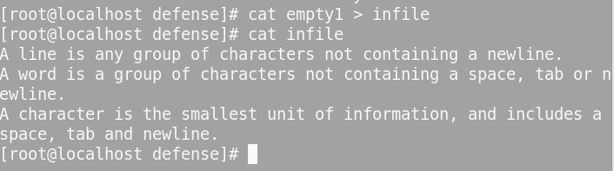
42.
43.

44.

45.
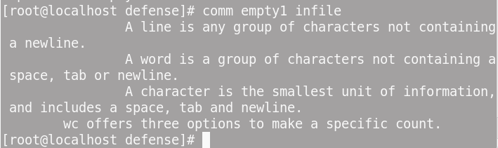

Lab Exercise - 3

- Construct pipelines to carry out the following jobs:
  - List all files beginning with the character “P” on the screen and also store them in a file called File1.
  - List all files beginning with the character “P” on the screen twice in succession.
  - Merge the contents of the files a.txt, b.txt and c.txt, sort them and display the sorted output on the screen page by page.
  - Display the list of last 20 files present in the current directory. Also store this list in a file ‘profile’.
  - Write a command to transfer 3 lines from one file (FILE1) to (FILE2) and vice versa.
  - Write a command to append the data of FILE1, FILE2 to FILE3.
- What Regular Expression would you use to do the following:
  - List all the records having either woodhouse or wodehouse.
  - List all the records having either trueman or truman.
  - List all the records having Wilcox or wilcocks.
  - List the records having first name as p. followed by any numbers of characters and last name as woodhouse.
  - List the records which begin with employee code 2…..
  - Inverse your regular expression i.e. list all except the ones starting with 2.
  - List all records having salary between 70000 to 79999.
  - List records having p.g. woodhouse as name
  - List only directories in your current directories.

Solutions of Lab Exercise 2 :-

a)


b)



c)
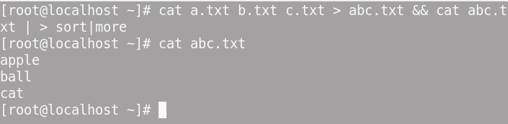

d)
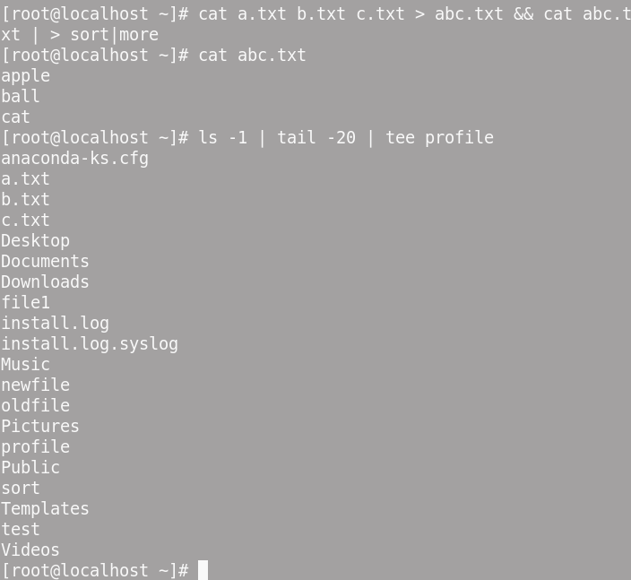

e)
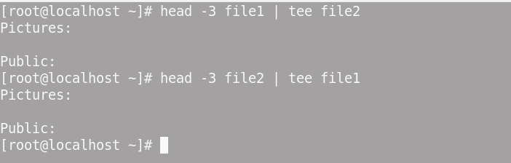

f)


- a)
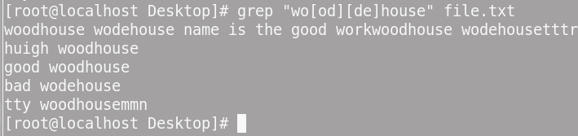

b)
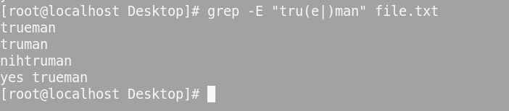

c)
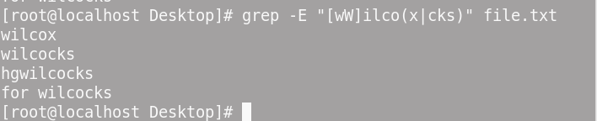

d)
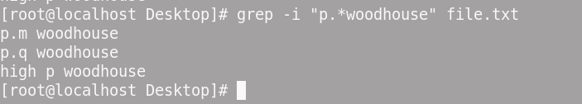

e)


f)
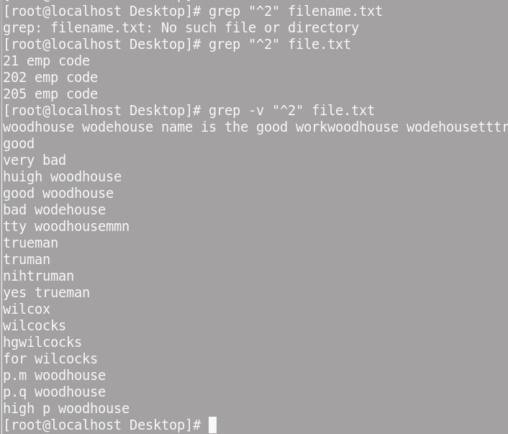

g)


h)
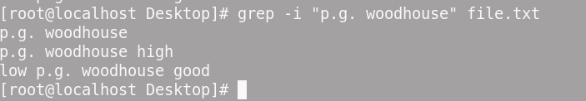

i)
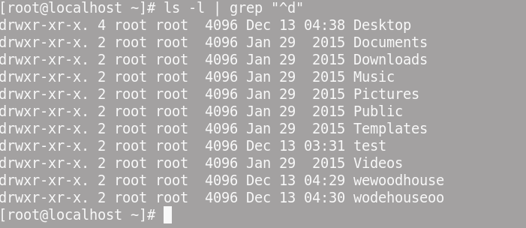

Lab Exercise - 4

- Devise suitable wild-card patterns to match the following filenames:
  - foo1, foo2 and foo5
  - quit.c, quit.o and quit.h
  - tutorial.ps and tutorial.pdf
  - all filenames beginning with a dot and ending with .swp
- Frame wild-card patterns to match all filenames where the first character is numeric and the last character is not alphabetic.
- Devise a command that copies all files named chap01, chap02, chap03 and so forth, and up to chap26 to the parent directory. Can a single wild-card pattern match them all?
- Can we write the following command in a more compact form?
Cat<file1 | grep John > result
- What is the difference between the commands:
wc –l < file1
wc –l file1

Solutions of Lab Exercise – 4 :-

i)


ii)


iii)


iv)


2.



3.
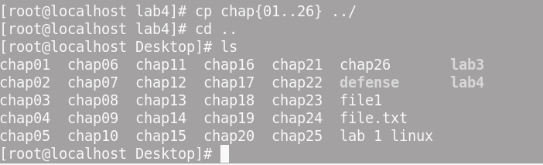

Yes, a single wild-card pattern like chap?? Or chap* can match all these files.
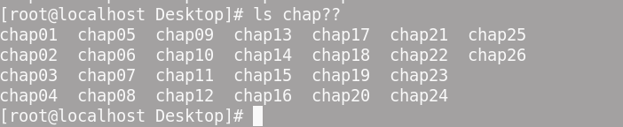
4.
5.
Ans: Both commands provide the line count for file1, but the first command (wc -l < file1) does not include the filename in the output, while the second command (wc -l file1)
does include the filename in the output.



Lab Exercise - 5

    - What is the difference between the commands:
    - cat<file1>file2
    - cat>file2<file1

    - You are given a file myfile. Without opening this file how would you make a fair estimate about its contents?
    - What will be the effect of following commands?
  - umask
  - chmodu+w g-w abcd.out
  - chmod 777 aaa.c
  - chmodug+rw a=x ffff.out
  - chmodu+tmydir

Solutions of Lab Exercise - 5

Ans: Both commands take the contents of file1 and overwrite the contents of file2 with them, and the only difference lies in the order of input and output redirections. The result is the same in both cases.

2.
Ans: Using ‘wc’ - word count command. It gives no. of lines, word, and character count for each file.


3.
(i) umask: It will give the default umask value for the current system.

(ii) ) chmod u+w g-w abcd.out :
This command will give write permission to user and remove write permission from the group of file “abcd.out”.



(iii) chmod 777 aaa.c :
This command will give all read(4), write(2) and execute(1) permissions to user, group, others of file aaa.c


(iv) chmod ug+rw a=x ffff.out:
This will add read and write permission to user and group and a=x will assign execute permission to all user, group and others of file ffff.out.



(v) chmod u+t mydir:
This will add a sticky bit to mydir directory. It means only user can delete or rename the files contained in mydir. Group and others cannot do the same.

Lab Exercise - 6

Q1 Using sed command, write down the commands for the followings

What Regular Expression would you use to do the following:
  - List all the records having either woodhouse or wodehouse.
  - List all the records having either trueman or truman.
  - List all the records having Wilcox or wilcocks.
  - List the records having first name as p. followed by any numbers of characters and last name as woodhouse.
  - List the records which begin with employee code 2…..
  - Inverse your regular expression i.e. list all except the ones starting with 2.
  - List all records having salary between 70000 to 79999.
  - List records having p.g. woodhouse as name
(r) List only directories in your current directories.

Solutions of Lab Exercise - 6

1.

- .
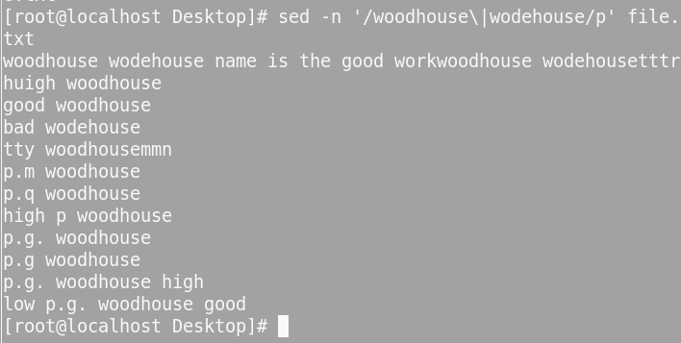

(k)
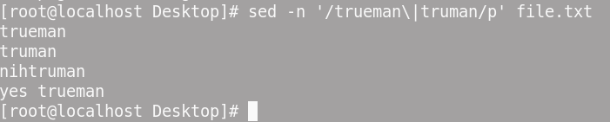

(l)
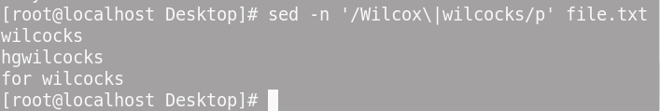

(m)
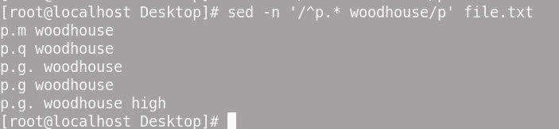\

(n)
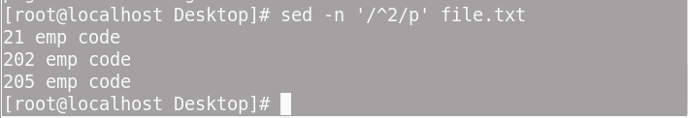

(o)
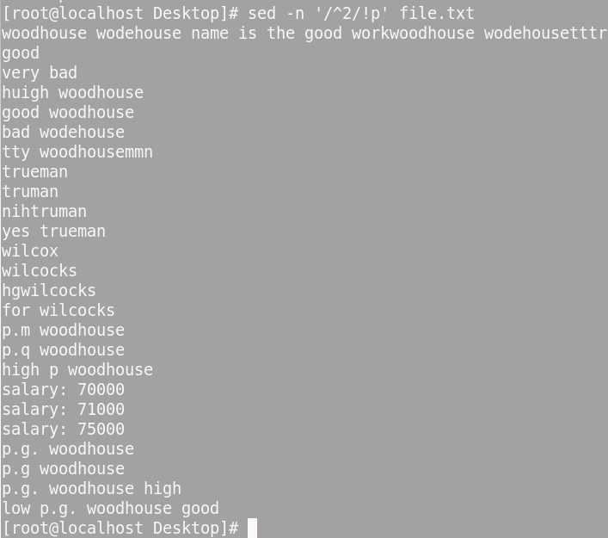

(p)


(q)
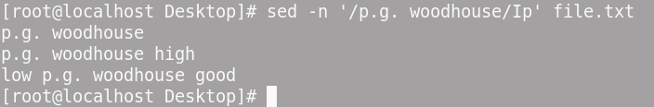

(r)

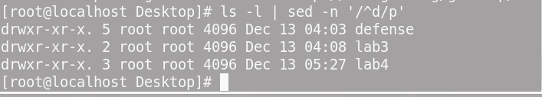

Lab Exercise –7

Question No. 1
Write a program to verify how many users are logged on to the system.
#vi file1.sh
#sh file1.sh
Echo “The no of users logged in are `who | wc -l`”

Question No. 2
Write a program that will calculate the amount of disk space your directory is using on the system.
Du
Dfspace
Echo “The amount of disk space used is `du`”

Question No. 3
Write Script to see current date, time, username, and current directory
Echo “The current date and time is `date`”
Echo “The current user logged in is `USERNAME` `LOGNAME`”
Echo “The current directory is `HOME`”
Echo “The present working directory is `pwd`”

Question No. 4
How to calculate 5.12 + 2.5 real number calculation at $ prompt in Shell ?
A=5.12
B=2.5
Echo “The value of calculation of a and b is `expr $a + $b`”
`echo $a + $b`
Echo “value is `expr 5.12 + 2.5`”
`echo 5.12 + 2.5`

Question No. 5
How to perform real number calculation in shell script and store result to
third variable ,lets say a=5.66, b=8.67, c=a+b?

Solutions of Lab Exercise -7 :-

Q1)
# file7.sh
echo “The no of Users logged in are `who | wc -l`”

Q2)
# diskspace.sh
echo “The amount of disk space used is `du`”
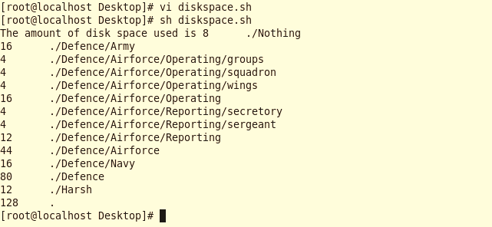

Q3)
# file3.sh
echo "The current date and time is `date`"
echo "The current user logged in is $USER $LOGNAME"
echo "The current directory is $HOME"
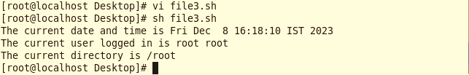

Q4)

# file4.sh
a=5.12
b=2.5
result=`echo $a + $b | bc`
echo "The value of calculation $a + $b is $result"

Q5)
# file5.sh
a=5.66
b=8.67
c=`echo $a + $b`
echo "The value of $a + $b = $c"

Lab Exercise - 8

Question No. 1
How to write script, that will print, Message "Hello World" , in Bold and Blink effect, and in different colors like red, brown etc using echo command.

Question No. 2
Write shell script to show various system configuration like
1) Currently logged user and his logname
2) Your current shell
Echo $SHELL
3) Your home directory
Echo $HOME
4) Your operating system type
Echo $OSTYPE
5) Your current path setting
Echo $PATH
6) Your current working directory
Echo $PWD
7) Show Currently logged number of users
Echo `who | wc -l`
8) About your os and version ,release number , kernel version
/etc/Redhat-version
/etc/Redhat-release
9) Show all available shells
/etc/shells

10) Show mouse settings
11) Show computer cpu information like processor type, speed etc
Cpuinfo
12) Show memory informationmemifo

13) Show hard disk information like size of hard-disk, cache memory, model etc
14) File system (Mounted)
/dev/mnt/cdrom
/dev/mnt/hda1

Question No. 3
If cost price and selling price of an item is input through the keyboard, write a program to determine whether the seller has made profit or incurred loss. Also determine how much profit was made or loss incurred.

Question No. 4
Any integer is input through the keyboard. Write a program to find out whether it is an even number or odd number.
If test `expr $a % 2`

Question No. 5
Write a shell script, which receives any year from the Keyboard, and determine whether the year is a leap year or not. If no argument is supplied the current year should be assumed.

Question No. 6
Write a shell script, which receives two filenames as arguments. It should check whether the two file’s contents are same or not. If they are same then second file should be deleted.

Solutions of Lab Exercise - 8

Q1)
# hello.sh
# bold
echo -e "\033[1m Hello World"
# blink
echo -e "\033[5m Hello World"
# colours
echo -e "\033[31m Hello World"
echo -e "\033[32m Hello World"
echo -e "\033[33m Hello World"
echo -e "\033[34m Hello World"
echo -e "\033[35m Hello World

Q2)

# ques2.sh
echo "Username: $USER"
echo "Logname: $LOGNAME"
echo "Current Shell: $SHELL"
echo "Home Directory: $HOME"
echo "Operating System Type: $OSTYPE"
echo "Path: $PATH"
echo "Current directory: `pwd`"
echo "Currently Logged: `who | wc -l` user(s)"
echo "OS: `cat /etc/os-release`"
echo "Kernel version: `uname -r`"
echo "Available shells: `cat /etc/shells`"
echo "Mouse settings: `cat /etc/sysconfig/mouse`"
echo "Memory info: `cat /proc/meminfo`"
echo "Model: `cat /proc/ide/hda/driver`"
echo "Cache Size: `cat /proc/ide/hda/cache`"
echo "File System(mount): `cat /proc/mounts`"

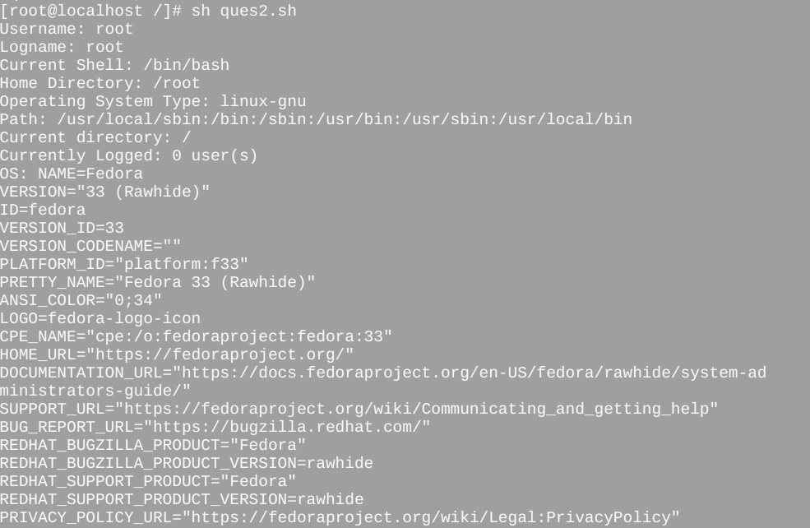

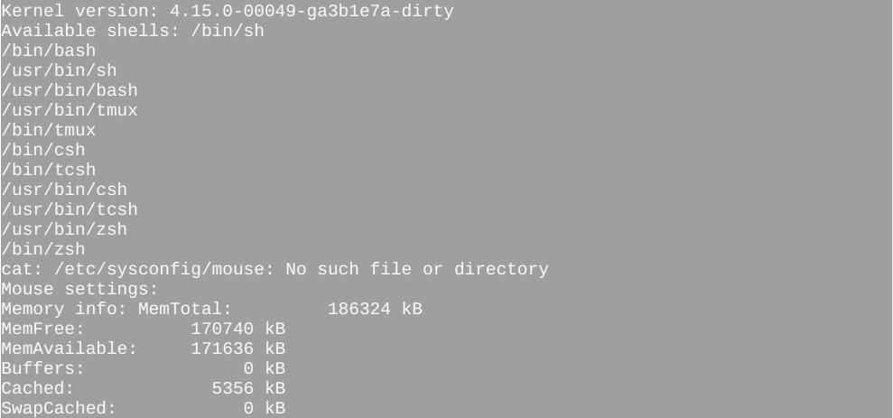

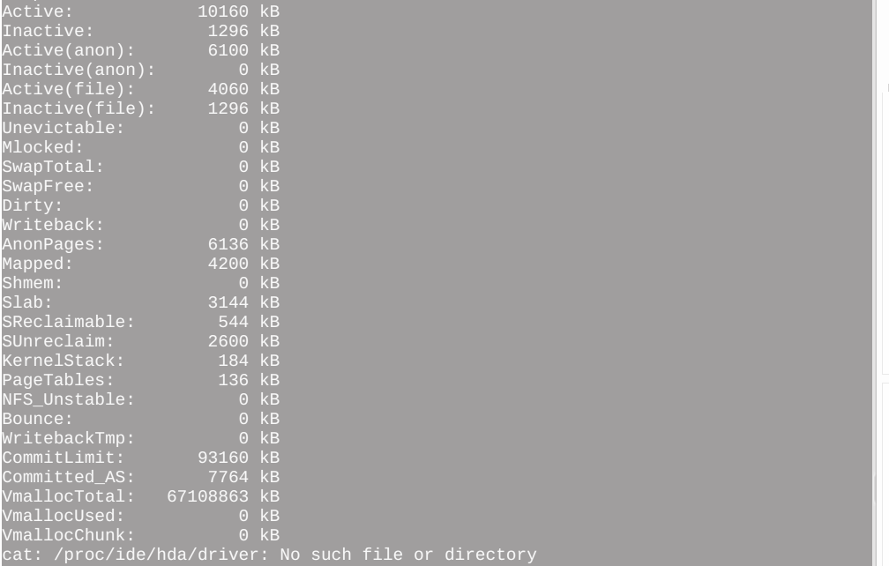

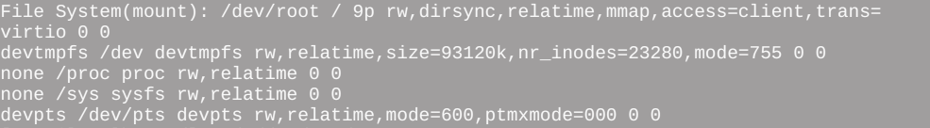

Q3)
echo "Ente Selling Price (SP): "
read sp
#!/bin/sh

# Input cost price and selling price
echo "Enter Cost Price (CP): "
read cp

echo "Enter Selling Price (SP): "
read sp

# Calculate profit or loss
if [ $sp -gt $cp ]
then
profit=`expr $sp - $cp`
echo "Profit: $profit"

elif [ $cp -gt $sp ]
then
loss=`expr $cp - $sp`
echo "Loss: $loss"

else
echo "No Profit, No Loss"

fi

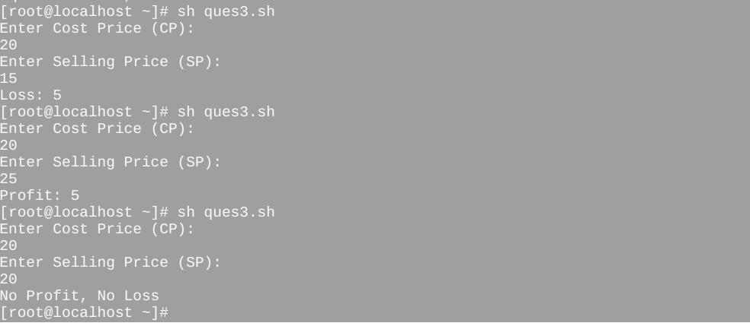

Q4)
If test `expr $a % 2`
# Check Even or Odd number
read -p "Enter a number: " num
if [ $($num%2) -eq 0 ]
then
echo "Number is even."
else
# Check Even or Odd number
read -p "Enter a number: " num
if [ $((num%2)) -eq 0 ]
then
echo "Number is even."
else
echo "Number is odd."
fi


Q5)
# find leap year
# If no argument is provided, use the current year
if [ "$#" -eq 0 ]; then
year = $(date +"%Y")
# find leap year

# If no argument is provided, use the current year
if [ "$#" -eq 0 ]; then
year=$(date +"%Y")
else
year=$1
fi

# Check if it's a leap year
if [ $((year % 4)) -eq 0 ] && [ $((year % 100)) -ne 0 -o $((year%400)) -eq 0 ]; then
echo "$year is a leap year."
else
echo "$year is not a leap year."
fi


Q6)
# Check if two filenames are provided as arguments
if [ $# -ne 2 ]; then
echo "Usage: $0 <file> <file2>"
exit 1
fi

file1=$1
# Check if two filenames are provided as arguments
if [ $# -ne 2 ]; then
echo "Usage: $0 <file> <file2>"
exit 1
fi

file1=$1
file2=$2

# Check if both files exist
if [ ! -e "$file1" -o ! -e "$file2" ]; then
echo "Error: Both files must exist."
exit 1
fi

# Check if the contents of the two files are the same
if cmp -s "$file1" "$file2"; then
echo "The contents of $file1 and $file2 are the Same. Deleting $file2"
rm "$file2"
else
echo "The contents of $file1 and $file2 are different."

Lab Exercise - 9
- Write a script that would first verify if file "myfile" exists. If it does not, create it, then ask the user for confirmation to erase it...
- Write a shell script to accept a file name. Test whether file is ordinary file or directory file. If ordinary file check whether readable and then display its contents. If directory display its contents.
- Write a shell script to print only those lines of file that do not contain word “example”, also store output in a file.
- Write a shell script to view all environment variables and store it in a file.

Solutions of Lab Exercise - 9

1.
# myfile.sh

# Check if the file exists
if [ -e $file ]; then
echo "File $file exists."
else
echo "File $file does not exist. Creating it."
touch $file
fi

# Ask for confirmation to erase the file

read -p "Do you want to erase the $file? (yes/no):" choice

if [ "$choice" == "yes" ]; then
rm $file
echo "$file has been erased."
else
echo "No action taken. $file is not erased."
fi


2.
# Accept a file name from the user

# Check if the file exists
if [ ! -e $filename ]; then
# Accept a file name from the user
read -p "Enter a file name: " filename

# Check if the file exists
if [ ! -e $filename ]; then
echo "Error: File $filename does not exists."
exit 1
fi

# Check if it's an ordinary file or a directory
if [ -f $filename ]; then
echo "$filename is an ordinary file."

# Check if the file is readable
if [ -r $filename ]; then
echo "Content of $filename:"
cat $filename
else
echo "Error: $filename is not readable."
fi

elif [ -d $filename ]; then
echo "$filename is a directory. Contents:"
ls $filename

else
echo "Error: $filename is neither an ordinary file nor a directory."
fi



3.
# textfile.sh
read -p "Enter the file name: " filename

# Check if the file exists
if [ ! -e "$filename" ]; then
echo "Error: File $filename does not exist."
exit 1
fi

# Specify the output file name
read -p "Enter Output file name: " outputfile

# Print lines not containing the word "example" to the console and store in the
# output file
read -p "Enter the file name: " filename

# Check if the file exists
if [ ! -e "$filename" ]; then
echo "Error: File $filename does not exist."
exit 1
fi

# Specify the output file name
read -p "Enter Output file name: " outputfile

# Print lines not containing the word "example" to the console and store in the
# output file
grep -v "example" "$filename" | tee "$outputfile"

echo "Filtered lines have been stored in '$outputfile'."


4.
# env.sh
# specify the output filename
read -p "Enter the output filename: " output_file

# view all environment variables and store in the output file
# env.sh

# specify the output filename
read -p "Enter the output filename: " output_file

# view all environment variables and store in the output file
# env.sh

# specify the output filename
read -p "Enter the output filename: " output_file

# env.sh
# env.sh
# specify the output filename
read -p "Enter the output filename: " output_file

# view all environment variables and store in the output file
env | tee $output_file

echo "Environment variables have been stored in $output_file"
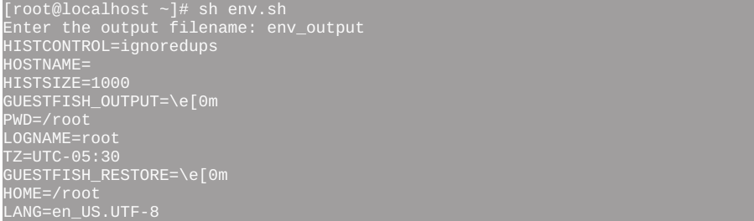

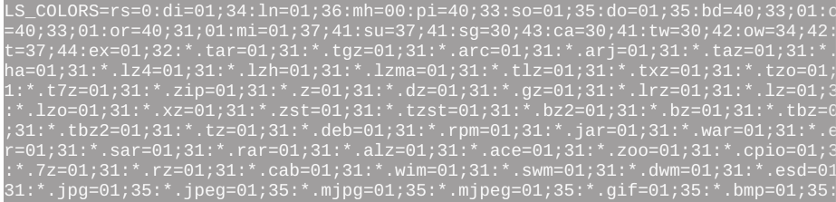

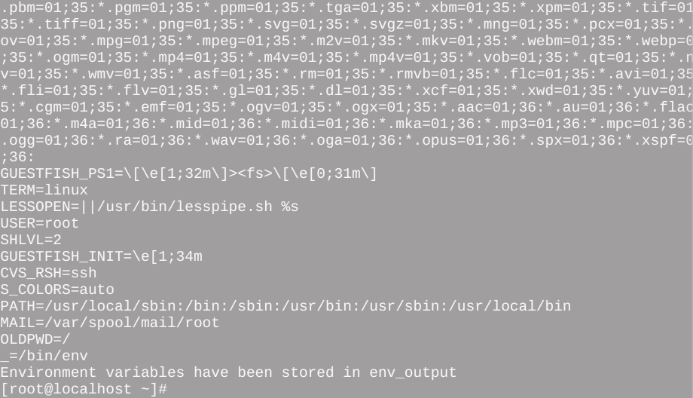

Lab Exercise - 10

- Write a shell script named count which takes a file name as its parameter and prints number of blank lines in it. Also display the lines containing “is” as a word.
- While executing a shell script either the LOGNAME or the UID is supplied at the command prompt. Write a shell script to find out at how many terminals has this user logged in.
- Given a file of numbers (one per line), write a script that will find the lowest and highest number.
- Write a shell script, which deletes all lines containing the word “unix” in the files, supplied as argument to this shell script.
Solutions of Lab Exercise - 10
1.
# Check if a file name is provided as an argument
if [ $# -eq 0 ]; then
echo "Usage: $0 <filename>"
exit 1
fi

filename="$1"

# Check if the file exists
if [ ! -e $filename ]; then
echo "Error: File $filename does not exist."
exit 1
fi

# Count the number of blank lines
blank_lines=`grep -c '^$' $filename`

echo "Number of blank lines in $filename: $blank_lines"

# Display lines containing 'is' as a word
echo "Lines containing 'is' as a word in $filename:"
grep -w "is" "$filename"
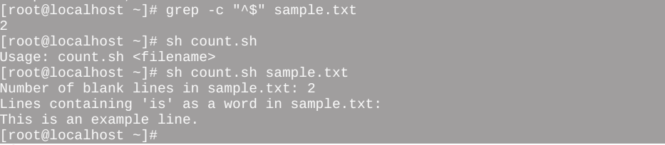

2.
#!/bin/bash

# Check if either LOGNAME or UID is supplied
if [ -z "$LOGNAME" ] && [ -z "$UID" ]; then
echo "Error: Neither LOGNAME nor UID is supplied."
exit 1
fi

# Determine the user
user=""
if [ -n "$LOGNAME" ]; then
user="$LOGNAME"
elif [ -n "$UID" ]; then
user=`id -un "$UID"`
fi

# Count the number of terminals the user is logged into
terminals_count=$(who | grep -c "^$user")

echo "User $user is logged into $terminals_count terminal(s)."
3.
if [ $# -eq 0 ];
then
echo "Filename not entered"
exit 1
fi

# sort the contents of the file and save to the same file
if [ $# -eq 0 ];
then
echo "Filename not entered"
exit 1
fi

# sort the contents of the file and save to the same file
sort "$1" -o "$1"

# Display minimum and maximum values
echo "Minimum: `head -1 $1`"
echo "Maximum: `tail -1 $1`"
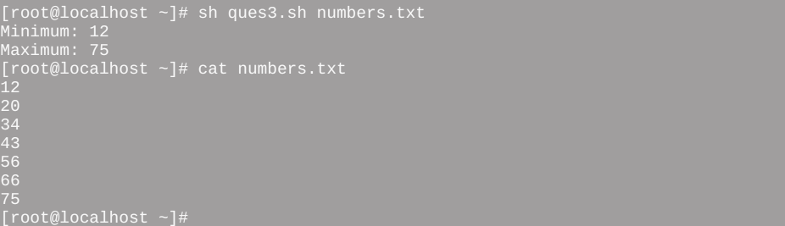
4.
#!/bin/bash

# Check if filenames are provided as arguments
if [ "$#" -eq 0 ]; then
echo "Usage: $0 <file1> [<file2> ...]"
exit 1
fi

# Loop through each filename provided as an argument
for file in "$@"; do
# Check if the file exists
if [ ! -e "$file" ]; then
echo "Error: File '$file' does not exist."
else
# Use sed to delete lines containing the word "unix"
sed -i '/unix/d' "$file"
echo "Lines containing 'unix' deleted from $file."
fi
done


Lab Exercise - 11

- Ramesh’s basic salary is input through the keyboard. His dearness allowance is 40% of basic salary, and house rent allowance is 20% of basic salary. WAP to calculate his gross salary.
- The distance between two cities (in km) is input through the keyboard. WAP to convert and print this distance in meters, feet, inches and centimeters.
- The length and breadth of a rectangle and radius of a circle are input through the keyboard. WAP to calculate the area and perimeter of the rectangle, and the area and circumference of the circle.
- If a five digit number is input through the keyboard, WAP to calculate the sum of its digits. (Use the modulus operator ‘%’)
- Write a shell script, which will automatically get executed, on logging in. This shell script should display the present working directory and report whether your friend whose logname is aa10 has currently logged in or not. If he has logged in then the shell script should send a message to his terminal suggesting a dinner tonight. If you do not have write permission to his terminal or if he hasn’t logged in then such a message should be mailed to him with a request to send confirmation about your dinner proposal.

Solutions of Lab Exercise - 11

(1)
# salary.sh

read -p "Enter basic salary: " sal

# Use backquotes for command substitution
# salary.sh

read -p "Enter basic salary: " sal

# Use backquotes for command substitution
da=`expr $sal \* 40 / 100`
hr=`expr $sal \* 20 / 100`

echo "Dearness allowence is: $da"
echo "House rent allowence is: $hr"

# Calculate gross salary
gs=`expr $sal + $hr + $da`

echo "Your gross salary is: $gs"


(2)
# Convert distance to meters, feet, inches, and centimeters using expr
#!/bin/bash
# Input distance in kilometers
echo "Enter distance between two cities in kilometers: "
read distance_km

# Conversion factors
meter_factor=1000
feet_factor=3280.84
inch_factor=39370.1
centimeter_factor=100000

# Convert distance to meters, feet, inches, and centimeters using expr
distance_meter=`echo "$distance_km * $meter_factor" | bc`
distance_feet=`echo "$distance_km * $feet_factor" | bc`
distance_inch=`echo "$distance_km * $inch_factor" | bc`
distance_centimeter=`echo "$distance_km * $centimeter_factor" | bc`

# Display the converted distances
echo "Distance in meters: $distance_meter m"
echo "Distance in feet: $distance_feet ft"
echo "Distance in inches: $distance_inch in"
echo "Distance in centimeters: $distance_centimeter cm"

(3)
#!/bin/bash
# Input length and breadth of the rectangle
read -p "Enter length of the rectangle: " length

read -p "Enter breadth of the rectangle: " breadth

# Input radius of the circle
read -p "Enter radius of the circle: " radius

# Calculate area and perimeter of the rectangle
rectangle_area=`echo "$length * $breadth" | bc`
rectangle_perimeter=`echo "2 * ($length + $breadth)" | bc`

# Calculate area and circumference of the circle
circle_area=`echo "3.1415 * $radius * $radius" | bc`
circle_circumference=`echo "2 * 3.1415 * $radius" | bc`

# Display the results
echo "Rectangle Area: $rectangle_area"
echo "Rectangle Perimeter: $rectangle_perimeter"
echo "Circle Area: $circle_area"
echo "Circle Circumference: $circle_circumference"


(5)
#!/bin/bash

# Input length and breadth of the rectangle
read -p "Enter length of the rectangle: " length

read -p "Enter breadth of the rectangle: " breadth

# Input radius of the circle
read -p "Enter radius of the circle: " radius

# Calculate area and perimeter of the rectangle
rectangle_area=`echo "$length * $breadth" | bc`
rectangle_perimeter=`echo "2 * ($length + $breadth)" | bc`

# Calculate area and circumference of the circle
circle_area=`echo "3.1415 * $radius * $radius" | bc`
circle_circumference=`echo "2 * 3.1415 * $radius" | bc`

# Display the results
echo "Rectangle Area: $rectangle_area"
echo "Rectangle Perimeter: $rectangle_perimeter"
echo "Circle Area: $circle_area"
echo "Circle Circumference: $circle_circumference"

Lab Exercise – 12

- Write a script that will echo the third parameter, but only if it is present.
- Write a script that would recognize if a word entered from the keyboard started with an upper or lower case character or a digit. Use the "case" statement.
Echo -e “Enter a word or no \c”
Read ans
Case $ans in
[a-z] *) echo “lower case”;;
[A-Z] *) echo “upper”;;
[0-9] * ech0 “no”;;
*) echo “none”;;
Esac
Exit 0
The script would then output the word, followed by "upper case", "lower case", "digit", or "not upper, lower, or digit".
- Write a program that will take an undetermined list of parameters, and reverse them.
If [ $# -eq 0 ]
Then
Echo “there were no arguments”
Exit
Fi
Args=” “
While [ ! $# -eq 0 ]
Do
Args=”$1 $args”
Shift
Done
Echo “Reversed arguments are $args”

- Write a script that will accept any number of parameters. The program should display whether an odd or an even number of parameters was given.
Rem=`expr $# % 2`
If [ $rem -eq 0 ]
Then
Echo “there were even no of arguments”
Else
Echo “there were odd no of arguments”
Fi
Exit 0
Cp $1 $2

- Write a script asking the user to input some numbers. The script should stop asking for numbers when the number 0 is entered. The output should look like:
    - user: logon_name
    - Lowest number entered:
    - Highest number entered:
    - Difference between the two:
    - Product of the two:

Solutions of Lab Exercise – 12

1.

# Check if the third parameter is present
if [ $# -ge 3 ]; then
echo "Third parameter: $3"
else
echo "Third parameter is not present."
fi


2.

#!/bin/bash

echo -e "Enter a word or number: \c"
read ans

case $ans in
[a-z]* ) echo "$ans is in lower case.";;
[A-Z]* ) echo "$ans is in upper case.";;
[0-9]* ) echo "$ans is a digit.";;
* ) echo "$ans is not upper case, lower case, or a digit.";;
esac

exit 0



3.
#!/bin/bash

if [ $# -eq 0 ]; then
echo "There were no arguments."
exit 1
fi

args=""

while [ $# -gt 0 ]; do
args="$1 $args"
shift
done

echo "Reversed arguments are $args"



4.
#!/bin/bash

if [ $# -eq 0 ]; then
echo "There were no arguments."
exit 1
fi
rem=$(( $# % 2 ))

if [ $rem -eq 0 ]; then
echo "There were even number of arguments."
else
echo "There were odd number of arguments."
fi
exit 0



5.
# Prompt the user for input
echo -e "Enter numbers (enter 0 to stop):"
# Initialize variables
read -p "Enter a number: " num
min=$num
max=$num
product=1
# Continue reading numbers until 0 is entered
while [ $num -ne 0 ]; do
if [ $num -lt $min ]; then
min=$num
fi

if [ $num -gt $max ]; then
max=$num
fi

read -p "Enter a number: " num
done
# Display the results
echo -e "\nUser: $LOGNAME"
echo "Lowest number entered: $min"
echo "Highest number entered: $max"
echo "Difference between the two: $((max - min))"
echo "Product of the two: $((max * min))"



Lab Exercise -13

- A shell script receives even number of filenames. Suppose four filenames are supplied then the first file should get copied into second file, the third file should get copied into fourth file, and so on. If odd number of filenames are supplied then no copying should take place and an error message should be displayed.
- Write a shell script, which displays a list of all files in the current directory to which you have read, write and execute permissions.
- Write a script that will take a person's name as a parameter to the program name. The script should greet that person, as
Good Day name_entered, How are you today?
If test $# -eq 0
Then
Echo “no name on command line”
Exit 1
Fi
Echo “Good Day $1, How are you today”
Exit 0
- Write a series of scripts that will count the number of parameters on the command line, first using the for statement, then the while and finally the until statement. (Three scripts).
Num=0
For I in $*
Do
Num=`expr $num + 1`
Done
Echo “There were $num arguments”
Exit 0
Num=0
While test $# -gt 0
Do
Num=`expr $num + 1`
shift
Done
Echo “There were $num arguments”
Exit 0
Num=0
Until test $# -eq 0
Do
Num=`expr $num + 1`
shift
Done
Echo “There were $num arguments”
Exit 0
- Write a script that will return the number of parameters on the command line.
- Write a script that will prompt the user for a name. That same name will then be displayed in the screen.
- Write a script to find out biggest number from given three numbers. Numbers are supplied as command line argument. Print error if sufficient arguments are not supplied.

Solutions of Lab Exercise -13

1.
#!/bin/bash

# Check if the number of arguments is even
if [ `expr $# % 2` -eq 0 ]; then
# Iterate over pairs of filenames and copy the first into the second
while [ $# -gt 0 ]; do
cp "$1" "$2"
echo "Copied $1 to $2"
shift 2
done
else
echo "Error: Odd number of filenames provided. No copying will take place."
echo "Enter only even number of filenames."
fi


2.
#!/bin/bash

echo "Files with read, write, and execute permissions:"
echo "----------------------------------------------"

for file in *; do
if [ -f "$file" ] && [ -r "$file" ] && [ -w "$file" ] && [ -x "$file" ];
then
echo "$file"
fi
done
3.
#!/bin/bash

if [ $# -eq 0 ]; then
echo "No name on the command line."
exit 1
fi

echo "Good Day $1, How are you today?"
exit 0

4.
# for.sh
num=0
for arg in "$@"; do
num=`expr $num + 1`
done

echo "There were $num arguments"
exit 0
# while.sh
num=0
while [ $# -gt 0 ]; do
num=`expr $num + 1`
shift
done

echo "There were $num arguments"
exit 0
# until.sh
num=0
until [ $# -eq 0 ]; do
num=`expr $num + 1`
shift
done

echo "There were $num arguments"
exit 0
5.
# count_param.sh

echo "Number of parameters on the command line: $#"

6.
echo -e "Enter name of user: \c"
read name
echo $name

7.
# find_biggest.sh

if [ $# -lt 3 ]; then
echo "Error: Insufficient arguments. Please provide three numbers."
exit 1
fi

num1=$1
num2=$2
num3=$3

max=$num1

if [ $num2 -gt $max ]; then
max=$num2
fi

if [ $num3 -gt $max ]; then
max=$num3
fi

echo "The biggest number is: $max"
exit 0



