Name:**Jucel Amor D. Vito** Course and Level: **BSIT-III**

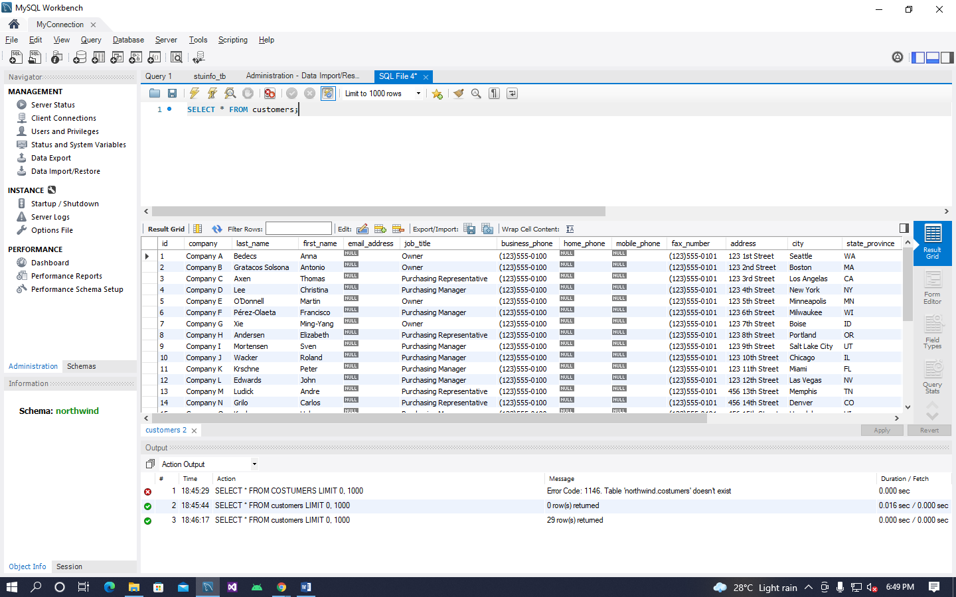**MySQL Workbench**

**GITHUB**

