Create statements

8) CREATE TABLE `answers` (

`AnswerID` int(11) NOT NULL AUTO_INCREMENT,

`Answer` varchar(45) NOT NULL,

`QuestionID` int(11) NOT NULL,

PRIMARY KEY (`AnswerID`),

KEY `question_idx` (`QuestionID`),

CONSTRAINT `question` FOREIGN KEY (`QuestionID`) REFERENCES `multichoicequestion` (`QuestionID`) ON DELETE CASCADE ON UPDATE CASCADE

) ENGINE=InnoDB AUTO_INCREMENT=38 DEFAULT CHARSET=utf8;

2) CREATE TABLE `branch` (

`ID` int(11) NOT NULL AUTO_INCREMENT,

`Name` varchar(45) NOT NULL,

PRIMARY KEY (`ID`)

) ENGINE=InnoDB AUTO_INCREMENT=6 DEFAULT CHARSET=utf8;

6)CREATE TABLE `multichoicequestion` (

`QuestionID` int(11) NOT NULL AUTO_INCREMENT,

`Question` longtext NOT NULL,

`Option1` varchar(45) NOT NULL,

`Option2` varchar(45) NOT NULL,

`Option3` varchar(45) NOT NULL,

`Option4` varchar(45) NOT NULL,

`TestID` int(11) NOT NULL,

PRIMARY KEY (`QuestionID`),

KEY `testnew_idx` (`TestID`),

CONSTRAINT `testnew` FOREIGN KEY (`TestID`) REFERENCES `testdetails` (`TestID`) ON DELETE CASCADE ON UPDATE CASCADE

) ENGINE=InnoDB AUTO_INCREMENT=20 DEFAULT CHARSET=utf8;

9) CREATE TABLE `results` (

`result_id` int(11) NOT NULL AUTO_INCREMENT,

`student_id` int(11) NOT NULL,

`test_id` int(11) NOT NULL,

PRIMARY KEY (`result_id`),

KEY `studentid_idx` (`student_id`),

KEY `testid_idx` (`test_id`),

CONSTRAINT `student_id` FOREIGN KEY (`student_id`) REFERENCES `student` (`EnrollmentID`) ON DELETE CASCADE ON UPDATE CASCADE,

CONSTRAINT `test_id` FOREIGN KEY (`test_id`) REFERENCES `testdetails` (`TestID`) ON DELETE CASCADE ON UPDATE CASCADE

) ENGINE=InnoDB AUTO_INCREMENT=16 DEFAULT CHARSET=utf8;

5)CREATE TABLE `singlechoicequestions` (

`QuestionID` int(11) NOT NULL AUTO_INCREMENT,

`Question` longtext NOT NULL,

`Option1` varchar(45) NOT NULL,

`Option2` varchar(45) NOT NULL,

`Option3` varchar(45) NOT NULL,

`Option4` varchar(45) NOT NULL,

`Answer` varchar(45) NOT NULL,

`TestID` int(11) NOT NULL,

PRIMARY KEY (`QuestionID`),

KEY `TestID_idx` (`TestID`),

CONSTRAINT `TestID` FOREIGN KEY (`TestID`) REFERENCES `testdetails` (`TestID`) ON DELETE CASCADE ON UPDATE CASCADE

) ENGINE=InnoDB AUTO_INCREMENT=21 DEFAULT CHARSET=utf8;

1)CREATE TABLE `student` (

`EnrollmentID` int(11) NOT NULL AUTO_INCREMENT,

`FirstName` varchar(45) NOT NULL,

`LastName` varchar(45) NOT NULL,

`Email` varchar(45) DEFAULT NULL,

`Phone` varchar(45) DEFAULT NULL,

`Password` varchar(45) NOT NULL DEFAULT 'Password1',

`Branch` int(11) NOT NULL,

`FirstLogin` enum('false','true') NOT NULL DEFAULT 'false',

PRIMARY KEY (`EnrollmentID`)

) ENGINE=InnoDB AUTO_INCREMENT=10012 DEFAULT CHARSET=utf8;

3)CREATE TABLE `subjects` (

`ID` int(11) NOT NULL AUTO_INCREMENT,

`Name` varchar(45) NOT NULL,

`BranchID` int(11) DEFAULT NULL,

PRIMARY KEY (`ID`),

KEY `ID_idx` (`BranchID`),

CONSTRAINT `ID` FOREIGN KEY (`BranchID`) REFERENCES `branch` (`ID`) ON DELETE CASCADE ON UPDATE CASCADE

) ENGINE=InnoDB AUTO_INCREMENT=9 DEFAULT CHARSET=utf8;

10)CREATE TABLE `testattempts` (

`id` int(11) NOT NULL AUTO_INCREMENT,

`result_id` int(11) NOT NULL,

`test_marks` int(11) NOT NULL,

`student_marks` int(11) NOT NULL,

`percentage` varchar(10) NOT NULL,

`grade` char(10) NOT NULL,

`status` varchar(45) NOT NULL,

PRIMARY KEY (`id`),

KEY `result_id_idx` (`result_id`),

CONSTRAINT `result_id` FOREIGN KEY (`result_id`) REFERENCES `results` (`result_id`) ON DELETE CASCADE ON UPDATE CASCADE

) ENGINE=InnoDB AUTO_INCREMENT=27 DEFAULT CHARSET=utf8;

4)CREATE TABLE `testdetails` (

`TestID` int(11) NOT NULL AUTO_INCREMENT,

`Title` varchar(45) NOT NULL,

`Questions` int(11) NOT NULL DEFAULT '0',

`Description` longtext NOT NULL,

`Marks` int(11) NOT NULL,

`Type` varchar(45) NOT NULL,

`SubjectID` int(11) NOT NULL,

PRIMARY KEY (`TestID`),

KEY `SubjectID_idx` (`SubjectID`),

CONSTRAINT `SubjectID` FOREIGN KEY (`SubjectID`) REFERENCES `subjects` (`ID`) ON DELETE CASCADE ON UPDATE CASCADE

) ENGINE=InnoDB AUTO_INCREMENT=36 DEFAULT CHARSET=utf8;

7)CREATE TABLE `truefalsequestions` (

`QuestionID` int(11) NOT NULL AUTO_INCREMENT,

`Question` longtext NOT NULL,

`Answer` varchar(40) NOT NULL,

`TestID` int(11) NOT NULL,

PRIMARY KEY (`QuestionID`),

KEY `Test_idx` (`TestID`),

CONSTRAINT `Test` FOREIGN KEY (`TestID`) REFERENCES `testdetails` (`TestID`) ON DELETE CASCADE ON UPDATE CASCADE

) ENGINE=InnoDB AUTO_INCREMENT=21 DEFAULT CHARSET=utf8;

Insert statements

branch

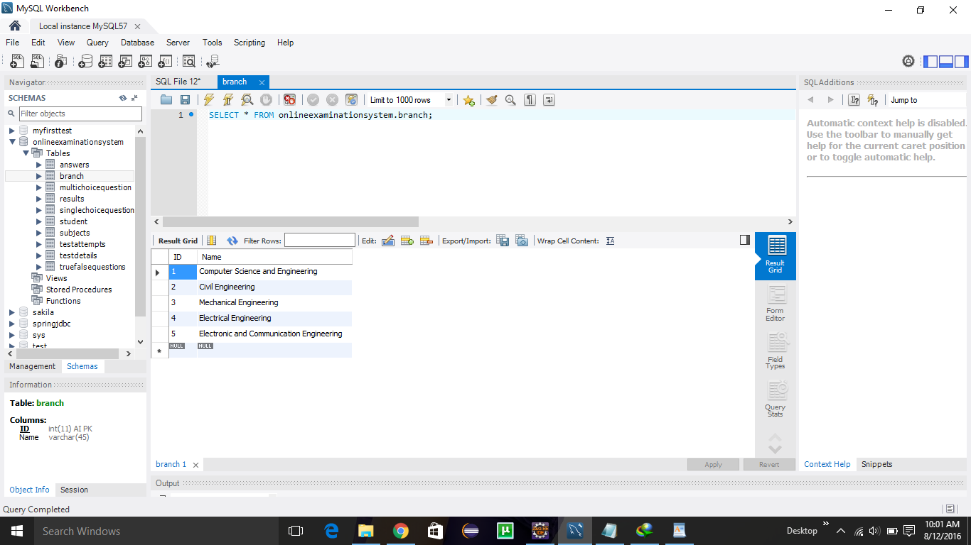

subject

