Name: Mohsen Shoraki

Professor: Dr. Richard Min

Course: SE3377.0W1

Assignment: Week8 Lab2

UTD-ID: MXS190064

# Part 1

* Review two cat and ls program
* Create directory week08
* Compile and execute given programs

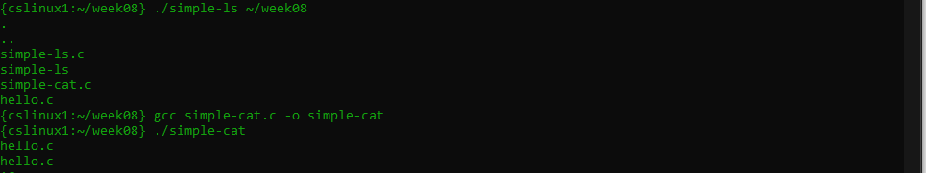

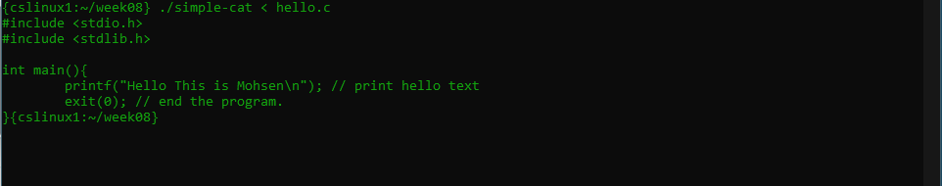

# Part 2

* Mix up two program two follow the given instruction
* Loop through each dir entry
* Print each file name
* If file ending with .c
* Fork the process
* Print out the file content
* Loop until print all names.

