Members: Mohsen Shoraki,

Professor:

Course:

Assignment:

# Sorting App Architecture

This is a web-based application developed by Group 6.

|  |  |
| --- | --- |
| **Back-End** | |
| **Technology** | **Description** |
| Java | Programming Language |
| Spring MVC | Framework used to develop REST API |
| Spring Boot | Framework used to take advantage of autoconfiguration and embedded tom cat. |
| JHardware | Library used to get the system information. |
| Maven | Tools used to manage dependencies. |

|  |  |
| --- | --- |
| **Front-end** | |
| **Technology** | **Description** |
| Type Script | Superset of Java script language. |
| Angular 7 | Framework used to develop front-end web base application |
| HTML | Markup language used to handle UI content. |
| Bootstrap | Framework used to design template in HTML based UI. |
|  |  |

# UI Image

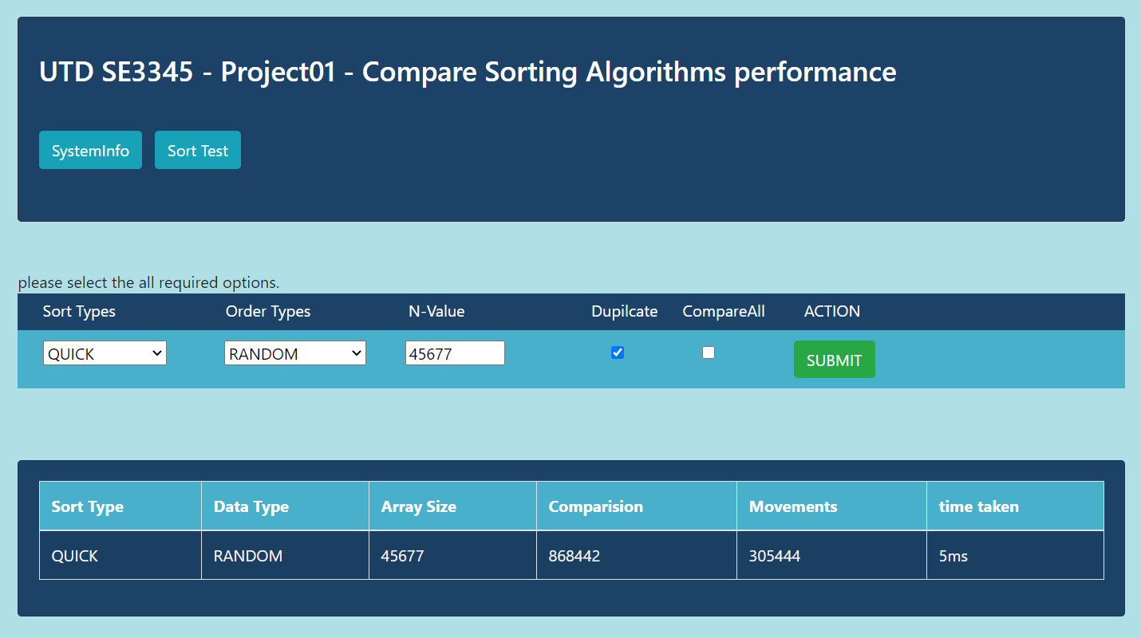

# Sort Algorithms Analysis

## Test 1

Approach:

Observation:

Conclusion:

## Test 2

Approach:

Observation:

Conclusion:

## Test 3

Approach:

Observation:

Conclusion:

## Test 4

Approach:

Observation:

Conclusion:

# Challenges