## Inter-Object Relationships

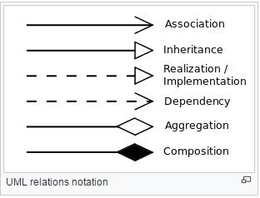

### Association

* Used to describe the static relationships between classes
* Used to indicate that there is a link or dependency

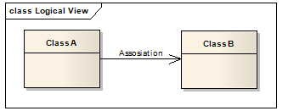

### Aggregation (Shared association)

* Special form of association to describe the exact (more specific) relationship if known
* In this example below, Class can also be aggregated by other classes (Professor)
* Represents has a relationship (Eg, Man has a Hand / Professor has a class)

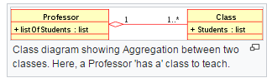

### Composition (Not-Shared association)

* Represents has a relationship (Eg, Man has a Hand)
* If Parent object dies, hand also dies

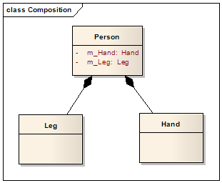

### Generalization

* It indicates that one of the two related classes (the subclass) is considered to be a specialized form of the other (the super type) and the superclass is considered a Generalization of the subclass

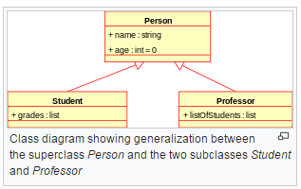

### Dependency

