Scheduling Subsystem
User Guide for the Create Array Panel, Scheduling Panel and Project/SB Search Panel

Version: R7.0
Status: Draft
2009-11-25
Prepared by: | Organization: | Date:
David Clarke | NRAO | 2009-11-25
IPT Leader Approvals: | Organization: | Date:
Released By: | Organization: | Date:
Change Record
Version | Date | Affected section(s) | Change Request # | Reason/Initiation/Remarks
A | 2006-08-22 | All | Created
A | 2006-08-28 | All | Modified | Clarified portions after input from readers
A | 2006-10-05 | 3.2, 4.1, 4.3, 5, 6 | Updated | Updated to reflect software state at R4
A | 2006-10-26 |  | Updated & Added Snapshots | Updated for Holography user test.
A | 2006-12-14 | All | Modified | Update for new Scheduling Panel
A | 2007-03-14 | 3, 4, 5 | Redid all snapshots, modified almost all text. | Updated for GUI FBT enhancements/changes
A | 2007-03-27 | 4.1, 4.8, 5 |  | Updated a few things for the AntennaVerification branch
A | 2007-05-01 | 4.4 |  | Fixed mismatch to software
A | 2007-05-07 | 4.3, 4.7 |  | Added new section about status reporting of a SB’s execution
A | 2007-08-03 | 1.1, 1.2, 3.1, 3.2, 4.1-4.4, 4.7, 6 |  | Update to reflect changes made during the GUI2 FBT
A | 2007-11-16 | 4.4, 5, 6 |  | Updated queued scheduling section
A | 2009-11-25 | All | Modified | Redid snapshots and text for R7.0. Recreated document after formatting loss.

Table of Contents
1. Description 5
1.1. Purpose 5
1.2. Scope 5
2. Related Documents and Drawings 5
2.1. References 5
2.2. Abbreviations and Acronyms 5
3. Setup and Startup 5
3.1. CDB & Configuration additions 5
3.2. Starting Create Array Panel inside the OMC 6
4. Functionality 7
4.1. General GUI Information and Functionality 7
4.1.1. Different types of schedulers 7
4.1.2. Default startup 7
4.1.3. Existing array tab 8
4.1.4. Search Archive Only Plug-in - Deprecated 8
4.2 Array Creation 9
4.3 Interactive Scheduling 9
4.2. Queued Scheduling 9
4.3. Dynamic Scheduling 10
4.4. Creating a Manual Array 11
4.5. Displaying the status of a scheduling block’s execution 11
4.6. Closing a Scheduler plug-in (does not destroy the array!) 12
4.7. Destroying an array 12
4.8. Searching the archive 12
5. List of Known Issues 12
6. Next official update 12
List of Tables

List of Figures

Description

Purpose
Provide information on how to create arrays and use the Scheduler Panels.

Scope
How to create arrays and how to use the Scheduler Panel features only.

Related Documents and Drawings

References

Abbreviations and Acronyms
OMC Operator Master Client from EXEC.
Plug-in A graphical component within the OMC that can be docked or floating from the OMC.
GUI Graphical User Interface.
ALMA-OT ALMA Observing Tool.
CDB Configuration Data Base.
SB Scheduling Block.
CCL Control Command Language.

Setup and Startup
If you do not set up the system yourself you can skip section 3.1. However keep in mind that the scheduling panel is best run with the FULL ALMA CDB.

CDB & Configuration additions
There needs to be an additional entry in the CDB. In the Components.xml file add the following entries:
<_ Name="*"
Code="alma.scheduling.AlmaScheduling.Interactive_PI_to_SchedulingHelper"
Type="IDL:alma/scheduling/Interactive_PI_to_Scheduling:1.0"
Container="schedulingContainer"/>
<_ Name="*"
Code="alma.scheduling.AlmaScheduling.Queued_Operator_to_SchedulingHelper"
Type="IDL:alma/scheduling/Queued_Operator_to_Scheduling:1.0"
Container="schedulingContainer"/>
<_ Name="*"
Code="alma.scheduling.AlmaScheduling.Dynamic_Operator_to_SchedulingHelper"
Type="IDL:alma/scheduling/Dynamic_Operator_to_Scheduling:1.0"
Container="schedulingContainer"/>
NOTE: Change the container name (shown above as “schedulingContainer”) to the real container in which you wish to run scheduling components.
Also, an addition to the ExecConfig.xml file is needed. Inside the plug-in list add:
<plugin name="CreateArray Panel"
class=“alma.scheduling.AlmaScheduling.GUI.OmcSchedulingPanel.SchedulingPanelMainFrame" />
<plugin name="Scheduler Panel"
class="alma.scheduling.AlmaScheduling.GUI.OmcSchedulingPanel.SchedulingPanelGeneralPanel" />
If you wish to use the deprecated Archive Search plugin, you should also add the following to the ExecConfig.xml, though it is recommended that you use Observatory Operations (OBOPS) facilities instead:
<plugin name="Project Search Panel"
class="alma.scheduling.AlmaScheduling.GUI.OmcSchedulingPanel.SearchArchiveOnlyPlugin" />

Starting Create Array Panel inside the OMC
The create array panel is now a regular OMC plug-in which must be started from the plug-ins menu (if not already started from there and saved as open in the omc.layout file). See the OMC’s documentation about starting plug-ins.

Functionality

General GUI Information and Functionality

Different types of schedulers
There are three different types of schedulers; Interactive, Queued and Dynamic. There is also a button to create a manual array but a scheduler does not get created for this type of array. When you click one of these buttons the array creation area becomes enabled and the created array (see 4.2 Array Creation) will be assigned to the scheduler type chosen. At which point a new plug-in for your scheduler will be created and displayed. For the manual array you will also get a new plug-in.

Default startup
When the OMC first starts and the ALMA system is in the OPERATIONAL mode the create array panel will connect to the scheduling system and a default of Interactive scheduling will be selected. See Figure 1 & Figure 2.
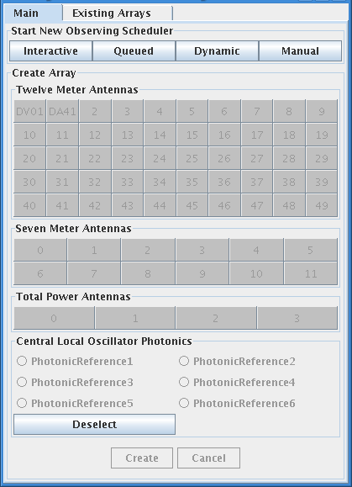Figure 1: Scheduling Panel - offline view | 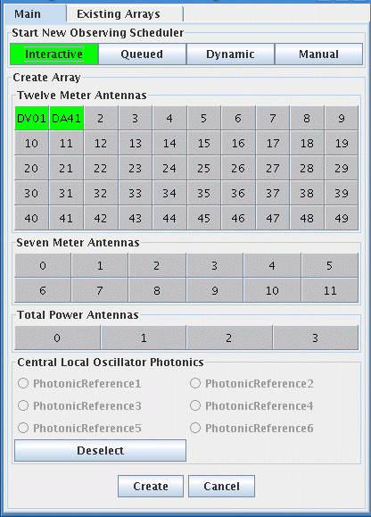Figure 2: Scheduling Panel - online view

Existing array tab
Another tab in the create array panel is for arrays that already exist. This tab shows all the current arrays and by selecting on, then using the right mouse button you can destroy the array, see Figure 3.
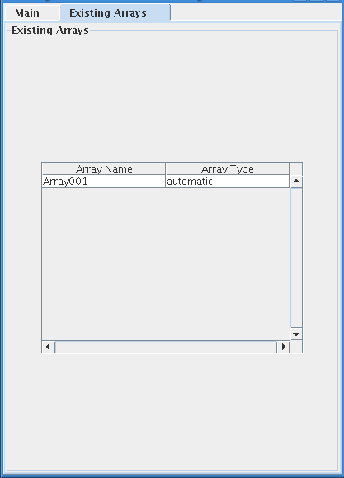Figure 3: Existing Arrays

Search Archive Only Plug-in - Deprecated
There is also a simple archive search plug-in. This will allow you to search the archive for projects but will not allow the search results to be assigned to any scheduling session. It is purely a view-only tab. This tab is deprecated and will be removed in a future release. The Project Tracker should be used to determine which projects are available.
Please note that search results from this deprecated panel will not be as specific as those in similar-looking parts of other Scheduler plug-ins. The Scheduler plug-ins are now careful to only show projects and SBs which are in a state to be executed, whereas the Search Archive plug-in will show projects and SBs regardless of their lifecycle state.

Array Creation
As seen in Figure 2, the create array section of the scheduling panel becomes enabled when one of the 4 buttons is pressed. The available antennas are then shown in green and the available photonic reference are also shown. To create an array select the antennas needed for the array and any photonic reference desired, then press the ‘Create’ button. To select multiple antennas use the ctrl or shift keys with a regular mouse click. A maximum of one photonic reference may be selected. After the ‘Create’ button is pressed the whole panel will be disabled until the array is created or a message is returned saying why the array cannot be created.

Interactive Scheduling
- To start an interactive scheduler you must have created an interactive array. See 4.2 Array Creation.
- When your interactive array is created a new array tab in the OMC will be opened for your session. See OMC documentation for array tab information.
- Within this array tab you will need to open a scheduler plug-in. If your ExecConfig.xml is configured properly it will show up in the plug-in menu of the OMC (see Figure 4).
- The default for interactive scheduling automatically searches the archive for all projects, selects the first project and selects the first scheduling block in that project. You can modify your search using the options at the top of the plug-in.
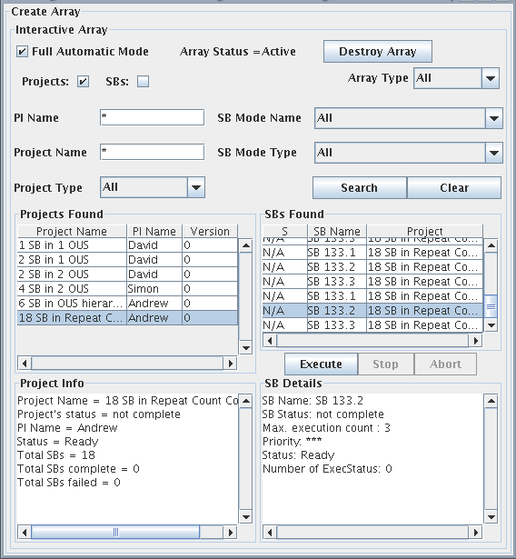Figure 4: Interactive Scheduling
- To execute a scheduling block, select it in the SBs Found table (the one on the right hand side) and press the “Execute” button.
- It is possible to stop a scheduling block when it is running normally using the “Stop” button. The scheduling block will stop after the currently running sub- scan has completed.
- It is also possible to abort a scheduling block. This should stop a scheduling block no matter where it is in its execution.

Queued Scheduling
- To start a queued scheduling session, begin by creating an array on the main tab after clicking the “Queued” button.
- You will then need to open a scheduler as described in section 4.3 step #3. The queued scheduler is seen in the following view (see Figure 5)
- To add scheduling blocks to the queue, you must first search for them. Then you must select them and click the “Add to Queue” button. This will add the selected SB to the lower left hand table. This is the SB Queue (see Figure 6).
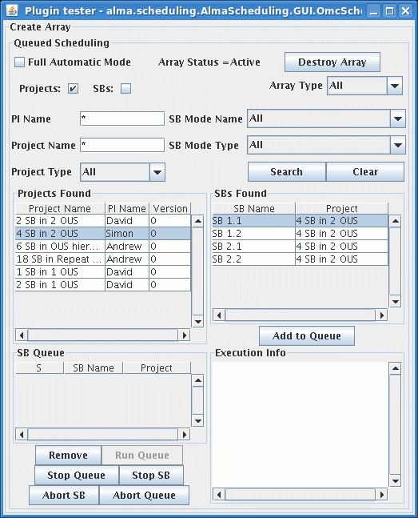Figure 5: Queued Scheduling
- To remove SBs from the queue, select the one you want to remove in the lower left hand table and then click the “Remove” button. Removal of SBs is permitted if the queue is active or not. However, if the queue is active you can not remove the currently running SB.
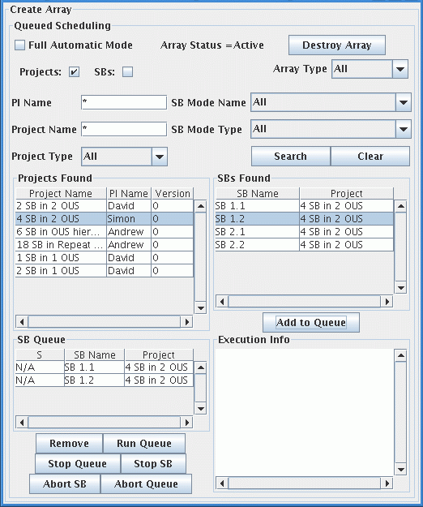Figure 6: SBs in the queue
- To run the whole queue, press the “Run Queue” button. If this is the second time running the queue the status’ will be reset to ‘N/A’ and the queue will start again from the very topmost SB. Note that the “Run Queue” will be disabled if either (a) the queue contains the same SB multiple times while not in Full Auto Mode or (b) the queue is empty.
- The StopSB button will stop the currently running SB in the queue and then it begins the next SB if there is one. Since this uses the stop method from the control system, the SB is stopped at the end of the next subscan so it may not stop immediately. Any results collected are archived.
- The StopQueue button stops the currently running SB but does not continue to the next SB. Likewise with the stop button mentioned in step 6, it is stopped at the end of its next subscan and any results are archived.
- The AbortSB button will abort the currently running SB immediately. No results are archived. The next SB will then be executed, if there is one in the queue.
- The AbortQueue button will abort the currently running SB and will not continue to the next one. No results are archived.
- The details of the SB’s execution will be displayed in the lower right hand side of the tab. See Figure 7.
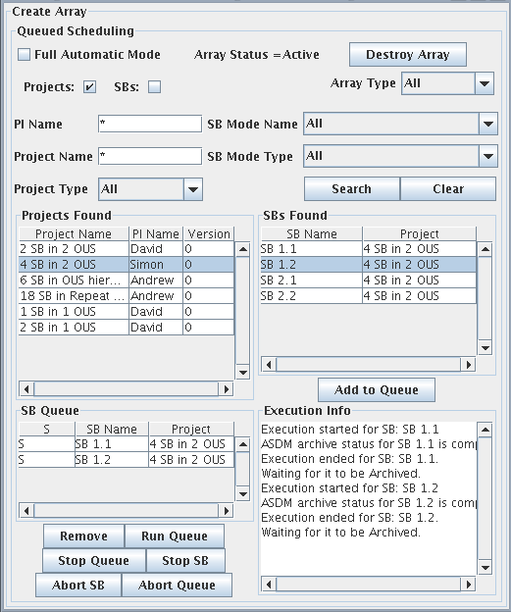Figure 7: Queued scheduling, execution details
SBs are added to the queue at the bottom. It is not possible to change the order of the queue’s list without removing and re-adding SBs. When the queue is running, it is possible to add and remove SBs in the queue, provided they are not currently being executed.
The stop and abort buttons are dependant on the state of the rest of the system. If there is a problem in another subsystem this could cause these buttons to not work properly.

Dynamic Scheduling
Disclaimer: Dynamic scheduling is only partially implemented in the scheduling panel and no guarantees about its interaction exist.
- When a dynamic array/scheduler is created. All the scheduling blocks appropriate for dynamic scheduling are selected. Appropriate SBs have finite execution counts. A scheduling block with in indefinite execution count will never be selected by a dynamic scheduler.
- Before a scheduling block is executed by the scheduler, the list of the scheduler’s top choices are displayed in the plug-in. The operator has the option to modify this list or accept it (before the time out has expired).
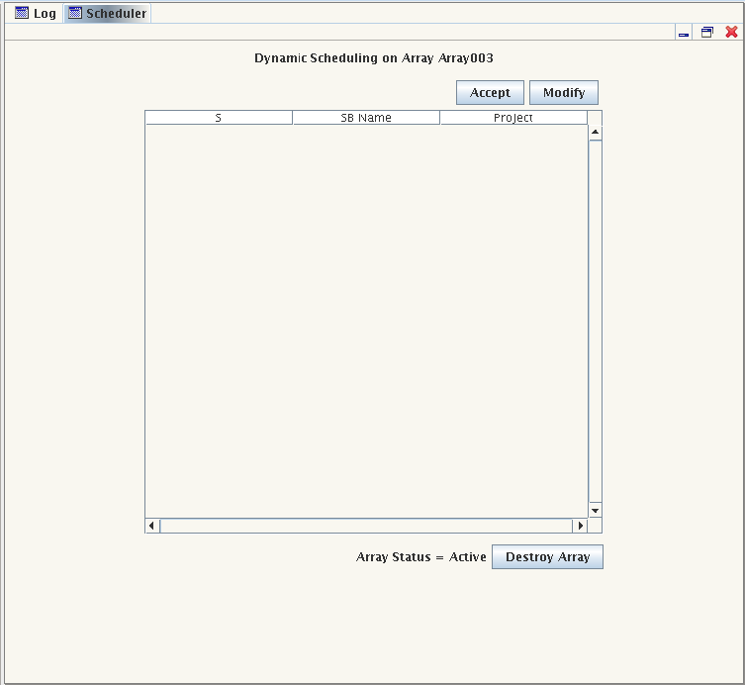Figure 8: Dynamic Scheduling
NOTE: Modify is not currently implemented and eventually all the SBs the dynamic scheduler is considering will be displayed. Also, eventually there will be a displayed timer to show how much time is remaining before the scheduler runs what it thinks is best.

Creating a Manual Array
The plug-in associated with a manual scheduler is very similar to that for an interactive scheduler (see Figure 9). The search facilities are the same as for interactive scheduling, except that the Projects found will be those marked as Manual Mode in the ALMA-OT and the SBs found will be only those in such Projects. Once you have selected the SB with which you wish to associate any ASDM created in this session, press the ‘Start Manual Session’ button.
In order to use the manual array, CCL commands should be entered in your preferred Python console. Documentation on the CCL is available both within a python session or at the system command line. For the latter, type “pydoc CCL” on a regular terminal where the software is installed and the modules you can choose from will be listed. Then for more detailed information on specific modules type “pydoc CCL.<mod name>” (replacing <mod name> with the actual module’s name). The same documentation is available in the Python Console by typing “import CCL” and “help(CCL)”.
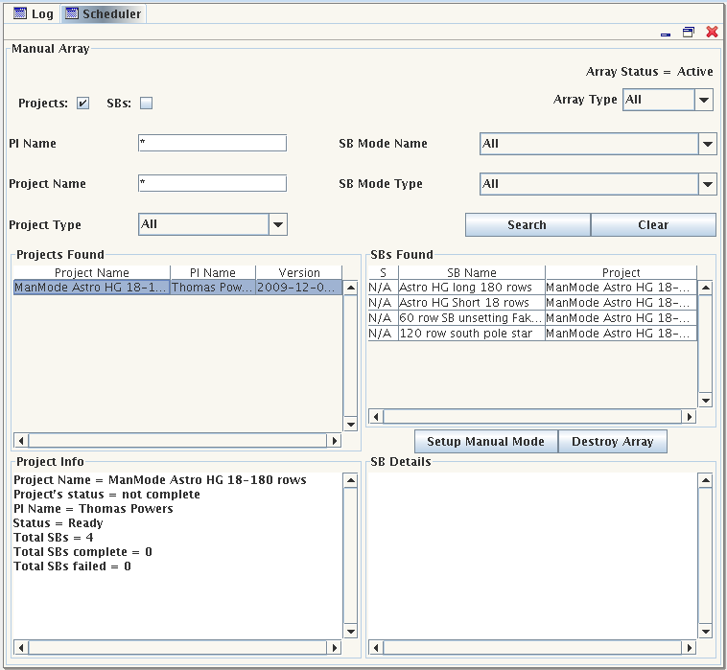Figure 9: Manual Scheduling

Displaying the status of a scheduling block’s execution
The status of the execution will be displayed in the “S” column of the Scheduling Block table.
Possible statuses include:
R SB is running
C SB has completed execution
AB SB has been aborted
S SB’s execution was successful
AR ASDM associated to this SB’s execution has been archived
F or FAIL SB’s execution has failed

Closing a Scheduler plug-in (does not destroy the array!)
To close a scheduler press the stop button that appears in the top right hand corner.
NOTE: This does not destroy the array!

Destroying an array
To destroy an array you have two options. The first is to use the “Destroy Array” button shown on every plug-in created after the array is created. See Figure 4 - Figure 9. The second option is to use the mouse’s right click menu on a selected array in the Existing Arrays tab. See Figure 3.
When a scheduler plug-in is still open, the status of an array will be displayed there. Current status’ are Active and Destroyed.

Searching the archive
It is possible to search the archive and get results by project or by SB. To choose, select the appropriate check box on the top of the panel.
There are 5 different parameters to search on; the PI name, the project name, the type of project, the type of SB and the mode of the SB. The types and mode correspond to what is defined in the ALMA-OT. Wildcard (*) is permitted which searching for the PI and Project names. It should also be possible to search with a partial word plus a wild card (for example Sarah*).

List of Known Issues
- Dynamic scheduling is not fully functional and I can almost guarantee problems will occur if using it!
- You can not modify the list sent to the dynamic scheduler.
- All SBs are not shown as choices in the dynamic scheduling tab.
- A determined user of Queued Scheduling will be able to add a second instance of an SB to a running queue, which will circumvent the disabling of the “Run Queue” button with unpredictable results.

Next official update
R7.1, June 2010

