Scheduling Subsystem
User Guide for the Create Array Panel, and Scheduling Panel

Version: R8.0
Status: Draft
2010-12-15
Prepared by: | Organization: | Date:
David Clarke | NRAO | 12/15/10
IPT Leader Approvals: | Organization: | Date:
Released By: | Organization: | Date:
Change Record
Version | Date | Affected section(s) | Change Request # | Reason/Initiation/Remarks
A | 2006-08-22 | All | Created
A | 2006-08-28 | All | Modified | Clarified portions after input from readers
A | 2006-10-05 | 3.2, 4.1, 4.3, 5, 6 | Updated | Updated to reflect software state at R4
A | 2006-10-26 |  | Updated & Added Snapshots | Updated for Holography user test.
A | 2006-12-14 | All | Modified | Update for new Scheduling Panel
A | 2007-03-14 | 3, 4, 5 | Redid all snapshots, modified almost all text. | Updated for GUI FBT enhancements/changes
A | 2007-03-27 | 4.1, 4.8, 5 |  | Updated a few things for the AntennaVerification branch
A | 2007-05-01 | 4.4 |  | Fixed mismatch to software
A | 2007-05-07 | 4.3, 4.7 |  | Added new section about status reporting of a SB’s execution
A | 2007-08-03 | 1.1, 1.2, 3.1, 3.2, 4.1-4.4, 4.7, 6 |  | Update to reflect changes made during the GUI2 FBT
A | 2007-11-16 | 4.4, 5, 6 |  | Updated queued scheduling section
A | 2009-11-25 | All | Modified | Redid snapshots and text for R7.0. Recreated document after formatting loss.
A | 12/15/10 | All | Modified for R8.0 | Reworked for refactored (R8.0) Scheduler

Table of Contents
1. Description 6
1.1. Purpose 6
1.2. Scope 6
2. Related Documents and Drawings 6
2.1. References 6
2.2. Abbreviations and Acronyms 6
3. Startup 6
4. Functionality 7
4.1. General GUI Information and Functionality 7
4.1.1. Different types of schedulers 7
4.1.2. Existing arrays tab 8
4.2. Array Creation 9
4.3. Interactive Scheduling 9
4.3.1. Array Panel Overview 9
4.3.2. Project Table. 10
4.3.3. SchedBlock Table. 11
4.3.4. Pending Executions. 11
4.3.5. Current Executions. 12
4.3.6. Recent Executions 12
4.4. Basic Operation. 12
4.4.1. Selecting And Queuing 13
4.4.2. SchedBlock Execution. 14
4.5. Creating a Manual Array 15
4.6. Closing a Scheduler plug-in (does not destroy the array!) 15
4.7. Destroying an array 15
5. List of Known Issues 16
6. Next official update 16
List of Tables

List of Figures

Description

Purpose
Provide information on how to create arrays and use the Scheduler Panels.

Scope
How to create arrays and how to use the Scheduler Panel features only.

Related Documents and Drawings

References

Abbreviations and Acronyms
OMC Operator Master Client from EXEC.
Plug-in A graphical component within the OMC that can be docked or floating from the OMC.
GUI Graphical User Interface.
ALMA-OT ALMA Observing Tool.
CDB Configuration Data Base.
SB Scheduling Block.
CCL Control Command Language.

Startup
Instructions on how to configure the R8.0 Scheduling subsystem can be found at http://almasw.hq.eso.org/almasw/bin/view/ITS/CdbPendingChanges#Setup_for_the_new_Scheduler.
The Create Array panel is a regular OMC plug-in which must be started from the plug-ins menu (if not already started from there and saved as open in the omc.layout file). See the OMC’s documentation about starting plug-ins.

Functionality

General GUI Information and Functionality

Different types of schedulers
There is now only one type of scheduling, Interactive scheduling. However, it now incorporates a SchedBlock queue, and so Queued scheduling is subsumed into it. Despite this, the CreateArray GUI (Figure 1) still shows options for Interactive and Queued – this is a pragmatic choice to allow reuse of the R7.0 CreateArray GUI, and both buttons actually invoke the same scheduler.
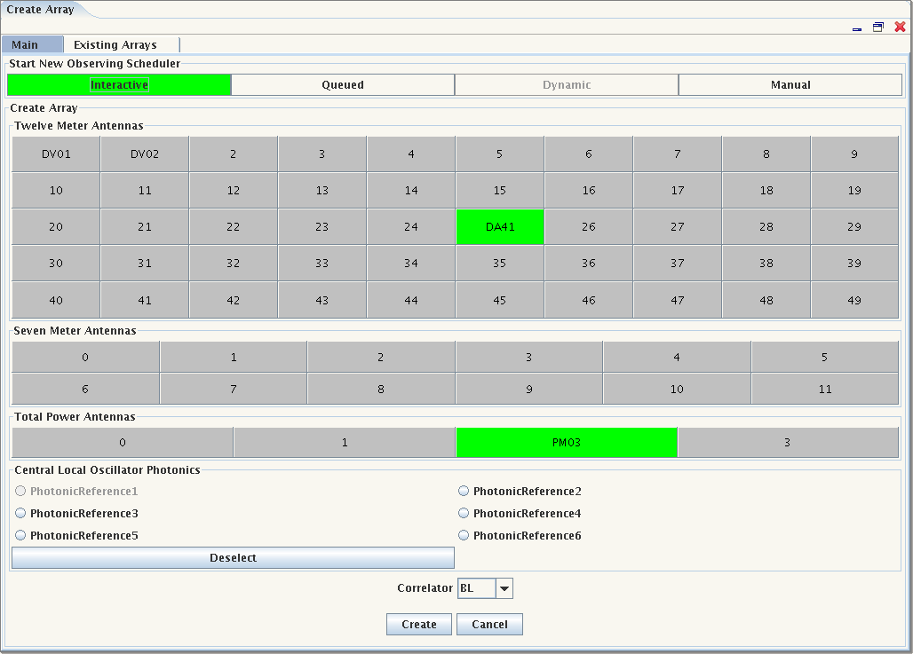Figure 1: Create Array Panel
There is also a button to create a manual array but a scheduler does not get created for this type of array. When you click one of these buttons the array creation area becomes enabled and the created array (see 4.2 Array Creation) will be assigned to the scheduler type chosen. At which point a new plug-in for your scheduler will be created and displayed.

Existing arrays tab
Another tab in the create array panel is for arrays that already exist. This tab shows all the current arrays and by selecting one, then using the right mouse button you can destroy the array or open a second plug-in to view and control the array, see Figure 2.
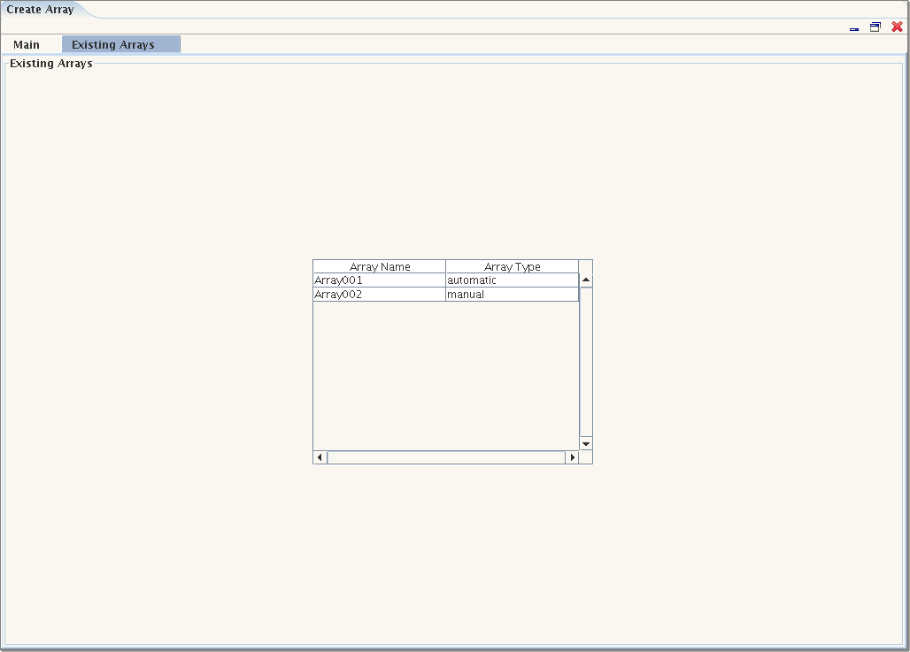Figure 2: Existing arrays

Array Creation
As seen in Figure 1, the create array section of the scheduling panel becomes enabled when one of the top 3 buttons is pressed (note that the Dynamic button is disabled). The panel then shows the available antennas (in green), the available photonic references and the correlators. To create an array select the antennas needed for the array and any photonic reference desired and the correlator to use, then press the ‘Create’ button. To select multiple antennas use the Ctrl or Shift keys with a left mouse click. A maximum of one photonic reference may be selected. After the ‘Create’ button is pressed the whole panel will be disabled until the array is created or a message is returned saying why the array cannot be created.

Interactive Scheduling

Array Panel Overview
The display for an Interactive Array (Figure 3) has 5 principal parts:
Figure 3: Array Panel for interactive scheduling, annotated to show the main parts

Project Table.
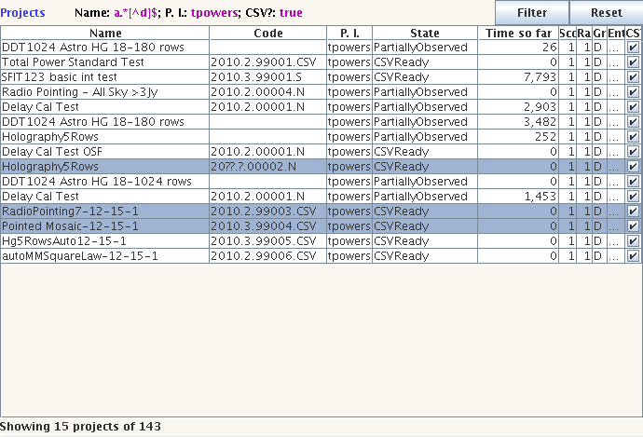
This displays information on the Projects which the Scheduler knows about, and which are suitable for this array (currently, the criteria are Manual Mode or non-Manual Mode). The table can be sorted on any column by clicking that column's header. Additionally, there is a powerful set of filters which allow the operator to control which subset of projects is displayed (see 4.4.1.Selecting And Queuing ).

SchedBlock Table.
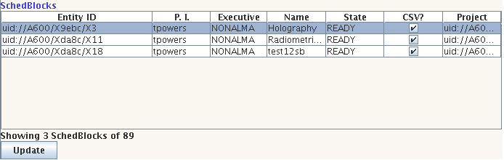
This shows the SchedBlocks which are part of the Projects displayed in the Project Table. By default, the table shows all the SchedBlocks for the Projects displayed in the ProjectTable, however, selecting one or more Projects in the Project Table will cause the SchedBlock Table to display the SchedBlocks for just those projects.

Pending Executions.
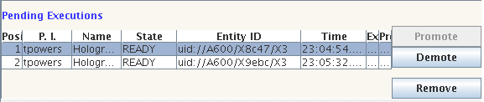
Shows the queue of pending SchedBlock executions, along with the time at which they were queued for execution. A SchedBlock execution in the queue can be manipulated by using the Promote, Demote and Remove buttons shown alongside the queue.

Current Executions.
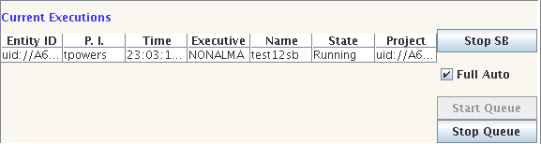
Shows the current SchedBlock executions (if any) and any which have finished observing but are waiting for their data to be archived. By default, an Interactive Scheduler starts with SchedBlock execution deactivated. To start observing, the operator should press the “Start Queue” button.

Recent Executions
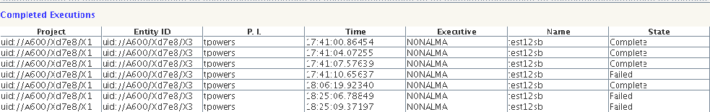
Shows SchedBlock executions which have completed while this plugin has been open. Allows the operator to review recent activity. Note that this information is stored in the Array Panel, and will be lost once the Array Panel is closed.
The horizontal and vertical dividers between these components can be dragged with the mouse to allow you to adjust the display to suit your preferences. Also, the vertical divider has small arrows on, clicking which will collapse one or other half of the display to allow you to focus on one part. The collapsed panel can be brought back by clicking the other arrow. Multiple Array Panels can be open on the same Array, allowing the user to manage their screen real-estate: for example one Array Panel showing the Project and SchedBlock tables and one showing the executions.

Basic Operation.
The basic method of working with the Interactive Scheduler is to select SchedBlocks which are to be observed and to queue them for execution. Once the observing queue is started (by pressing the “Start Queue” button), each SchedBlock will be taken from the queue and executed in turn.
More SchedBlocks can be added to the queue as it is running, and the queue can be managed as described above. Note that the same SchedBlock can appear in the queue more than once, including consecutively.

Selecting And Queuing
To add SchedBlocks to the execution queue, firstly select one or more SchedBlocks in the SchedBlock Table, then click the right mouse button within the table. The pop-up menu which appears has two options for queueing SchedBlocks.
To queue the selected SchedBlock(s), select the “Queue Selected SchedBlock(s)” option. To queue the SchedBlock which was under the cursor at the time the menu was popped-up, select the “Queue SchedBlock <entity-id>” (the entity-id will be that of the SchedBlock which will be queued).
In order to help manage the list of SchedBlocks in the table, you can:
- Sort the table on any column by clicking on the column header. Clicking again will reverse the direction of sorting.
- Resize the columns by clicking and dragging the dividers between the column headers.
- Rearrange the columns by dragging and dropping the headers.
- Reduce the number of SchedBlocks displayed by either selecting a number of projects in the Project Table (in which case the SchedBlock table will show only the SchedBlocks for the selected projects), or by filtering the Project Table (q.v.).
Like those in the SchedBlock Table, the columns in the Project Table can be sorted, resized and rearranged. In addition to this, search criteria can be specified for any set of columns in the Project Table, and only the rows which match all of these criteria will be shown. This process is termed “filtering”.
To specify the filters for the Project Table, press the “Fillter” button which is located just above the Project Table. A dialogue will appear with an entry for each column of the Project Table. Each entry consists of three parts:
- A label indicating to which column in the Project Table this filter will apply.
- A text field into which you should type a regular expression. Only rows in which the value in this column matches the regular expression will be displayed.
- A checkbox which controls whether to use this filter or not (note that this is automatically set when you type something into the textfield described above).
Filtering happens as you type, so you can easily check that you are getting the correct results. The current filtering is also summarised just above the Project Table.
The filtering is individual to each Array Panel, so if you open the plugin again, a new set of filters will be created and used on that second plugin, independently from those on the first plugin.
Things to note about filtering:
- Matching is done in a case insensitive way (so “bob”, “BOB” and “Bob” will all match the value “Bob”).
- The search filters are regular expressions, one notable result of this is that a single asterisk is NOT a valid regular expression. To match any string use the string “.*” (without the quotation marks). You can always just switch off a particular filter.
- Boolean values are shown in the tables as check boxes which are either ticked or not. However, their values are “True” and “False”. So, as an example, to show only those projects which are CSV projects, set the CSV filter to “true” (remember, it is not case sensitive).
- If you enter a malformed regular expression, it will turn red (be aware that this can happen when you're in the middle of typing as half a regular expression will probably not be syntactically valid– if it does, just keep typing the rest of the expression and things should work out).

SchedBlock Execution.
As mentioned above, an Interactive Array is created with SchedbBlock execution switched off. To switch it on, press the “Start Queue” button. When you do this, the first SchedBlock in the Pending Executions queue will be taken and put to the Control subsystem for execution. In the Array Panel, it will move from the Pending Executions display to the Current Executions display, and its status will be changed to Running. To monitor progress of the observation, you should open the DataFlow plugin.
Once the SchedBlock has finished execution, it's status will change to Archiving until such time as the Control subsystem notifies the Scheduler that the observation data has been archive, when the state of the Execution will be changed to Complete and the Execution will move to the Recently Completed display.
At the same time as the current SchedBlock execution is moved to Archiving, the next SchedBlock is taken from the Pending Executions queue and execution of that SchedBlock begins. This continues until either the queue is empty or observing is suspended by pressing the Stop Queue button.
In the case of the Stop Queue button being pressed, the current SchedBlock execution will complete, but after that no new SchedBlock will be taken from the Pending Queue until observing is restarted (by pressing the Start Queue button).
If observing stops because the Pending Executions queue is empty, simply add a new SchedBlock to the queue and observing will start straight away.
Should a SchedBlock execution be unsuccessful, the state of the Execution will be changed to Failed and the Execution will move to the Recently Completed display. As with a successful execution, the next Execution will be started.

Getting New or Updated Projects and SchedBlocks
Behind the scenes, there is a component called the ArchiveUpdater which monitors the ObsProjects, SchedBlocks and Status objects stored in ALMA's databases. If it detects any changes, it will update the Scheduler's records of what Projects &c are available for scheduling. These records are stored in the Scheduling Working Database (or SWDB). Changes to the ObsProjects, SchedBlocks or their Statuses should be reflected in the SWDB within two minutes (though this can be changed, so your installation may have a different time between updates).
The Array Panel does not update automatically in response to SWDB updates (changing displays under the user's feet proved to be a bad thing), but pressing the Update button at the bottom left of the Scheduling Table will update the Project and SchedBlock Tables. Note that this could result in Projects or SchedBlocks disappearing from the tables as a result of them no longer being ready to schedule.

Creating a Manual Array
The plug-in associated with a manual scheduler is very similar to that for an interactive scheduler The Project and SchedBlock search and selection facilities are the same as for interactive scheduling, except that the Projects found will be those marked as Manual Mode in the ALMA-OT and the SchedBlocks found will be only those in such Projects. Select a SchedBlock in exactly the same way as for interactive scheduling (though note that only one SchedBlock can be selected at once). To Configure the array for the selected SchedBlock, use the pop-up menu on the SchedBlock table (activated by clicking the right mouse button).
In order to use the manual array, CCL commands should be entered in your preferred Python console. Documentation on the CCL is available both within a python session or at the system command line. For the latter, type “pydoc CCL” on a regular terminal where the software is installed and the modules you can choose from will be listed. Then for more detailed information on specific modules type “pydoc CCL.<mod name>” (replacing <mod name> with the actual module’s name). The same documentation is available in the Python Console by typing “import CCL” and “help(CCL)”.

Closing a Scheduler plug-in (does not destroy the array!)
To close a scheduler simply close the window by clicking on the red X in the top right hand corner.
NOTE: This does not destroy the array!

Destroying an array
To destroy an array use the mouse’s right click menu on a selected array in the Existing Arrays tab. See Figure 2.
When a scheduler plug-in is still open, the status of an array will be displayed there. Plug-ins for destroyed arrays will have all their controls disabled.

List of Known Issues
- Restarting the queue while the previous SchedBlock is still active will not work.
- Currently there is no check against trying to run a SchedBlock marked as Running. Whilst a Running SchedBlock can appear in the Pending queue, it must not be running when it gets selected from the top of the queue. Note that the Scheduler is smart enough to cope with two (or more) consecutive executions of the same SchedBlock – it clears the Running state for the first execution before starting the second.
- The “Details” dialogues are not yet implemented and do nothing.
- Scheduler plug-in startup from the OMC View menu is intermittent. Use the pop-up menu on the Array Table (invoked by clicking the right mouse button over the array in which you are interested).
- Opening an Array Panel while a SchedBlock is running will fail to show the current execution. Once a new SchedBlock execution starts, the display will work as expected.
- Certain failures in execution (particularly those which happen before a SchedBlock execution gets properly underway), will not appear in the Completed Executions table.

Next official update
R8.0.1

