Robert Chesser

8/23/19

Homework 6

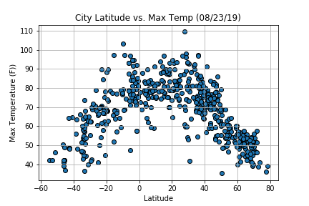

This graph clearly shows a relationship between latitude and temperature. As the latitude increases or decreases away from the equator, the temperature also decreases. The biggest question I have about this is why the temperatures appear to “peak” on or about 20 degrees latitude.

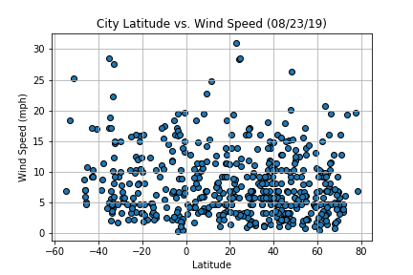

This graph seems to show a fairly even distribution of wind speed across all latitudes. I expected to see a bit of the reverse of temperature relative to the equator. Winter winds often seem harsh and consistent whereas summer winds may be strong but are more sporadic. This graph does not support that perception.

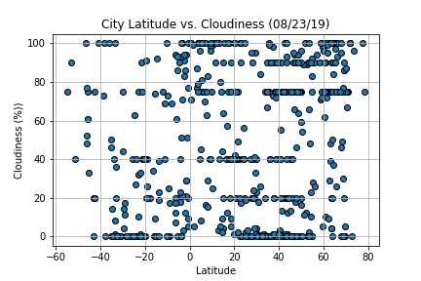

This graph is much like the wind graph in that there does not appear to be a concentration in any specific latitude. I would have expected for more northern areas to have increased cloud cover, but this graph does not show that to be the case.

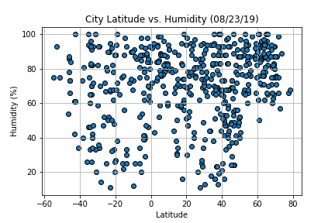

This graph seems to indicate that higher humidity is not related to latitude. However, there is a concentration of higher humidity values in the ~20 to ~75 degrees latitude. To further understand these graphs, I would like to determine the number of sampling sites/cities both north and south of the equator.